All Screens On

VicScreen Annual Report 2025/26
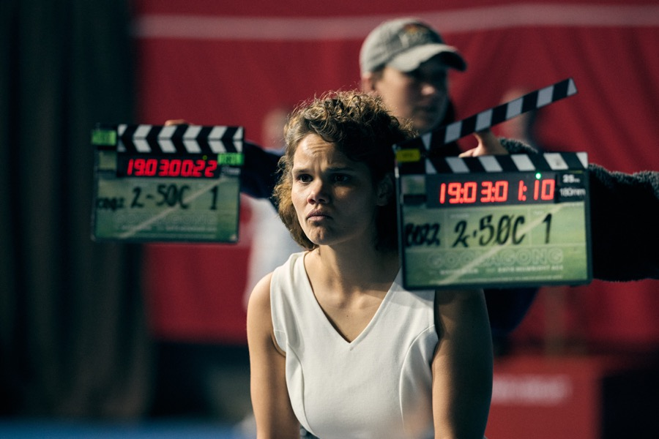
Actress Lila McGuire on the set of Goolagong. Photo by Narelle Portanier


Contents
About VicScreen 5
50 Years of Supporting the Screen Industry 8
President’s Report 11
CEO’s Report 13
2025/26 Year in Review 18
Key Deliverables 21
Governance & Report of Operations 66
Disclosure of Payments 2025/26 114
Financial Statements 132
Image credits: 183

Acknowledgment of Traditional Owners
VicScreen acknowledges the Traditional Owners of Country throughout Victoria, their ongoing connection to this land and water, and we pay our respects to their culture and their Elders – past and present.
We acknowledge that First Peoples’ self-determination is a human right as enshrined in the United Nations Declaration on the Rights of Indigenous Peoples. Building on this, we are committed to developing strong and enduring partnerships with First Peoples that will contribute to growing a prosperous, thriving and strong Victorian First Peoples community.

Responsible Body’s Declaration
In accordance with the Financial Management Act 1994, I am pleased to present Film Victoria’s (trading as VicScreen) Annual Report for the year ending 30 June 2026.

Financial Management Compliance Attestation Statement
I, George Lekakis AO, on behalf of the Responsible Body, certify that Film Victoria (trading as VicScreen) has no Material Compliance Deficiency with respect to the applicable Standing Directions under the Financial Management Act 1994 and Instructions.
George Lekakis AO
President, VicScreen
27 August 2026
VicScreen is the Victorian Government’s creative and economic screen development agency.
It is focused on boosting Victoria’s position as a global screen powerhouse, enriching the lives of all Victorians.
The organisation leads the screen industry through investing in compelling Victorian content and intellectual property (IP), driving industry growth and jobs, developing skills and talent, and building market and audience engagement.
In a rapidly changing environment, VicScreen works closely with screen businesses, individuals and organisations across Australia and priority international territories, to anticipate and respond to shifting market dynamics. VicScreen supports the state’s screen industry to achieve sustained creative, cultural and economic success

Actress Elizabeth Cullen and Actor Marton Csokas in Goolagong. Photo by Ben King

About VicScreen
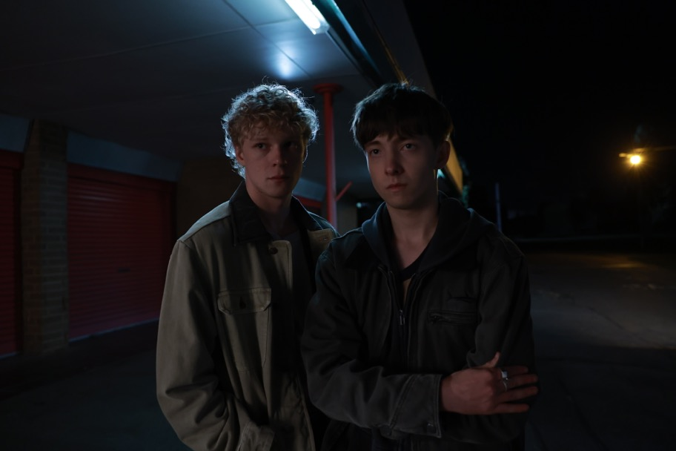
Actors Stacy Clausen and Joe Bird in Leviticus. Photo by Ben Saunders

Origins
Initially constituted as the Victorian Film Corporation in 1976 under an Act of Parliament, the Corporation became Film Victoria in 1982 by virtue of the Film Victoria Act 1981.
In 1997 the functions of Film Victoria were amalgamated with those of the State Film Centre of Victoria to form Cinemedia Corporation, under the Cinemedia Act 1997.
In 2001 Cinemedia Corporation was dissolved, and Film Victoria and the Australian Centre for the Moving Image (ACMI) were constituted as separate entities under the Film Act 2001.
In 2022 Film Victoria changed its trading name to VicScreen, to more accurately reflect the diversity of screen activity that the organisation supports, encompassing film and television, online content, virtual reality, augmented reality and digital games.

Film Act 2001
The Film Act 2001 requires Film Victoria, trading as VicScreen, to provide “strategic leadership and assistance to the film, television and multimedia industry of Victoria to encourage innovation and the creation of new projects of high quality that are of economic or cultural benefit to Victoria”.
The Act prescribes eight functions for VicScreen:
- Provide financial and other assistance to the film, television and multimedia industry in Victoria
- Promote, whether in Victoria or elsewhere, the use of locations or services in Victoria for the production of any film, television or multimedia project
- Provide financial assistance, whether in Victoria or elsewhere, to organisations, events or activities including festivals, conferences, publications or exhibitions, where film or other screen-based programs are made, seen or discussed
- Establish and facilitate, whether in Victoria or elsewhere, relationships for the development of film, television or multimedia programs
- Provide leadership to the film, television and multimedia industry in Victoria
- Develop strategic plans for the development and improvement of the film, television and multimedia industry in Victoria
- Advise the Minister on matters relating to the film, television and multimedia industry in Victoria
- Develop relationships or enter into partnerships with other organisations, including government bodies, whether in Victoria or elsewhere, to improve the film, television and multimedia industry in Victoria.
VicScreen contributes to the delivery of the Victorian Government’s creative industries strategy, Creative State 2025, and VICSCREEN: Victoria's Screen Industry Strategy 2021–2025 (VICSCREEN strategy).
VicScreen supports the principles and objectives enshrined in the Creative Victoria Act 2017, especially those that recognise that creative industries have an intrinsic value and contribute significantly to Victoria’s wealth and prosperity.

50 Years of Supporting the Screen Industry
For half a century, the agency has driven the state's film, television, digital games, and creative industries.
1976: Established as the Victorian Film Corporation.

1982: Became Film Victoria through the creation of the Film Victoria Act 1981.
1997: Integrated with the State Film Centre of Victoria, to form Cinemedia Corporation, under the Cinemedia Corporation Act 1997.
2001: Film Act 2001 abolished Cinemedia Corporation and established Film Victoria and the Australian Centre for the Moving Image (ACMI) as separate statutory authorities.

Actress Kate Winslet in The Dressmaker. Photo by Ben King
2015: Film Victoria integrated with Creative Victoria alongside government agencies across arts and culture, screen and design.
2021: Launch of VICSCREEN: Victoria's Screen Industry strategy 2021–2025, a whole of Victorian Government plan to reshape and expand Victoria’s screen industry.
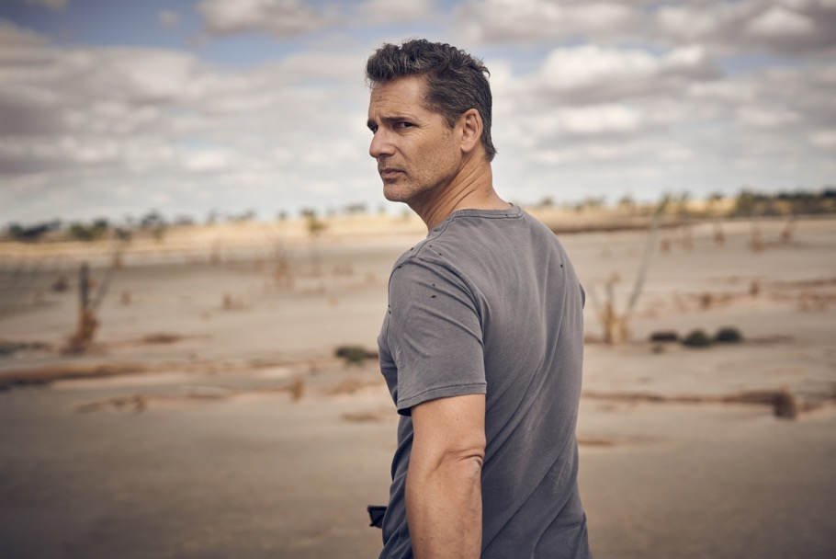
Actor Eric Bana in The Dry. Photo by Ben King
2022: Film Victoria re-branded as VicScreen, better reflecting the diversity of screen activity the agency supports, from film, television, online, virtual reality (VR) and digital games.

2026: Celebrating 50 years of supporting the screen industry.

President’s Report

As president of VicScreen, I am pleased to present the 2025–26 Annual Report.
This has been a year of transition for Victoria’s screen industry and for VicScreen as the organisation looked beyond a period of unprecedented investment to the next stage of its development. The Board’s focus has been on stewardship: protecting the strengths built over recent years, supporting clear priorities, and ensuring VicScreen remains well positioned to serve the industry in a more complex environment.
The conclusion of the Victorian Government’s four-year VICSCREEN strategy 2021–2025 provides an important moment to reflect on the foundations now in place across the sector. Victoria enters this next chapter with deep creative capability, strong production infrastructure, respected businesses and a screen culture built over decades.
This year also marks an important milestone: 50 years since the Victorian Film Corporation was established in 1976 under an Act of Parliament. This anniversary is significant not only for Victoria, but for Australia’s film and television history. Across five decades, VicScreen has helped build the creative talent, production capability and screen culture that continue to underpin Victoria’s success today.
Strong strategic leadership and maintaining a long-term view is critical. The global screen industry is changing rapidly, but Victoria’s enduring strengths give us confidence: exceptional talent, mature creative businesses, world-class production capability and a reputation for ambitious, distinctive storytelling.
As a Board, we recognise that our role extends beyond responding to immediate challenges. We must maintain a long-term view and ensure the decisions we make today lay the foundations for a thriving screen industry in the years ahead.
The Board has supported VicScreen’s work to engage with industry, government and community partners on the priorities that should guide the organisation’s next phase. Those conversations have reinforced the importance of a stable production pipeline, sustainable screen businesses, workforce capability and strong audience connections.
On behalf of the Board, I thank the Victorian Government for its ongoing support of Victoria’s screen industry. I extend my sincere gratitude to the former Minister for Creative Industries, Colin Brooks MP, for his leadership and advocacy, and welcome the newly appointed Minister for Creative Industries, Vicki Ward MP, whose enthusiasm and commitment to the portfolio are already evident.
I acknowledge the contribution of my fellow Board members, whose expertise, judgement and commitment continue to support VicScreen’s important work. I also extend my sincere thanks to CEO Caroline Pitcher, the Executive Team and all VicScreen staff for the energy, professionalism and dedication they bring to the organisation every day. I also thank our partners at Docklands Studios Melbourne, Creative Victoria and ACMI for their ongoing collaboration and shared commitment to Victoria’s screen sector.
George Lekakis AO, President, VicScreen

CEO’s Report

This was a year that tested Victoria’s screen industry, and one where VicScreen remained focused on delivery.
The 2025–26 financial year marked a new chapter, following the conclusion of the Victorian Government’s VICSCREEN strategy 2021–2025. After four years of strong growth and targeted investment, our focus was to translate that momentum into practical outcomes for industry, while operating with discipline in a financially tighter and more uncertain environment.
We stayed close to industry, listened carefully, and made practical decisions about where VicScreen could have the greatest impact. This meant backing people, businesses and ideas that strengthen Victoria’s competitive edge, while working with government, industry and partners to understand what the sector needs next.
VicScreen’s Masterclass series and Future Vision 2025 brought Victorian practitioners into conversation with leading local and international voices, sharing practical insights on audiences, commissioning, financing, distribution and the opportunities emerging across the global screen economy.
That future focus was particularly evident in games, animation and visual effects. The GameChanger Academy moved from concept to delivery, establishing a new industry-led training pipeline to help build Victoria’s workforce of the future. In partnership with the Victorian Government and Melbourne games studio Massive Monster, we also supported the creation of MASS, a dedicated games co-working hub designed to strengthen collaboration, capability and business growth.
We continued to back new voices and distinctive Victorian stories. Initiatives including Footy Shorts and Sovereign Shorts provided emerging storytellers with pathways to develop their craft, while productions such as Goolagong demonstrated the importance and impact of investing in First Peoples stories, creators and careers.
The economic results were significant. VicScreen-supported projects generated approximately $444 million in direct Victorian expenditure and supported more than 7,921 jobs across the state’s screen industry. These numbers represent work for crews, cast, post-production teams, games developers, animators, visual effects artists, production accountants, location managers, caterers, suppliers and the many other people and businesses which make up and benefit from Victoria’s screen ecosystem.
Major international productions including Empire City, Fog City, Insidious 6 and Last Seen brought substantial investment into Victoria and created real opportunities for Victorian talent, businesses and technical expertise.
At the same time, Victorian-made projects continued to travel. War Machine, written, directed, produced and made in Victoria, and Thrash, filmed in Victoria, both reached Netflix’s Global Top 10. Together with Victorian-led projects including, Saccharine, Leviticus, Sweet Milk Lake and Hotel Hotel Hotel Hotel, these works showed the depth of our creative talent and the strength of an industry that can attract world-leading productions, while developing local stories with genuine global appeal.
Screen culture was another highlight. The Melbourne International Film Festival (MIFF) delivered its most successful edition on record, and the Indian Film Festival of Melbourne (IFFM) continued to draw audiences, industry and international attention to Victoria. Across festivals, immersive experiences and audience programs, VicScreen-supported activity helped connect people with bold work, celebrating our state’s creative energy.
Thank you to the VicScreen Board for its guidance and support, and the VicScreen team for the care, skill and commitment they bring to their work every day. This organisation is small, but its impact is large because of the people behind it.
Most of all, I thank Victoria’s screen industry. In a challenging year, you kept creating, adapting, employing, mentoring, building, pitching, producing and taking Victorian stories to audiences here and around the world. Your ambition and persistence are what make this industry so powerful, and why VicScreen’s work matters.
Caroline Pitcher, Chief Executive Officer, VicScreen.

Performance
Throughout this report:
- Economic impact and employment figures include estimates, as some projects have not yet concluded reporting.
- Amounts for previous years have been updated with acquitted results and may differ from results reported in previous annual reports which included estimates.
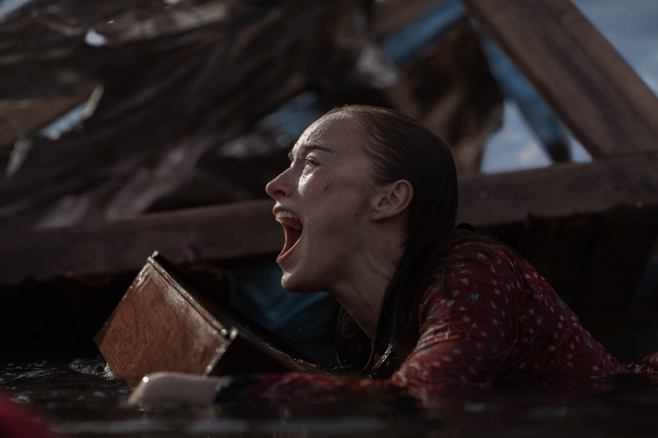
Actress Phoebe Dynevor as Lisa in Thrash. Photo by Ben King

2025/26 Year in Review

Comedian Urzila Carlson and Comedian Nazeem Hussain in Separated at Birth. Photo by Jane Zhang
This year, VicScreen’s support:
- Generated $444.5m in direct Victorian expenditure (2024–25: $502.4 million)
- Created 7,921 local job opportunities, equating to 3,405 direct full-time equivalent (FTE) jobs (2024–25: 8,141 job opportunities, 3,594 FTE)
- Delivered an ROI of $1:$12 meaning, for every dollar invested by VicScreen, 12 dollars were delivered back to Victoria in direct economic expenditure (2024–25 $1:$11)
- Enabled 94 film, television, online and digital game projects to commence production or post-production in Victoria (2024–25: 72 projects)
- Produced 157 hours of film, television and online content (2024–25: 140 hours)

Actors Stacy Clausen and Joe Bird in Leviticus. Photo by Ben Saunders
This year, through VicScreen:
- 31 feature films commenced production or post-production in Victoria, delivering $281 million in direct Victorian expenditure
- 37 television and online series and one-off projects commenced production in Victoria, delivering $124.5 million in direct Victorian expenditure
- 50 film, television and online projects received funding through the Victorian Production Fund, generating an estimated $138 million in direct Victorian expenditure
- 15 Victorian-led games projects commenced development, delivering $4.5 million of direct Victorian expenditure
- 13 digital games projects were supported through the Victorian Screen Incentive and Victorian Digital Screen Rebate, delivering $35 million in direct Victorian expenditure
- 52 film, television, digital games and online projects received $0.84 million in development funding*
- $4.2m was invested in industry and skills development programs and initiatives
*Excludes labs, development travel and business capability grants

Actor Duke McCloud as Milo and Actress Sarah Snook as Marissa Sarah in All Her Fault. Photo by Sarah Entickn

Key Deliverables

Key Deliverable 1: Provide Strategic Leadership
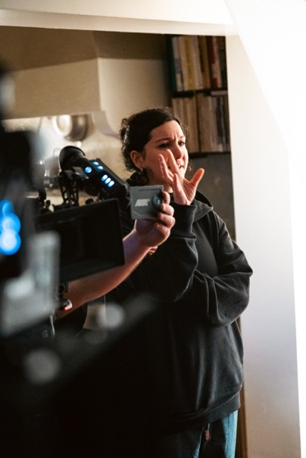
Director Gena Lida Riess of Revealed: Death Cap Murders. Photo by John Servedio
VicScreen sets the direction for Victoria’s screen industry, bringing together insight, partnerships and advocacy to ensure the state stays globally competitive and future-ready. In the past financial year, VicScreen has focused on strengthening capability, unlocking new pathways to a global market, and backing a diverse, resilient, and skilled screen workforce. The initiatives below highlight some of the ways VicScreen is turning strategy into action.
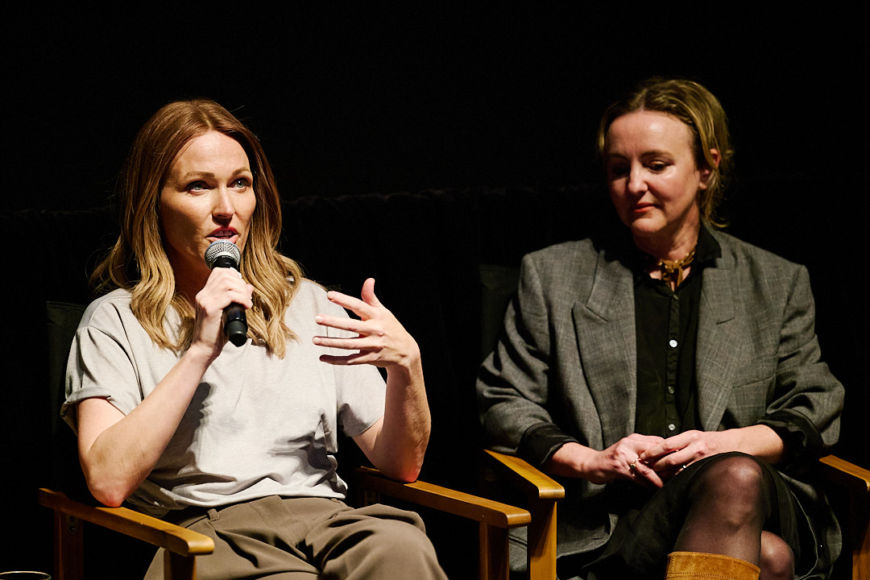
Writer Sally Hepworth and Screenwriter Sarah Scheller and from The Family Next Door. Photo by Daniel Mahon

VicScreen masterclasses and conversations – building a highly skilled Victorian screen workforce
VicScreen’s masterclass and conversation series of events have provided screen practitioners with direct access to leading domestic and international subject matter experts, translating global market trends, sustainable practices, audience behaviours, and career development pathways into practical insights for Victorian screen creators.
These events were designed to deepen understanding across an evolving sector, including direct to audience production approaches, craft development, and unique perspectives of filmmaking practice, to ensure local content creators can remain competitive in a rapidly evolving, global screen industry.
In September 2025, New York Times best-selling Victorian author Sally Hepworth, Producer Melinda Wearne and Screenwriter Sarah Scheller discussed how they took The Family Next Door from a best-selling novel to the screen.
“Adapting a book [for TV], you’re looking for a really good story; you’re looking for plot. And if it’s a mystery, you want a good twist.”
- Sarah Scheller, screenwriter and showrunner, The Family Next Door
“It was very appealing to me that this book option came with a plan and a very strong desire to actually see it made. For me, the most important thing was their enthusiasm for my story and their vision for it.”
- Sally Hepworth, author, The Family Next Door
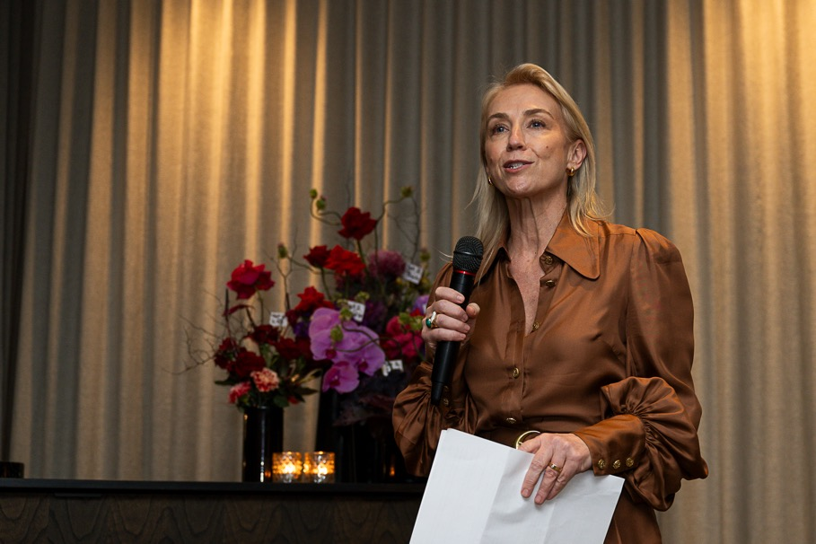
Managing Director, Streaming & Broadcast at Nine Amanda Laing. Photo courtesy of Future Vision.

Future vision – developing globally competitive, original television
Future Vision 2025 brought together some of the most powerful and celebrated voices in television including Richard Gadd, creator/ star of Baby Reindeer, Sally Wainwright, creator/director of Happy Valley, and Soo Hugh, the creative force behind Pachinko. The three-day exchange of ideas included keynote addresses and panel discussions on the theme Optimism in the Face of Uncertainty, covering topics such as authenticity, the fear of potential, and the difference between being agreeable and being interesting.
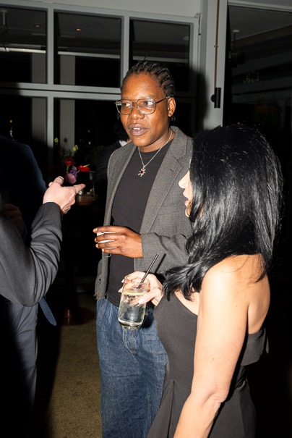
Writer and Director Tig Terera. Photo courtesy of Future Vision.
“I think every time I felt fearful of an idea, it’s probably because I’m scared of its potential in some way.”
- Richard Gadd, actor, comedian and writer
“My mantra to commissioners is that there should always be a show on your slate that you are terrified that you will lose your job over.”
- Tony Ayres, showrunner, screenwriter and director
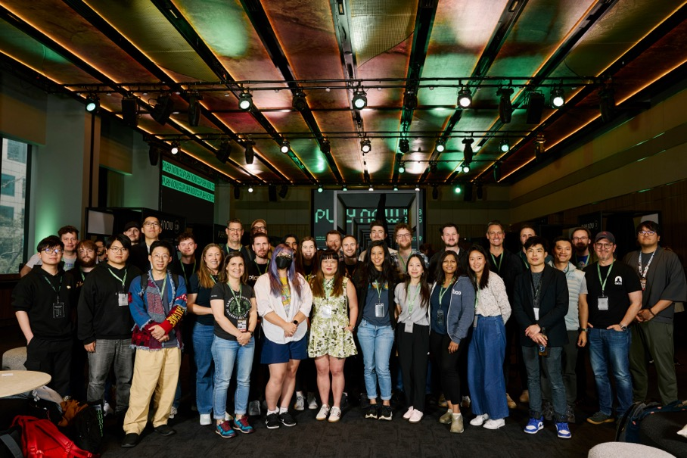
Play Now 2025 attendees. Photo by Daniel Mahon

Play Now Melbourne – Australia’s Leading Games Market
Play Now Melbourne 2025 showcased why Australia is one of the most exciting regions for independent game development in the world. This one-of-a-kind games market attracted 21 international and local publishers, platform holders and investors including Ukiyo Studios, The One Games, Akupara Games, Devolver Digital, PlaySide Studios and UltraPlayers. There were 78 projects pitched from developers such as Escape Pod Games, Oddlark and Wali Studios. VicScreen’s Originate suite of content development programs is supported by the Community Support Fund through the Victorian Government’s Department of Treasury and Finance via the Department of Jobs, Skills, Industry and Regions.
“Seeing players create communities around games is really exciting. There are a lot more video games being developed out here in Australia.”
- Vicky Wei, head of finance, Akupara Games
“I think what we’re seeing globally at the moment is that photorealism and graphical fidelity in games isn’t the only thing that makes a lot of money anymore.”
- Megan Webber, product marketing manager, PlaySide Studios

Play Now 2025 meeting. Photo by Daniel Mahon

Film friendly training – making Victoria more accessible for production
VicScreen’s Film Friendly training initiative is a statewide program designed to improve the efficiency, consistency and effectiveness of the film permitting processes across Victoria. Delivered in partnership with councils, government agencies and other industry stakeholders, and made possible by the Business Acceleration Fund and Department of Treasury and Finance, the program provides training, resources and best-practice guidance to help permitting organisations better understand screen productions’ needs, and their role in supporting a thriving screen industry. By promoting the Film Friendly principles and highlighting the economic, cultural and community benefits of filming, the initiative encourages local governments and permitting agencies to become active partners in attracting screen production to their regions.
The Film Friendly initiative delivers significant benefits to the screen industry by streamlining access to filming locations, reducing administrative barriers and creating a more consistent experience for productions across the state. This enhances Victoria’s competitiveness as a production destination, helping to attract local and international projects that generate jobs, economic activity and opportunities for the state’s screen practitioners and businesses.
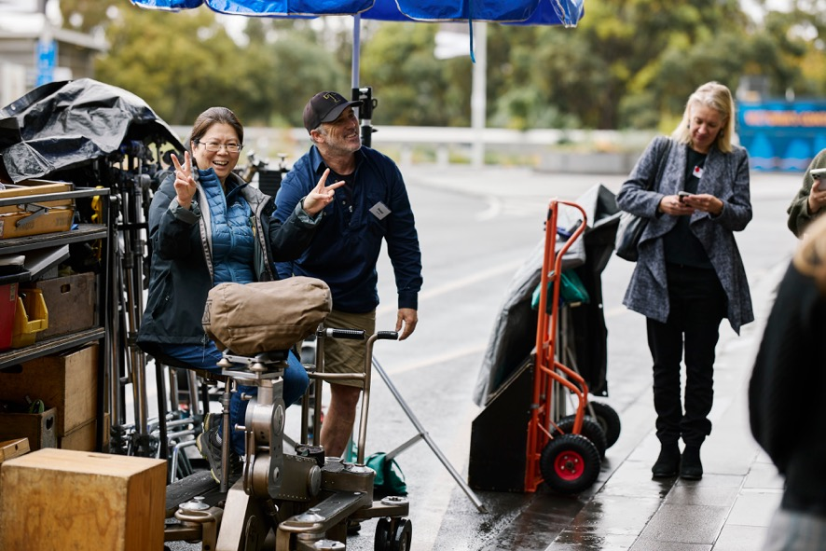
Film Friendly participant and Key Grip Peter MacDonnell. Photo by Daniel Mahon

Melbourne Screen Hub (MSH) – a dedicated home for the local screen sector, supporting businesses to collaborate
2025–26, VicScreen actively supported increased uptake by domestic productions at Melbourne Screen Hub (MSH), with several projects basing their production offices there. Domestic features using MSH include Gnomes, Stake Out, Kick On, and Hotel Hotel Hotel Hotel, as well as the series High Country S2, which rounded out the year.
Permanent tenants now cover approximately 70% of MSH’s fixed costs (primarily rent). To strengthen market appeal, MSH has recently expanded its offerings by adding a postproduction editing suite and purpose-built laundry and fitting rooms, increasing the facility’s versatility.
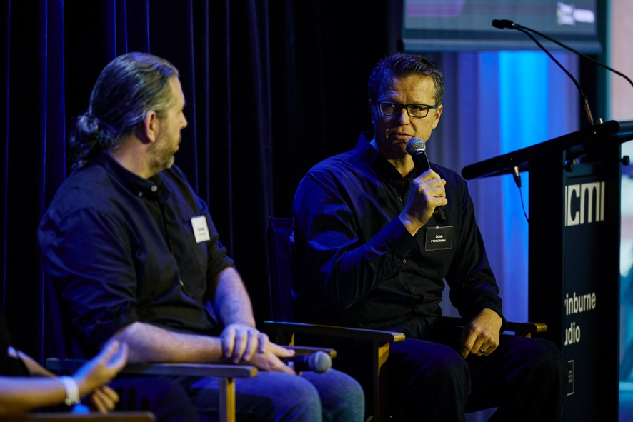
Joe Brinkmann, VicScreen
In 2025–26:
- 8 workshops were delivered across metropolitan and regional Victoria
- 64 of Victoria’s 79 local councils engaged in film friendly workshops (81% uptake)
- 20 Victorian agencies engaged in the workshops
- 210 participants attended workshop sessions

Key Deliverable 2: Encourage Innovation

Astroverse digital game by Escape Pod Games
VicScreen invests in people, ideas and connections to strengthen Victoria’s screen sector and support a highly capable, adaptable and future-ready workforce. Through skills development, industry partnerships and engagement, and infrastructure, we help shape the conditions for innovation to thrive. The following initiatives showcase how VicScreen is leading in this space.

Gamechanger Academy – Melbourne’s home of VFX, animation, and game development training
Over the past financial year, VicScreen’s GameChanger Academy successfully transitioned from concept to delivery, establishing a new industry-led training pipeline for Victoria’s games, animation and visual effects sectors. The Academy commenced courses in early 2025 and has since delivered its first suite of programs, providing hands-on, studio-based training supported by mentorship from leading local and international practitioners from studios such as Princess Bento and Luma Pictures. Early cohorts have completed intensive training through the flagship program Good to Great, developing advanced skills across disciplines including game design, animation, and visual effects (VFX), as well as participating in industry-style production environments that mirror real-world workflows and expectations.
The program has demonstrated early outcomes in building job-ready capability and strengthening the sector’s talent pipeline. Graduates have progressed rapidly to a professional standard, with a number transitioning into professional roles across Victoria’s games and screen industries. By aligning training closely with industry needs and embedding real production experience, the Academy is contributing to a more skilled, adaptable workforce and reinforcing Victoria’s position as a leading centre for global screen and games production.

Sustainable Screens Australia – embedding sustainability into everyday practices on set
VicScreen’s relationship with Sustainable Screens Australia (SSA) strengthened as ways of creating change and impact were explored further in 2025–26. SSA engaged with Melbourne Screen Hub, GameChanger Academy and VicScreen leadership and staff to present current best practice, opening up the opportunity for questions and valuable discussion. In mid-2026, a pilot initiative was established that is set to ignite change from within Victorian productions as well as collect crucial data about the adoption of new sustainable practices. The first of four productions is currently receiving the guidance of SSA through weekly meetings and reporting.
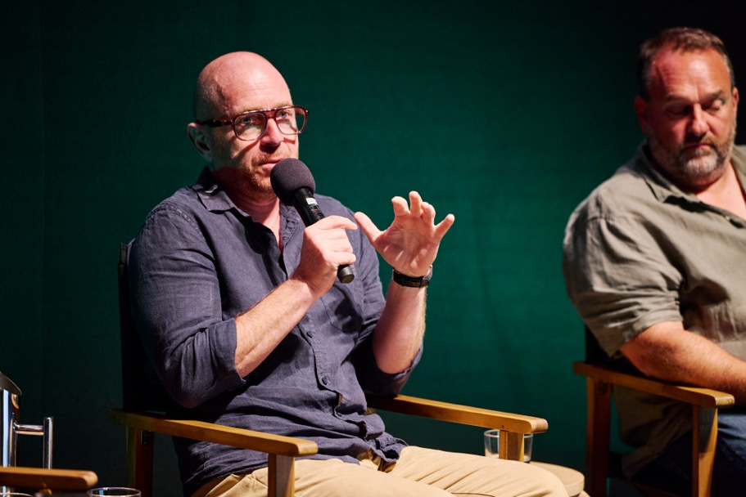
Unit Production Manager Paul Walton for All Her Fault. Photo by Daniel Mahon

MASS – Melbourne’s newly launched co-working sanctuary for game developers
Backed by a two million dollar investment by the Victorian Government and delivered in partnership with VicScreen, MASS, a new games co-working space, is set to open in Collingwood in 2026. MASS will be run by world-renowned Victorian studio Massive Monster – the award-winning independent games studio behind the VicScreen-supported global smash hit Cult of the Lamb.
The new co-working space will enable Victorian game developers to build their businesses, providing access to industry resources, networking, and professional development opportunities.


Person at Game Changer Academy. Photo by Daniel Mahon

Footy Shorts – short films capturing the love, traditions, myths and connections to AFL on the big screen
The inaugural Footy Shorts initiative offered five emerging Victorian screen storytellers the chance to create short documentaries exploring Australian Rules football on and off the field. Each team received a $25,000 production budget, as well as professional development and mentorship from industry leaders, and access to the Australian Football League’s (AFL) archival footage. Footy Shorts films reached more than 30,000 viewers through MIFF 2025 screenings, the AFL’s Grand Final week celebrations at Federation Square, and MIFF and AFL online channels.
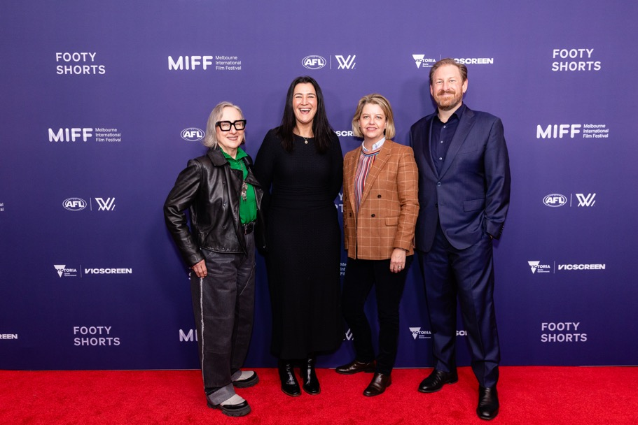
Melbourne International Film Festival Board Chair Teresa Zolnierkiewicz, AFL Executive General Manager of Football Operations Laura Kane, VicScreen Chief Executive Officer Caroline Pitcher and Melbourne International Film Festival (MIFF) Chief Executive Officer Damien Hodgkinson at Footy Shorts premiere (from left to right). Photo by Diana Risteski

Sovereign Shorts – a documentary initiative exploring treaty through a first peoples’ lens
National Indigenous Television (NITV) and MIFF partnered with VicScreen to launch Sovereign Shorts, a new initiative supporting First Peoples screen storytellers to explore Treaty as lived experience. Announced following Victoria’s historic Statewide Treaty, the initiative provides mentorship and production support to four short documentaries, each reflecting the depth, diversity and local realities of First Peoples communities across the state.
The selected films will premiere at MIFF in 2026 and continue to reach audiences through festival screenings, free streaming on MIFF Online, and national broadcast via NITV and SBS On Demand. The projects span stories of political activism, cultural connection and intergenerational resilience, amplifying First Peoples’ voices and perspectives on sovereignty and Treaty for audiences in Victoria and beyond. The initiative will provide professional development and mentorship for First Nations filmmakers and high-profile exhibition and distribution to a global audience, increase visibility of underrepresented First Nations narratives, and spark a critical cultural conversation.

Writer, Director and Producer Tracey Rigney. Photo by Joshua Scott

Writer, Director and Producer Theo McMahon. Photo by Joshua Scott

Goolagong (First Nations talent development) – creating opportunities for First Nations talent behind the scenes
The three-part ABC mini-series Goolagong is based on the inspiring true-life story of world champion tennis player Evonne Goolagong, one of Australia’s most revered sporting heroes. It was brought to life for the screen by esteemed Indigenous screen leaders, Director Wayne Blair (Mystery Road), Writer Steven McGregor (Mystery Road: Origin), and Co-producer Danielle MacLean (True Colours).
Goolagong filmed on location across Melbourne and regional Victoria including in Kyneton, Seaford, Seymour, Sunshine, Tallarook and Woodend, to recreate dramatic historical tennis matches from 1970 through to 1980. Iconic points were reimagined on court at Kooyong Lawn Tennis Club and Royal South Yarra Lawn Tennis Club, along with a purpose-built set of Wimbledon’s Centre Court.
The production injected over $9 million into the Victorian economy and created 387 jobs for Victorian screen workers, and seven skills development opportunities for emerging First Peoples screen creatives and workers.
The production was committed to employing First Nations crew in as many departments as possible, for all their attachment and placement roles. Merryn Trescott took on a director placement, mentored by Wayne Blair, while VicScreen developed the bespoke role of First Peoples training coordinator to culturally and professionally support the many First Nations opportunities in the on-set and production environment. This was recognised as a highly important and successful initiative and grew to encompass many of the First Nations cast as well. There were VicScreen-supported attachments in costume, assistant directing, camera and art departments. At VicScreen’s Fireside Yarns, an industry event series designed to connect First Peoples screen practitioners with industry opportunities, Director Wayne Blair (Batjala, Mununjali, Wakka Wakka) discussed directing Goolagong.
“It was brilliant to have other First Nations mob there on set in specific departments, to be there every day, not only in the production of it, but pre-production. That doesn’t happen a lot.”
- Wayne Blair, Goolagong director
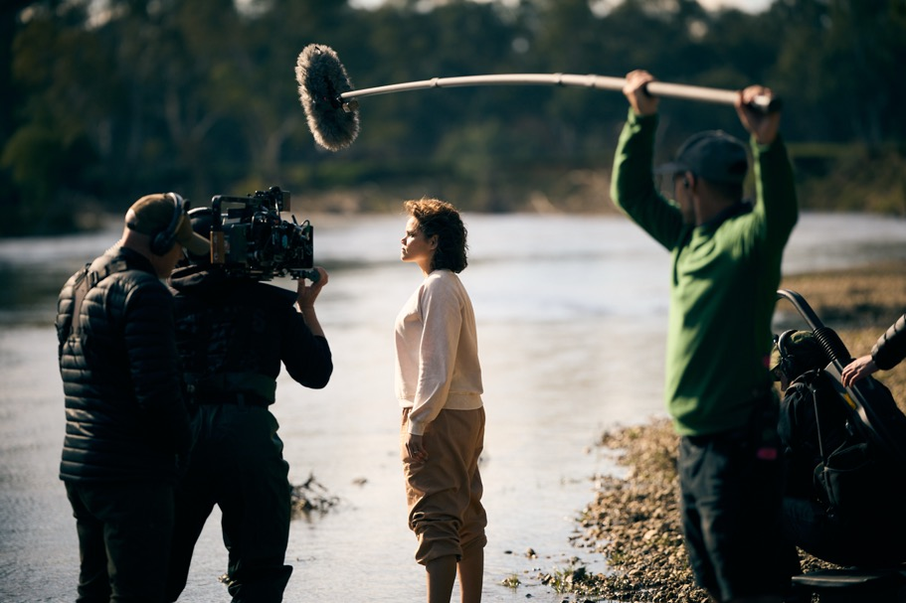
Actress Lila McGuire on set of Goolagong with film crew. Photo by Ben King

Victoria’s state-of-the-art VFX continue to impress on the world stage
Victoria’s global reputation for VFX continued to grow this financial year, with major international studios investing in the state’s talent and infrastructure to help deliver projects like Ted Season 2, The Hunger Games: Sunrise on the Reaping, Moana, and Sonic the Hedgehog 4.
VicScreen supported Framestore to work on the second season of Ted, which has become a smash hit with global audiences and critics alike since its March 2026 premiere. The eight-episode season was the leading original comedy across all streaming platforms after its release, generating more than 1.2 billion minutes viewed.
Framestore VFX Supervisor Glenn Melenhorst said after the company’s long history with Ted – spanning two movies and the first series – returning for Season 2 felt a little like coming home. “It was great to be back, animating that foulmouthed bear, finding new ways to bring life and nuance to his performance, and helping him hold his own as the lead of an ensemble cast. Each time we revisit him, the team adds greater subtlety to his performance, finds new ways for him to interact with the real world, and advances the technology behind Ted, making what is, in reality, a complex marathon of a show look effortless.”
Moana, by contrast, Melenhorst continued, was a fast turnaround project. “A bright burst of colour, chaos and invention where we were invited to design the visuals for the iconic, You’re Welcome song. From previsualisation and design through to on-set supervision and animation, it was great fun to bring our creative vision to the project. Countless concepts and designs were made by the Framestore Melbourne team and presented to the director and Disney’s cultural departments for approval. Then hundreds of props and characters and animation rigs and FX simulations were generated to accomplish the complex 2D and 3D choreography. And now that we are finished, even though I’ve now heard that song a thousand times, I’m still not sick of it!”

Key Deliverable 3: Drive Economic Benefits
VicScreen fuels economic growth by attracting major international productions, backing local intellectual property (IP) and supporting home-grown screen businesses to deliver jobs, skills and economic return to Victoria. This means focusing resources where they will generate the greatest industry impact. The following examples highlight this impact in action.

Actress Lila McGuire and Luke Carroll in Goolagong. Photo by Ben King

Local Ip – Championing Local Stories
VicScreen continues to champion and reinforce the local creative forces driving the state’s screen ecosystem. Despite mounting global environmental pressures, the Victorian writers, directors, producers, and screen practitioners who keep our local industry thriving created numerous critically acclaimed and commercially successful projects in 2025– 2026. Among them, Gnomes, Dog Park, High Country S2, Do Not Watch This Show, Ground Up, The Airport Chaplain and Bad Company have cumulatively contributed almost $53.5 million to the local Victorian economy while creating 1,829 jobs for Victorian screen workers.

Actor Hugo Weaving and Actress Claudia Karvan in The Airport Chaplain. Photo by Ben King
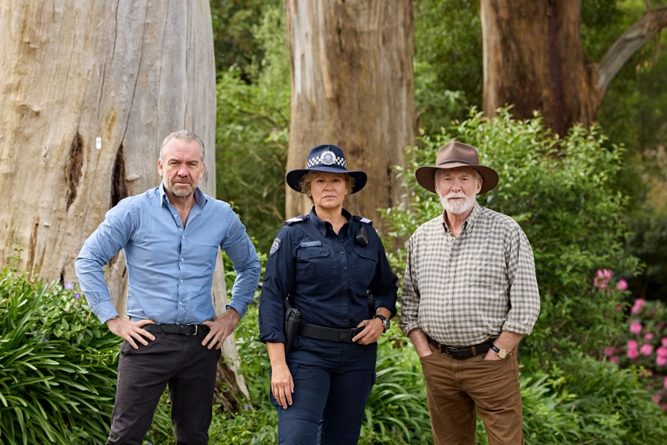
Actor Brendan Cowell, Actress Leah Purcell and Actor Ian McElhinney in High Country Season 2. Photo by Narelle Portanier

Actress Whitney Peak as Dakota on the set of Thrash. Photo by Ben King

International IP – a strong slate of global projects
This financial year, VicScreen attracted several major international productions to the state, creating thousands of jobs for Victorian screen practitioners and generating substantial opportunities for local businesses.

Empire City
Empire City, an action thriller starring Gerard Butler and Hayley Atwell, filmed in Melbourne across late 2025 and early 2026. Directed by Michael Matthews (Love and Monsters) and produced by Paul Currie (Better Man), alongside Marc Butan and Alan Siegel, this high-octane feature was attracted to Victoria through VicScreen’s Victorian Screen Incentive. The production injected $41.5 million into the state’s economy, creating 1,163 jobs and engaging approximately 466 local businesses.
Filming took place across a wide range of Melbourne locations – including Docklands Studios Melbourne, the central business district (CBD), Abbotsford, Fitzroy and the Royal Exhibition Building – with the city’s architecture doubling for New York. The story follows firefighter Rhett (Butler) and his New York Police Department (NYPD) officer wife Dani (Atwell) as they battle their way through a skyscraper during a high-stakes hostage crisis. Empire City showcases Victoria’s ability to support large-scale, globally focused action filmmaking, further reinforcing the state’s reputation as a world-class production destination.
“From the moment I arrived in Melbourne and met with the team at VicScreen, I knew it was the perfect place to make a film.”
- Marc Butan, producer, Empire City
“The state’s artists, technicians, and facilities are second to none, and together we’re crafting a film that pushes the boundaries of commercial storytelling and hopefully connects with audiences everywhere.”
- Paul Currie, producer, Empire City
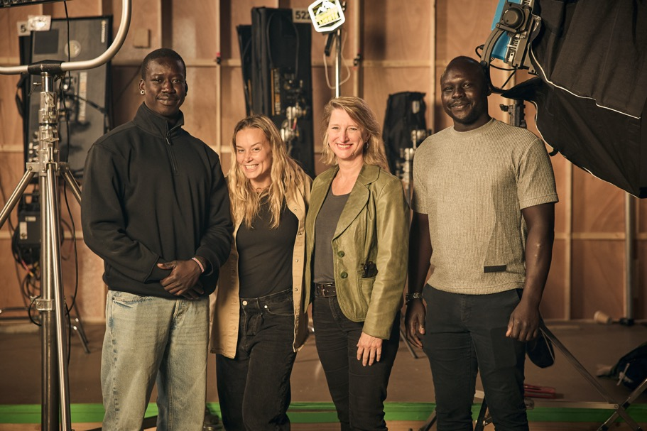
Stunt Performer Buomkuoth (BK) Thong, Stunt Coordinator Philli Anderson, Minister for Creative Industries Vicki Ward and Stunt Performer Loang Rout (left to right). Photo by Ben King

Fog City
International feature film Fog City is written and directed by Dan Pritzker and set in Depression-era San Francisco against the construction of the Golden Gate Bridge, with Melbourne doubling for 1930s San Francisco.
Supported through VicScreen’s Victorian Screen Incentive, the production is expected to inject around $60 million into Victoria’s economy, employing approximately 365 local crew and more than 2,600 cast and extras, while engaging around 250 local businesses.
The production is making extensive use of the state’s diverse locations and world-class facilities, including Docklands Studios Melbourne and a range of heritage landmarks like Labassa Mansion in Caufield North. The film’s production further reinforces Victoria’s reputation as a premier destination for international filmmaking, combining highly skilled crews, diverse locations and cutting-edge facilities to deliver ambitious international projects at scale.

Thrash
Victorian-made survival thriller Thrash delivered strong global impact, topping Netflix charts as the number one streamed title globally in early 2026. Filmed at Docklands Studios Melbourne, the production showcased local ingenuity, with crews constructing bespoke sets including an outdoor tank holding nearly two million litres of water. Thrash became the second Victorian-made feature film to reach number one on Netflix within a month following War Machine, highlighting Victoria’s ability to make globally successful content.

Hotel Hotel Hotel Hotel
The latest feature film from acclaimed Victorian writer/ director Michael Shanks, Hotel Hotel Hotel Hotel, filmed at Docklands Studios Melbourne using NantStudios’ world class virtual production stages and demonstrating the state’s end-to-end screen capability. Starring Academy Award® winner Daniel Kaluuya, the project reflects Victoria’s capability to deliver internationally financed screen productions made for global audiences, led by homegrown creative talent.
Attracted to the state through VicScreen’s Victorian Screen Incentive, the production generated significant industry impact, creating approximately 279 jobs for Victorian screen workers and engaging more than 250 local businesses across a wide range of services. Produced by leading Victorian production companies Princess Pictures, Shanks Productions and HyperObject Industries, the film is an example of a growing model where Victorian-led creative vision attracts international finance, while the production remains firmly rooted in the state.
“This project is a testament to the strength of our local industry. Princess Pictures is a wholly independent company and VicScreen’s consistent support through established funding programs hasn’t just allowed Princess to grow as a business, it has enabled us to develop homegrown, Victorian projects such as Hotel Hotel Hotel Hotel that will compete on a global stage, shining a light on the exceptional Victorian creative and production talent.”
- Emma Fitzsimons, Managing Director Princess Pictures, Producer Hotel Hotel Hotel Hotel
Actress Amelia Eve in Insidious: Out of the Further. Photo by Narelle Portanier

Insidious: Out of the Further
Insidious: Out of the Further further strengthens Victoria’s reputation as the home of genre productions, with the latest instalment of the hit horror franchise filmed across Melbourne locations and Docklands Studios Melbourne. The production injected almost $30 million into the state’s economy and created over 500 jobs for Victorian workers, including key crew and heads of department roles. Insidious 6 underscores Victoria’s ability to attract major international franchises, support local talent, and deliver high-value screen production.
“As someone who grew up in Melbourne, it’s a dream to bring an Insidious film back to my hometown. The city offers such a versatile backdrop and incredible filmmaking talent – I can’t wait for audiences to see how it elevates the film.”
- Leigh Whannell, producer, Insidious: Out of the Further

Victorian digital games, making their mark worldwide
Victoria is known for being Australia’s home of digital games. Local developers create ambitious, experimental, playful and distinctively Victorian games that connect with, and entertain, global players. One of the sector’s most anticipated titles released in 2025–26, Mixtape, comes from Melbourne-based studio Beethoven & Dinosaur. This vivid coming-of-age adventure game has generated significant international attention and showcases the creativity, ambition and global appeal of Victorian game development.
Beethoven & Dinosaur producer Woody Woodward said, “VicScreen has supported us with developing Mixtape in so many ways, not only to upskill and keep our staff, but to grow our team and make a diverse team here in Melbourne as well.”
Alongside high-profile projects such as Mixtape, Victorian developers are continuing to build a pipeline of distinctive work, from ORIGAME DIGITAL’s Penguin Colony and Toot Games’ My Arms are Longer Now, to Regions of Ruin: Runegate, Spellsided and Cyber Paradise, demonstrating the breadth, innovation and commercial potential of the state's games industry.
In addition to local games, millions of people around the world play games from major international publishers and partners that have been developed in Victoria with support from VicScreen’s Victorian Screen Incentive, such as the smash hit franchise The Sims Freeplay from Electronic Arts. Games projects that were funded in 2025–26 are expected to generate $40.4 million in Victorian production expenditure and employ 410 Victorians.

Travel delegations to global markets
VicScreen’s travel delegation to Annecy in June 2026 strengthened the international profile of Victoria’s animation sector by facilitating Victorian studios, creators and service providers to connect directly with global broadcasters, distributors, financiers, producers and creative partners at the world’s leading animation marketplace. As part of a coordinated Australian presence featuring more than 40 companies, Victorian participants were able to showcase projects in development, build strategic relationships and explore new pathways for international collaboration and investment, further strengthening Victoria’s reputation as a leading centre for animation production and talent.
Similarly, VicScreen’s Gamescom 2025 and BitSummit 2026 travel delegations delivered significant international market exposure for Victorian game developers. Developers reported valuable meetings with global publishers, platform holders and investors, while several developers built on relationships originally established at VicScreen’s Play Now market, demonstrating the growing international influence of Victoria’s games ecosystem.

Key Deliverable 4: Deliver Cultural Benefits
VicScreen plays a vital role in shaping Victoria’s cultural identity by backing bold storytelling, major festivals and new audience screen experiences. By championing diverse voices and supporting key platforms, we ensure Victorian stories are seen, heard and celebrated both here and overseas. The festival and event highlights described below demonstrate this impact.
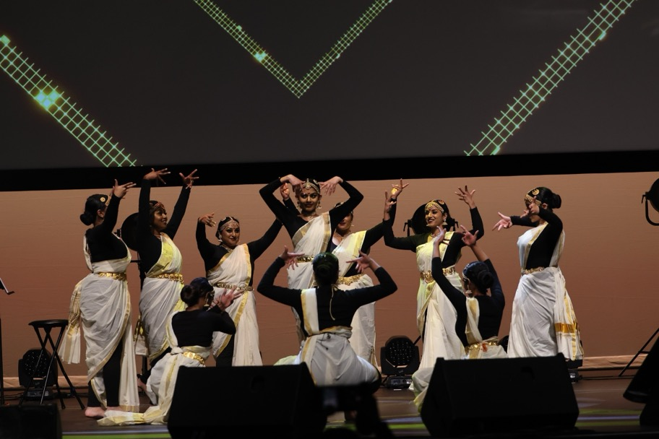
Bollywood dancers at the Indian Film Festival of Melbourne 2025. Photo courtesy: Indian Film Festival of Melbourne (IFFM)

Major Events
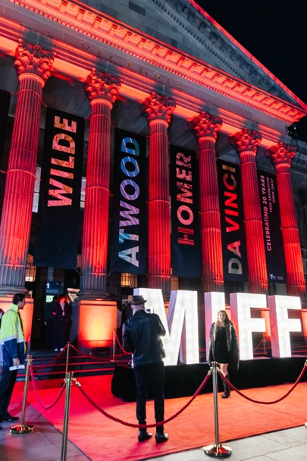
Red carpet at Melbourne International Film Festival 2025 (bottom left). Photo by Dijana Risteska

Melbourne International Film Festival (MIFF) – Australia’s largest film festival
MIFF continues to go from strength to strength with the support of VicScreen. MIFF 2025 was the most successful edition to date, delivering record audience growth, expanded reach, and significant positive economic impact. Across 310 films from 76 countries, including 29 world premieres and 151 Australian premieres, the festival’s program showcased a dynamic mix of global and local storytelling, with strong representation of female, non-binary and First Nations creators. Total audience engagement increased by 10% to more than 183,000 attendees, with strong growth across regional Victoria and MIFF Online, while nearly half of all sessions sold out. The festival generated $12.9 million for the City of Melbourne, up 14% year-on-year, reinforcing MIFF’s role as a major cultural and economic driver, with audiences also contributing strongly to the state’s broader visitor economy.
Beyond audience success, MIFF continued to strengthen its impact on industry development, talent pathways and cultural participation. The 37°South Market and Accelerator Lab connected hundreds of local producers, emerging filmmakers and global financiers, fostering new projects and international collaboration, while the MIFF Premiere Fund supported a slate of distinctive Australian features, like the VicScreen supported Originate Features film Pasa Faho. The prestigious $140,000 VicScreen Bright Horizons Award, a cornerstone of MIFF’s support for first- and second-time filmmakers, was awarded to Simón Mesa Soto for his feature A Poet. MIFF 2025 received record satisfaction levels among audiences, further cementing its position as a leading international film festival and a vital platform for profiling Australian cinema.
“To have been supported by the MIFF Premiere Fund and to have had Pasa Faho’s festival journey begin right here at home felt not only strongly fitting, given that this film was made for and by the city, but also incredibly moving. Seeing the response and appetite for works such as our own was a moment of real pride and affirmation.”
- Kalu Oji, director, Pasa Faho

Indian Film Festival of Melbourne flag-raising ceremony to celebrate Independence Day. Photo courtesy: Indian Film Festival of Melbourne (IFFM)

Indian Film Festival Melbourne (IFFM) – the biggest celebration of Indian cinema outside
India The 16th IFFM delivered a vibrant and far-reaching program in 2025, attracting over 31,000 attendees across 11 days of Indian cinema and culture. Showcasing 80 films in 37 languages, including two world premieres and 46 Australian premieres, the festival combined major public screenings, industry events and cultural activations across nine iconic Melbourne locations.
A sold-out Awards Night, drawing 2,500 guests, highlighted IFFM’s growing prestige, while high-profile appearances from leading talent such as Aamir Khan amplified visibility and global intrigue. Engagement extended beyond physical audiences, with more than 86,000 streams on the IFFM365 platform and a substantial media and digital footprint, including over 1.2 billion social media impressions and over 239 pieces of media coverage.
Beyond its scale, 2025’s IFFM reinforced its role as a key cultural bridge between Victoria and India, fostering creative exchange, industry collaboration and community connection. A diverse program of panels, masterclasses, Q&As and networking events supported filmmakers and emerging talent, while partnerships with universities, cultural institutions and industry leaders deepened knowledge-sharing and innovation.
IFFM’s 2025 theme, Our Collective Home, drove strong global participation, with nearly 1,400 submissions from countries all over the world, highlighting stories of belonging and shared responsibility. Through its inclusive programming, strong audience engagement and global reach, IFFM continues to strengthen Melbourne’s position as a leading international hub for film, culture and cross-cultural dialogue.

Screen Culture – Expanding Screen Experiences Beyond the Cinema
In 2025–26, VicScreen continued to champion innovative screen experiences and creative talent development through a slate of partnerships and initiatives. Highlights included The Giants Immersive at Melbourne Museum, an installation that transports audiences into Tasmania’s ancient forests, extending the impact of the VicScreen supported 2022 documentary The Giants and combining the talents of the film’s Victorian directors, Laurence Billiet and Rachael Antony, and French artist Alex Le Guillou.
VicScreen also partnered with the Melbourne International Comedy Festival (MICF) to launch the inaugural VicScreen Greenlight Award, recognising a Victorian comedian with outstanding screen potential. Comedian Bron Lewis was named as the inaugural recipient.
VicScreen collaborated with Hear My Eyes and Arts Centre Melbourne earlier this year to present a reimagined Terminator 2: Judgment Day, featuring a live score by acclaimed local and international artists, demonstrating VicScreen’s commitment to bold, cross-disciplinary storytelling that engages new audiences.

Truth is stranger than fiction – the rise of documentary and factual storytelling
Victoria has seen an impressive growth of documentary projects enter development, commence production, and hit screens in the past year. There’s no shortage of nonfiction storytelling talent in this state, with true crime, sport, music history and social justice documentaries all keeping the factual pipeline bustling.
Recognising the opportunity to strengthen support for factual series, VicScreen has increased its investment in project and skills development in recent years. This investment built on the success of the Originate Factual program and translated into a marked increase in production activity and outcomes in factual series, such as Revealed: Death Cap Murders, Final Siren: Inside The Game, and The Siege.

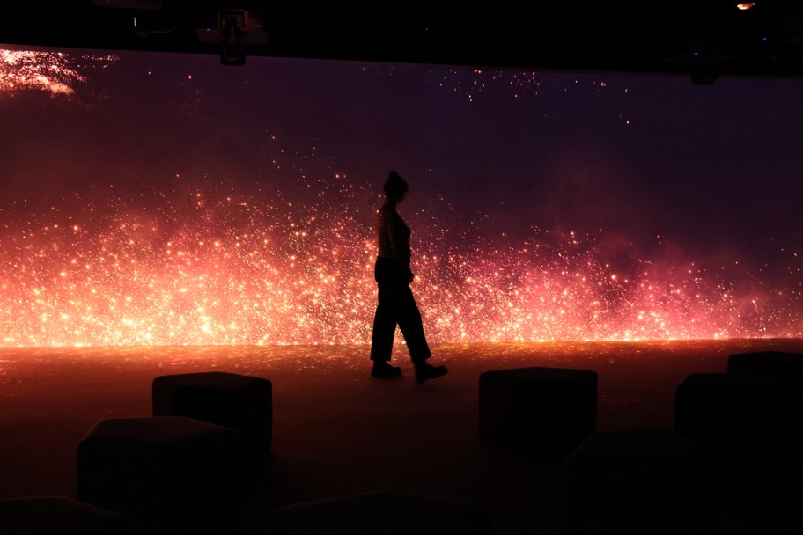
The Giants Immersive at Melbourne Museum. Photo by Museums Victoria

Development programs exceed production targets
In the fiction development space, the On Demand Fiction program continues to support Victorian creative teams to develop new feature film and series projects for global audiences. In 2025–26, 13 feature film projects and nine series were supported. Additionally, a further eight series projects were provided with script development support through the Originate Series initiative. VicScreen’s development programs continue to exceed expectations in terms of conversion into production. Over the past six years, 21.8% of projects supported in our Development on Demand programs have been produced, exceeding our 20% target by 1.8%.

Key Deliverable 5: Maximise Efficiency and Performance
Behind every successful outcome is a strong, effective organisation. VicScreen is continually strengthening its systems, processes and governance to ensure every dollar invested delivers maximum impact to industry. By embracing technology, data, and smarter ways of working, we’re building a high-performing organisation that is futureproof and capable of steering Victoria’s screen industry. The projects and activities listed below are ensuring VicScreen is accountable, transparent and set up to perform.

Actress Midori Francis as Hana in Saccharine. Photo by Narelle Portanier

Diversity, equity and inclusion – making Victoria’s screen industry more equitable
In 2025–26, VicScreen progressed the implementation of its Diversity, Equity and Inclusion (DEI) Action Plan, embedding key initiatives across its operations.
A major milestone was the completion of the Workplace Gender Audit and development of the organisation’s inaugural Gender Equality Action Plan, ensuring legislative requirement compliance and the establishment of a robust evidence base to drive future action. The Workplace Gender Audit involved comprehensive data collection and organisation-wide reporting, with findings informing priorities to improve gender equity outcomes.
VicScreen also strengthened accessibility and inclusion across its events activities, embedding requirements for funded partners to proactively communicate access provisions, capture attendee needs and report on outcomes. These practices are now integrated into VicScreen’s standard agreements and events, resulting in events being consistently accessible, driving positive participant feedback.
Behind the scenes, VicScreen supported productions to improve their accessibility and inclusivity over the past year. The film Last Seen engaged several attachments who were hearing impaired, providing an adaptive workplace with specialised headsets for crew to assist hearing aids. In conjunction with SBS’s Talent Escalator program, a deaf writer was employed in the script coordinator role on The Airport Chaplain and VicScreen continued to support producer placement roles in the Inclusive Producer Program with Bus Stop Films.
Gristmill Productions had a sight impaired attachment working in their accounts department on Ground Up and that person has been employed on subsequent projects. This year, VicScreen also delivered and facilitated a range of initiatives that strengthened inclusive storytelling, including initiatives such as the Disability Justice Lens training, led by people with disability. The organisation continues to support screen projects from underrepresented voices, like Miss Sultanah.
Work to formalise organisation-wide cultural safety frameworks, expand DEI data collection, and strengthen external assessor processes will continue into 2026-27, providing a clear focus for the next phase of implementation.

Organisational workforce changes
During the reporting period, changes to funding levels required VicScreen to review its operating model and workforce structure. As part of this process, employee numbers decreased by approximately 14%, ensuring the organisation remained appropriately aligned with available resources while continuing to deliver on its strategic priorities.

Klevr program – improving operations inside VicScreen
VicScreen has made meaningful progress against a key priority to maximise efficiency throughout 2025–26 by implementing a new Client Relationship and Grants Management platform. The project is central to the organisation’s transformation program, focused on modernising VicScreen’s technology environment through efficient digital processes. This will enable VicScreen to deliver improved services, strengthen relationships with industry stakeholders and leverage data-driven insights.
The new platform will support the end-to-end grants lifecycle. It includes client self-service functionality, alongside new marketing and communications capabilities, centralised information management and real-time reporting.
Project delivery commenced in May 2025 and grant applicants will be able to submit and manage their applications and contracts via the new ‘My VicScreen’ online portal from August 2026.
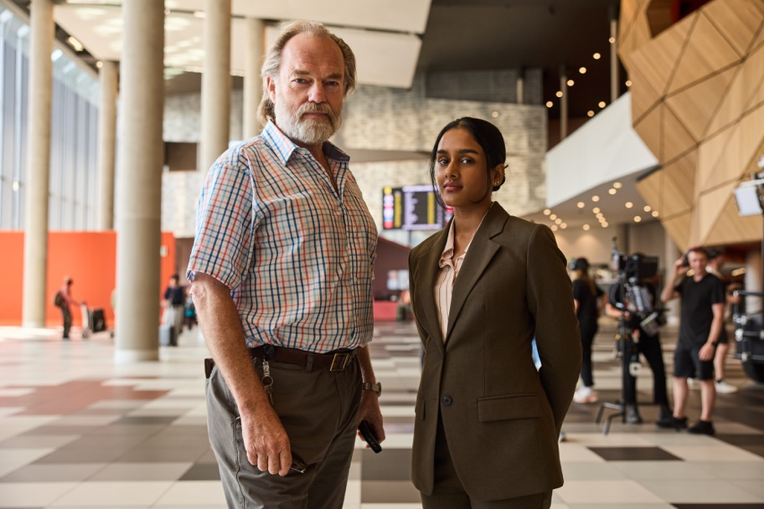
Actor Hugo Weaving and Actress Shabana Azeez on set of The Airport Chaplain. Photo by Ben King

Governance & Report of Operations
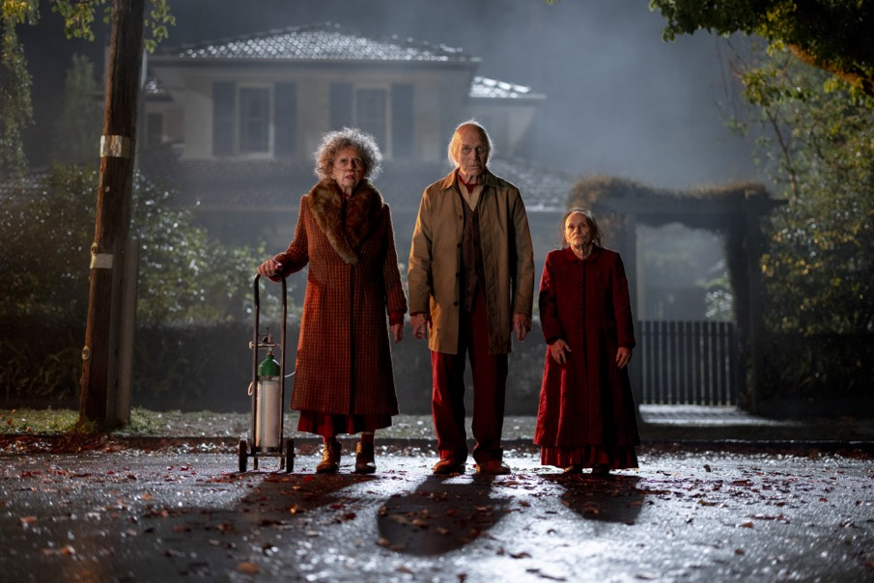
Actress Robina Beard, Actor Joseph Lopez and Actress Susan Gray of Insidious: Out of the Further. Photo by Narelle Portanier

(standing) Actor Ras-Samuel Welda'abzgi, Comedian and Writer Celia Pacquola, Actor Leon Ford, (seated) Actress Florence Gladwin, Actress Grace Chow and Actress Elizabeth Alexander of Dog Park. Photo by Jane Zhang

Governance and Organisational Structure
During this financial year, until 20 April 2026, VicScreen reported to the Minister for Creative Industries, Colin Brooks MP. From 21 April 2026, following a ministerial portfolio change, VicScreen reported to Vicki Ward MP.

As of 30 June 2025
- Minister for Creative Industries
The Hon. Colin Brooks MP (until 21 April 2026)
Vicki Ward MP (from 21 April 2026)
  - VicScreen Board
Audit & Risk Committee
Finance Committee
People and Executive Remuneration Committee
Victorian Screen Economic Development Committee
    - VicScreen Chief Executive Officer
Caroline Pitcher
      - Office of the CEO
      - Content and Talent
Ross Hutchens (until 5 November 2025)
Sacha Gregson (from 7 April 2026)
        - Talent Development
Games & Interactive
Project Development
Production Investment
      - Economic and Industry Development
Michael Hudson
        - Strategy & Industry Development
Skills & Business Development
Incentives & Production Support
      - Governance and Operations
Liahn Nortjé (until 8 May 2026)
        - Finance, Risk & Procurement
Information Technology
Grant Governance & Administration
Legal
Strategy & Performance
      - Marketing and Engagement
Kirsten Badcock
        - Marketing & Communications
Stakeholder Engagement
Audience Engagement
Industry Engagement
Screen Culture
      - People, Culture and Capability
Alison Bennett
        - HR Operations
Organisational Effectiveness & Engagement
Learning & Development
Safety & Wellbeing
  - Department of Jobs, Skills, Industry and Regions (DJSIR) Secretary
Matt Carrick
    - Creative Victoria Chief Executive Officer
Claire Febey

VicScreen Board
In accordance with the Film Act 2001, VicScreen Board members are appointed by the Governor in Council on the recommendation of the Minister. The majority of members should be selected from individuals who, in the opinion of the Minister, are experienced in the film, television, or multimedia industries, and the remaining members are to be chosen based on their expertise in business administration or other fields appropriate to the functions of VicScreen.

George Lekakis AO, President, Since October 2022
George has worked in the not-for-profit community services sector and government.
An experienced industry leader, George has spent much of his 40-year social work career in leadership roles.
George was the longest serving chairperson of the Victorian Multicultural Commission, having held the role from September 2001 to January 2011. He also served as the Chief Executive Officer of the New Hope Foundation and Fronditha Care and was an Executive Director of the Victorian Department of Business and Innovation.
Most recently George chaired the boards of the Victorian Interpreting and Translating Service, and Multicultural Arts Victoria. Currently he is the Deputy Chairperson of the Chisholm Institute Board and a Director of the Victorian Fisheries Authority.
George has also been a member of many other government and nongovernment boards and committees in executive roles.

Mitu Bhowmick Lange AM, Since July 2018
Mitu is a Festival Director, distributor, producer and cultural connector whose work has transformed the presence of Indian cinema in the Pacific region.
As founder of Mind Blowing Films and the Indian Film Festival of Melbourne, Mitu has championed stories that bridge cultures and celebrate diverse voices. Under her leadership, Indian films entered the Australian mainstream, with record-breaking box office success and historic festival milestones.
Mitu serves on the board of the Centre for Australia- India Relations and was appointed to the Premier’s Business Council in 2023. She continues to be a powerful advocate for inclusive storytelling in the global screen industry.

Andrea Denholm, Since July 2018
Andrea is a highly skilled executive producer and experienced creative executive. She creates, develops and produces premium scripted content and has held senior roles in major production companies, most recently as Executive Producer and Head of Development for Tony Ayres Productions.
Andrea's credits as producer, executive producer, story producer and writer span over 100 hours of content including premium Netflix drama The Survivors, award winning ABC drama series Fires, BBC/ ABC children's live action series Spooky Files, International Emmy® nominated Wrong Kind of Black, screen opera The Divorce, returning seasons of popular comedies How to Stay Married and It’s A Date, groundbreaking comedy 8MMM Aboriginal Radio, and the landmark documentary series Sporting Nation with John Clarke. Andrea's other credits include Tripping Over, SeaChange (1998- 2000), After the Deluge, CrashBurn, Worst Best Friends and Outland.
Andrea is Deputy Chair of the Australian Children’s Television Foundation.

Nick Forward, Since February 2024
Nick was most recently General Manager of Digital at the AFL where he oversaw content, product, customer experience and marketing. Prior to the AFL, Nick spent time in the Middle East as Managing Director and Group Chief Content Officer for leading local streamer OSN+. Nick was also Stan's first Chief Content Officer, playing a pivotal leadership role in bringing both the concept of the Stan streaming platform to life and growing it into the product it has become.
During his time at Stan, Nick commissioned and produced several acclaimed series and movies including the Palme D'Or nominated NITRAM in 2021, as well as Logie and AACTA winning series including No Activity, Bloom, Bump, Wolf Creek and Romper Stomper.
Prior to Stan, Nick spent time at Sky UK, Virgin Media and Lonely Planet, where he gained significant experience across media, product, marketing and general

Anne Jackson, Since October 2025
Anne is an experienced Finance, Audit and Risk professional, with over 30 years in leadership positions. Her business experience includes senior Risk Management roles at National Australia Bank (NAB) and, prior to NAB, she was a partner in a major accounting firm, providing audit and risk consulting services to clients across a range of industries. Over the past 10 years, Anne has worked in the superannuation sector, focusing on enhancing governance, risk and compliance capabilities with a number of organisations.
Anne is an experienced non-executive director, with over 25 years serving on boards in the corporate, government and not-for-profit sectors. She was an independent member of State Library Victoria’s Audit and Risk Management Committee from February 2011 until December 2024 and was chair of the committee from May 2019.

Lisy Kane, Since October 2023
An experienced videogame producer and creative leader, Lisy is Production Director at CULT Games and assessor for the WINGS Fund as well as board member of the IGDA Foundation.
In 2014, Lisy joined independent games studio League of Geeks and co-founded Girl Geek Academy, a social startup focusing on advocating and driving gender equality within the STEM sector. From her work on Girl Geek Academy, Lisy and her co-founders were awarded QUT’s Young Innovation & Entrepreneurship Alumni Award (2018).
In 2017, Lisy was recognised by Forbes in its prestigious top 30 list: Forbes 30 Under 30 2017: Games.

Greg McLean, Since September 2018
Greg McLean is an acclaimed Australian writer, director and producer known for bold, visceral storytelling across film and television. He broke out with the horror classic Wolf Creek and went on to direct Rogue, Wolf Creek 2, The Belko Experiment and Jungle, starring Daniel Radcliffe. Greg created and directed two seasons of the Wolf Creek series, and directed all six episodes of Territory (2024), Netflix's neo- Western drama, which topped the global chart, reached the Top 10 in 74 countries, and earned seven Logie nominations. His other directing credits include Jack Irish, The Gloaming, Bloom, La Brea, The Twelve and Scrublands.
Greg recently co-founded Huge Film with director Patrick Hughes and screenwriter James Beaufort. Its debut feature, War Machine, starring Alan Ritchson (Reacher) and directed by Hughes with Greg producing, was a worldwide smash – Netflix's No. 1 film globally for two weeks and one of the platform's 10 most-watched films ever.

Stuart Menzies, Since December 2025
Stuart is a highly regarded television executive with four decades’ experience across content creation, production, commissioning, channel management, programming and financing.
He was the Managing Director at Werner Film Productions from 2018-25 and executive produced a range of productions including acclaimed and multi award-winning drama series The Newsreader, Surviving Summer, Crazy Fun Park, Knee High Spies and Goolagong. Stuart was also Associate Producer on Apple TV's Last Seen.
Stuart was the Australian producer on the Synchronicity Films (UK) production of The Cry and has previously held various senior management positions at ABC Australia including as the inaugural controller of ABC2 (2010- 2014), where he drove the commissioning of bold, original content for the network’s younger skewing digital channel.

Tiriki Onus, Since October 2022
Tiriki Onus is a Yorta Yorta and Dja Dja Wurrung artist, academic and filmmaker serving as Pro Vice-Chancellor (Indigenous) at the University of Melbourne, where they are also Head of the Wilin Centre for Indigenous Arts and Cultural Development and co-direct the Research Unit in Indigenous Arts and Culture.
A multidisciplinary practitioner, Tiriki’s work spans visual arts, curatorship, performance and opera. In 2014, they were awarded the inaugural Hutchinson Indigenous Fellowship, supporting their work with communities to revitalise biganga (possum skin cloak) technologies. Tiriki co-directed the acclaimed documentary Ablaze (2021), which uncovers a historic film by their grandfather, Aboriginal rights leader William ‘Bill’ Onus. Their creative and research practice continues this legacy, including the installation Thrivance: Then, Now, Next (2025). Their PhD, Biganga – Mapping Paths Back to Knowing, was awarded in early 2025.
Tiriki’s work continues to foster innovation in research, development, advocacy, representation and inclusion of Indigenous arts, cultural practices and practitioners.

Jenny Taing (Sheehy) OAM, Since June 2023
Jenny Taing OAM is a financial services lawyer and a managed funds and exchange traded funds specialist. She is currently an Ombudsman at the Australian Financial Complaints Authority. Prior to this role, Jenny was a partner in private practice, held legal and commercial roles at Vanguard Investments Australia, and also spent 10 years as a lawyer at the Australian Securities & Investments Commission (ASIC).
Jenny is an experienced chair and director, also serving on the AFL Victoria Board. She is a Cricket Victoria tribunal member, former Chair of the Western Bulldogs Community Foundation, and a director of Screen Australia, the Australian Health Practitioner Regulation Agency, The Royal Victorian Eye & Ear Hospital and Channel 31. Jenny is Vice President of the University of Melbourne Alumni Council and a former Commissioner of the Victorian Multicultural Commission.
Jenny has a Bachelor of Arts/Bachelor of Laws (Honours) from the University of Melbourne. In 2016, she attended Harvard Business School as the Hugh DT Williamson Scholar. She is also a graduate of the Australian Institute of Company Directors and the Australian Institute of Superannuation Trustees.

Committees and Assessment Panels

Board committees
The VicScreen Board has committees that review and assist organisational performance and assess funding applications. Committees are comprised of Board members and external members (where noted).

People and Executive Remuneration Committee
The People and Executive Remuneration Committee assist the VicScreen Board in fulfilling its responsibilities in relation to remuneration and performance of the organisation’s Chief Executive Officer and the remuneration of its Executive Officers. The People and Executive Remuneration Committee also provides oversight of VicScreen’s Board-approved people strategies, focusing on their ongoing alignment with the organisation's strategy and the effectiveness of their implementation.
The committee’s members are George Lekakis AO (Chair), Nick Forward and Lisy Kane.
The committee met on three occasions in 2025–26.

Victorian Screen Economic Development Committee
The Victorian Screen Economic Development Committee considers applications to the Victorian Screen Incentive (VSI).
The committee’s members are George Lekakis AO, Nick Forward, Debra Allanson (external member), Sarah Coughlan (external member), Anne Jackson (from November 2025) and Tiriki Onus (from November 2025).
Leonie Morgan AM was a retiring member (up to August 2025).
The committee met on 13 occasions in 2025–26 and assessed a total of 46 applications, all of which were supported.

Audit and Risk Committee
The Audit and Risk Committee assists VicScreen to achieve its strategic objectives in an efficient and effective manner. The committee achieves this through independently reviewing and assessing the effectiveness of VicScreen’s systems and controls for financial management, performance, sustainability, risk management and any other matters referred to it by the Board.
The committee oversees and reviews the internal and external audit functions, including considering recommendations made by these functions, and monitors the implementation of remedial actions.
The committee’s members are Jenny Taing OAM (chair from August 2025), Liz Grainger (chair and member, up to August 2025), Andrea Denholm, Anne Jackson (from August 2025) and Kushal Shah (external member, from December 2024). All members are independent.
The committee met on five occasions in 2025–26.

Finance Committee
The Finance Committee assists VicScreen to achieve its strategic objectives by monitoring, advising and reporting to the Board on matters relating to VicScreen’s financial performance. The committee does not have any delegated authority.
The committee’s members are George Lekakis AO (Chair) and Jenny Taing OAM.
The committee met on one occasion in 2025–26.
The Finance Committee was dissolved in October 2025, with responsibilities being absorbed by the Board and the Audit and Risk Committee.

External Assessor Pool
VicScreen engages screen industry experts for a three- year period to assess certain funding applications for project development and production and make funding recommendations for final approval by financial delegates (heads of division, CEO or Board).
External assessors who participated in assessment meetings for project development and production programs in 2025–26 were:
- Alyce Adams
- Amanda Higgs
- Anu Hasbold
- AP Pobjoy
- Beth Frey
- Brendan Keogh
- Brian Udovich
- Britt Arthur
- Carmel McAloon
- Carmen Knox
- Cherie Davidson
- Christopher Kam
- Clea Frost
- Corrie Chen
- David Elliot Jones
- David Hannam
- Emma Fitzsimons
- Hollie Black
- Imogen Banks
- Isaac Elliott
- Jacob Hickey
- Jason Imms
- Jeff Daniels
- Jini Maxwell
- Joanna Werner
- Joe Park
- Kate Laurie
- Kate Pappas
- Kelly Lefever
- Kim Ho
- Kodie Bedford
- Laura Crawford
- Lauren Merolli
- Lee Naimo
- Lee-Ann Woon
- Liam Esler
- Lindsay Devlin
- Liz Kearney
- Magda Wozniak
- Michele Turnure-Salleo
- Paul Walton
- Pip Campey
- Rhian Skirving
- Rhiannon Poley
- Sarah Shaw
- Seph Mckenna
- Stuart Menzies*
- Tim Williams
- Virginia Whitwell
*Stuart Menzies has not served on any assessment panels since becoming a Board member
Staff members who participated in the assessment and/ or approval of applications across all funding programs in 2024–25 were:
- Chief Executive Officer Caroline Pitcher
- Acting Chief Executive Officer Liahn Nortjé (until 8 May 2026)
- Director Content and Talent Ross Hutchens (until 5 November 2025)
- Director Content and Talent Sacha Gregson (commenced at VicScreen 7 April 2026)
- Director Economic and Industry Development Michael Hudson
- Director Marketing and Engagement Kirsten Badcock
- First Peoples Strategic Lead Sarah Bond
- Head of Content Investment Samantha Dinning
- Head of Games and Interactive Paul Callaghan
- Head of Production and Investment Attraction Joe Brinkmann
- Senior Manager Industry Capability Michelle Shepherd
- Production Executive Katy Roberts
- Production Executive Davey Thompson (until 3 October 2025)
- Production Executive Ariel Waymouth
- Production Executive Lise Leitner
- Manager Development Mackenzie Lush
- Manager Skills and Industry Development Chris Barker
- Manager Partnerships and Engagement Matthew Phoenix (until 29 August 2025)
- Manager Partnerships and Engagement Jacqueline Hanlin (from 22 September 2025)
- Development Coordinator Kate Darrigan
- Incentives Coordinator Tess Hamilton
- Industry and Skills Development Coordinator Kara Masters
- Industry and Skills Development Coordinator Marea Markou (until 26 November 2025)
- Events and Engagement Coordinator Rachel Duffy

Board attendance
Name | Eligible to attend | Attended
George Lekakis AO (Chair) | 8 | 8
Mitu Bhowmick Lange (AM) | 8 | 4
Andrea Denholm | 8 | 8
Nick Forward | 8 | 7
Liz Grainger | 2 | 2
Lisy Kane | 8 | 7
Greg McLean | 8 | 4
Leonie Morgan AM | 2 | 2
Tiriki Onus | 8 | 6
Jenny Taing OAM | 8 | 8
Anne Jackson | 6 | 6
Stuart Menzies | 4 | 4
Note: This excludes urgent out-of-session meetings of the VicScreen Board during 2025–26.

Applications assessed and approved by funding program
Program | Received | Supported
Development On Demand – Documentary | 40^ | 22#
Development On Demand – Fiction | 77^ | 23#
Footy Shorts 2026 | 5 | 5
Industry Capability On A Production | 7 | 7
Industry Development – Programs | 3 | 3
International Travel – BitSummit 2026 | 19 | 9
International Travel – Content London 2025 | 10 | 5
Key Talent Placements Register | 1 | 1
Key Talent Production Placements (KTP) | 6 | 6
Originate Slate | 1 | 1
Professional Attachments | 52 | 52
Professional Attachments Register (New Applicants)*  *For 2025–26, 57 of the approved applications relate to applications received in 2024–25. | 12 | 69
Sovereign Shorts (PKA Treaty Shorts) 2026 | 9 | 4
Specialist Placements | 3 | 3
Victorian Production Fund (VPF) Games | 64^ | 22#
Victorian Production Fund (VPF) Screen | 84^ | 42#
Note: the above figures represent all applications received and approved in 2025–26, noting that some applications were received in the previous year but assessed within 2025–26.
# Includes applications supported in 2025–26 but received in 2024–25.
^ Includes applications received in 2025–26 that are yet to be assessed.
* For 2025–26, 57 of the approved applications relate to applications received in 2024–25.

Applications assessed and approved by Initiative
Initiative | Received | Supported
AIDC 2026 First Peoples Creator Passes | 18 | 15

Overview of Financial Performance for the year ended 30 June 2026

Five-Year Financial Summary
Item | Note | 30-Jun-26  $’000 | 30-Jun-25  $’000 | 30-Jun-24  $’000 | 30-Jun-23  $’000 | 30-Jun-22  $’000
Comprehensive result – surplus / (deficit) | 1 | (30,780) | 11,611 | (1,970) | 20,247 | 9,653
Comprising:
Income from the Victorian Government | 1 | 44,868 | 61,131 | 51,741 | 67,215 | 46,228
Other income | 2 | 3,830 | 3,955 | 4,260 | 4,110 | 718
Less:
Program costs | 3 | (66,941) | (40,318) | (46,595) | (40,120) | (28,526)
Operating expenses | 4 | (12,558) | (13,155) | (11,369) | (10,965) | (8,750)
Other economic flows |  | 21 | (1) | (7) | 6 | (17)
Commitments | 5 | 66,826 | 95,166 | 102,230 | 113,199 | 108,535
Total assets |  | 59,067 | 90,898 | 78,501 | 80,774 | 58,117
Total liabilities |  | (3,514) | (4,566) | (3,779) | (4,083) | (1,673)
Net worth | 6 | 55,553 | 86,333 | 74,721 | 76,691 | 56,444
Net cash inflow / (outflow) | 7 | (32,601) | 13,118 | (23) | 17,903 | 9,270
- Comprehensive result
The nature and scale of VicScreen’s Comprehensive result will vary year on year, reflecting timing differences between when income from the Victorian Government is recognised in the Financial Statements, and when the related expenditure on programs is accounted for. The former is generally recognised when received, as required under Australian Accounting Standards, whereas program costs are only brought to account once contracted milestones are reached, or other grant conditions are met. This can be more than two years after the relevant income is received.
Government funding was higher in 2025–26 due to increased funding, including support for the delivery of VICSCREEN: Victoria’s Screen Industry Strategy 2021–2025, additional funding received for the Victorian Screen Rebate, the GameChanger Academy, a new games co-working space and the NBCUniversal Partnership (a multi-year government partnership announced in the 2022–23 state budget). Income has declined as a result of the lapsed VICSCREEN: Victoria’s Screen Industry Strategy 2021–2025 funding only being partially renewed in the 2025–26 state budget.

2. Other income
Other income includes interest earned on cash deposits held with the State Centralised Banking System and program income received from sources other than the Victorian Government. Other income is relatively consistent with the prior year.

3. Program costs
Program costs are payments made under VicScreen’s funding agreements and are only recognised as an expense in the comprehensive operating statement once contracted milestones are reached, or other grant conditions are met. For larger productions this can be more than two years after funds have been committed. The increase in program costs in the year ended 30 June 2026 reflects the application of increased government funding in prior years, with larger productions associated with this funding satisfying contracted conditions in the current year.

4. Operating expenses
Staff costs make up the majority of VicScreen’s operating expenses. Prior year staff costs included a provision for 3% salary increments and a one-off $5,600 payment to eligible employees related to the Cultural and Creative Agencies Enterprise Agreement 2025.

5. Commitments
Commitments largely relate to contracted program costs which are not yet due at the year-end and are, therefore, not recognised in the balance sheet as liabilities. Project commitments are only recognised as a liability once all obligations under the funding agreements are met and, as described above, this can be some time after the initial commitments are made. The decrease in commitments reflect the level of program payments made during the year.
All commitments are either fully funded by existing cash holdings, or by confirmed future government income. Further details of commitments are provided in note 6.2 of the financial statements.

6. Net worth
Total assets mainly comprise cash and cash equivalents, the majority of which are allocated to funding existing program commitments, as explained above.
Total liabilities include provisions for benefits accruing to employees, including annual and long service leave, and liabilities in respect of the office lease.

7. Net cash flow
Cash flows are primarily affected by the timing of program costs and the receipt of government income.

8. Subsequent events
VicScreen is not aware of any material events after the balance sheet date which would materially affect these financial statements.

Employment-Related Disclosures

Health, safety and wellbeing
VicScreen’s Health, Safety and Wellbeing policy outlines its commitment to providing and maintaining a work environment that is, so far as is reasonably practicable, safe and free of risks to staff member and visitor health, safety and wellbeing. An Occupational Health & Safety (OH&S) framework comprising health and safety representatives, building wardens and first aid officers is part of a system of safe work and is critical to VicScreen meeting its responsibilities under the Occupational Health and Safety Act 2004.
The OH&S Committee, comprising management and staff representation, met regularly throughout the year. Scheduled workplace inspections were conducted by employee health and safety representatives and findings were reviewed by the committee to identify opportunities for improvement.

Incident management
VicScreen maintained a very low rate of workplace incidents, hazards and near misses throughout the reporting period. All reported incidents were assessed and where appropriate, investigated. Control measures were implemented to eliminate or reduce risks and to prevent recurrence.
There were two incident reports received in 2025–26, with no lost time injuries or notifiable incidents recorded during the period.
Measure | KPI | 2025/26 | 2024/25 | 2023/24
Incidents | Number of reported incidents | 2 | 10 | 5
 | Rate per 100 FTE | 3.9 | 15.2 | 8.2
 | Number of incidents requiring first aid and/or further medical treatment | 0 | 4 | Not reported
Fatalities | Number of fatality claims | - | - | -
Consultation and participation | Evidence of agreed OH&S structure, health and safety representatives and issue resolution procedures | Yes | Yes | Yes
Policy currency | OH&S policy current (reviewed at least annually) | Yes | Yes | Yes
Risk management | Number of quarterly OHS committee meetings | 4 | 4 | 4
 | Percentage of internal audits/inspections conducted as planned | 100% | 100% | 100%
 | Percentage of reported incidents investigated* | 100% | 100% | 100%
 | Number of Improvement Notices issued by a WorkSafe Inspector | - | - | -
 | Percentage of issues identified and actioned arising from:
 | — Internal OH&S audits | 100% | 100% | 100%
 | — HSR provisional improvement notices | - | - | -
 | — WorkSafe notices | - | - | -
*This includes investigations or where no investigation was required.

Employment and conduct principles
VicScreen applies merit and equity principles in all recruitment and appointment processes. Selection processes ensure applicants are assessed fairly and equitably against key selection criteria and role requirements, without discrimination.
The Public Administration Act 2004 established the Victorian Public Sector Commission (VPSC), which plays a key role in strengthening public sector efficiency, effectiveness and capability and promoting public sector professionalism and integrity. VicScreen operates in accordance with the Cultural and Creative Agencies Enterprise Agreement 2025 and its policies and practices are aligned with the VPSC’s employment standards. These frameworks support fair treatment, career opportunities and the early resolution of workplace issues. Employees are provided with clear guidance on managing conflicts of interest, responding to offers of gifts, benefits and hospitality, and understanding how VicScreen misconduct is addressed. The Film Act 2001 also provides guidance to the Board, executive and staff on conflict-of-interest matters.
VicScreen’s induction program familiarises new employees with expected workplace behaviours and organisational procedures including equal opportunity, harassment and discrimination and dispute resolution processes. This is further supported by a program of online learning modules covering topics such as workplace bullying, equal opportunity and discrimination.

Industrial disputes
VicScreen maintains a cooperative and constructive relationship with the Community and Public Sector Union (CPSU) and employee representatives.
No working days were lost due to industrial dispute during the reporting period.

Workforce data
The 2025–26 state budget outcome was lower than the average annual funding provided over the life of VICSCREEN: Victoria’s Screen Industry Strategy 2021–2025. This reduction in funding, including the scaling back or cessation of some programs, initiatives and services, resulted in a decrease in workload associated with delivering these activities. In response, VicScreen reduced its staffing profile to ensure the continued delivery of priority activities while operating within the available budget. This was achieved through a combination of measures including the non-renewal of fixed term contracts in areas of reduced activity, as well as the declaration of some roles as surplus where activities were no longer required or required at a reduced level. Employees have been correctly classified in workforce data collections.
The table below outlines full-time equivalent (FTE) staffing trends for VicScreen for the period 2022–26.

FTE staff at reporting date
Item | 2026 | 2025 | 2024 | 2023 | 2022 | 2021
All employees | 51.8* | 66* | 62.2 | 59.2 | 46.5 | 42
*Includes two employees on paid parental leave.

Employment levels in June 2026 and June 2025, which reflect that at least two thirds of VicScreen staff identify as women or self-described
June 2026
Item | Item | All employees – Headcount | All employees – FTE | Ongoing – Full-time (headcount) | Ongoing – Part-time (headcount) | Ongoing – FTE | Fixed term and casual – Headcount | Fixed term and casual – FTE
Demographic | Gender
 | Female | 36 | 35 | 30 | 4 | 33 | 2 | 2
 | Male | 17 | 15.8 | 12 | - | 12 | 5 | 3.8
 | Self-described | 1 | 1 | 1 | - | 1 | - | -
 | Age
 | 15–24 | - | - | - | - | - | - | -
 | 25–34 | 8 | 8 | 7 | - | 7 | 1 | 1
 | 35–44 | 19 | 18.2 | 18 | 1 | 18.8 | 2 | 1
 | 45–54 | 21 | 19.8 | 18 | 1 | 18.8 | 2 | 1
 | 55–64 | 6 | 5.8 | 4 | 1 | 4.8 | 1 | 1
 | 65+ |  |  | - | - |  | - | -
Classification | Grade
 | VPS 2 | - |  | - | - | - | - | -
 | VPS 3 | 9 | 8.8 | 6 | 1 | 6.8 | 2 | 2
 | VPS 4 | 16 | 14.6 | 13 | 1 | 13.6 | 2 | 1
 | VPS 5 | 14 | 13.6 | 10 | 1 | 10.8 | 3 | 2.8
 | VPS 6 | 11 | 10.8 | 10 | 1 | 10.8 | - | -
 | Executives | 4 | 4 | 4 | - | 4 | --- | -
Total employees |  | 54 | 51.8 | 43 | 4 | 46 | 7 | 5.8
Notes:
- All figures reflect employment levels during the last full pay period in June of each year.
- Staff on unpaid leave during the last full pay period in June are excluded.
- Ongoing employees includes people engaged on an open-ended contract of employment, and executives engaged on a standard executive contract who were active in the last full pay period of June.
June 2025
Item | Item | All employees – Headcount | All employees – FTE | Ongoing – Full-time (headcount) | Ongoing – Part-time (headcount) | Ongoing – FTE | Fixed term and casual – Headcount | Fixed term and casual – FTE
Demographic | Gender
 | Female | 43 | 41.2 | 29 | 4 | 31.5 | 10 | 9.7
 | Male | 21 | 20.4 | 16 | 0 | 16 | 5 | 4.4
 | Self-described | 2 | 2 | 0 |  | 0 | 2 | 2
 | Age
 | 15–24 | - | - | - | - | - | - | -
 | 25–34 | 15 | 14.6 | 8 | 1 | 8.8 | 6 | 5.8
 | 35–44 | 21 | 19.9 | 14 | 2 | 15.2 | 5 | 4.7
 | 45–54 | 26 | 25.1 | 20 | 1 | 20.5 | 5 | 4.6
 | 55–64 | 3 | 3 | 2 | 0 | 2 | 1 | 1
 | 65+ | 1 | 1 | 1 | - | 1 | - | -
Classification | Grade
 | VPS 2 | 1 | 1 | - | - | - | 1 | 1
 | VPS 3 | 14 | 12.5 | 8 | 2 | 8.9 | 4 | 3.6
 | VPS 4 | 20 | 19.4 | 15 | 1 | 15.8 | 4 | 3.5
 | VPS 5 | 16 | 15.8 | 8 | 1 | 8.8 | 7 | 7
 | VPS 6 | 10 | 9.9 | 9 | 0 | 9 | 1 | 1
 | Executives | 5 | 5 | 5 | 0 | 5 | - | -
Total employees |  | 66 | 63.6 | 45 | 4 | 47.5 | 16 | 15.1

Executive data
For VicScreen, a member of the Senior Executive Service (SES) is defined as a person employed as an executive under Part 3 of the Public Administration Act 2004. All figures reflect employment levels at the last full pay period in June of the reporting year. The table below reflects executive turnover during 2025–26 including one vacant role.

Total number and gender of SES employees for VicScreen in June 2026, compared to the previous reporting period
Classification | All – 2026 | All – 2025 | Women – 2026 | Women – 2025 | Men – 2026 | Men – 2025 | Self-described – 2026 | Self-described – 2025
SES-3 | - | - | - | - | - | - | - | -
SES-2 | 1 | 1 | 1 | 1 | - | - | - | -
SES-1 | 3 | 4 | 2 | 1 | 1 | 3 | - | -
Total | 4 | 5 | 3 | 2 | 1 | 3 | - | -
*Note: one vacant SES-1 role not included.

Reconciliation of Executive numbers
Item | 2025/26 | 2024/25
Executives (Financial statements Note 8.2) | 3 | 4
Accountable Officer (CEO) | 1 | 1
Total | 4 | 5
*Note - The total number of Executive Officers in Note 8.2 of the financial statements includes persons who meet the definition of Key Management Personnel (KMP) of the entity under AASB 124 Related Party Disclosures. The table above includes only executives employed under Part 3 of the Public Administration Act 2004 (PAA), as defined in FRD 15 Executive Officer Disclosures. Accordingly, the number of Executive Officers disclosed in Note 8.2 may not agree to the number reported in the table above.

Other Disclosures

Performance against output performance measures
VicScreen reports to the Victorian Government on three budgetary and performance outputs with associated targets. Results for the 2024–25 reporting period are below.
Performance indicator | 25/26  Actual | 25/26  Target | 25/26  Variance | 24/25  Actual
Value of film, television and digital media production supported by VicScreen | $444m | $278m | 60% | $502m
Additional employment from production supported by VicScreen | 7,921 | 6,500 | 22% | 8,141
Direct FTE roles from production supported by VicScreen | 3,405 | 1,625 | 110% | 3,594
The outcomes are higher than expected, reflecting strong demand and ROI from international productions choosing to locate in Victoria in 2025–26. A number of significant projects have also been secured to start production in 2025–26 with incentives to be paid from the 2026-27 budget.

Consultancies under $10,000
In 2025–26 VicScreen did not engage any consultancies where the total fees payable to the consultants were less than $10,000.

Consultancies over $10,000
In 2025–26 VicScreen did not engage any consultancies where the total fees payable to the consultants were $10,000 or greater.

Reviews and studies expenditure
In 2025–26, VicScreen did not undertake any reviews and/or studies.

Government advertising expenditure
VicScreen’s expenditure on government advertising in the 2025–26 reporting period did not exceed $100,000.

Information and Communications Technology (ICT) expenditure 2025–26
ICT expenditure refers to VicScreen’s costs in providing business-enabling ICT services within the current reporting period. It comprises business as usual (BAU) and non-business as usual (non-BAU) ICT expenditure. Non-BAU ICT expenditure relates to extending or enhancing VicScreen’s current ICT capabilities. In the current year, VicScreen invested in replacing systems that had reached end of life. BAU ICT expenditure is all remaining ICT expenditure, which primarily relates to ongoing activities to operate and maintain the current ICT capability.
In 2025–26, VicScreen had a total ICT expenditure of $1,920,000, with details shown in the table below.
ICT expenditure 2025/26 | Expenditure ($)
Operational expenditure
Business as usual | 990,000
Non-business as usual | 890,000
Total ICT operating expenditure | 1,880,000
Capital expenditure
Business as usual | 40,000
Non-business as usual | Nil
Total ICT capital expenditure | 40,000

Local Jobs First Act 2003
The Local Jobs First Act 2003 (the Act) establishes the Local Jobs First scheme which is set out in the Act, the regulations and the Local Jobs First Policy. The Local Jobs First Policy comprises the Victorian Industry Participation Policy (VIPP) and Major Project Skills Guarantee (MPSG).
Departments and public bodies within the meaning of the Financial Management Act 1994 must apply Local Jobs First as required to regional projects worth more than $1 million, statewide or metro Melbourne projects worth at least $3 million, or other projects with a lower budget declared by the Minister as a standard or strategic project.
For grants provided during 2025–26, one interaction reference number was required, which entailed a conversation with the Industry Capability Network (Victoria) Ltd.

Emergency procurement
VicScreen’s Emergency Procurement protocols were not activated in 2025–26, resulting in nil spend on emergency procurement.

Social procurement
The Social Procurement Framework governs how the Victorian Government undertakes social procurement. The framework applies to the procurement of all goods, services and construction undertaken by, or on behalf of, entities subject to the Standing Directions 2018 under the Financial Management Act 1994.
The framework enables buyers and suppliers to use the Government’s buying power to deliver social, economic and environmental outcomes that benefit the Victorian community, the economy and the environment.
VicScreen prioritises the social procurement objectives of:
- Sustainable Victorian social enterprises and Aboriginal businesses
- Women’s equality and safety
- Environmentally sustainable business practices.
VicScreen incorporates social value into procurement processes to deliver a positive impact on local communities and our environment. This included using evaluation criteria to favour businesses whose practices support social and sustainable procurement objectives. VicScreen also seeks opportunities where available to directly or indirectly procure from social enterprises, Australian Disability Enterprises or Aboriginal businesses.

Procurement complaints
Under the Governance Policy of the Victorian Government Purchasing Board, VicScreen must disclose any formal complaints relating to procurement of goods and services. VicScreen received no procurement complaints in 2025–26.

Office-based environmental impacts
VicScreen endeavours to reduce its environmental impact where possible, noting it has limited control over some impacts as a tenant of a shared office building. For instance, VicScreen encourages recycling using a three-bin system and utilising Victoria’s Container Deposit Scheme, uses recycled, carbon neutral or sustainably sourced paper and ensures most office spaces are equipped with timers to automatically switch off lights and heating/cooling during evenings and weekends. All electricity is purchased.
Indicator | 2025/26 | 2024/25
Total units of copy paper purchased (reams) | 37 | 45
Percentage of purchased reams that were either 100% recycled content, carbon neutral or sustainably sourced | 95 | 100
Average daily energy usage (kWh) | 156.81 | 159.88
Average quarterly greenhouse gas emissions (tonnes) | 12.78 | 12.47
Percentage of electricity matched by renewable sources | 100 | 100

Competitive Neutrality policy
Competitive neutrality requires government businesses to ensure where services compete, or potentially compete with the private sector, any advantage arising solely from their government ownership be removed if it is not in the public interest. Government businesses are required to cost and price these services as if they were privately owned.
The Competitive Neutrality policy supports fair competition between public and private businesses and provides government businesses with a tool to enhance decisions on resource allocation. This policy does not override other policy objectives of government and focuses on efficiency in the provision of service.
VicScreen continues to apply the Competitive Neutrality policy principles in its business undertakings.

Building Act 1993
VicScreen does not own or control any government buildings and consequently is exempt from notifying its compliance with the building and maintenance provisions of the Building Act 1993.

Freedom of Information Act 1982
Under the Freedom of Information Act 1982 (Vic), everyone has a right to request access to documents held by Victorian public sector agencies, including VicScreen. This comprises documents both created by VicScreen or information supplied to VicScreen by an external party.
The Act allows VicScreen to refuse access, in full or in part, to certain documents including cabinet documents, some internal working documents, documents covered by legal professional privilege (such as legal advice), personal information about other people, and information provided to VicScreen in confidence.
Under the Act, the processing time for FOI requests is 30 days. However, when external consultation is required under ss29, 29A, 31, 31A, 33, 34 or 35, the processing time is 45 days. Processing time may also be extended by periods of 30 days in consultation with the applicant. With the applicant’s agreement this may occur any number of times. However, obtaining an applicant’s agreement for an extension cannot occur after the expiry of the timeframe for deciding a request.
If an applicant is not satisfied by a decision made by VicScreen, under section 49A of the Act they have the right to seek a review by the Office of the Victorian Information Commissioner (OVIC) within 28 days of receiving a decision letter.

Making an FOI request
As detailed in section 17 of the Freedom of Information Act, access to documents in the possession of VicScreen may be obtained through a written request to VicScreen’s FOI Officer – by email foi@vicscreen.vic.gov.au or sent via mail to:
Freedom of Information Officer
VicScreen
563 Bourke Street
Melbourne Victoria 3000
For an FOI request to be valid, it must be in writing clearly identifying the documents being sought and accompanied by payment of the application fee of $33.60. Access charges may also be payable for search times and generating documents from data.

FOI applications
VicScreen received one valid FOI request in 2025–26, from a Member of Parliament. VicScreen issued its decision to the Member of Parliament within the statutory time period. The applicant has referred this decision to the Office of the Victorian Information Commissioner for review.

Further information
Further information regarding the operation and scope of FOI can be obtained from the Act, regulations made under the Act and ovic.vic.gov.au.

Public Interest Disclosures Act 2012
The Public Interest Disclosures Act 2012 encourages and assists people in making disclosures of improper conduct or detrimental action by public officers and public bodies. The Act provides protections to people who make disclosures in accordance with the Act and establishes a system for the matters disclosed to be investigated and for rectifying action to be taken.
VicScreen condemns improper conduct and detrimental action taken in reprisal for a public interest disclosure.
VicScreen is committed to ensuring transparency and accountability in its administrative and management practices, and supports the making of disclosures that reveal improper conduct and/or detrimental conduct.
VicScreen is committed to the protection of people making public interest disclosures and to protect the welfare of people who have cooperated or intend to cooperate with an investigation of a public interest disclosure, including members of the public who may be clients or users of VicScreen’s services. As an employer, VicScreen has legislative and administrative obligations to ensure the health and wellbeing of staff members.

Reporting procedures
The responsible authority for receiving disclosures of improper conduct or detrimental action by VicScreen or its employees is the Independent Broad-based Anti-Corruption Commission Victoria (IBAC). Contact details for IBAC are:
Level 3, 2 Lonsdale Street, Melbourne 3000
Phone: 1300 735 135
Mail: IBAC, GPO Box 24234, Melbourne Victoria 3001
Web: ibac.vic.gov.au

Further information
VicScreen has a policy for the protection of persons from detrimental action in reprisal for making a protected disclosure about VicScreen or its employees. This policy can be obtained on the VicScreen website.

Additional information available on request
In compliance with the requirements of the Standing Directions 2018 under the Financial Management Act 1994, details in respect of the items listed below have been retained by VicScreen and are available on request, subject to the provisions of the Freedom of Information Act 1982.
In compliance with best practice disclosure policies and where relevant, details about some of the following matters have been disclosed in this annual report:
- A statement that declarations of pecuniary interests have been duly completed by all relevant officers
- Details of shares held by a senior officer as nominee or held beneficially in a statutory authority or subsidiary
- Details of publications produced by VicScreen about its activities and how they can be obtained
- Details of changes in prices, fees, charges, rates and levies charged by VicScreen
- Details of major external reviews carried out in respect of the operation of VicScreen
- Details of major research and development activities undertaken by VicScreen
- Details of overseas visits undertaken including a summary of the objectives and outcomes of each visit
- Details of major promotional, public relations and marketing activities undertaken to develop community awareness of VicScreen and its services
- Details of assessments and measures undertaken to improve the occupational health and safety of employees
- A general statement on industrial relations within the organisation and details of time lost through industrial accidents and disputes
- A list of major committees sponsored by VicScreen, the purposes of each committee, and the extent to which the purposes have been achieved
- Details of all consultancies and contractors including:
  - Consultants/contractors engaged
  - Services provided
  - Expenditure committed to each engagement.
This information is available on request from:
Freedom of Information Officer
VicScreen
563 Bourke Street
Melbourne Victoria 3000

Deena, Squash and Jeremy Buttons in Knee High Spies: Mission Protect the Playhouse

Disclosure of Payments 2025/26
During the 2025–26 financial year, VicScreen made a total of $66,507,638 in grants payments to various organisations and individuals.
This comprises $26,356,200 in discretionary grants and $40,151,438 in Commercial-in-Confidence grants.
Total funding provided is often split over multiple financial years.

Development Programs

Content Development
The Content Development program supports Victorian producers and talented content creators to develop projects through the Slate Development Fund and Originate initiatives.
Recipient | Payment $
0 Seconds Studio Pty Ltd | 50,000
Adam Bigum | 4,000
Alexander Nesic | 10,000
Big Bold Wolf | 4,000
Blackapple Productions Pty Ltd | 80,000
Bodacious Games Pty Ltd | 49,260
Catherine Bonny | 10,000
Cecile Richard | 10,000
Christopher Kam | 5,000
Danielle Stamoulos | 10,000
Excellent Friends And Future Success Pty Ltd | 22,000
Film Camp Pty Ltd | 16,000
Gillian Crosby | 10,000
Gristmill Pty Ltd | 25,800
GUCK Pty Ltd | 120,000
Hannah Ngo | 4,000
Haus Of Maude Pty Ltd | 15,000
Into The Blue Pty Ltd | 4,000
Kindling Pictures Holdings Pty Ltd | 112,500
Kirsty Fisher | 5,000
Leura Konstanze Smith | 48,976
Lindsay Devlin Redlawsk | 700
Louise Dianne Fox | 5,000
Mark Patrick Ryan | 20,904
Mark Thomson | 20,000
Mashup Pictures Pty Ltd | 4,500
Matchbox Productions Pty Ltd | 11,266
Matter Obscura Films Pty Ltd | 20,000
Meg Duncan | 20,000
Michael Hudson | 10,000
Mikhayla Dennis | 10,000
Mitchell William Withers | 20,000
New Mac Video Agency Pty Ltd | (18,750)
Nicola Aken | 2,500
Paige Cardona | 4,000
Pink Lake Creative Pty Ltd | 89,500
Pork Store Productions Pty Ltd | 20,000
Ramon Watkins | 10,000
Ruma Films Pty Ltd | 22,000
Scott Limbrick | 10,000
Siobhan Dent | 25,000
Sweet Milk Productions Pty Ltd | 27,500
Tony Ayres Productions Pty Ltd | 21,165
Trak Studios Pty Ltd | 22,000
Typecast Pty Ltd | 124,000
Werner Film Projects Pty Ltd | 41,411
Wilson-Anastasios Pty Ltd | 5,000
Winston Tang | 15,000
TOTAL CONTENT DEVELOPMENT | 1,178,232

Development On Demand
The Development On Demand program supports writers and producers to develop narrative fiction or documentary projects, including VR for any release platform, including cinema, television, and online.
Recipient | Payment $
Alexander Nesic | 14,000
All Access Productions Pty Ltd | 14,000
Arenamedia Pty Ltd | 31,000
Blacksand Pictures Pty Ltd | 14,000
Blue Noddy Pty Ltd | 25,000
Catherine Bonny | 14,000
Chemical Media Pty Ltd | 4,500
Contact Films Pty Ltd | 7,500
Easy Tiger Productions Pty Ltd | 32,500
Endemol Shine Australia Pty Ltd | 6,969
Film Camp Pty Ltd | 10,150
Forward Media Pty Ltd | 8,750
Fringe Dweller Films Pty Ltd | 15,000
Fury Film Co. Pty Ltd | 7,000
General Strike Pty Ltd | 15,000
Gillian Crosby | 17,500
Goldynaut Pty Ltd | 4,500
Good Thing Productions Company Pty Ltd | 55,214
Goran Stolevski | 25,000
LateNite Films Pty Ltd | 45,461
Making Visible Pty Ltd | 3,000
Marisa Nanakhorn Brown | 16,950
Mashup Pictures Pty Ltd | 7,140
Media Stockade Two Pty Ltd | 10,227
Moccasin Pty Ltd | 17,500
MOFA Pty Ltd | 15,000
Natalie Camilleri | 7,700
Never Too Small Pty Ltd | 10,500
Nicholas Verso | 25,000
Old Dog Pictures 5 Pty Ltd | 8,977
Oldbaby Films Pty Ltd | 23,500
Oldbaby Pty Ltd | 17,500
Orange Entertainment Pty Ltd | 14,700
Origma 45 Pty Ltd | 25,000
Parandeh Pictures Pty Ltd | 17,500
Phoria Studios Pty Ltd | 4,500
Pink Lake Creative Pty Ltd | 6,900
Pizza Oven Productions Pty Ltd | 14,000
Portmanteau Pictures Pty Ltd | 8,820
Primary School SPV Pty Ltd | 6,500
SA Films Pty Ltd | 10,500
Starsapphire Productions Pty Ltd | 3,000
Sweet Shop Green Pty Ltd | 5,980
Trak Studios Pty Ltd | 7,000
Walking Fish Rights Pty Ltd | 8,750
Werner Film Projects Pty Ltd | 25,000
Whitefalk Films Pty Ltd | 3,600
Wooden Horse Pty Ltd | 49,985
Zoe Coldham | 7,000
TOTAL DEVELOPMENT ON DEMAND | 748,773
TOTAL DEVELOPMENT PROGRAMS | 1,927,005

Investment Programs

Victorian Production Fund – Film, Tv & Online
The Victorian Production Fund – Film, TV & Online supports Victorian production companies, Victorian project originators and Victorian key creatives to produce high-quality, diverse and engaging film, television, online and virtual reality (VR) projects.
Recipient | Payment $
Bad Company Season One Pty Ltd | 500,000
Banta Productions Pty Ltd | 3,674
Bit School Production Pty Ltd | 23,175
Blacksand Pictures Pty Ltd | 18,710
Bourke St Films Pty Ltd | 100,000
Breakaway Femmes Pty Ltd | 22,000
Careless SPV Pty Ltd | 18,600
CopthisSPV Pty Ltd | 70,000
DNWTS Pty Ltd | 495,589
DOAS Productions Pty Ltd | 50,000
Dog Park Films Pty Ltd | 500,000
Double Axis Pty Ltd | 135,616
Evelyn Bay Productions Pty Ltd | 160,000
Feet First Films Pty Ltd | 128,000
Film Camp Pty Ltd | 4,000
Find Your Fish Pty Ltd | 40,000
First Verse Pty Ltd | 358,800
Footy Project Pty Ltd | 147,614
Fremantlemedia Australia Pty Ltd | 600,000
Ghost Crowded House Pty Ltd | 43,500
Gnometown Pty Ltd | 480,000
Goolagong Productions Pty Ltd | 815,640
Ground Up SPV Pty Ltd | 360,000
Happy House Productions Pty Ltd | 564,000
Hard As Puck Pty Ltd | 20,214
Hazara Refugee Productions Pty Ltd | 45,000
James Edu-Tainment Pty Ltd | 14,977
Jebediah Are We Ok Pty Ltd | 34,570
Journey Home Films SPV Pty Ltd | 10,000
KEWL Studio Pty Ltd | 35,461
Knee High Spies 2 Productions Pty Ltd | 322,000
Knee High Spies Productions Pty Ltd | 109,418
Lemon Meringue Pictures Pty Ltd | 10,668
Leviticus Films Pty Ltd | 639,000
Little Lunch Next Gen SPV Pty Ltd | 350,000
Love Divided SPV Pty Ltd | 211,008
Martini Film Productions Pty Ltd | 22,100
Mostly Fish Pty Ltd | 9,000
Old Dog Pictures 5 Pty Ltd | 115,000
Penny Lane Film Pty Ltd | 35,000
Poster Boy Productions Pty Ltd | 44,261
Princess Pictures Holdings Pty Ltd | 400,000
Retaining Wall Productions Pty Ltd | 26,000
River Guardianship Pty Ltd | 16,600
Saccharine Pty Ltd | 227,000
Scales Productions Pty Ltd | 107,500
Separate Films Pty Ltd | 496,000
Shiver Productions Pty Ltd | 431,003
SJC Romance 17 Har Spv Pty Ltd | 110,000
South By South Productions Pty Ltd | 47,517
Spirited Pictures Pty Ltd | 13,500
STBS Productions S3 Pty Ltd | 82,724
Sultanah Inclusion Fund Pty Ltd | 150,000
Sweat It Out Productions Pty Ltd | 160,000
Sweet Milk Productions Pty Ltd | 17,500
SYBM Pty Ltd | 65,000
The Northern Run Pty Ltd | 102,000
The Sanctuary Series Spv Pty Ltd | 125,440
The Search For The Snowy Pty Ltd | 72,000
Themeda Productions Pty Ltd | 25,535
Waves Film Pty Ltd | 18,798
Wellington St Productions Pty Ltd | 300,000
When Life Gives You Lemons Pty Ltd | 680,627
Wildbear Knowledge Pty Ltd | 68,656
Winter Herd Film Pty Ltd | 13,909
You Got A Light? Productions Pty Ltd | 22,375
TOTAL VICTORIAN PRODUCTION FUND – FILM, TV & ONLINE | 11,446,279

Victorian Production Fund – Games
The Victorian Production Fund – Games supports Victorian digital games companies and Victorian key creatives to develop and release high-quality, diverse and engaging digital games.
Recipient | Payment $
2pt Pty Ltd | 142,500
Apartment 809 Pty Ltd | 39,076
Barrel Smash Studios Pty Ltd | 32,000
Beethoven & Dinosaur Pty Ltd | 60,000
Bin Chicken Studios Pty Ltd | 36,000
Blythe Enterprises Pty Ltd | 110,000
Bob Hawke Surf Team Pty Ltd | 19,994
Cain Maddox | 4,000
DavidChen Pty Ltd | 22,500
DDmeow Games Pty Ltd | 114,055
Escape Pod Games Pty Ltd | 150,000
Fictive Enterprises Pty Ltd | 111,000
Fine Feathered Fiends Pty Ltd | 27,000
Gameclaw Pty Ltd | 73,600
Ghoulish Pty Ltd | 93,296
Intarsia Interactive Pty Ltd | 96,000
Juicegoose Games Pty Ltd | 20,400
League Of Geeks Pty Ltd | 54,000
Little Pink Clouds Pty Ltd | 28,233
Luke Miller | 34,200
Mass Transfer Interactive Pty Ltd | 126,010
Metal Pandas Studio Pty Ltd | 36,413
Nonsense Machine Pty Ltd | 35,000
Oddlark Pty Ltd | 34,000
Olivia Haines | 31,320
Onerat Pty Ltd | 21,672
Origame Digital Pty Ltd | 115,390
O'Saurus Studios Pty Ltd | 16,330
Perseus Harris | 26,842
Playlunch Games Pty Ltd | 40,000
Shawnthemiller Pty Ltd | 47,500
Studio Folly Pty Ltd | 60,000
Studio Tinkerhaus Pty Ltd | 28,456
T-Dog By T-Dog Pty Ltd | 112,500
The Voxel Agents Pty Ltd | 50,000
Tin Man Games Pty Ltd | 45,678
Toot Games Pty Ltd | 185,494
Twice Different Pty Ltd | 28,000
Vectorstorm Pty Ltd | 75,000
Wali Studios Pty Ltd | 158,200
Winters Group Estate Pty Ltd | 35,780
Yak & Co Pty Ltd | 30,000
TOTAL VICTORIAN PRODUCTION FUND – GAMES | 2,607,439
TOTAL INVESTMENT PROGRAMS | 14,053,718

Screen Culture Programs
The Screen Culture program supports innovative and inclusive screen activity that brings audiences together to enjoy the very best Victorian, Australian and international screen content and storytelling.
Recipient | Payment $
Arts Access Society Inc | 3,000
Birrarangga Film Festival Ltd | 16,000
C-Doc Ltd | 16,000
City Of Port Phillip | 39,600
Cult Cinema & Bar Pty Ltd | 16,000
Filmfest Ltd t/as Melbourne International Film Festival | 3,954,300
Indian Film Festival Melbourne | 762,500
Melbourne Cinematheque Inc | 3,000
Melbourne Queer Film Festival Inc | 40,000
TOTAL SCREEN CULTURE PROGRAMS | 4,850,400

Skills And Industry Development Programs

Industry Development
The Industry Development program supports organisations and guilds to deliver activities that provide skills, capacity and capability development opportunities for a diverse and inclusive range of Victorian key creatives and crew.
Recipient | Payment $
AIDC Ltd | 430,890
Amanda Higgs Pty Ltd | 15,875
Ausfilm International Incorporated | 3,000
Australian Children's Television Foundation | 150,000
Australian Writers Guild Ltd | 20,000
Australians In Film | 25,000
CG Spectrum Pty Ltd | 1,120,000
Changer Pty Ltd | 28,855
Compton School Pty Ltd | 38,040
Fifth House Films Pty Ltd | 205,000
Filmfest Ltd t/as Melbourne International Film Festival | 1,189,600
First Verse Pty Ltd | 10,548
Garuwa Creative Pty Ltd | 5,647
GGOZ Pty Ltd | 24,000
IGEA Conference Holdings Pty Ltd | 20,000
Little Lunch Next Gen Spv Pty Ltd | 23,436
Mass Co-Work Pty Ltd | 1,250,000
Matthew John Packwood | 17,000
Melbourne International Comedy Festival Ltd | 10,000
Melbourne Screen Hub Ltd | 88,000
Screen Producers Association Of Australia | 39,480
Sustainable Screens Australia Ltd | 57,475
TOTAL INDUSTRY DEVELOPMENT | 4,771,846

Skills Development
The Skills Development program supports Victorian key creatives and crew to develop and increase their practical skills and industry knowledge and experience, helping to build and maintain a skilled and professional screen industry workforce.
Recipient | Payment $
Arenamedia Pty Ltd | 13,750
Australians In Film | 24,642
Beethoven & Dinosaur Pty Ltd | 6,086
Big Ant Studios Pty Ltd | 5,744
Bin Chicken Studios Pty Ltd | 4,654
Blackfella Films Pty Ltd | 8,000
Bus Stop Films Ltd | 11,848
Cathartic Pictures Pty Ltd | 3,455
Curio Pictures Hc2 Pty Ltd | 12,373
Deluxe Creative Australia Pty Ltd | 9,413
Dog Park Films Pty Ltd | 33,089
Dreamchaser Entertainment Pty Ltd | 8,000
Easy Tiger Productions Pty Ltd | 4,873
Fremantlemedia Australia Pty Ltd | 70,000
Gnometown Pty Ltd | 8,214
Goolagong Productions Pty Ltd | 12,000
GUCK Pty Ltd | 10,000
Knee High Spies Productions Pty Ltd | 4,400
Media World Pictures Pty Ltd | 3,168
Michael Hudson | 1,125
Moyne River Pty Ltd | 12,985
New Mac Video Agency Pty Ltd | 38,408
Orange Entertainment Pty Ltd | 1,999
Philip Squared Pty Ltd | 47,540
Screen Careers Institute Ltd | 80,000
Separate Films Pty Ltd | 8,093
Shiver Productions Pty Ltd | 22,273
Tracey Rigney | 950
Trak Studios Pty Ltd | 4,000
Walking Fish Productions Pty Ltd | 2,719
Wellington St Productions Pty Ltd | 5,920
Werner Film Projects Pty Ltd | 7,166
When Life Gives You Lemons Pty Ltd | 41,988
Wildbear Entertainment Pty Ltd | 23,000
TOTAL SKILLS DEVELOPMENT | 551,875

Travel
The Travel program supports Victorian creators to attend international festivals, markets and business meetings in person to build international connections and promote their skills, projects and businesses.
Recipient | Payment $
Adam Kamien | 3,452
Adrian Cabrie | 3,700
Alexander Swords | 4,000
Andrew Onorato | 5,000
Angharad Lloyd | 4,000
Ausfilm International Incorporated | 7,000
Bin Chicken Studios Pty Ltd | 4,000
Carly Brand | 2,606
Carver Films Pty Ltd | 4,000
Catherine Smyth-Mcmullen | 4,000
Escape Pod Games Pty Ltd | 4,000
Excellent Friends Pty Ltd | 4,000
Fine Feathered Fiends Pty Ltd | 4,000
Frantales Productions Pty Ltd | 4,000
Ganguly & Associates Pty Ltd | 3,000
Ghoulish Pty Ltd | 4,000
Haven't You Done Well Productions Pty Ltd | 4,000
Hayley Kumpis | 4,000
Jemma Cotter | 4,000
Kristina Kraskov | 4,000
Latenite Films Pty Ltd | 5,000
Lunar Films Pty Ltd | 3,000
Melonhead Games Pty Ltd | 4,000
Michael Greaney | 5,000
Millicent L Holten | 5,000
Onerat Pty Ltd | 3,900
Origame Digital Pty Ltd | 3,092
Oscar Brittain | 3,024
Outer Urban Projects Ltd | 4,000
Pancake Originals Pty Ltd | 4,000
Pernickety Split Pty Ltd | 4,000
Plot Twist Pty Ltd | 3,700
Princess Bento Pty Ltd | 5,000
Princess Pictures Pty Ltd | 4,000
Savy Soda Pty Ltd | 8,000
Searching Interactive Pty Ltd | 3,007
Sense & Centsability Pty Ltd | 4,000
Spirited Pty Ltd | 4,000
Studio Folly Pty Ltd | 7,875
Studio Showoff Pty Ltd | 5,000
T-Dog By T-Dog Pty Ltd | 4,000
Ten Days Pty Ltd | 4,000
The Dhadjowa Foundation | 4,000
Tiny Beast Pty Ltd | 4,000
Toot Games Pty Ltd | 4,000
Total Fiction Pty Ltd | 4,000
Unicorn Films Pty Ltd | 4,000
Yuxiang Huang | 4,000
TOTAL TRAVEL | 201,356
TOTAL SKILLS AND INDUSTRY DEVELOPMENT PROGRAMS | 5,525,077

Screen Incentive Programs

Commercial-In-Confidence
The Incentives programs are economic development initiatives that offer grants to attract footloose physical productions and/or post-production, regional filming, VFX, animation and digital games projects activities in Victoria.
Recipient | Payment $
Infrastructure – one recipient | 11,367,703
Victorian Screen Incentive – 43 recipients | 28,783,735
TOTAL SCREEN INCENTIVE PROGRAMS | 40,151,438
TOTAL PAYMENTS | 66,507,638
Note: All amounts are GST exclusive and disclosed on a gross basis (investment program payments include any applicable development investment).
Negative amounts indicate a repayment of a prior period payment.
Figures in the tables and in the text have been rounded to the nearest dollar.
Discrepancies in tables between totals and sums of components reflect rounding.

Actor Alan Ritchson as 81 in War Machine. Photo by Ben King

Financial Statements

Declaration in the Financial Statements
The attached financial statements for Film Victoria, trading as VicScreen, have been prepared in accordance with Direction 5.2 of the Standing Directions 2018 under the Financial Management Act 1994, applicable Financial Reporting Directions, Australian Accounting Standards including interpretations, and other mandatory professional reporting requirements.
We further state that, in our opinion, the information set out in the comprehensive operating statement, balance sheet, statement of changes in equity, cash flow statement and the accompanying notes, presents fairly the financial transactions during the year ended 30 June 2026 and financial position of VicScreen at 30 June 2026.
At the time of signing, we are not aware of any circumstance which would render any particulars included in the financial statements to be misleading or inaccurate.
We authorise the attached financial statements for issue on 27 August 2026.
George Lekakis AO, President, VicScreen, 27 August 2026
Caroline Pitcher, Chief Executive Officer, VicScreen, 27 August 2026
Andrew Posselt CA, Acting Chief Financial Officer VicScreen, 27 August 2026

Comprehensive operating statement
For the financial year ended 30 June 2026
Item | Notes | 2026 ($) | 2025 ($)
CONTINUING OPERATIONS
Income from transactions | 2.1
Income from the Victorian Government |  | 44,868,183 | 61,130,619
Interest |  | 3,460,429 | 3,657,004
Other income |  | 370,020 | 297,967
Total income from transactions |  | 48,698,632 | 65,085,590
Expenses from transactions | 3.1
Program costs |  | 66,940,645 | 40,317,628
Employee expenses |  | 9,447,367 | 9,996,001
Depreciation |  | 685,164 | 680,988
Lease liability interest expense |  | 87,879 | 103,932
Other operating expenses |  | 2,338,460 | 2,374,420
Total expenses from transactions |  | 79,499,515 | 53,472,969
Net result from transactions - net operating balance |  | (30,800,883) | 11,612,621
Other economic flows included in net result | 8.4
Items that may be reclassified subsequently to net results
Net gains/(losses) on disposal of property plant and equipment |  | (218) | -
Net gains/(losses) from revaluation of long service leave liability |  | 21,053 | (1,465)
Total other economic flows included in net result |  | 20,835 | (1,465)
Net result from continuing operations |  | (30,780,048) | 11,611,156
COMPREHENSIVE RESULT |  | (30,780,048) | 11,611,156

Balance sheet
As at 30 June 2026
Item | Note | 2026 ($) | 2025 ($)
ASSETS
Financial assets
Cash and cash equivalents | 6.1 | 54,999,137 | 87,599,744
Receivables | 5.1 | 1,595,595 | 216,339
Total financial assets |  | 56,594,732 | 87,816,083
Non-financial assets
Property, plant and equipment | 4.1 | 2,225,510 | 2,868,089
Prepayments |  | 246,625 | 213,896
Total non‑financial assets |  | 2,472,135 | 3,081,985
Total assets |  | 59,066,867 | 90,898,068
LIABILITIES
Payables | 5.2 | 378,654 | 971,053
Employee related provisions | 3.3.2 | 1,297,856 | 1,417,655
Other provisions | 5.3 | 260,000 | 260,000
Lease liabilities | 5.4 | 1,577,838 | 1,916,793
Total liabilities |  | 3,514,348 | 4,565,501
Net assets |  | 55,552,519 | 86,332,567
EQUITY
Accumulated surplus/(deficit) |  | 27,804,545 | 58,584,593
Contributed capital |  | 27,747,974 | 27,747,974
NET WORTH |  | 55,552,519 | 86,332,567

Cash flow statement
For the financial year ended 30 June 2026
Item | Note | 2026 ($) | 2025 ($)
CASH FLOWS FROM OPERATING ACTIVITIES
Receipts
Receipts from the Victorian Government |  | 44,868,183 | 61,909,119
Receipts from other entities |  | 415,004 | 414,314
Interest received |  | 3,460,429 | 3,657,004
Goods and services tax received from the ATO (net receipts) |  | 5,481,998 | 3,478,399
Total receipts |  | 54,225,614 | 69,458,836
Payments
Payments to funding recipients |  | (73,558,856) | (44,235,340)
Payments to suppliers and employees |  | (12,800,444) | (11,576,936)
Lease liability interest paid |  | (87,879) | (103,932)
Total payments |  | (86,447,179) | (55,916,208)
Net cash flows from operating activities |  | (32,221,565) | 13,542,628
CASH FLOWS FROM INVESTING ACTIVITIES
Purchases of non-financial assets |  | (39,367) | (115,361)
Sales of non-financial assets |  | 514 | -
Net cash flows used in investing activities |  | (38,853) | (115,361)
CASH FLOWS FROM FINANCING ACTIVITIES
Payment of lease liabilities |  | (340,189) | (309,660)
Net cash flows used in financing activities |  | (340,189) | (309,660)
Net increase/(decrease) in cash and cash equivalents |  | (32,600,607) | 13,117,607
Cash and cash equivalents at beginning of the year |  | 87,599,744 | 74,482,137
CASH AND CASH EQUIVALENTS AT END OF THE YEAR | 6.1 | 54,999,137 | 87,599,744

Statement of changes in equity
For the financial year ended 30 June 2026
Item | Accumulated surplus/(deficit) ($) | Contributions by owner ($) | Total ($)
Balance at 30 June 2024 | 46,973,437 | 27,747,974 | 74,721,411
Net result for the year | 11,611,156 | – | 11,611,156
Balance at 30 June 2025 | 58,584,593 | 27,747,974 | 86,332,567
Net result for the year | (30,780,048) | – | (30,780,048)
Balance at 30 June 2026 | 27,804,545 | 27,747,974 | 55,552,519
The accompanying notes form part of these Financial statements.

Notes to the Financial Statements
Note 1. About this report 137
1.1 Basis of Operation 137
1.2 Compliance information 139
1.3 Style conventions 139
Note 2. Funding the delivery of services 140
2.1 Summary of income that funds the delivery of services 140
2.2 Interest 142
Note 3. How costs are incurred 142
3.1 Summary of expenses incurred in the delivery of services 142
3.2 Program costs 143
3.3 Employee expenses 143
3.4 Other operating expenses 147
Note 4. Property, plant and equipment (PPE) 147
4.1 Total PPE 148
4.2 Impairment 150
Note 5. Other assets and liabilities 151
5.1 Receivables 151
5.2 Payables 152
5.3 Other provisions 152
5.4 Lease liabilities 153
Note 6. Financing VicScreen’s operations 154
6.1 Cash and cash equivalents 154
6.2 Commitments for expenditure 155
Note 7. Financial risks, contingencies and fair value 157
7.1 Financial instruments specific disclosures 157
7.2 Contingent assets and liabilities 158
7.3 Fair value determination 159
Note 8. Other disclosures 161
8.1 Responsible persons 161
8.2 Remuneration of executives 164
8.3 Related parties 164
8.4 Other economic flows included in net result 168
8.5 Remuneration of auditors 169
8.6 Subsequent events 169

Note 1. About this report
Film Victoria (trading as VicScreen) is the State Government agency that provides strategic leadership and support to the Victorian screen industry to achieve sustained creative, cultural and economic success. A description of the nature of its operations and its principal activities is included in the Report of Operations, which does not form part of these Financial statements. Film Victoria was established under the Film Act 2001. Its principal address is 563 Bourke Street, Melbourne, Victoria 3000.
  - Basis of Operation
These financial statements are Tier 2 general purpose Financial statements prepared in accordance with AASB 1060 General Purpose Financial Statements – Simplified Disclosures for For-Profit and Not-for-Profit Tier 2 Entities (AASB 1060) and Financial Reporting Direction 101 Application of Tiers of Australian Accounting Standards (FRD 101). VicScreen is a Tier 2 entity in accordance with FRD 101.
These Financial statements are in Australian dollars and the historical cost convention is used unless a different measurement basis is specifically disclosed in the note associated with the item measured on a different basis.
The accrual basis of accounting has been applied, whereby assets, liabilities, equity, income and expenses are recognised in the reporting period to which they relate, regardless of when cash is received or paid.
Judgements, estimates and assumptions are required to be made about financial information being presented. Any significant judgements made in the preparation of these Financial statements are disclosed in the notes where amounts affected by those judgements are disclosed. Estimates and assumptions are based on professional judgements derived from historical experience and various other factors that are believed to be reasonable under the circumstances. Actual results may differ from these estimates.
Revisions to accounting estimates are recognised in the period in which the estimate is revised and also in future periods that are affected by the revision.
Consistent with the requirements of AASB 1004 Contributions, contributions by owners (that is, contributed capital and its repayment) are treated as equity transactions and do not form part of the income and expenses of VicScreen.
Additions to net assets that have been designated as contributions by owners are recognised as contributed capital. Other transfers that are in the nature of contributions to or distributions by owners have also been designated as contributions by owners.
Any foreign currency transactions during the financial year are brought to account using the exchange rate in effect at the date of the transaction. VicScreen does not have any foreign monetary balances at the end of the reporting period.
Despite reporting a deficit of $30,780,048 and net operating cash outflows of $32,221,565 in 2025–26, the financial statements have been prepared on a going concern basis. The result primarily reflects timing differences between recognising income from government and the related program expenditure. Program expenditure is only recognised when contractual milestones are achieved, or other grant conditions are satisfied. This can be more than two years after the related income is recognised. VicScreen continues to maintain a strong financial position, including cash and cash equivalents of $54,999,137. Outstanding commitments as at 30 June 2026 are expected to be met through existing cash reserves and confirmed future Victorian Government funding (note 6.2).

1.2 Compliance information
These general purpose Financial statements have been prepared in accordance with the Financial Management Act 1994 (FMA) and applicable Australian Accounting Standards (AASs) which include Interpretations, issued by the Australian Accounting Standards Board (AASB).
Where appropriate, those AASs paragraphs applicable to not-for-profit entities have been applied. Accounting policies selected and applied in these Financial statements ensure that the resulting financial information satisfies the concepts of relevance and reliability, thereby ensuring that the substance of the underlying transactions or other events is reported.

1.3 Style conventions
Figures in the tables and in the text have been rounded to the nearest dollar. Discrepancies in tables between totals and sums of components reflect rounding.
The notation used in the tables is as follows:
- | Zero, or rounded to zero
(xxx) | negative numbers
202x | Calendar year
202x-2x | Financial year

Note 2. Funding the delivery of services
VicScreen is predominantly funded by the Victorian Government. Other income sources include interest earned on cash and cash equivalents, development investment repayments and program funding received from sources other than the Victorian Government.

2.1 Summary of income that funds the delivery of services
Item | Notes | 2026 ($) | 2025 ($)
Income from the Victorian Government
Recurrent funding |  | 12,650,183 | 11,869,119
Non-discretionary funding |  | 32,218,000 | 49,261,500
Total income from the Victorian Government |  | 44,868,183 | 61,130,619
Interest | 2.2
Interest on cash and cash equivalents |  | 3,460,429 | 3,657,004
Total interest |  | 3,460,429 | 3,657,004
Other income
Other income |  | 370,020 | 297,967
Total other income |  | 370,020 | 297,967
TOTAL INCOME FROM TRANSACTIONS |  | 48,698,632 | 65,085,590
Income that funds the delivery of VicScreen’s services is accounted for in accordance with the requirements of the relevant AASs disclosed in the following notes.
VicScreen’s recurrent funding from the Victorian Government is appropriated to the Department of Jobs, Skills, Industry and Regions (DJSIR) annually. This funding covers the operational expenses of VicScreen and supplements its core program delivery. Non-discretionary funding for major screen events, programs and other initiatives is granted by DJSIR and Creative Victoria for specific purposes, usually for a set period of one to four years.
VicScreen recognises income from the Victorian Government in accordance with AASB 1058 Income of Not-for-Profit Entities, except when there are enforceable and sufficiently specific performance obligations. In this case, revenue is accounted as contracts with customers in accordance with AASB 15 Revenue from Contracts with Customers.
Income from the Victorian Government without any sufficiently specific performance obligations, or with obligations that are not enforceable, is recognised when VicScreen has an unconditional right to receive cash which usually coincides with the receipt of cash. No income was deemed to have sufficiently specific performance obligations with respect to the year ended 30 June 2026 (2023–24: nil).
Non-discretionary funding was higher in the prior year due to increased funding, including support for the delivery of VICSCREEN: Victoria’s Screen Industry Strategy 2021–2025, additional funding received for the Victorian Screen Rebate, the Game Changer Academy, a new games co-working space and the NBCUniversal Partnership (a multi-year government partnership announced in the 2022–23 State Budget). This was offset to an extent by the partial renewal of lapsed VICSCREEN: Victoria’s Screen Industry Strategy 2021–2025, funding in the State Budget 2025–26.

2.2 Interest
Interest income comprises interest earned on cash and cash equivalents. Interest income is recognised using the effective interest method which allocates the interest over the relevant period in which the interest accrued.

Note 3. How costs are incurred
The most significant cost for VicScreen relates to the cost of funding and supporting programs for screen productions, cultural events and development initiatives. VicScreen also incurs day-to-day running costs in the management and delivery of its services, the majority of which are employee related.

3.1 Summary of expenses incurred in the delivery of services
Item | Notes | 2026 ($) | 2025 ($)
Program costs | 3.2 | 66,940,645 | 40,317,628
Employee expenses | 3.3 | 9,447,367 | 9,996,001
Depreciation | 4.1 | 685,164 | 680,988
Lease liability interest expense | 5.4 | 87,879 | 103,932
Other operating expenses | 3.4 | 2,338,460 | 2,374,420
TOTAL EXPENSES FROM TRANSACTIONS |  | 79,499,515 | 53,472,969
Expenses from transactions are recognised as they are incurred and reported in the financial year to which they relate.

3.2 Program costs
VicScreen provides funding to support the development and production of feature film, television, online, virtual reality and digital games projects. In addition, funding is provided to support and develop Victorian practitioners and businesses in other ways through VicScreen’s various programs and initiatives. VicScreen also supports a variety of cultural events delivered by industry organisations or other businesses with the aim of connecting audiences with local and international screen content and culture. Program costs are payments made to approved funding recipients of VicScreen’s programs. Program costs are recognised when commitments become payable, i.e. when contracts are executed and recipients satisfy contracted conditions. For larger productions this can be more than two years after funds have been committed. Commitments which are not yet payable are detailed in note 6.2.
The increase in program costs in the year ended 30 June 2026 reflects the application of increased Government funding in prior years, with larger productions associated with this funding satisfying contracted conditions in the current year.

3.3 Employee expenses

3.3.1 Employee expenses in the Comprehensive operating statement
Item | Notes | 2026 ($) | 2025 ($)
Wages, salaries and leave entitlements |  | 8,341,817 | 9,038,481
Termination benefits |  | 221,032 | -
Defined contribution superannuation expense | 3.3.3 | 884,518 | 957,520
TOTAL EMPLOYEE EXPENSES |  | 9,447,367 | 9,996,001
Employee expenses include all costs directly related to employment including wages and salaries, superannuation, fringe benefits tax, leave entitlements, termination payments, payroll tax, allowances and WorkCover premiums. 2024–25 costs also included a one-off $5,600 payment to eligible employees related to the Cultural and Creative Agencies Enterprise Agreement 2025.
Termination benefits are payable when employment is terminated before the normal retirement date, or when an employee accepts an offer of benefits in exchange for the termination of employment. Termination benefits are recognised when VicScreen is demonstrably committed to terminating the employment of current employees according to a detailed formal plan without possibility of withdrawal or providing termination benefits as a result of an offer made to encourage voluntary redundancy.

3.3.2 Employee benefits in the Balance sheet
Provision is made for benefits accruing to employees in respect of annual leave and long service leave for services rendered up to the reporting date and is recorded as an expense during the period the services are delivered.
Item | 2026 ($) | 2025 ($)
CURRENT PROVISIONS
Annual leave | 536,267 | 613,095
Long service leave | 398,239 | 511,437
On-costs | 55,913 | 67,280
Total current provisions for employee benefits | 990,419 | 1,191,812
NON-CURRENT PROVISIONS
Long service leave | 290,075 | 213,089
On-costs | 17,362 | 12,754
Total non-current provisions for employee benefits | 307,437 | 225,843
TOTAL EMPLOYEE RELATED PROVISIONS | 1,297,856 | 1,417,655

Annual leave
The annual leave provision is classified as a current provision and measured at the amount which is expected to be paid. VicScreen does not have an unconditional right to defer settlement of the liability for more than 12 months after the end of the reporting period.

Long service leave
Unconditional long service leave is disclosed as a current liability even where VicScreen does not expect to settle the liability within 12 months, because it does not have the unconditional right to defer the settlement of the entitlement should an employee take leave within 12 months. The components of this current long service leave liability are measured at undiscounted value if VicScreen expects to wholly settle within 12 months, or present value if VicScreen does not expect to wholly settle within 12 months. Conditional long service leave is disclosed as a non-current liability. VicScreen has the right to defer the settlement of the entitlement until the employee has completed the requisite years of service. This non-current long service leave is measured at its present value.
Any gain or loss following revaluation of the present value of non-current long service leave liability is recognised as a transaction, except to the extent that a gain or loss arises due to changes in bond interest rates for which it is then recognised as an ‘other economic flows included in net result’.

On-costs
Employment on-costs such as payroll tax and workers compensation are not employee benefits. They are disclosed separately as a component of the provision for employee benefits.

3.3.3 Defined contribution superannuation expense
Employees of VicScreen are entitled to receive superannuation benefits. The amount recognised in the Comprehensive operating statement in relation to superannuation is the employer contribution for members of defined contribution superannuation plans, paid or payable during the reporting period.

3.4 Other operating expenses
Other operating expenses generally represent the day-to-day running costs incurred in normal operations.
Item | Notes | 2026 ($) | 2025 ($)
Information and technology management |  | 907,617 | 619,497
Occupancy and other organisational expenses |  | 642,696 | 625,264
Consulting and professional services |  | 467,434 | 744,856
Marketing, events and communications |  | 310,980 | 376,361
Operating leases |  | 9,733 | 8,442
TOTAL OTHER OPERATING EXPENSES |  | 2,338,460 | 2,374,420
Occupancy and other organisational expenses include property occupancy costs, insurances, travel and other related costs. Information and technology management costs have increased as a result of VicScreen's investment into a Digital Transformation program, which included the introduction of three new technology products to replace systems that had reached end of life. Consulting and professional services costs have decreased due to a number of lapsing program evaluations undertaken in the prior year, these evaluations are required under the Department of Treasury and Finance's Resource Management Framework when seeking renewal of lapsed funding.

Note 4. Property, plant and equipment (PPE)
VicScreen controls physical assets that are utilised in fulfilling its objectives and conducting its activities. These comprise of right-of-use assets, leasehold improvements, computer equipment and office equipment.

4.1 Total PPE
Item | Gross carrying amount ($) | Accumulated depreciation ($) | Net carrying amount ($)
2026
Right-of-use assets: Building | 2,864,312 | (1,329,859) | 1,534,453
Leasehold improvements | 590,791 | (270,482) | 320,309
Computer equipment | 727,465 | (521,755) | 205,710
Office equipment | 360,369 | (195,331) | 165,038
TOTAL AT 30 JUNE 2026 | 4,542,937 | (2,317,427) | 2,225,510
2025
Right-of-use assets | 2,864,312 | (920,672) | 1,943,640
Leasehold improvements | 590,791 | (185,067) | 405,724
Computer equipment | 807,262 | (519,163) | 288,099
Office equipment | 360,108 | (129,482) | 230,626
TOTAL AT 30 JUNE 2025 | 4,622,473 | (1,754,384) | 2,868,089
Note: As a result of a change in FRD 104 Leases effective for reporting periods from 30 June 2026, right-of-use assets are measured at cost for reporting period 2026. The comparative information for reporting period 2025 is not restated and is reported at the previously determined fair value. For further information, refer to note 8.6.
Where the assets included in this section are carried at fair value, additional information is disclosed in Note 7.3 in connection with how those fair values were determined.

Initial recognition – Right-of-use asset
VicScreen recognises a right-of-use asset and a lease liability at the lease commencement date. The right-of-use asset is initially measured at cost which comprises the initial amount of the lease liability adjusted for:
- any lease payments made at or before the commencement date, plus
- any initial direct costs incurred, and
- an estimate of costs to dismantle and remove the underlying asset or to restore the underlying asset or the site on which it is located, less any lease incentives received.

Initial recognition – All other PPE
Items of PPE are initially measured at cost. Where an asset is acquired for no or nominal cost, the cost is its fair value at the date of acquisition. The cost of leasehold improvements is capitalised and depreciated over the shorter of the remaining term of the lease or their estimated useful lives. PPE with a cost in excess of $500 are capitalised.

Subsequent measurement – Right-of-use asset
Right-of-use assets are subsequently measured at cost less accumulated depreciation, impairment and any adjustments for remeasurement of the lease liability. VicScreen depreciates right-of-use assets on a straight line basis from the lease commencement date to the earlier of the end of the useful life of the right-of-use asset or the end of the lease term.
Impairment of right-of-use assets is determined and accounted for in accordance with AASB 136 Impairment of Assets. VicScreen has assessed all right-of-use assets for impairment, and no indicators of impairment are identified as at 30 June 2026.

Subsequent measurement – All other PPE
PPE are subsequently measured at fair value less accumulated depreciation and any allowance for impairment. Depreciated historical cost is generally a reasonable proxy for fair value because of the short useful lives of the assets concerned.

Reconciliation of movements in carrying amount of PPE
Item | Right-of-use assets ($) | Leasehold improvements ($) | Computer equipment ($) | Office equipment ($) | Total ($)
Estimated useful life (years) | <4* | <4* | 3–5 | 3–7
Balance at 30 June 2025 | 1,943,640 | 405,724 | 288,099 | 230,626 | 2,868,089
Additions | – | – | 41,146 | 2,171 | 43,317
Disposals | – | – | – | (732) | (732)
Depreciation | (409,188) | (85,416) | (123,535) | (67,025) | (685,164)
Balance at 30 June 2026 | 1,534,452 | 320,308 | 205,710 | 165,040 | 2,225,510
* Shorter of the useful life and the remaining lease term (note 5.4).
Note: As a result of a change in FRD 104 Leases effective for reporting periods from 30 June 2026, right-of-use assets are measured at cost for reporting period 2026. The comparative information for reporting period 2025 is not restated and is reported at the previously determined fair value. For further information, refer to note 8.6.
Depreciation on PPE is generally calculated on a straight-line basis, at rates that allocate the asset’s value less any estimated residual value, over its estimated useful life. Typical estimated useful lives for the different assets classes are included in the table above.
The estimated useful lives, residual values and depreciation methods are reviewed at the end of each annual reporting period, and adjustments made where appropriate.

4.2 Impairment
All PPE assets are held for their current service potential rather than to generate net cash inflows. The recoverable amount of primarily non-cash-generating assets of not-for-profit entities, which are typically held for continuing use of their service capacity, is expected to be materially the same as fair value determined under AASB 13 Fair Value Measurement, with the consequence that AASB 136 Impairment of Assets does not apply to such assets that are regularly revalued.

Note 5. Other assets and liabilities
This section describes those assets and liabilities that arise from VicScreen’s controlled operations, including receivables and payables that are short-term in nature and provisions associated with the lease for office accommodation.

5.1 Receivables
Item | 2026 ($) | 2025 ($)
Contractual receivables | - | 8,185
Net statutory receivables | 1,595,595 | 208,154
TOTAL RECEIVABLES | 1,595,595 | 216,339
All receivables as at the reporting date for 2025–26 and 2024–25 are current receivables (expected to settle in less than 12 months) and not past due.
Contractual receivables are classified as financial instruments and categorised as ‘financial assets at amortised cost’. They are initially recognised at fair value plus any directly attributable transaction costs. Subsequent to initial measurement they are measured at amortised cost using the effective interest method, less any impairment.
Statutory receivables do not arise from contracts and are recognised and measured similarly to contractual receivables, but are not classified as financial instruments.

5.2 Payables
Item | 2026 ($) | 2025 ($)
Contractual
Supplies and services | 309,392 | 238,522
Wages and salaries | 69,262 | 732,531
TOTAL PAYABLES | 378,654 | 971,053
All payables as at the reporting date for 2025–26 and 2024–25 are current payables, expected to be settled within 12 months.
Contractual payables are classified as financial instruments and measured at amortised cost. It represents liabilities for goods and services provided to VicScreen prior to the end of the financial year that are unpaid. Payables for supplies and services have an average credit period of seven days.
2024–25 wages and salaries included a one-off $5,600 lump sum payment to eligible employees and backpay for salary increments under the new Cultural and Creative Agencies Enterprise Agreement 2025.

5.3 Other provisions
Item | 2026 ($) | 2025 ($)
Non-current
Make good provision (lease) | 260,000 | 260,000
TOTAL OTHER PROVISIONS | 260,000 | 260,000
A make good provision is recognised for the leasehold property at 563 Bourke Street, Melbourne. In accordance with the lease agreement, VicScreen must remove any leasehold improvements from the leased property and restore the premises to its original condition at the end of the lease, unless the lease is renewed. There was no movement in the provision during the reporting period.

5.4 Lease liabilities
Item | 2026 ($) | 2025 ($)
Current lease liabilities | 371,513 | 338,955
Non-current lease liabilities | 1,206,325 | 1,577,838
TOTAL LEASE LIABILITIES | 1,577,838 | 1,916,793

Lease liabilities include leases for office space and office equipment. VicScreen leases office equipment and office space at 563 Bourke Street, Melbourne. The lease for the offices has a seven-year lease term (expiring on 31 March 2030) and provides for an option to renew for three additional years thereafter.
Office equipment comprises items of low value. VicScreen has elected not to recognise right-of-use assets and lease liabilities for these leases.

Related disclosures
- Right‑of‑use assets - Note 4.1
- Lease liability interest expenses - Note 3.1
- Expenses relating to leases of low‑value assets - Note 3.4
- Cash outflows for leases - Cash flow statement.

Lease liability – initial measurement
The lease liability is initially measured at the present value of the unpaid lease payments at the commencement date, discounted using the interest rate implicit in the lease if that rate is readily determinable or VicScreen’s incremental borrowing rate. Lease payments included in the measurement of the lease liability comprise the following:
- fixed payments (including in-substance fixed payments), and
- variable payments based on an index or rate, initially measured using the index or rate as at the commencement date.

Lease liability – subsequent measurement
Subsequent to initial measurement, the liability will be reduced for payments made and increased for interest. It is remeasured to reflect any reassessment or to reflect revised in-substance fixed lease payments. When the lease liability is remeasured, the corresponding adjustment is reflected in the right-of-use asset, or the Comprehensive operating statement if the right-of-use asset is already reduced to zero.

Note 6. Financing VicScreen’s operations
This section includes disclosures of financial assets (cash and cash equivalents) that are used in financing VicScreen’s operations. This section also includes commitments for expenditure arising from contractual agreements relating to program funding and low value leases. Note 7.1 provides additional financial instrument disclosures.

6.1 Cash and cash equivalents
Cash and cash equivalents comprise cash at bank.
VicScreen invests its funds in accordance with the requirements of the Standing Directions 2018 under the FMA and all funds are held in the State Centralised Banking System.
Item | 2026 ($) | 2025 ($)
Cash at bank | 54,999,137 | 87,599,744
TOTAL CASH AND CASH EQUIVALENTS | 54,999,137 | 87,599,744

6.2 Commitments for expenditure
Commitments for future expenditure are operating commitments arising from contracts that are not yet recognised as a liability in the Balance sheet. These commitments are recorded below at their nominal value. These future expenditures cease to be disclosed as commitments once the related liabilities are recognised in the balance sheet.
Item | < 1 year ($) | 1–5 years ($) | Total ($)
2026
Program commitments | 54,602,818 | 18,901,066 | 73,503,884
Operating lease commitments | 4,389 | – | 4,389
Total commitments (incl. GST) | 54,607,207 | 18,901,066 | 73,508,273
Less: GST recoverable | (4,964,292) | (1,718,279) | (6,682,571)
TOTAL COMMITMENTS (EXCL. GST) | 49,642,915 | 17,182,787 | 66,825,702
2025
Program commitments | 74,654,099 | 30,018,709 | 104,672,808
Operating lease commitments | 5,267 | 4,389 | 9,656
Total commitments (incl. GST) | 74,659,366 | 30,023,098 | 104,682,464
Less: GST recoverable | (6,787,215) | (2,729,373) | (9,516,588)
TOTAL COMMITMENTS (EXCL. GST) | 67,872,151 | 27,293,725 | 95,165,876
Program commitments are contracted program payments that remain undisbursed and unrecognised as a liability at the end of the financial year. These commitments are recognised as a liability when funding contracts are executed and recipients satisfy contracted conditions. Payment of program commitments are expected within five years of the balance sheet date.
Operating lease commitments relate to office equipment. The contracts do not allow VicScreen to purchase the equipment after the lease ends.
Total commitments of $66,825,702 (excl GST) as at 30 June 2026 comprise $49,472,326 committed against cash reserves of $54,999,137 and $17,353,376 committed against confirmed future income from the Victorian State Government.

Note 7. Financial risks, contingencies and fair value
VicScreen’s operations, assets and liabilities are exposed to various risks. Uncertainty may also inhibit the quantification of certain assets and liabilities until certain future events occur. This section provides more information on VicScreen’s financial risks, contingencies and fair value judgements.

7.1 Financial instruments specific disclosures
Financial instruments arise out of contractual agreements that give rise to a financial asset of one entity and a financial liability or equity instrument of another entity. Due to the nature of VicScreen’s activities, certain financial assets and financial liabilities arise under statute rather than a contract (for example, taxes). As a result, these assets and liabilities do not meet the definition of financial instruments.

7.1.1 Financial assets
Item | Notes | 2026 ($) | 2025 ($)
Cash and cash equivalents | 6.1 | 54,999,137 | 87,599,744
Contractual receivables | 5.1 | – | 8,185
TOTAL CONTRACTUAL FINANCIAL ASSETS |  | 54,999,137 | 87,607,929
Net holding gain/(loss):
Interest income |  | 3,460,429 | 3,657,004
VicScreen's financial assets predominately consist of cash at bank, held in the State Government Centralised Banking System (a collection of Government transactional bank accounts, held with a panel bank through the Banking and Financial Services State Purchase Contract).

7.1.2 Financial liabilities
Item | Notes | 2026 ($) | 2025 ($)
Contractual payables | 5.2 | 378,654 | 971,053
Lease liabilities | 5.4 | 1,577,838 | 1,916,793
TOTAL CONTRACTUAL FINANCIAL LIABILITIES |  | 1,956,492 | 2,887,846
VicScreen's financial liabilities predominately consist of payables for wages and salaries and lease liabilities. Recognition and measurement of these liabilities are described in Notes 5.2 and 5.4 respectively.

7.2 Contingent assets and liabilities
Contingent assets and contingent liabilities are not recognised in the balance sheet but are disclosed and, if quantifiable, are measured at nominal value.
VicScreen’s development programs support writers and producers to develop narrative fiction or documentary projects. The funding is repayable to VicScreen where the project progresses into production and other criteria are met. Repayments are only recognised as revenue once criteria are met, there are significant uncertainties associated with whether this will occur. Any future revenue that is likely to be received from outstanding development investments is uncertain and unquantifiable and, consequently, no contingent assets are reportable.
There are no reportable contingent liabilities at balance sheet date (2024–25: nil).

7.3 Fair value determination
Fair value determination requires judgement and the use of assumptions. This section discloses the most significant assumptions used in determining fair values. Changes to assumptions could have a material impact on VicScreen’s results and financial position.
Fair value is the price that would be received to sell an asset or paid to transfer a liability in an orderly transaction between market participants at the measurement date.
VicScreen determines the policies and procedures for determining fair values for both financial and non-financial assets and liabilities as required.
In addition, the fair values of other assets and liabilities which are carried at amortised cost, also need to be determined for disclosure purposes. VicScreen has only short-term financial instruments, such as cash at bank, trade receivables and payables, and their carrying amount is a reasonable approximation of fair value. As such, a fair value disclosure on financial instruments is not required.

Description of significant unobservable inputs and valuation techniques
Item | Leasehold improvements | Other PPE
Valuation technique | Current replacement cost | Current replacement cost
Significant unobservable inputs | Useful life of the improvement | Useful life of the asset class and cost per unit
Significant unobservable inputs have remained unchanged during the reporting period.

Note 8. Other disclosures
This section provides other information and disclosures required by accounting standards or otherwise, to assist in the understanding of these Financial statements. These disclosures include responsible persons’ remuneration, related parties and significant events occurring after the reporting date.

8.1 Responsible persons
In accordance with the Standing Directions 2018 under the FMA, the following disclosures are made regarding responsible persons for the reporting period.
As per the Film Act 2001 Board Members are appointed by the Governor in Council on the recommendation of the Minister. Members of the VicScreen Board were remunerated. Remuneration was based on the Victorian Public Sector Commission’s Appointment and Remuneration Guidelines for remunerating board members of non-department entities in Victoria.
The compensation detailed below excludes the salary and benefits received by the Minister for Creative Industries. The Minister’s remuneration and allowances are set by the Parliamentary Salaries and Superannuation Act 1968 and are reported within the State’s Annual Financial Report.
Item | 2026 ($) | 2025 ($)
MINISTER FOR CREATIVE INDUSTRIES
The Hon. Vicki Ward MP (from 21/04/2026) | n/a | n/a
The Hon. Colin Brooks MP (to 20/04/2026) | n/a | n/a
BOARD PRESIDENT
George Lekakis AO | 40,000 - 49,999 | 40,000 - 49,999
BOARD MEMBERS
Alexander Stuart Menzies (from 2/12/2025) | 10,000 - 19,999 | n/a
Andrea Denholm | 10,000 - 19,999 | 10,000 - 19,999
Anne Jackson (from 14/10/2025) | 10,000 - 19,999 | n/a
Greg McLean | 10,000 - 19,999 | 10,000 - 19,999
Jenny Taing | 10,000 - 19,999 | 10,000 - 19,999
Leonie Morgan (to 30/08/2025) | up to 9,999 | 10,000 - 19,999
Lisy Kane | 10,000 - 19,999 | 10,000 - 19,999
Liz Grainger (to 30/08/2025) | up to 9,999 | 10,000 - 19,999
Mitu Bhowmick Lange | 10,000 - 19,999 | 10,000 - 19,999
Nick Forward | 10,000 - 19,999 | 10,000 - 19,999
Tiriki Onus | 10,000 - 19,999 | 10,000 - 19,999
CHIEF EXECUTIVE AND ACCOUNTABLE OFFICER (CEO)
Caroline Pitcher | 440,000 - 449,999 | 460,000 - 469,999
Remuneration amounts disclosed in the table above include all employee benefits (as defined in AASB 119 Employee Benefits), which are all forms of consideration paid, payable or provided by VicScreen, in exchange for services rendered. Accordingly, remuneration is determined on an accrual basis and includes employee benefits, consistent with the disclosure in Note 8.2.

8.2 Remuneration of executives
The number of executive officers, other than the CEO, and their total remuneration during the reporting period are shown in the table below. Remuneration comprises employee benefits in all forms of consideration paid, payable or provided by the entity, or on behalf of the entity, in exchange for services rendered, this includes wages, annual leave, sick leave, allowances, retirement benefits and long service leave. Total executive remuneration decreased due to the resignation of one executive officer and the conclusion of another executive officer's contract during the year.
No termination benefits were paid for 2025–26 and 2024–25.
Item | 2026 ($) | 2025 ($)
TOTAL EXECUTIVE REMUNERATION | 892,413 | 1,022,033
Total number of executives | 4 | 4
Total full-time equivalent (FTE) | 4 | 4
Notes:
- The total number of Executive Officers as at reporting date includes persons who meet the definition of Key Management Personnel (KMP) of the entity under AASB 124 Related Party Disclosures and are also reported within the related parties note disclosure (note 8.3).
- FTE is based on the time fraction worked as at reporting date.

8.3 Related parties
Related parties of VicScreen include:
- all Key Management Personnel (KMP), their close family members and personal business interests (entities that KMP have significant influence over)
- all cabinet ministers and their close family members, and
- all departments and public sector entities that are controlled and consolidated into the whole of state consolidated financial statements.

Remuneration of KMP
KMP of VicScreen include the Minister for Creative Industries, the CEO of VicScreen, members of the VicScreen Board (all detailed in Note 8.1) and the Executive Officers of VicScreen who served throughout the year:
- COO/Director of Governance and Operations, Liahn Nortjé (to 8 May 2026)
- Director of Economic and Industry Development, Michael Hudson
- Director of Marketing and Engagement, Kirsten Badcock
- Director Content and Talent, Ross Hutchens (to 5 November 2025)
- Director Content and Talent, Sacha Gregson (from 7 April 2026)
- Acting Chief Financial Officer, Andrew Posselt (from 11 May 2026).
Note that KMP remuneration is also included in the disclosure of responsible persons (Note 8.1) and Executive Officers (Note 8.2).
The compensation detailed below excludes the salaries and benefits the Portfolio Minister receives.
Item | 2026 ($) | 2025 ($)
TOTAL KMP REMUNERATION | 1,534,082 | 1,687,062

Transactions with KMP
Given the breadth and depth of State Government activities, related parties transact with the Victorian public sector in a manner consistent with other members of the public, e.g. paying stamp duty and other government fees and charges. Transactions within the Victorian public sector occur on terms and conditions consistent with the Public Administration Act 2004 and Codes of Conduct and Standards issued by the Victorian Public Sector Commission. Procurement processes occur on terms and conditions consistent with the Victorian Government Procurement Board requirements.
Transactions with KMP and their related parties, as detailed in the following table, cover payments and receipts relating to VicScreen programs for production investment and attraction, content development and professional development as well as participation in committees. Program payments are disclosed net of development and professional attachment deductions. Members of the VicScreen Board, committees, its CEO and staff are bound by the conflict of interest provisions of the Film Act 2001 (Vic.) (s. 39-42), VicScreen’s Conflict of Interest and Private Interests policy and procedures and the Code of Conduct for the Victorian Public Sector (s. 34-37). Anyone who has a conflict of interest in a matter must not be present during any deliberations on the matter, unless the President directs otherwise, and is not entitled to vote on the matter.
All such transactions are carried out at arm’s length with the entities involved and receive the same amount of scrutiny that applies to all applicants to the VicScreen programs. Transactions are only disclosed for the period during which an individual was a KMP of VicScreen. Clearly trivial at arm’s length transactions have not been disclosed.
Item | Related party | 2026 ($) | 2025 ($)
PAYMENTS
Australian Children's Television Foundation | Andrea Denholm | 150,000 | 150,000
Evelyn Bay Productions Pty Ltd | Andrea Denholm | 415,000 | 240,000
Spooky Files 2 Pty Ltd | Andrea Denholm | – | 175,200
Tony Ayres Productions Pty Ltd | Andrea Denholm | 21,165 | 39,040
Ausfilm International Incorporated | Caroline Pitcher | 31,500 | 20,500
Mass Co-Work Pty Ltd | Lisy Kane | 1,250,000 | –
Mind Blowing Films Pty Ltd | Mitu Bhowmick Lange | 762,500 | 520,852
My Melbourne Film Pty Ltd | Mitu Bhowmick Lange | – | 120,000
COMMITMENTS OUTSTANDING AT REPORTING DATE
Australian Children's Television Foundation | Andrea Denholm | 30,000 | 30,000
Evelyn Bay Productions Pty Ltd | Andrea Denholm | – | 415,000
Mass Co-Work Pty Ltd | Lisy Kane | 750,000 | –
Mind Blowing

Significant transactions with government-related entities
Item | 2026 ($) | 2025 ($)
Department of Jobs, Precincts and Regions (DJPR)/ Department of Job, Skills, Industry and Regions (DJSIR)
Recurrent funding | 12,650,183 | 11,869,119
Non-discretionary funding | 32,028,000 | 49,066,500
DEPARTMENT OF TREASURY AND FINANCE
Business Accelerator Fund | 190,000 | 195,000
TOTAL INCOME FROM THE VICTORIAN GOVERNMENT | 44,868,183 | 61,130,619
As at 30 June 2026, no amounts were outstanding from government-related entities (At 30 June 2025: nil).

8.4 Other economic flows included in net result
Other economic flows are changes in the volume or value of an asset or liability that do not result from transactions. This includes net gains/(losses) from the revaluation of the present value of the long service leave liability due to changes in bond interest rates and net gains/(losses) on disposal of PPE.

8.5 Remuneration of auditors
Item | 2026 ($) | 2025 ($)
Victorian Auditor-General's Office
Audit of the Financial statements | 40,300 | 38,300
TOTAL REMUNERATION OF AUDITORS | 40,300 | 38,300

8.6 Right-of-use assets

Right-of-use assets
VicScreen has made a change in accounting policy to change the measurement basis from the revaluation model to the cost model for the subsequent measurement of right-of-use assets arising from market leases, in accordance with the updated requirements under FRD 104.
Previously, VicScreen had measured all right-of-use assets arising from market leases using the revaluation model under AASB 13. Following the change in accounting policy, VicScreen will measure all right-of-use assets using the cost model. Right-of-use assets measured using the cost model are held at cost less accumulated depreciation and impairment and any adjustments for remeasurement of lease liability. Periodic revaluations are not required; however, the cost model requires annual impairment assessments in accordance with AASB 136.
Upon adoption of the cost model, VicScreen has applied a modified retrospective approach. The approach takes the right-of-use asset’s carrying amounts recorded under the revaluation model as at 30 June 2025 as the right-of-use asset’s opening balances on application of the cost model.
Accordingly, the comparative information presented is not restated and is reported at the previously determined fair value.

Impacts on financial statements
On transition to the cost model, there was no impact on VicScreen's financial statements. No impairment was identified by VicScreen for the right-of-use asset held as at 30 June 2026.

8.7 Subsequent events
VicScreen is not aware of any material events after the balance sheet date which would materially affect these financial statements.

Auditor-General’s Report


Independent Auditor’s Report
To the Board of Film Victoria (trading as VicScreen)
Opinion
I have audited the financial report of Film Victoria (trading as VicScreen) (the entity) which comprises the:
- balance sheet as at 30 June 2026
- comprehensive operating statement for the year then ended
- statement of changes in equity for the year then ended
- cash flow statement for the year then ended
- notes to the financial statements, including material accounting policy information
- declaration in the financial statements.
In my opinion, the financial report presents fairly, in all material respects, the financial position of the entity as at 30 June 2026 and its financial performance and cash flows for the year then ended in accordance with the financial reporting requirements of Part 7 of the Financial Management Act 1994 and applicable Australian Accounting Standards.
Basis for Opinion
I have conducted my audit in accordance with the Audit Act 1994 which incorporates the Australian Auditing Standards. I further describe my responsibilities under that Act and those standards in the Auditor’s Responsibilities for the Audit of the Financial Report section of my report.
The Constitution Act 1975 establishes my independence. My staff and I are independent of the entity in accordance with the ethical requirements of the Accounting Professional and Ethical Standards Board’s APES 110 Code of Ethics for Professional Accountants (the Code) that are relevant to my audit of the financial report in Victoria. My staff and I have also fulfilled our other ethical responsibilities in accordance with the Code.
I believe that the audit evidence I have obtained is sufficient and appropriate to provide a basis for my opinion.
Board’s responsibilities for the financial report
The Board of the entity is responsible for the preparation and fair presentation of the financial report in accordance with Australian Accounting Standards - Simplified Disclosures, and for such internal control as the Board determine is necessary to enable the preparation and fair presentation of a financial report that is free from material misstatement, whether due to fraud or error.
In preparing the financial report, the Board is responsible for assessing the entity’s ability to continue as a going concern, disclosing, as applicable, matters related to going concern and using the going concern basis of accounting unless it is inappropriate to do so.
Auditor’s responsibilities for the audit of the financial report
As required by the Audit Act 1994, my responsibility is to express an opinion on the financial report based on the audit. My objectives for the audit are to obtain reasonable assurance about whether the financial report as a whole is free from material misstatement, whether due to fraud or error, and to issue an auditor’s report that includes my opinion. Reasonable assurance is a high level of assurance but is not a guarantee that an audit conducted in accordance with the Australian Auditing Standards will always detect a material misstatement when it exists. Misstatements can arise from fraud or error and are considered material if, individually or in the aggregate, they could reasonably be expected to influence the economic decisions of users taken on the basis of this financial report.
As part of an audit in accordance with the Australian Auditing Standards, I exercise professional judgement and maintain professional scepticism throughout the audit. I also:
- identify and assess the risks of material misstatement of the financial report, whether due to fraud or error, design and perform audit procedures responsive to those risks, and obtain audit evidence that is sufficient and appropriate to provide a basis for my opinion. The risk of not detecting a material misstatement resulting from fraud is higher than for one resulting from error, as fraud may involve collusion, forgery, intentional omissions, misrepresentations, or the override of internal control.
- obtain an understanding of internal control relevant to the audit in order to design audit procedures that are appropriate in the circumstances, but not for the purpose of expressing an opinion on the effectiveness of the entity’s internal control
- evaluate the appropriateness of accounting policies used and the reasonableness of accounting estimates and related disclosures made by the Board
- conclude on the appropriateness of the Board’s use of the going concern basis of accounting and, based on the audit evidence obtained, whether a material uncertainty exists related to events or conditions that may cast significant doubt on the entity’s ability to continue as a going concern. If I conclude that a material uncertainty exists, I am required to draw attention in my auditor’s report to the related disclosures in the financial report or, if such disclosures are inadequate, to modify my opinion. My conclusions are based on the audit evidence obtained up to the date of my auditor’s report. However, future events or conditions may cause the entity to cease to continue as a going concern.
- evaluate the overall presentation, structure and content of the financial report, including the disclosures, and whether the financial report represents the underlying transactions and events in a manner that achieves fair presentation.
I communicate with the Board regarding, among other matters, the planned scope and timing of the audit and significant audit findings, including any significant deficiencies in internal control that I identify during my audit.
Melbourne
2 September 2026

Paul Martin
as delegate for the Auditor-General of Victoria

Disclosure Index
VicScreen’s Annual Report is prepared in accordance with all relevant Victorian legislations and pronouncements. This index has been prepared to facilitate identification of VicScreen’s compliance with statutory disclosure requirements.
Ministerial Directions and Financial Reporting Directions (FRDs)
Legislation | Requirement | Page reference
Report of operations
FRD 22 | Manner of establishment and the relevant Ministers | 5-7, 67-69
FRD 22 | Purpose, functions, powers and duties | 5-7
FRD 22 | Key initiatives and projects | 21-65
FRD 22 | Nature and range of services provided | 21–65
Management and structure
FRD 22 | Organisational structure | 67-69
Financial and other information
FRD 8 | Performance against output performance measures | 103
FRD 10 | Disclosure index | 178-182
FRD 15 | Executive disclosures | 102
FRD 22 | Employment and conduct principles | 91-101
FRD 22 | Occupational health and safety policy | 91-92
FRD 22 | Summary of the financial results for the year | 88-89
FRD 22 | Significant changes in financial position during the year | 89-91
FRD 22 | Major changes or factors affecting performance | 89-91
FRD 22 | Subsequent events | 91
FRD 22 | Reviews and studies expenditure | 104
FRD 22 | Details of consultancies over $10,000 | 103-104
FRD 22 | Details of consultancies under $10,000 | 104
FRD 22 | Government advertising expenditure | 104
FRD 22 | ICT expenditure | 104-105
FRD 22 | Emergency procurement | 105-106
FRD 22 | Procurement complaints | 106
FRD 22 | Social procurement | 106
FRD 22 | Competitive neutrality policy | 107-108
FRD 22 | Compliance with building and maintenance provisions of the Building Act 1993 | 108
FRD 22 | Application and operation of the Freedom of Information Act 1982 | 108-109
FRD 22 | Application and operation of the Public Interest Disclosures Act 2012 | 110-111
FRD 22 | Statement of availability of other information | 111-113
FRD 22 | Grants and transfer payments | 114-131
FRD 24 | Environmental reporting | 107
FRD 25 | Local Jobs First policy | 105
FRD 29 | Workforce data | 95-101
SD 5.2 | Specific requirements under Standing Direction 5.2 | 132-133
Compliance attestation and declaration
SD 5.1.4 | Attestation for compliance with Ministerial Standing Direction | 3
SD 5.2.3 | Declaration in report of operations | 3
FINANCIAL STATEMENTS
Legislation | Requirement | Page reference
Declaration
SD 5.2.2 | Declaration in the financial statements | 132-133
Other requirements under Standing Directions 5.2
SD 5.2.1(a) | Compliance with Australian Accounting Standards and other authoritative pronouncements | 139-142
SD 5.2.1(a) | Compliance with Standing Directions | 132-133
Other disclosures as required by FRDs in notes to the financial statements*
FRD 11 | Disclosure of ex-gratia expenses | n/a
FRD 21 | Disclosures of responsible persons, Executive Officers and other personnel (contractors with significant management responsibilities) in the financial report | 163-165
FRD 103 | Non-financial physical assets | 150-154
FRD 110 | Cash flow statements | 135-137
*Note: References to FRDs have been removed from the Disclosure Index if the specific FRDs do not contain requirements that are of the nature of disclosure.
Legislation | Page reference
Freedom of Information Act 1982 | 108-109
Building Act 1993 | 108
Public Interest Disclosures Act 2012 | 110-111
Local Jobs First Act 2003 | 105
Financial Management Act 1994 | 139-142
Film Act 2001 | 6-7

Image credits:
Actress Lila McGuire on the set of Goolagong. Photo by Narelle Portanier 1
Actress Elizabeth Cullen and Actor Marton Csokas in Goolagong. Photo by Ben King 4
Actors Stacy Clausen and Joe Bird in Leviticus. Photo by Ben Saunders 5
Actress Kate Winslet in The Dressmaker. Photo by Ben King 9
Actor Eric Bana in The Dry. Photo by Ben King 10
Actress Phoebe Dynevor as Lisa in Thrash. Photo by Ben King 17
Comedian Urzila Carlson and Comedian Nazeem Hussain in Separated at Birth. Photo by Jane Zhang 18
Actors Stacy Clausen and Joe Bird in Leviticus. Photo by Ben Saunders 19
Actor Duke McCloud as Milo and Actress Sarah Snook as Marissa Sarah in All Her Fault. Photo by Sarah Entickn 20
Director Gena Lida Riess of Revealed: Death Cap Murders. Photo by John Servedio 21
Writer Sally Hepworth and Screenwriter Sarah Scheller and from The Family Next Door. Photo by Daniel Mahon 22
Managing Director, Streaming & Broadcast at Nine Amanda Laing. Photo courtesy of Future Vision. 23
Writer and Director Tig Terera. Photo courtesy of Future Vision. 24
Play Now 2025 attendees. Photo by Daniel Mahon 25
Play Now 2025 meeting. Photo by Daniel Mahon 26
Film Friendly participant and Key Grip Peter MacDonnell. Photo by Daniel Mahon 28
Joe Brinkmann, VicScreen 29
Astroverse digital game by Escape Pod Games 30
Unit Production Manager Paul Walton for All Her Fault. Photo by Daniel Mahon 32
Person at Game Changer Academy. Photo by Daniel Mahon 33
Melbourne International Film Festival Board Chair Teresa Zolnierkiewicz, AFL Executive General Manager of Football Operations Laura Kane, VicScreen Chief Executive Officer Caroline Pitcher and Melbourne International Film Festival (MIFF) Chief Executive Officer Damien Hodgkinson at Footy Shorts premiere (from left to right). Photo by Diana Risteski 34
Writer, Director and Producer Tracey Rigney. Photo by Joshua Scott 35
Writer, Director and Producer Theo McMahon. Photo by Joshua Scott 36
Actress Lila McGuire on set of Goolagong with film crew. Photo by Ben King 38
Actress Lila McGuire and Luke Carroll in Goolagong. Photo by Ben King 42
Actor Hugo Weaving and Actress Claudia Karvan in The Airport Chaplain. Photo by Ben King 43
Actor Brendan Cowell, Actress Leah Purcell and Actor Ian McElhinney in High Country Season 2. Photo by Narelle Portanier 44
Actress Whitney Peak as Dakota on the set of Thrash. Photo by Ben King 44
Stunt Performer Buomkuoth (BK) Thong, Stunt Coordinator Philli Anderson, Minister for Creative Industries Vicki Ward and Stunt Performer Loang Rout (left to right). Photo by Ben King 46
Actress Amelia Eve in Insidious: Out of the Further. Photo by Narelle Portanier 48
Bollywood dancers at the Indian Film Festival of Melbourne 2025. Photo courtesy: Indian Film Festival of Melbourne (IFFM) 54
Red carpet at Melbourne International Film Festival 2025 (bottom left). Photo by Dijana Risteska 55
Indian Film Festival of Melbourne flag-raising ceremony to celebrate Independence Day. Photo courtesy: Indian Film Festival of Melbourne (IFFM) 57
The Giants Immersive at Melbourne Museum. Photo by Museums Victoria 60
Actress Midori Francis as Hana in Saccharine. Photo by Narelle Portanier 62
Actor Hugo Weaving and Actress Shabana Azeez on set of The Airport Chaplain. Photo by Ben King 65
Actress Robina Beard, Actor Joseph Lopez and Actress Susan Gray of Insidious: Out of the Further. Photo by Narelle Portanier 66
(standing) Actor Ras-Samuel Welda'abzgi, Comedian and Writer Celia Pacquola, Actor Leon Ford, (seated) Actress Florence Gladwin, Actress Grace Chow and Actress Elizabeth Alexander of Dog Park. Photo by Jane Zhang 67
Deena, Squash and Jeremy Buttons in Knee High Spies: Mission Protect the Playhouse 114
Actor Alan Ritchson as 81 in War Machine. Photo by Ben King 132
Published by VicScreen
Melbourne Victoria Australia
September 2026
Also published at vicscreen.vic.gov.au
© Copyright VicScreen 2026
You are free to re-use this work under a Creative Commons Attribution — No Derivatives 4.0 International Licence provided you credit VicScreen as author, indicate if changes were made and comply with the other licence terms. The licence does not apply to any images, photographs or branding, including the VicScreen logo and Victorian Government logo.
VicScreen
ABN 30 214 952 770
hello@vicscreen.vic.gov.au
vicscreen.vic.gov.au



