

A Guide to Filming in your Council or Agency
2026

Section 1: Filming in [Public Agency Name]

Introduction
Victoria is internationally recognised as a world-class screen production destination with excellent crews, stunning locations, film friendly location providers and exceptional production facilities.
In turn, screen production has a profoundly positive impact on the state and its residents - economically, culturally and socially.
This guide has been produced in partnership with VicScreen as a resource for filmmakers seeking permits or approvals to film on public land within the jurisdiction of [Public Agency Name].
It covers the practical aspects of the approval process, from planning your production, to applying for permits from a variety of public agencies to the many resources available to assist you.
It reflects our ongoing commitment to supporting film and television production.
We hope that you find the guide useful and look forward to assisting you in [Public Agency Name] with your next production.

Acknowledging [Public Agency Name] Traditional Land Owners

[Insert Traditional Land Owners policy, as applicable]

Why Film in [Public Agency Name]?
The state of Victoria is committed to supporting a vibrant and professional film and television industry. [Public Agency Name] is proud to be supporting the screen industry and the opportunities it brings to businesses and the broader community.
We have many years’ experience playing host to notable feature films, documentaries, television series and television commercials and are proud to facilitate a growing number of productions that choose to locate their filming in [Public Agency Name].
[Public Agency single point of contact] are able to provide advice and expertise on how to make the most of your time when dealing with [Public Agency Name], including information about specialised filming requirements.
We look forward to assisting with your production needs.

Our Commitment
[Public Agency Name] is film friendly and the [Public Agency single point of contact] is here to help make your next filming activity a success.
The [Public Agency Name]’s objective is to ensure your experience working with [Public Agency Name] is a positive and productive one.

Disclaimer
While every effort has been made to ensure the accuracy of the information in this guide at the time of its publication, the information provided is subject to change at any time and its accuracy is not guaranteed. [Public Agency Name] accepts no liability or responsibility arising from the use or reliance on the information or data contained in the guide.

Section 2: Applying For a Film Permit

What is a film permit and when is it necessary?
Public agencies can approve filming on public land as a permit, licence, approval, location agreement, or as some other form of written permission.
A wide range of filming may require a permit, including student, commercial, community and not-for-profit productions, as well as still photography.
A film permit ensures public space is used safely and in accordance with all applicable legislation, local laws and regulations. At the same time, it ensures any disruption is minimal, public land and facilities are managed effectively and that anyone who may potentially be impacted is notified.
The Filming Approval Act 2014 sets in place specific standards for public agencies processing and approving permits for commercial filming.
[Public Agency Name] requires a film permit for:
- [Agency policy on who requires a permit, as applicable]

The role of the [Public Agency Single Point of Contact]
Assessing a film permit application often requires consultation with different teams within a public agency. The [Public Agency single point of contact] is your single point of contact for [Public Agency Name] during the application process.
We understand that filming is a cost-sensitive and deadline-driven business and we are here to assist you so that you can get your permit or approval as quickly as possible and with minimum inconvenience.

Planning your filming

Getting started
If you do not already have one, we strongly advise you to appoint an experienced location manager. This person will be the key liaison between the production and [Public Agency single point of contact]. Having someone who understands the local environment and processes will help your production run more smoothly and efficiently.
It is crucial to allow sufficient time for planning your production, familiarising yourself with the practicalities of filming and determining what additional support you might need.

Engaging with the [Public Agency single point of contact] early in the process of planning your production will help streamline the application process and keep everyone informed.
If your planned activities are complex, please contact us as soon as possible and before submitting your application form, as some discussion and negotiation may be required.
It is sometimes useful to arrange a face-to-face consultation with [Public Agency single point of contact] to discuss the production before any paperwork is submitted. The [Public Agency single point of contact] should be able to give an idea of the viability of filming at your preferred locations, including specific dates and times. This is also the time to ‘flag’ issues or unusual filming requirements, like erecting structures, using firearms, or major disruption to traffic.
In our experience, proactive relationships achieve the best outcomes. [Public Agency single point of contact] may be able to assist with location options, traffic management, consultation advice and other assistance with film permit applications.

Submitting your application
Your film permit application should be submitted formally and in writing as soon as you have enough information to supply to the [Public Agency single point of contact].
All supporting documentation should be submitted at the same time, as this is the most efficient way of processing your application. We understand that this can occasionally be difficult and if some information is presented at a later date, it may still be possible to approve the application. Speak with [Public Agency single point of contact] to discuss this possibility. Delays in providing supplementary documentation without speaking with [Public Agency single point of contact] may result in a delay in processing your application.
It is also important to consider the impact of the weather on your filming activity and to set up contingency plans to deal with unexpected changes. [Name of Filming Application Form] features ‘weather hold’ alternative dates, but please let us know if there are any other factors that may cause changes to your filming date or location.
Filming applications can be lodged [method for Public Agency]. Please refer to the website [Public Agency filming webpage] for more information.

Timeframes
Applications for filming that do not have any impact on the flow of traffic or significant pedestrian impact should be submitted [number of business days] business days before you intend to start filming.
Applications that do require traffic management planning or significant pedestrian management should be submitted with [number of business days] business days’ notice. This allows enough time to contact any residents, businesses or public authorities in the immediate vicinity of the location and streamlines the communication process.

Decision and notification
Once it is submitted, the [Public Agency single point of contact] will assess your application and contact other relevant internal stakeholders to let them know about the request and coordinate any other internal approvals that are needed.
We will notify you of [Public Agency Name]’s decision in writing, including details of terms and conditions that apply and any associated fees.

Filming begins
Once your film permit is approved, you may begin filming. The [Public Agency single point of contact] will already have exchanged contact details with the location manager and/or production contact, as they are responsible for managing the location and adhering to the permit’s terms and conditions.
When filming is over, the location must be left in the same condition as it was found. If it has been changed or damaged in any way, the production company is responsible for restoring it to its original condition and paying for any repairs. We also expect the crew to leave the area in a clean and tidy condition.

Non-compliance with film permits
[Public Agency Name] makes every effort to accommodate filming, but occasionally a production does not comply with the terms and conditions of a film permit.
In such cases, we may take any of the following actions:
- cancellation of any approval that has been issued for the day in question
- instruction to cease all activities immediately and remove all personnel and equipment from the site
- forfeit of any and all fees paid to [Public Agency Name] to offset any losses or damages incurred
- additional fees may be incurred to offset any losses, damages or reinstatement costs
- restriction on the use of a particular location for further filming
If there are complaints from members of the pubic, we may investigate them.
Production companies which are experiencing difficulties on location can contact us on [Public Agency contact details] for assistance.

Best practice film permit application and approval process
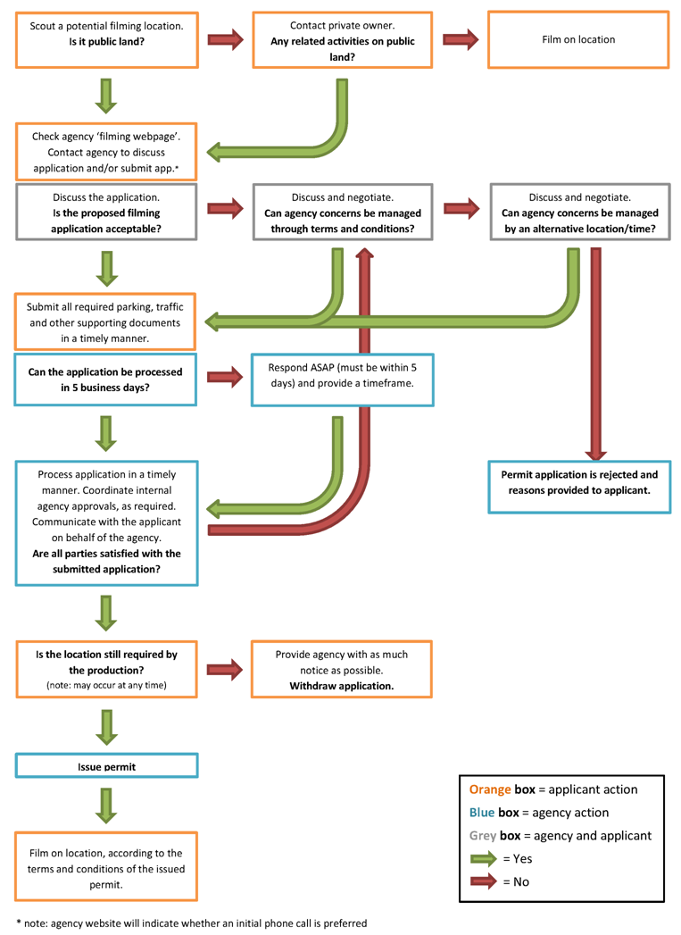
Please note: Some locations may require detailed discussion over a period of time prior to a filming application being submitted.

Who [Public Agency single point of contact] may coordinate with
Assessing a film permit application can require consultation with different areas within [Public Agency Name]. [Public Agency single point of contact] provides industry with a seamless customer experience throughout the process.

Parks and gardens
Under the Crown Land (Reserves) Act 1978, [Public Agency Name] manages a number of the parks and gardens. These public spaces may be environmentally sensitive and need to be protected wherever possible.
Please let the [Public Agency single point of contact] know if you wish to erect structures (i.e. pop-ups, marquees, etc.) in the following locations, as there may be restrictions.
Structures are permitted in other parks, as long as they meet [Local policy on structures in parks, as applicable].
The following rules apply to the erection of structures in [Public Agency Name] parks and gardens:
- structures, where permitted, must be weighted not pegged
- when using water-weighted structures, water weights should be pre-filled and cannot be emptied onto the grass
- no item may be tied, stapled or attached to any tree limb or park infrastructure without written permission
- damage to trees, shrubs, lawns, flower beds or park infrastructure is the responsibility of the production
Vehicles are not permitted to enter [Public Agency Name] parks and gardens without written approval.
Where filming takes place in a park, applications for the installation of a unit base will be considered on a case-by-case basis.

Parking
Generally, vehicles form part of filming requirements, for example, wardrobe and make-up vans, equipment transporters, lighting trucks, catering vans and so on.

Arrangements can be made to accommodate these vehicles. Before you begin filming, it is best practice to carry out a parking bay audit around the proposed site and then submit the following information to us:
- the total number of spaces you require
- specific date and time of filming
- street details, including names of streets and specific locations of where vehicles will be parked – a Melways reference is preferred
- a mud map showing where parking is required, with the number of spaces clearly marked (there is an example in the appendixes)
The [Public Agency single point of contact] will forward all parking applications to the [Name of Public Agency parking department]. Please submit your parking request [number of business days] business days before filming begins.
Once a booking has been approved, you will be given a written confirmation, which must be displayed in the vehicles according to the permit’s terms and conditions.
Fees may apply to parking, and these vary according to the number of spaces and days the parking is required.

[Public Agency Name]’s roads
[Public Agency Name] receives many requests to film on its roads, laneways, footpaths and in public open spaces. Specific approvals may be required for this. See Section 3 for more information on VicRoads managed road networks.

Significant or sensitive locations
Some sites in [Public Agency Name] may require additional negotiation. Please contact [Public Agency single point of contact] or visit our website for more information.

Low impact filming
In some cases, if filming is considered to be low impact, a permit can be approved in a shorter timeframe.
Low impact filming involves minimal equipment and crew, and causes little disruption to pedestrians, traffic and residents. It involves [low impact number of people] people, inclusive of all production crew and cast, and uses [low impact equipment requirements].
An example of low impact filming is a two-person crew gathering ‘vox pops’ for a football commentary show.

This type of filming can generally be approved in [number of business days] business days, since it does not require sign off from other stakeholders.
To discuss whether your filming is eligible for low impact status, contact the [Public Agency single point of contact] at [Public Agency contact details].

What documents do you need to submit?
The following documents are compulsory in [Public Agency Name]. If you are unable to provide any of them, please discuss this with us rather than submitting an incomplete application.

Description of your filming activity
A description outlining what is being filmed on the day: What will take place? What will the cast and crew be doing? Are specialised vehicles or equipment going to be used? Your description should include any disruptive or potentially hazardous activities such as the use of firearms or explosions.

Location manager contact details
The name/s of the person responsible for the set and the unit base on the day of filming must be provided as part of the application process.

Site plan/mud map
A site plan/mud map should provide details of the exact location of the filming activity, as well as what equipment, infrastructure and major props, sets or vehicles will be used and where they will be placed on site. See the appendixes for an example.

Site plan/mud map for unit bases and essential vehicles
A unit base/essential vehicle mud map should indicate where your unit base is located, including all marquees, vehicles and other infrastructure. For an example, see the appendixes.

Infrastructure, equipment and props list
A high-level list detailing what equipment will be on site on the day of filming, i.e. track and dolly, trolleys, camera, lights, reflector boards, marquees and any major props proposed. See the appendixes for an example.

Public liability insurance
Evidence of public liability insurance that comprehensively covers your legal liabilities in relation to your filming activities. The amount of cover for filming must not be less than A$[Local public liability policy, as applicable] million.

Traffic and pedestrian management plans (if applicable)
If filming is likely to interrupt the normal flow of traffic or pedestrian or cycling access, including being stopped, held or diverted, you must provide a traffic and/or pedestrian management plan from an accredited traffic management company.

Risk management plan
Filming in [Public Agency Name] may require a risk management plan to be completed. Please refer to the appendixes for an example.

Communication strategy with stakeholders (if applicable)
Clear communication with stakeholders is important before filming begins. It helps to minimise any impact on surrounding stakeholders and can be very useful when filming actually begins.
A draft stakeholder letter, if required, must include contact details of the location and/or production contact in case stakeholders have questions on the day or need arrangements to be made for access. Please see the appendixes for an example.
Once the wording of the letter has been provided to the [Public Agency single point of contact] you should confirm when the letter drop will take place and which streets are involved. [Public Agency Name] may suggest additional streets to be included. For all lane or road closures, a letterbox drop should take place at least [number of business days] business days before the scheduled filming.

Filming schedule/running sheet
A filming schedule sets out the filming times and locations in chronological order, including bump-in and bump-out times. See the appendixes for an example.

Health services permit
If your filming activity includes catering, you may need to submit a Statement of Trade and a copy of the Caterers Victorian Food Act Registration. If it involves catering to the general public, you must meet further requirements.

Waste Management Plan
Film crews are expected to remove all of their waste when they leave a location. In addition to the disposal of general rubbish, a waste management plan may be required to ensure that any waste resulting from the filming activity is cleared from the site (for example, scraps of tickertape paper, special effects remnants, animal waste etc). This requirement may be added to the terms and conditions of a permit to ensure compliance.

Fees and charges
Please refer to our website for current information on fees and charges:
[Public Agency filming webpage]

Section 3: External agencies and issues to consider
A wide range of agencies issue film permits. Some agencies also issue approvals for activities related to filming. The most commonly approached agencies include:
- Transport Victoria – filming on arterial roads, highways etc., use of specialised filming vehicles and changes to vehicles for the purposes of filming
- Victoria Police – police resources including traffic management and on-screen appearance, 'generic' police uniform and equipment hire, research assistance and filming notifications
- public transport providers
- Parks Victoria and the Department of Environment and Primary Industries (DEPI) – filming on land under their jurisdiction, including coastal areas and assets, such as buildings, piers and ramps

Department of Transport and Planning
The Department of Transport and Planning (DTP) is responsible for managing all of Victoria’s arterial roads except for tollways, which are privately managed, e.g. CityLink and EastLink. Local roads are managed by the relevant council. Requests for filming activities such as feature films, commercials, television shows or still photography on Victoria’s arterial roads are considered to be a ‘non-road activity’ and require a permit. These permits are issued in accordance with Section 99B (2) of the Road Safety Act 1986.
Other road managers, such as Parks Victoria and DEECA, manage roads in national parks and other restricted areas.
DTP generally supports filming on the road network, as long as road infrastructure is not damaged, and there are no adverse impacts on traffic flow and road safety. Applications for filming on unopened or disused roads are handled on a case-by-case basis.
Applications to film on the roads network frequently involve traffic management, police involvement and an assessment of public safety. As a general guide, DTP requires a minimum of five business days for applications including police traffic management that do not require police escort. Applications for specialist filming vehicles that require police escort or supervision may take longer to process. In all cases, DTP is a film friendly agency and provides a timely response to applicants.
Permits are required from DTP for the following circumstances:
- filming on arterial roads
- where specialist filming vehicles are being used on both arterial and non-arterial roads
- when talent/artists are under direction while driving a vehicle
- if a modified vehicle is being used on both arterial and non-arterial roads. This includes camera mounts, rigging, and dressed vehicles such as police cars, left hand drives, or vehicles with changed number plates
- if filming activity involves the use of an unregistered vehicle
If any road rules or regulations are to be broken in the course of filming an application for the necessary exemptions from the Road Safety Act, Road Rules or Road Safety (Vehicles) Regulations needs to be made. Situations where an exemption to the Act, rules or regulations is required include:
- a person travelling in the back of a trailer or a load area of a vehicle
- a driver or passenger travelling without a seatbelt
- someone riding a bicycle without a helmet
- vehicles driving on the wrong side of the road
- vehicles exceeding the speed limit
- vehicles fitted with external camera mounts or other modifications
- vehicles being used while unregistered
DTP is unlikely to give permission for the following circumstances due to operational and public amenity considerations:
- daytime filming on roads with heavy traffic, such as freeways and major roads that may disrupt traffic or cause a distraction to drivers and have an adverse impact on road safety
- filming on any major metropolitan road during the morning or afternoon peak periods. Morning peak is between 6.30am and 10am, afternoon peak is between 3.30pm and 7pm
- filming that delays traffic on tourist routes during peak periods and seasons (e.g. Great Ocean Road, Phillip Island Tourist Road)
- filming at a location where there are other scheduled activities during the same period, such as roadworks
DTP advises that it should be contacted as soon as possible before scheduled filming, especially if a permit or an exemption to the road rules is required. Extra time may be needed for more complex requests (such as changes to infrastructure or changes to the speed limit), so it is best to contact DTP as early as possible. Approval maybe revoked or delayed in cases of emergency.
You may need to contact the following organisations to discuss your plans.

Public Transport Victoria
If your filming activity is likely to affect public transport in any way, you must submit an Event Notification Form to Public Transport Victoria (PTV). If you do not notify PTV, it may seek costs as a result.

Victoria Police Film and Television Office
This unit is responsible for all liaisons between the film and television industry and Victoria Police. The advantage of this is that filmmakers do not have to approach individual police stations for advice or assistance and have a single point of contact when planning a production. The Film and Television Office coordinate the use of police resources such as traffic management and on-screen appearances, 'generic' police uniforms, equipment hire and research assistance for filmmakers.
Victoria Police authorise, manages and controls traffic management during filming if it is required by VicRoads or other road authority. It does not issue film permits or exemptions but enforces the law in every aspect relating to road management and ensures public safety.
See Useful Contacts for Victoria Police contact details.

Notifying Triple Zero Victoria of your filming activity
Recently ESTA became Triple Zero Victoria or 000VIC.
To notify 000VIC of filming activities and potential impacts to Emergency Services you should send an email to statedutyofficerSDO@triplezero.vic.gov.au . They must be notified if your filming activity if it involves firearms, weapons, special effects, private traffic management, mock police scenes or scenes which may cause public concern. The purpose of this is to reduce the number of false callouts received by 000VIC when a member of the public mistakes a filming event for a real incident.
If your filming is likely to impact other emergency services (e.g. fire or ambulance) you must contact the relevant agencies directly before filming begins and inform them of your plans.

Timeframes
Information on timeframes can be found on the Victoria Police Film and Television Office website at www.police.vic.gov.au

Road closures, blocks and holds
For all road closures and/or hold and releases, you must submit an accredited Traffic Management Plan to [Public Agency Name]. The [Public Agency single point of contact] will circulate your Traffic Management Plans to the relevant internal stakeholders.

Specialist filming vehicles
In most cases, specialist filming vehicles can only be used on public roads, when escorted by police.
The decision around police attendance is determined in consultation with the Film and TV office, and the Department of Transport and Planning (formerly VicRoads).

To determine if you need a police escort, contact the Victoria Police Film and Television office.
Examples of specialist filming vehicles are:
- tracking vehicles
- low loaders
- camera mounted vehicles
- other specialist filming vehicles as designated by Department of Transport and Planning.
Any filming on a public road is called a non-road activity. You will need to secure a permit from the department that manages that road to do this, such as:
- the Department of Transport and Planning (formerly VicRoads)
- the local council
- Transurban
- EastLink
- Parks Victoria.
The vehicle that you are using may also need a permit. Check if you need one from the Department of Transport and Planning.

Applying for a Film Permit when using a Specialist Filming Vehicle

For all event and filming applications you will need to complete DTP’s online form.

WorkSafe
Filming may also need to comply with WorkSafe legislation for No Go Zones. For details, visit www.worksafe.vic.gov.au

Section 4: Additional Information

Noise management
Managing noise levels is an important part of [Public Agency Name]’s commitment to providing a liveable, supportive environment for all. During filming cast and crew should be considerate of anyone using the surrounding area so that sounds from vehicles, generators, cast and crew do not cause unnecessary noise disturbance.
The EPA’s Noise Control Guidelines, Publication 1254 provides guidance on noise and sound management. The guidelines are used as a basis for public agencies to assess the potential noise impacts of filming. You can find this at www.epa.vic.gov.au

Safety on set
Members of the screen industry in Victoria are responsible for securing the safety of employees, any other individuals at the workplace and the general public. They must comply with occupational health and safety requirements under the law at all times.
All cast and crew on location must follow the direction of the safety supervisor by reading and understanding the production’s Safety Report and take responsibility for individual and collective safety. Relevant sections of the Safety Report may need to be submitted to [Public Agency Name].
They must also be aware of the objectives and principles of the Occupational Health and Safety Act 2004 and implement a system for health and safety management.

[Public Agency Name] acknowledgment
[Public Agency Name] supports filming. We would appreciate acknowledgement in the end credits of your production, or as mutually agreed.
This acknowledgment should read “Filmed in [Public Agency Name]” or “Thanks to [Public Agency Name]”.

Useful contacts
[Public Agency Name]
[Public Agency single point of contact]
[Public Agency contact details]

VicScreen
03 9660 3200
contact@vicscreen.vic.gov.au
www.vicscreen.vic.gov.au/

Screen Australia
03 8682 1900
www.screenaustralia.gov.au

Victoria Police Film and Television Office
03 9247 5599
film.tv@police.vic.gov.au
www.police.vic.gov.au

Parks Victoria
13 19 63 or 03 8627 4699
www.parkswebvic.gov.au

Yarra Trams
03 9619 3200
www.yarratrams.com.au

Metro Trains
03 9610 2610
www.metrotrains.com.au

V/Line
03 9619 5901
www.vline.com.au

Section 5: Glossary
Bump in refers to the process of setting up a location before filming commences. This may include setting up infrastructure, equipment and camera positions, props and scenery.
Bump out refers to the process of packing up a location after filming has been completed. This may include breaking down infrastructure, equipment, props and scenery.
Camera Mounts/Rigs refers to a camera or another piece of equipment which is safely and securely attached internally or externally to a vehicle.
Certificate of Currency is documentary evidence that an insurance contract is issued by an insurer, outlining the insurance policy details, including the level of insurance held, dates of policy and the interested parties.
Director is the person responsible for overseeing the creative aspects of a film, including controlling the content and flow of the film's plot, directing the performances of actors, selecting the locations in which the film will be shot, and managing technical details such as the positioning of cameras, the use of lighting, and the timing and content of the film's soundtrack.
Essential Vehicles are vehicles that are required to be positioned as close to the filming location as possible and generally include camera truck, grips truck, electrics truck, standby props truck, sound van, generator van, safety and nurse vehicles.
Establishing Shots are images taken of the outside of a building or other structure to show where another scene is set. These are usually quick to film and have low-impact requirements, with minimal crew or equipment.
Filming in this handbook refers to the recording of images, including but not limited to film, video, digital or electronically for the purpose of exhibition and/or broadcast (television, cinema, internet, etc). Generally, it includes photography and photo shoots.
Film-maker/Film Applicant is the person/company responsible for the overall management of the filming activity and is the key contact for [Public Agency single point of contact].
[Public Agency single point of contact] is the single point of contact at [Public Agency Name] responsible for managing film permit applications.
Film Permit is the document that the filming applicant is issued upon successful submission and review of all filming activity plans and documentation. The film permit authorises the applicant to film in accordance with the terms and conditions outlined in the permit. This ensures that it is conducted in accordance with the safety and amenity regulations of a public agency.
Filming Schedule/Running Sheet is a comprehensive list, which details the timing, sequence and location of filming activity in chronological order so that the filmmaker, [Public Agency single point of contact] and other stakeholders know what is happening and when. A good running sheet includes a timeline of the filming activity, bump in and out details and scenes being filmed.
Hazard is anything that has the potential to cause damage to life, health or property and applies to substances, work methods or machines or any other factors in the work environment.
Hold and release is a temporary road closure where traffic is prevented by an accredited traffic management person, from travelling on a road where filming is taking place.
Key Crew refers to the most important people in the crew with authority to make decisions.
Location is the area of production, whether it relates to parking, traffic control, crew facilities, the filming set or unit base site.
Location Manager is the person responsible for finding and securing locations to be used for the production and managing the logistics, permits and costs involved. They are the face of the production to the community. On large-scale productions, the head of the location teams may be referred to as the supervising location manager.
Location Scout is the person responsible for the initial scouting of locations for the production, taking into account production logistics such as location fees and budgetary restrictions, local permitting costs and regulations, camera and ling requirements, convenience to other locations, production services, crew and unit parking.
Location Survey/Recce refers to a pre-filming visit to a location to work out its suitability for filming, including access to necessary facilities and assessment of any potential lighting or sound issues. This is usually undertaken by a location manager or location scout.
Low Loader is a specialist filming vehicle used to safely transport a vehicle containing talent while moving on open roads.
Make Good means to recompense or repair damage. In terms of filming ‘making good’ refers to the agreement that a production company will, ‘make good’ a location upon completion and that it is returned to the same condition it was in prior to filming. This will include repairing any damage that may have occurred during the course of filming.
Mobile Production Office is sometimes part of large-scale productions and is used by crew to work on the details of logistics and running sheets for upcoming filming.
On-Set Location Manager assists the location manager and is on set before, during, and after the filming process. General responsibilities include arriving first at the location to allow the set dressers onto the set, maintaining the cleanliness of the location areas during filming and liaising with residents and other stakeholders on the day.
Pre-Production is the planning stage of a film’s production cycle, once the project has been financed but before actual filming begins. This can include script editing, budgeting, set design, location scouting and casting.

Producer has ultimate responsibility for the entire production and controls matters such as raising finance, hiring the writer, director and other key personnel, along with all the business associates. The producer is involved throughout the production from development to completion of filming and postproduction until the project is released theatrically or broadcast on television.
Line Producer/Production Manager supervises the physical aspects of the production including personnel, equipment, budget, and scheduling. It is their production manager’s responsibility to make sure the filming stays on schedule and within its budget. The production manager often works under the supervision of a line producer and directly supervises the production coordinator. It is not unusual for production to have both or just one of these roles.
Production is the general process of putting a film together from pre-production through to its completion and delivery. It also refers to the middle stage of the process (preceded by pre-production and followed by post-production). The production stage is when principal photography occurs (the actual filming).
Production Designer is responsible for creating the physical, visual appearance of the film - settings, costumes, props, character makeup
Postproduction is the final stage in a film’s production once principal photography concludes. This stage typically includes picture editing, sound editing, visual effects, musical scoring, sound mixing and dubbing.
Public Agency means a committee of management, council, Court Services Victoria, a Department Head, Minister, public entity, the Secretary of the Department of Environment and Primary Industries, a trust established by legislation to manage Crown land or the Victorian Racing Club Limited
Public Land means Crown land or land owned by or vested in a public agency.
Risk depends on such factors as the nature of the hazard, the degree of exposure, the potential consequences and individual characteristics such as susceptibility to hazardous substances.
Risk Assessment means the process of evaluating the probability and consequences of injury or illness arising from exposure to an identified hazard and for the purposes of this document includes hazard identification and risk control initiatives.
Rigging Shots includes setting, hanging or attaching any additional features, equipment or scaffolding to a vehicle in order to capture a particular camera position.
Road closure is the complete blockage of a road for a set period of time. Road closures require detours to be organised and do not occur on major roads unless suitable precautions have been taken. ‘Partial’ or single lane closures are often used to avoid complete road closures.

Rolling roadblocks is a technique is used on a road when it is not suitable to stop traffic completely (e.g. on a freeway) and enables traffic to move safely at a controlled speed, but to not get in the way of filming during a shot.
Safety Supervisor works with the producer to oversee the safety of the cast and crew and any other individual who may come in contact with the film crew or filming activities. They also ensure the implementation of recommendations contained in the production safety report and/or safety plan.
Site Plan (Mud Map) is a snapshot of the location, which identifies all aspects of the filming activity including equipment, infrastructure, camera position/s, pedestrian and or traffic control, generators, amenities, etc. The site plan should also reference streets, laneways and other distinguishable landmarks.
Specialist Filming Vehicles includes tracking, low loader vehicles or vehicles with camera mounts and/or rigging shots that require a special registration from VicRoads to be allowed to drive on open roads.
Stakeholders refer to a person, resident, business or group with an interest in any happenings taking place in the vicinity of where their residence or business is situated.
Tracking Vehicle is a specialist filming vehicle designed specifically for film crew to be transported safely while filming a moving vehicle on open roads. Tracking Vehicles can also have rigs and cranes attached to them.
Unit Base is the term used when referring to the hub of a film production while filming on location. The unit base will generally consist of unit truck/van, makeup/ wardrobe/greenroom buses, catering truck and runner vehicles. This is where the cast and crew gather for meals and the onset production office is managed.
Vox pop is an interview with members of the general public. It is an abbreviation of the Latin phrase vox populi which means ‘voice of the people’.

Section 6: Appendices
In this section, you will find examples of:
- Filming Schedule / Running Sheet
- Contact list
- Infrastructure, Equipment and Major Props List
- Site Plan
- Unit Base/Essential Vehicles Mud Map
- Risk Management Checklist
- Risk Management Plan
- Sample Stakeholder Notification Letter
- Filmmakers Checklist

Example Filming Schedule / Running Sheet
Filming Schedule / Running Sheet sets the timing, sequence and location of your filming activity in chronological order so that film companies, [Public Agency single point of contact] and other stakeholders know what is happening and when. A useful running sheet includes a timeline of the filming activity bump in; scenes being filmed and bump out details.
Scene refers to scene number marked within the script.
Internal/External refers to whether the filming is taking place in an Interior location or exterior location.
Scheduled Time refers to the times that certain scenes will be filmed and always refers to the 24-hour clock/
Scene/Location refers to the scene location according to the script.
Actual Location refers to the actual location within the [Public Agency Name] where the scene is being filmed.
Action refers to what will be happening in the scene being filmed.

FILMING SCHEDULE
Filming Activity:
Date:
Time:
Scene | Internal/External | Scheduled Time | Scene Location | Actual Location | Action
 | 0700 – 0730 |  |  | Grey Street | Bump In
13/34 | External | 0730 – 1030 | Exterior Hospital | Grey Street | Exterior dialogue scene where character is leaving hospital and bumps into friend. Conversation takes place.
12/36 | External | 1030 - 1430 | Exterior Hospital | Grey Street | Exterior cut away of characters going their separate ways
12/37 | Internal | 1430 - 2000 | Hospital | Mercy Hospital | Internal dialogue scene set in hospital room with patient in bed.
 |  | 2000 - 2030 |  |  | Bump Out

Example Contact List
Contact List outlining key contacts for the filming activity.
Please note a contact list should include the full name of the person, their position and their contact number for on the day of filming.

CONTACT LIST
Filming Activity:
Date:
Time:
Name | Title/Position | Mobile | Bus Phone
 | Producer
 | Location Manager
 | On Set Location Manager
 | Traffic Management Officer
 | Safety Officer
 | Victoria Police Personnel

Example Infrastructure, Equipment and Major Props List
Infrastructure, equipment and major props list should detail all infrastructure, equipment and major props on location which will then be detailed in the film permit. Anything not listed is not approved and, if used, will mean a breach of permit conditions.

INFRASTRUCTURE, EQUIPMENT AND MAJOR PROPS LIST
Filming Activity:
Date:
Time:
Department | Equipment
Camera | Camera, lens, tripods, trolleys
Sound | Boom, Microphones, Sound cart
Lighting | Light, cables
Grips | Dolly, tracks, stands, rigging equipment
Generator | Generator, cables
Unit | Tea/coffee cart, chairs, rubbish bins, pop up tent
Art | List all major props – couch, light, etc.
Safety | Cable mats, witches hats, safety mat, signs
Vehicles | 3x trucks, 2x cars, 1x mock-up police car
Other

Example Site Plan / Mud Map
A Site Plan, commonly referred to by the industry as a Mud Map, identifies the location and all aspects of the filming activity, including equipment, infrastructure, major props, camera position/s, pedestrian and/or traffic control/movement, generators, amenities, etc.

SITE PLAN/MUD MAP
Filming Activity:
Date:
Time:
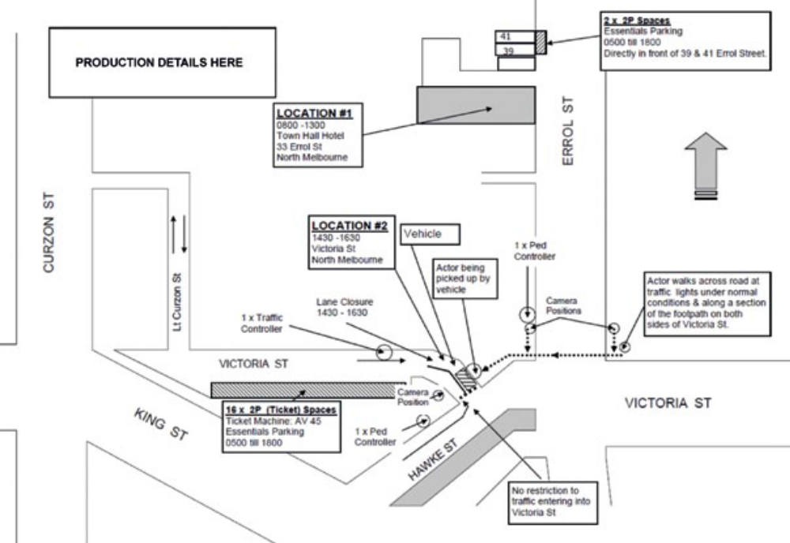

Example Unit Base/Essential Vehicles Mud Map
A Unit Base/Essential Vehicles Mud Map clearly identifies where the essential vehicles and unit base will be located. In the below example it shows where the essential vehicles will be located and what they are.

UNIT BASE/ESSENTIAL VEHICLES MUD MAP
Filming Activity:
Date:
Time:
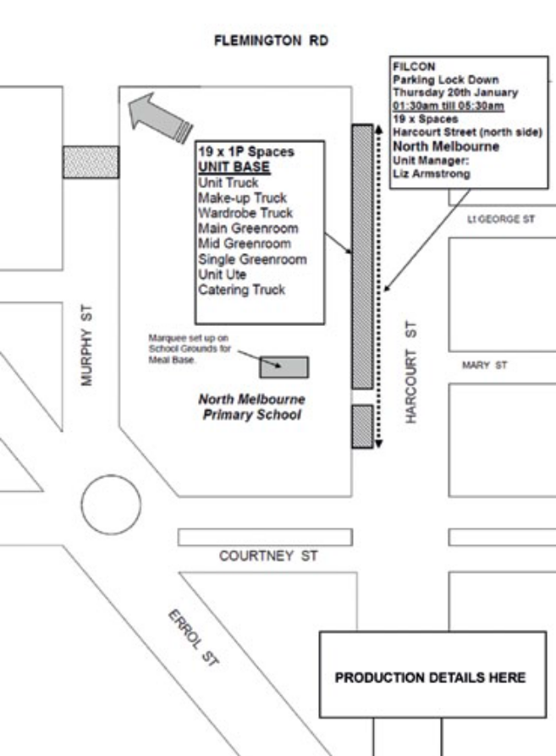 | Details
UNIT BASE (all day)
19 x 1P spaces north side Harcourt St, Nth Melb between Flemington Rd and Courtney St from 0500 till 2000 Friday 3 October 2014. (Note: school holiday period)

ESSENTIALS Loc #1 and #2
16 x 2P Spaces south side Victoria St, Nth Melb between Hawke St and Lt Curzon St from 0500 till 1800 Friday 3 October 2014 (ticket machine AV 45).
2 x 1P Spaces west side Errol St, Nth Melbourne between Errol Pl and Queensberry St directly in front of Shops no: 39 and 41, from 0500 till 1800, Friday 3 October 2014.

ESSENTIALS Loc #3
15 x 3P Spaces south side Dudley St, West Melb between King St and Peel St from 0500 till 1900 Friday 3 October 2014 (ticket machine MWT 467).

Example Risk Management Checklist
A Risk Management Checklist is used to identify and manage risks associated with the filming activity. Please use the below example as a guide only, as each production will have its own unique requirements.

RISK MANAGEMENT CHECKLIST
Filming Activity:
Date:
Time:
# | Risk description | OK | Not OK | N/A | Details
1 | Barriers in place – safety fences
2 | Catering checklists
3 | Confined spaces
4 | Disabled access and facilities
5 | Drinking water
6 | Electrics – i.e. lighting, stands
7 | Elevated work platforms – i.e. scissor lift
8 | Emergency access
9 | Emergency exits unlocked/ clear
10 | Emergency services briefed
11 | Exit signage
12 | Extension leads, cables, plugs
13 | Flammable storage
14 | Fire Brigade briefed
15 | Firearms, replicas and weapons
16 | Fire extinguishers in position
17 | Gas bottles secured
18 | Hot surfaces out of public reach
19 | Housekeeping
20 | Ladders
21 | Manual handling
22 | Participants/ marshals briefed
23 | Noise
24 | Pedestrian access
25 | Performers trained
26 | Powered and non-powered lifting devices – i.e. crane
27 | Police briefed
28 | Radio (2 way) function
29 | Roads and walkway condition
3 | Safety officers
31 | Scaffolding – i.e. sets
32 | Sharp and protruding objects
33 | Steps and handrails condition
34 | Special effects – i.e. smoke machines, explosions
35 | Specialist filming vehicles
36 | Special rigs
37 | Sufficient number of toilets
38 | Tents/marquees secured
39 | Toilets functioning
40 | Trees and branches
41 | Tripping hazards – i.e. electrical cords, cables, ropes
42 | Umbrellas secured
43 | Vehicles removed from site
44 | Wardens
45 | Warning signage
46 | Weather and wind conditions
47 | Work involving heights
Safety concerns transferred to sign off sheet and handed to site safety officer

Inspected by______________________________ Date______________________

Example Risk Management Plan
A Risk Management Plan is used to identify and manage risks associated with filming. From your risk management checklist, you will be able to determine the level of risk and what measures have been put in place to mitigate that risk arising from possible incidents from happening.
- Identify all foreseeable risks (as per risk management checklist).
- Describe their physical consequence should risk occur (i.e. injury, financial loss).
- Review current strategies (controls) for eliminating this risk. Current strategies are what is currently in place in your work strategies to mitigate certain risks.
- Assess the risk (likelihood, consequence and rating).
- Accept or reject risk Accept (A) if satisfied with the current control to manage risk. Reject (R) if you would like to implement further controls to better manage risk.
- If rejected, assess further controls.
- Re-assess the risk based on new control measures (likelihood, consequence and rating).
- Assign strategies to relevant and appropriate persons.
Use the following risk matrix to identify and rate any foreseeable risks, then complete the risk management.
Likelihood |  | Consequences
 |  | Insignificant | Minor | Moderate | Major | Catastrophic
 |  | 1 | 2 | 3 | 4 | 5
A (almost certain) |  | H | H | E | E | E
B (likely) |  | M | H | H | E | E
C (moderate) |  | L | M | H | E | E
D (unlikely) |  | L | L | M | H | E
E (rare) |  | L | L | M | H | H
Legend
E | EXTREME RISK: immediate action required
H | HIGH RISK: senior management attention needed
M | MODERATE RISK: management responsibility must be specified
L | LOW RISK: manage by routine procedures

Below is an example of how two risks identified in the risk management checklist have been rated and what controls are in place to stop any potential incident. This needs to be done for all identified risks.

RISK MANAGEMENT PLAN
Filming Activity:
Date:
Time:
Location
Organiser responsible
# | Risk | Consequence | Current Controls | Risk rating | Accept/ Reject | Person Responsible
23 | Noise | Unpleasant surroundings causing aggravation to cast, crew and stakeholders. | First AD to prevent excessive and unpleasant noise levels. | D2  L | A | First AD
41 | Tripping hazards – i.e. electrical cords, cables, ropes | Bodily injury to public or cast/crew. | All cables covered or taped down. Barriers used to fence off area from public. | C2  M | A | Safety Officer

- Example Sample Stakeholder Notification Letter
A Stakeholder Notification Letter is used to inform stakeholders (businesses, residents, public transport authorities, etc.) in the vicinity of where your filming activity is taking place about what you are doing and where. The purpose is to minimise any impact and allow stakeholders to make contact if they have any questions or need arrangements to be made for access.

PRODUCTION COMPANY NAME/LETTER HEAD

DATE

RE: NOTIFICATION OF FILMING

Dear Resident/Tenant,

This letter is to inform you that (INSERT PRODUCTION COMPANY) will be filming scenes for a (TELEVISION COMMERCIAL / TELEVISION SERIES / FEATURE FILM / STUDENT FILM) at locations in this area. Please see details below.

FILMING DETAILS
DAY / DATE
START TIME to FINISH TIME
INSERT BRIEF DESCRIPTION OF FILMING
LIST STREETS/PARK/LOCATIONS AFFECTED and HOW THEY WILL BE AFFECTED

To facilitate the filming, the production has obtained permission from the [Public Agency Name] to park some equipment vehicles on the following streets:

LIST BLOCKS WHERE PARKING IS BEING HELD

This will mean a reduction in the available parking between DAY/TIME to DAY/TIME in the area.

We appreciate the support of the public in our use of locations in and around [Public Agency Name] and will make every effort to minimise our impact on your neighbourhood. Noise will be kept to a minimum at all times.

An application for a film permit has been lodged with the [Public Agency Name], and we will conduct our activities in accordance with the rules and regulations of the [Public Agency Name].

We thank you in advance for your understanding and cooperation on this matter.

Should you have any queries or require more information please don’t hesitate to contact our onsite location manager/production manager, NAME on MOBILE NUMBER or the [Public Agency Name] [Public Agency single point of contact] on [Public Agency contact details].

Kind Regards,

LOCATION DEPARTMENT
PHONE NUMBER
ADDRESS
FAX NUMBER
EMAIL

9. Filmmakers Checklist
The following is a best practice guide for filmmakers to use to ensure that they have all the correct documentation for their film permit application.

FILMMAKERS CHECKLIST
Film Details Overview
☐ Filming activity title/production name
☐ Filming activity date and times (includes bump in/bump out)
☐ Filming activity location/s
☐ Filming activity organiser’s details
☐ Filming activity description
☐ Number of crew/cast
Film Documents Required
☐ Public Liability Insurance
☐ Running Schedule
☐ Number of crew/cast
☐ Infrastructure, Equipment and props list
☐ Site Plan/Mud Map
☐ Pedestrian Management Plan (where applicable)
☐ Traffic Management Plan (where applicable)
☐ Risk Management Plan
☐ Communication Plan / Stakeholder Notification Letter
☐ Parking (where applicable)
☐ Unit Base and Essential Vehicles Mud Map
☐ Waste Management Plan
☐ Health Services – Catering approval
☐ Film Permit

