

A New Era for Screen
Annual Report 2024/25
Writer/director of Memoir of a Snail, Adam Elliot. Photo Matt Irwin


Contents
Contents 2
Acknowledgment of Traditional Owners 3
About VicScreen 5
President’s Report 8
CEO’s Report 12
VicScreen: Victoria’s Screen Industry Strategy 2021–25 17
Performance 18
Governance & Report of Operations 110
Disclosure of Payments 2024/25 161
Image credits: 178

Acknowledgment of Traditional Owners
VicScreen acknowledges the Traditional Owners of Country throughout Victoria, their ongoing connection to this land and water, and we pay our respects to their culture and their Elders—past and present.
We acknowledge that First Peoples self-determination is a human right as enshrined in the United Nations Declaration on the Rights of Indigenous Peoples. Building on this, we are committed to developing strong and enduring partnerships with First Peoples that will contribute to growing a prosperous, thriving and strong Victorian First Peoples community.

Responsible Body’s Declaration
In accordance with the Financial Management Act 1994, I am pleased to present Film Victoria’s (trading as VicScreen) Annual Report for the year ending 30 June 2025.

Financial Management Compliance Attestation Statement
I, George Lekakis AO, on behalf of the Responsible Body, certify that Film Victoria (trading as VicScreen) has no Material Compliance Deficiency with respect to the applicable Standing Directions under the Financial Management Act 1994 and Instructions.
George Lekakis AO
President, VicScreen
28 August 2025
Throughout this report:
- Economic impact and employment figures include estimates, as some projects have not yet concluded reporting.
- In some instances, amounts for previous years have been updated with acquitted results and may differ from results reported in previous annual reports which included estimates.
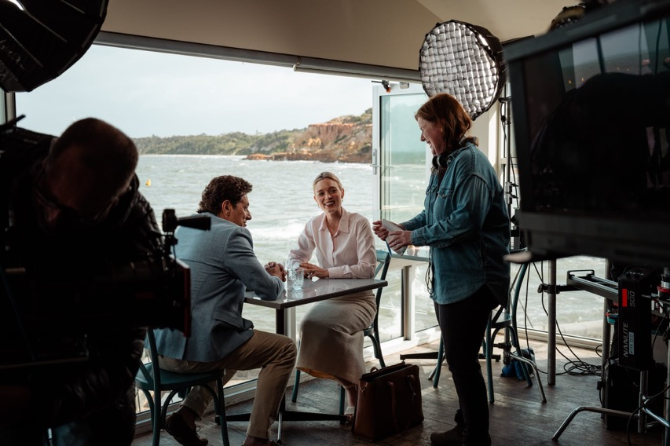
The Family Next Door
VicScreen is the Victorian Government’s creative and economic screen development agency.
It is focused on boosting Victoria’s position as a global screen powerhouse, enriching the lives of all Victorians.
The organisation leads the screen industry through investing in compelling Victorian content and intellectual property (IP), driving industry growth and jobs, developing skills and talent, and building market and consumer engagement.
In a rapidly changing environment, VicScreen works closely with screen businesses, individuals and organisations across Australia and priority international territories to anticipate and respond to shifting market dynamics. VicScreen supports the state’s screen industry to achieve sustained creative, cultural and economic success.

About VicScreen
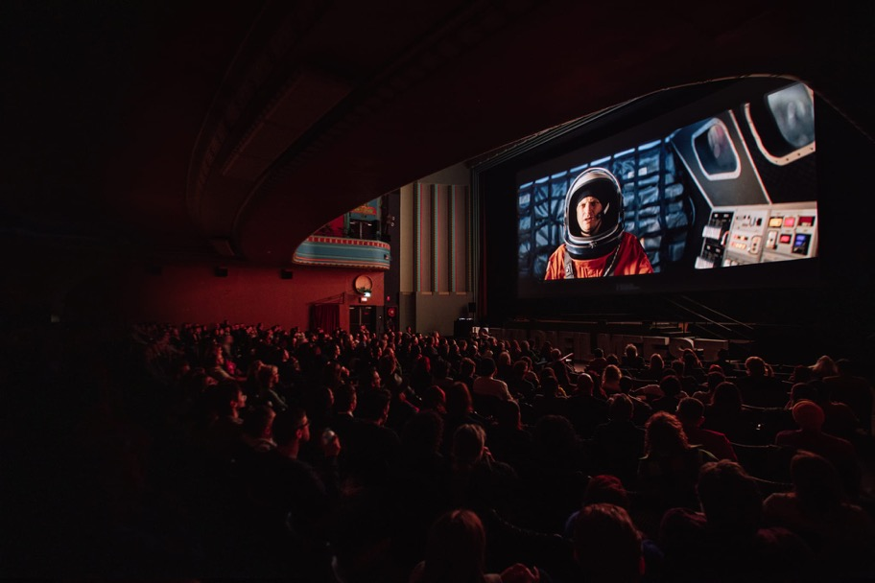
St Kilda Film Festival

Origins
Initially constituted as the Victorian Film Corporation in 1976 under an Act of Parliament, the Corporation became Film Victoria in 1982 by virtue of the Film Victoria Act 1981.
In 1997 the functions of Film Victoria were amalgamated with those of the State Film Centre of Victoria to form Cinemedia Corporation, under the Cinemedia Act 1997.
In 2001 Cinemedia Corporation was dissolved, and Film Victoria and the Australian Centre for the Moving Image (ACMI) were constituted as separate entities under the Film Act 2001.
In 2022 Film Victoria changed its trading name to VicScreen, to more accurately reflect the diversity of screen activity that the agency supports, from film and television to online content, virtual reality, augmented reality and digital games.

Film Act 2001
The Film Act 2001 requires Film Victoria, trading as VicScreen, to provide “strategic leadership and assistance to the film, television and multimedia industry of Victoria to encourage innovation and the creation of new projects of high quality that are of economic or cultural benefit to Victoria”.
The Act prescribes eight functions for VicScreen:
- Provide financial and other assistance to the film, television and multimedia industry in Victoria
- Promote, whether in Victoria or elsewhere, the use of locations or services in Victoria for the production of any film, television or multimedia project
- Provide financial assistance, whether in Victoria or elsewhere, to organisations, events or activities including festivals, conferences, publications or exhibitions, where film or other screen-based programs are made, seen or discussed
- Establish and facilitate, whether in Victoria or elsewhere, relationships for the development of film, television or multimedia programs
- Provide leadership to the film, television and multimedia industry in Victoria
- Develop strategic plans for the development and improvement of the film, television and multimedia industry in Victoria
- Advise the Minister on matters relating to the film, television and multimedia industry in Victoria
- Develop relationships or enter into partnerships with other organisations, including government bodies, whether in Victoria or elsewhere, to improve the film, television and multimedia industry in Victoria.
VicScreen contributes to the delivery of the Victorian Government’s creative industries strategy, Creative State 2025, and VICSCREEN: Victoria's Screen Industry Strategy 2021–2025 (VICSCREEN strategy).
VicScreen supports the principles and objectives enshrined in the Creative Victoria Act 2017, especially those that recognise that creative industries have an intrinsic value and contribute significantly to Victoria’s wealth and prosperity.

President’s Report

Photo Daniel Mahon
It was a blockbuster financial year for Victoria’s screen industry, setting a new record for production expenditure and delivering a remarkable final year of VICSCREEN: Victoria’s Screen Industry Strategy 2021–2025 (VICSCREEN strategy).
This landmark strategy, which was launched in 2021, has elevated Victoria’s reputation as a global screen powerhouse and delivered some outstanding 2024–25 performance results—a record $502.4 million in direct Victorian expenditure, over 8,100 jobs, and an impressive return on investment of 1:11. These achievements are testament to the strength, ambition and long-term vision of the strategy, which has driven Victoria’s screen industry to new heights.
Victoria’s screen industry continues to be a powerful driver of economic, creative and cultural prosperity. Over the past four years, we have built a globally recognised and thriving screen economy—one that showcases our talent, tells our stories and delivers real value to the state.
Across the life of the strategy, VicScreen supported an impressive number of productions, contributing to a vibrant and diverse content slate. While 2024–25 saw fewer projects supported, several large productions contributed to the record year of expenditure. It was pleasing to see acclaimed Victorian creatives at the forefront of many of these productions, including War Machine (directed by Patrick Hughes) and All Her Fault (with the second block directed by Kate Dennis), reinforcing our state’s reputation as a centre of creative excellence.
This year, Victoria played host to a slate of high-profile productions that will light up our screens and showcase our world-class capabilities. In addition to War Machine and All Her Fault, highlights included The Mongoose, with Liam Neeson returning to Victoria for his third film, The Dispatcher, and the Untitled John Tuggle Project, which transformed Kardinia Park in Geelong into a major filming location.
2024–25 delivered a dynamic slate of local productions that continued to cement Victoria’s status as Australia’s premier destination for high-quality screen content. Among the standout projects in production were The Family Next Door, adapted from the bestselling novel by Victorian author Sally Hepworth, children’s shows Knee High Spies and Do Not Watch This Show (ABC), Dear Life (Stan) and Goolagong (ABC), a powerful story celebrating one of Australia’s iconic sporting figures with some of Australia's most exciting First Peoples talent both in front of and behind the camera.
This financial year, audiences were treated to a diverse and impactful lineup of releases, including Apple Cider Vinegar (Netflix), The Survivors (Netflix), Little J and Big Cuz Season 4 (ABC/NITV), Fake (Paramount+/Channel 10), Bay of Fires Season 2 (ABC) and the much anticipated third and final season of The Newsreader (ABC). Together, these productions reflect the depth, diversity and creative excellence that define Victoria’s screen industry.
Over the life of the strategy, we’ve seen significant growth in larger-scale projects, with increased expenditure across games, post-production and visual effects (PDV), and physical production, further cementing Victoria’s global status as a creative and commercial centre for screen production.
2024–25 also marked the first year of VicScreen’s Diversity, Equity and Inclusion (DEI) Roadmap to 2033 and the establishment of the First Peoples working group—two landmark commitments that will shape a more inclusive and representative screen industry for years to come.
I extend my sincere thanks to the Victorian Government for its continued support of our screen industry, and in particular to the Minister for Creative Industries, The Hon. Colin Brooks MP, for his leadership and advocacy. I also acknowledge my fellow Board members for their valuable expertise and ongoing contribution to VicScreen’s success.
My gratitude goes to VicScreen CEO Caroline Pitcher, the executive team and all VicScreen staff for their outstanding work and unwavering dedication throughout the year. I would also like to thank our partners at Docklands Studios Melbourne, Creative Victoria and ACMI for their collaboration and shared commitment to the growth and vibrancy of Victoria’s screen sector.
As we close this chapter of the VICSCREEN strategy, we look ahead with confidence and ambition, ready to build on our collective success and continue to support the industry to deliver exceptional screen content that reflects and enriches Victoria.
George Lekakis AO, President, VicScreen
Victoria’s screen industry continues to be a powerful driver of economic, creative and cultural prosperity. Over the past four years, we have built a globally recognised and thriving screen economy—one that showcases our talent, tells our stories and delivers real value to the state.

CEO’s Report
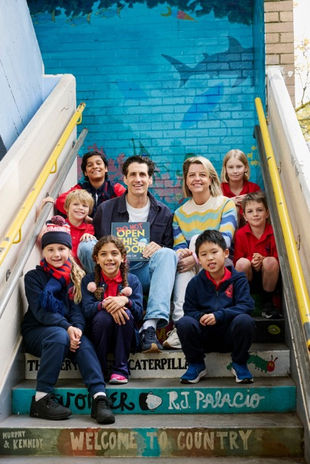
Caroline Pitcher and Andy Lee, creator of Do Not Watch This Show, with Richmond Primary School students
It has been a breakthrough year for Victoria’s screen industry—one defined by resilience, innovation and achievement. As the industry rebounded from disruption at home and abroad, Victoria’s balanced and diverse screen ecosystem proved its strength.
Our strategic mix of local and internationally attracted productions, alongside thriving games, documentary and scripted content, has positioned us as a global centre of screen excellence.
Victorian stories continued to captivate audiences and critics alike. Premium series Apple Cider Vinegar and The Survivors were both critical and commercial successes, with Apple Cider Vinegar spending three weeks in Netflix’s top 10 English Series list with over 12.2 million views during that time and The Survivors amassing 19.2 million views in its first four weeks from release. Adam Elliot’s animated feature, Memoir of a Snail, earned an Academy Award nomination and won the prestigious Cristal for Best Feature Film at Annecy International Animation Film Festival, while Together, a supernatural body horror film by Victorian Michael Shanks starring Dave Franco and Alison Brie, sparked a major bidding war at Sundance Film Festival 2024, becoming one of the richest deals in the festival’s history. Left Write Hook won the 2024 Melbourne International Film Festival (MIFF) Audience Award and My Melbourne made waves across India, showcasing the global reach of our local voices.
The VICSCREEN strategy delivered record-breaking outcomes for employment and expenditure. Over the four years from 2021–22 to 2024–25, VicScreen-supported projects created 46,700 Victorian jobs and collectively engaged over 17,000 Victorian businesses, and total Victorian production expenditure reached $1.7 billion, growing 89% from $0.9 billion in the previous four-year period from 2015–16 to 2018–19.
The strategy has been instrumental in amplifying the success of Victorian companies and series. Productions like The Newsreader and Fisk have become cultural touchstones, while the acquisition of Werner Film Productions by BBC Studios stands as a shining example of Victorian business success on the world stage.
Victoria’s reputation for technical excellence continues to grow. Wētā FX joined global visual effects (VFX) leaders Framestore and Luma Pictures in choosing Melbourne as its Australian base. This investment led to local talent working on two Academy Award®-nominated productions, Better Man and Kingdom of the Planet of the Apes—a powerful endorsement of Victoria’s creative and technical capabilities.
Our screen ecosystem is powered by thousands of skilled professionals—screen service businesses, sole traders and crew—who bring these stories to life. From camera operators and costume designers to post-production specialists and caterers, every role is essential. These professionals form the backbone of our industry, and a recent economic impact study reported that the Victorian screen industry employed over 22,000 full-time equivalent (FTE) positions and injected $3.2 billion into the state’s economy in a single year.
At the heart of our industry’s success are Victorian screen creators and their brilliant ideas. This year, we launched Future Vision, a bold new initiative that brought some of the world’s most influential showrunners and creative leaders to Melbourne. Designed to spark collaboration and elevate local talent, it created rare opportunities for Victorian creatives to engage directly with global industry innovators.
The continued success of the Originate suite of programs has also played a key role in nurturing new voices and generating original Victorian IP. Originate has become a launchpad for exciting new content, including Pasa Faho, which will premiere at MIFF in 2025.
Another highlight was the launch of Screen Careers, a national initiative to address skills shortages across the industry. This Victorian-based program is delivering tailored, industry-led training for below-the-line crew, ensuring our workforce is match fit for the future.
We were also proud to host masterclasses with industry leaders including Ivan Sen at Birrarangga Film Festival, the team behind All Her Fault on environmentally sustainable production, and international visionaries like Sir William Sargent and Todd Cherniawsky.
Victoria’s games sector continues to thrive. Local titles attracted global investor interest at Play Now, Australia’s premier games market, while the GameChanger Academy is expanding our talent pipeline in games, VFX and animation.
NantStudios’ cutting-edge LED volume screens at Docklands Studios Melbourne have transformed the state’s production capabilities, hosting international projects like Play Dead and supporting local series like The Survivors.
We deepened partnerships to reach new audiences, including Footy Shorts—a collaboration between VicScreen, the Australian Football League (AFL) and MIFF, which brings screen and sport together in a uniquely Victorian celebration.
On behalf of VicScreen, I extend my heartfelt thanks to the state’s screen professionals and businesses for their insight, perseverance and extraordinary work. We are immensely proud to champion such a highly skilled and respected local workforce whose talent continues to elevate Victoria’s global screen reputation.
I also wish to express my sincere gratitude to the VicScreen Board for their leadership and guidance. Additionally, I thank the VicScreen team for their passion and commitment which has made a lasting contribution to the strength and success of our sector.
As we look to the year ahead, we do so with optimism and determination—ready to build on the strength of the VICSCREEN strategy and continue shaping a vibrant, inclusive and world-leading screen industry for all Victorians to take great pride in.
Caroline Pitcher, Chief Executive Officer, VicScreen
As we look to the year ahead, we do so with optimism and determination—ready to build on the strength of the VICSCREEN strategy and continue shaping a vibrant, inclusive and world-leading screen industry for all Victorians to take great pride in.

VicScreen: Victoria’s Screen Industry Strategy 2021–25

Do Not Watch This Show

Vision
Victoria is a global powerhouse for screen – enriching the lives of all Victorians.

Strategic Priorities
In addition to the four priorities in VICSCREEN: Victoria’s Screen Industry Strategy 2021–2025, VicScreen’s Corporate Plan includes a priority relating to the strategy’s successful delivery.
VICSCREEN: Victoria’s Screen Industry Strategy 2021-2025

Performance
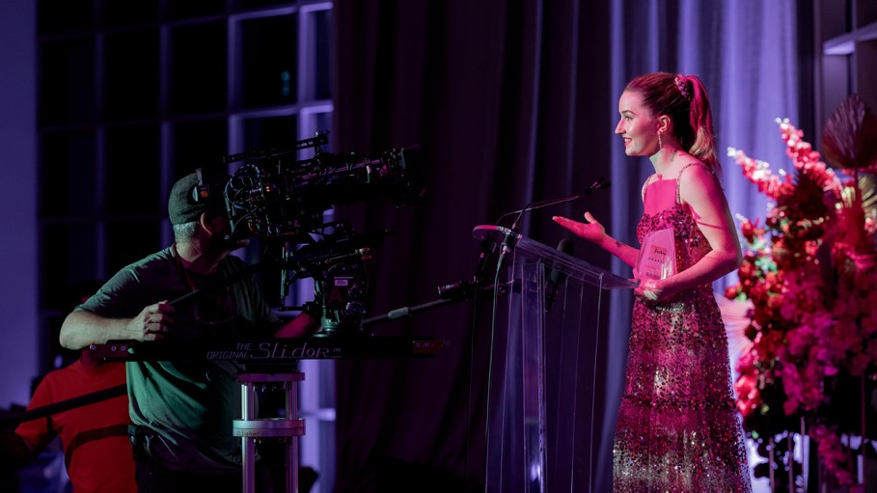
Apple Cider Vinegar

2025/25 Year in Review
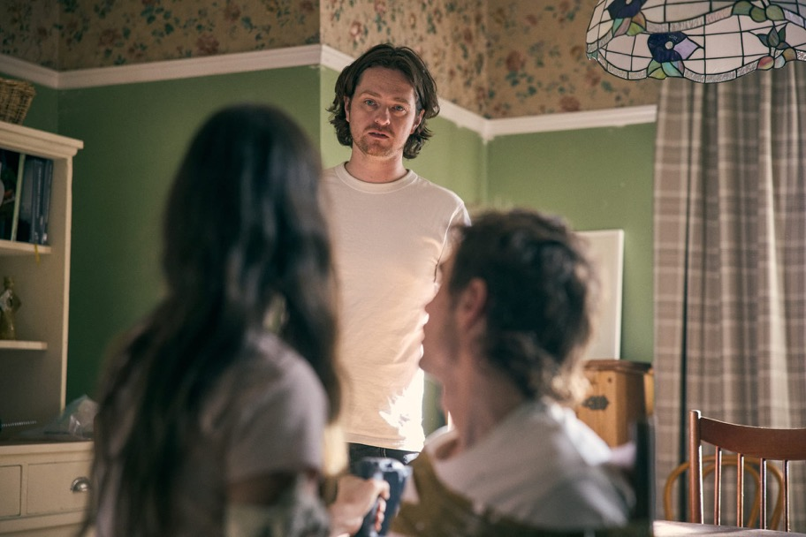
Director Michael Shanks on the set of Together.
This year, VicScreen’s support:
- Generated $502.4m in direct Victorian expenditure (2023–24: $331.3 million)
- Created 8,141 local job opportunities, equating to 3,594 direct full time equivalent (FTE) jobs (2023–24: 6,970 job opportunities, 2,626 FTE)
- Delivered an ROI of $1:$11 — for every one dollar invested by VicScreen, 11 dollars were delivered in direct Victorian expenditure (2023–24: 1:11)
- Enabled 72 film, television, online and digital game projects to commence production or post-production in Victoria
- Produced 140 hours of film, television and online content
This year, through VicScreen:
- 26 feature films commenced production or post- production in Victoria, delivering $260.1 million in direct Victorian expenditure
- 20 television and online series and one-off projects commenced production in Victoria, delivering $228.1 million in direct Victorian expenditure
- 27 film, television and online projects received funding through the Victorian Production Fund, and are expected to generate $95.8 million in direct Victorian expenditure
- 20 Victorian-led games projects commenced development, and are expected to deliver $6.3 million of direct Victorian expenditure
- 7 digital games projects were supported through the Victorian Screen Rebate and Victorian Digital Screen Rebate, and are expected to deliver $7.9 million of direct Victorian expenditure
- 65 film, television, digital games and online projects received $1.7 million in development funding*
- $5.9m was invested in industry and skills development programs and initiatives
*Excludes labs, development travel and business capability grants

Strategic Priority 1: Generate Compelling Victorian Content and IP
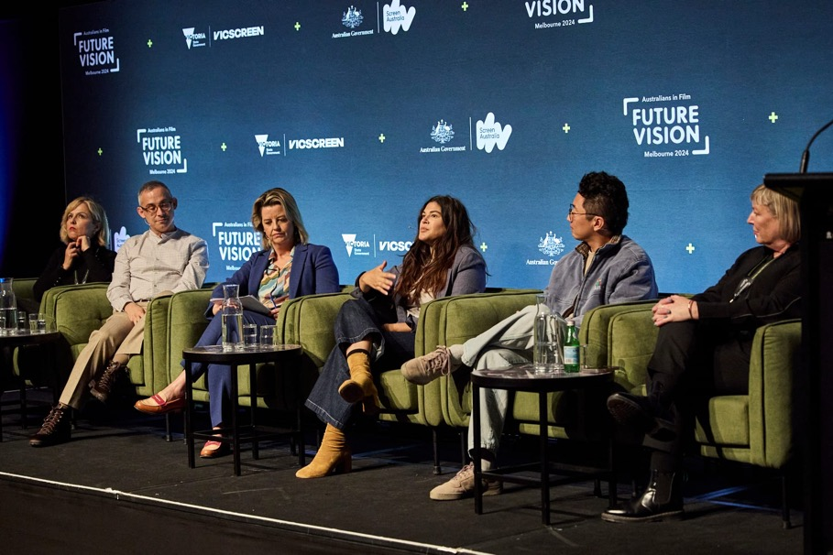
Future Vision
Generating high-quality, globally recognised intellectual property is essential to the continued success and growth of Victoria’s screen industry. This strategic priority is focused on supporting the development of compelling, diverse and wide-reaching screen content that secures market interest and attracts production finance.
Through internationally recognised initiatives, VicScreen has championed Victorian creators and screen businesses, empowering them to produce critically acclaimed and commercially viable projects that showcase the state’s creative excellence on the world stage. At the conclusion of the fourth and final year of the VICSCREEN strategy, the achievements of the Victorian screen industry continue to mount.
In the past year...
- 8,100+ Industry jobs created
- $500m+ Production expenditure contributed to our state’s economy

Envisioning the future of screen storytelling
Held at ACMI in July 2024, the inaugural Future Vision brought together the best of Australian and international talent working in television today to drive conversation and ignite boldness in both the creative and commissioning spaces.
Produced by Australians in Film, Future Vision facilitated a three-day symposium where Australian and international storytellers, producers and commissioners working in premium television drama and narrative comedy could collaborate towards the same goal, elevating Australian television and expanding its reach to global audiences.
Screen innovators including Writer/Director/Producer Joanna Calo (The Bear), Creator/ Writer/Director/Producer Lee Sung Jin (Beef), Director/Producer Minkie Spiro (3 Body Problem) and David Levine, Chief Creative Officer, Anonymous Content, attended the event, providing insight, expertise and valuable perspectives on the evolving landscape of the screen industry.
VicScreen has secured Future Vision for three years, ensuring Victorian screen creators continue to have access to Australia’s premier global television exchange.
“Future Vision has been amazing. It’s been really incredible to hear from such high profile talent about their methodologies and processes of making the literal best TV in the entire world. And just having that come to Australia has been incredible.”
- Lucy Coleman, Writer/Director, Exposure
“The amount of talent that is in this room and that has been in Future Vision is the world’s best.”
- Tig Terera, Writer/Director, Swift Street

Originate Genre: nurturing breakthrough storytellers
Victoria is known for its genre filmmaking and VicScreen-supported titles Together, Saccharine and Leviticus have all stood out in the market due to their unique perspective and re-envisioning of classic genre tropes. In March 2025, VicScreen launched Originate Genre, a new initiative to support emerging Victorian screenwriters in creating market-ready genre films. Originate Genre builds on the success of the Originate suite of programs, which have fast-tracked new voices and bold storytelling, with supported projects already backed by some of the screen industry’s biggest names. This two-phase program incorporates both online seminars and an intensive six-month Writers’ Lab. Led by acclaimed University of California, Los Angeles (UCLA) screenwriting professor Wendall Thomas, participants in Originate Genre will receive expert training across several genres including romance, comedy, horror and sci-fi. Eight selected projects will receive tailored development support and a $10,000 grant to deliver a polished first draft screenplay.
In 2024–25 VicScreen provided $3.2 million in development funding, supporting 65 projects and facilitating the delivery of four Originate Series Writers' Rooms, an online Writer’s Seminar and a six-month Writer’s Intensive for Originate Genre, and Future Vision.
The six-year* average conversion rate of projects supported by VicScreen in development going into production exceeds VicScreen’s 20% target by 2.4%.
20% Target
*The strategy target of 20% development conversions is calculated using a six-year average to accommodate the time it takes to convert a development project into production.
VicScreen’s Originate suite of content development programs is supported by the Community Support Fund through the Victorian Government’s Department of Treasury and Finance via the Department of Jobs, Skills, Industry and Regions.

Memoir Of A Snail
ARENAMEDIA
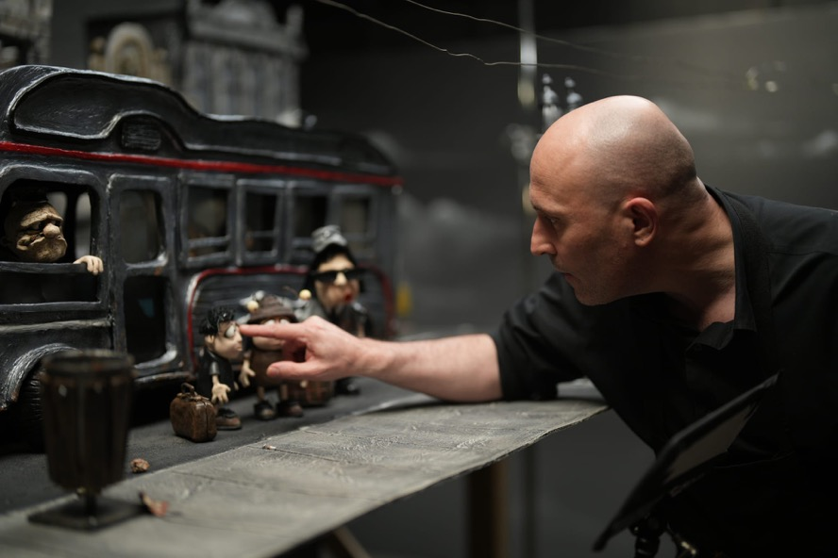
Memoir of a Snail
Academy Award®-winning writer, director and animator Adam Elliot’s poignant Memoir of a Snail stands as a testament to how a unique creative vision, technical mastery and cultural specificity can bring international acclaim to Victoria.
Almost a decade in the making, with thousands of clay ears, eyes, noses and mouths forming the characters, Elliot’s claymation feature film Memoir of a Snail had its Australian premiere at MIFF on opening night in 2024.
Memoir of a Snail depicts the unlikely friendship between Grace Puddle, a melancholic Australian woman who hoards snails, romance novels and guinea pigs, and Pinky, an eccentric elderly lady, who helps Grace develop the courage to let go of what’s cluttering her home and mind. Cultural landmarks like Luna Park and Arts Centre Melbourne, modelled meticulously in clay, help give the story its distinctly Victorian flavour.
Born and bred in Melbourne, Elliot has made all his films in his home city. The stop-motion drama features the voices of acting royalty, including Victorians Sarah Snook, Jacki Weaver, Kodi Smit-McPhee, Magda Szubanski and Eric Bana.
“All the talent is here. We haven't had to import anybody, even from interstate, everybody's local and lives less than 30 minutes from the studio. So, there's no reason why we can't bring big stop-motion projects to Melbourne, just like live action does.
“This time around, I'm really enjoying seeing the emerging talent come through our industry. We've got half a dozen VCA [Victorian College of the Arts] graduates working on this film, and it's great seeing them have this opportunity, because when I left the VCA, there were no opportunities. It sounds a bit soppy, but I like giving back a little bit…[Producer] Liz Kearney and I really get a buzz out of giving people jobs.”
— Adam Elliot, writer/director/animator
Funding
Memoir of a Snail was supported through VicScreen’s Victorian Production Fund.

Outcome
Memoir of a Snail was nominated for an Academy Award® and won the Cristal for Best Feature Film at the prestigious Annecy International Animation Film Festival. These accolades demonstrate the quality and compelling screen content being developed by Victorian auteurs.
Impact
- $6.8m Production expenditure in Victoria
- 85 Industry jobs generated
- 49 Direct FTE jobs generated
- 1 Director placement
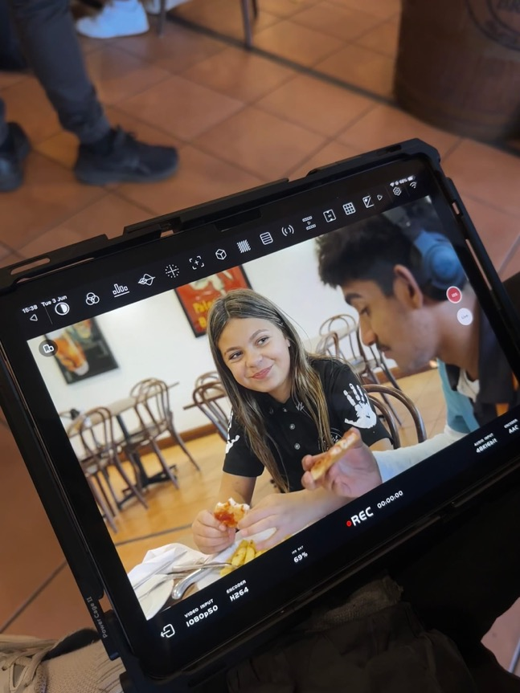
Bush Boots, produced through Footy Shorts, an initiative of MIFF, the AFL and VicScreen.

Victorian-made games making waves
Victoria’s digital games sector continues to demonstrate global excellence, with local developers and studios showcasing the state’s creativity, innovation and technical capability. VicScreen’s support plays a key role in helping studios scale, strengthen their market position and deliver high-quality games to international audiences.
Conscript, a WWI survival horror game by solo developer Jordan Mochi, exemplifies the power of independent vision. Developed over eight years and supported by VicScreen’s Victorian Production Fund, the game blends historical depth with a haunting visual aesthetic. Published by Team17 and launching successfully on PC and Console, Conscript garnered critical acclaim, winning multiple awards at the 2024 Australian Game Developer Awards including Game of the Year.
Pixel Starships 2, developed by Melbourne studio Savy Soda and supported by VicScreen through the Victorian Digital Screen Rebate and Victorian Production Fund, builds on the success of its predecessor with a fully 3D sequel. With over 10 million players worldwide, the franchise has captivated audiences through its unique blend of strategy, resource management and space exploration.
Together, these projects highlight the technical innovation and creative ambition of Victoria’s games industry and its ability to deliver sought-after content to players worldwide.

Kids content riding knee high
VicScreen has long supported the perspective of young people being reflected on screen. That is why it prioritises the creation of quality, local children’s content and why, together with the ABC, the Australian Children’s Television Foundation (ACTF) and Screen Australia, it supported the production of new children’s series Knee High Spies in early 2025.
From the award-winning Victorian team at Werner Film Productions and internationally beloved creator Tim Bain (Kangaroo Beach), the series showcases an unstoppable mix of puppetry, VFX and live action performances, in which adventurous teddy bear, Jeremy Buttons, and his ragtag team of toy spies must race against the clock to save their human family from the mischievous schemes of Machiavellian pet guinea pig, Silver Paw.
Knee High Spies throws into the mix a fresh cast of newcomers alongside favourite performers including Christie Whelan Browne, Mark Samual Bonanno and Ali McGregor. The series is directed by Jack Jameson (Sesame Street) and produced by Nicole Minchin (Fisk).
Knee High Spies created 160 job opportunities for screen workers in Victoria, including upskilling and professional development opportunities in direction, props/puppetry and VFX, and injected $6.2 million directly into the Victorian economy.
Other children’s content supported by VicScreen that was completed in this financial year include Do Not Watch This Show, Little J & Big Cuz Season 4 and Magic Beach.

Kick-starting screen careers
In February 2025, MIFF, the AFL and VicScreen teamed up to launch Footy Shorts, an exciting initiative giving emerging Victorian filmmakers the opportunity to make a short documentary that captures the deep love, traditions and connections shared through Australian Rules Football.
Five projects have been financed with $20,000 from VicScreen, and teams were provided with mentorship, access to the AFL’s prized footage archive and support in accessing its clubs. The documentaries will showcase how the game, across its many different forms, unites and shapes Australian life for players, fans, families and communities.
The Footy Shorts projects will have their world premiere screening at a gala presentation at MIFF 2025 and be available Australia-wide through MIFF Online, streaming via ACMI Cinema 3. The films will also be available digitally across all AFL platforms, including AFL.com.au and the AFL app.
“MIFF is excited to be a part of the Footy Shorts initiative this year—launching new docs on the game that Melburnians hold dear from a range of exciting emerging filmmakers. The five teams selected are set to share stories that range from the celebrated to the unseen—from elite players to those making their name on the field, to die- hard fans and intra-family rivalries—that will bring forward the meaning of footy, through film, to Melbourne audiences.”
- Al Cossar, Artistic Director, MIFF

Supporting First Peoples leadership
VicScreen is developing a strategic action plan to drive growth in the First Peoples screen sector. In acknowledgement that future success in the sector will be heavily dependent on First Peoples leadership, VicScreen, in consultation with the First Peoples production community, created a program designed to support established First Peoples-led screen production companies to expand their capability in the short to medium term. Grants of up to $150,000 per company were provided to four companies to enable them to address identified gaps in expertise and/or capacity within the company.

4 Years In Review
Over the four years of this strategy, VicScreen championed Victorian creativity by investing in people and their brilliant ideas to deliver real outcomes and set the Victorian screen industry up for the future. Through flagship initiatives like Future Vision—which brought Hollywood’s top talent to Melbourne—and the Originate suite of programs, VicScreen cultivated bold storytelling and fostered new voices. From blockbuster games to multi- series success stories, VicScreen supported the creation of commercially successful Victorian screen stories that resonated locally and globally.
From Script to Screen
- 35% of productions supported through the Victorian Production Fund – Film, TV & Online came through VicScreen's Development programs
- 39% of project conversions occurred within a year of VicScreen development support, compared to 26% over the previous four-year period
Victorian-Driven Production Generated Significant Economic Impact

New Voices, New Ideas
VicScreen’s Originate suite of programs delivered powerful support for screen projects of every kind. Through immersive labs and hands-on workshops, these bespoke hot-housing initiatives sparked creativity and achieved exceptional outcomes, driving the creation of world-class Victorian screen content.
First-time applicants to VicScreen…
Focus On First Peoples
$475k across four First Peoples-led screen businesses through First Peoples Business Capability Grant
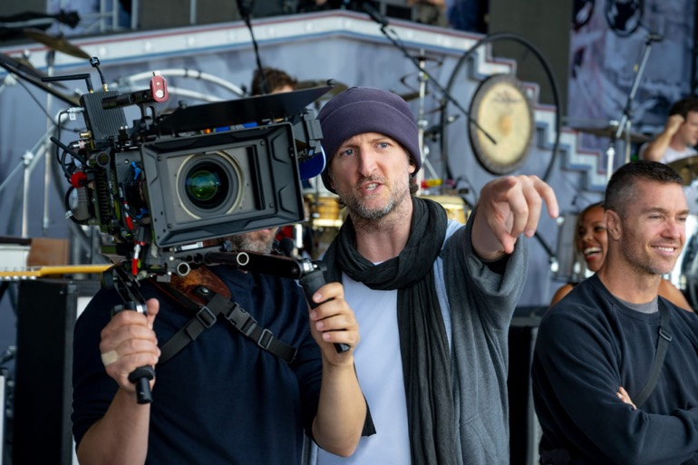
Writer/Director Michael Gracey on the set of Better Man.
Victorian Content With Global Impact
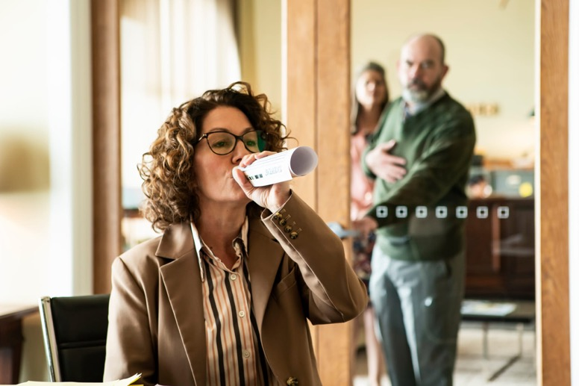
Fisk
Fisk Series 2 landed a spot in NETFLIX’S GLOBAL TOP 10 and 3 MILLION AUSTRALIANS watched its Series 3 premiere on the ABC.
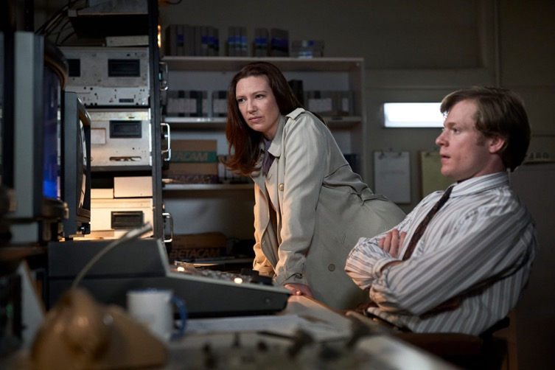
The Newsreader
The Newsreader sold to 20+ COUNTRIES and took home 20+ AWARDS including AACTA Best Drama for all three series.

Surviving Summer
Surviving Summer Series 1 hit NETFLIX’S GLOBAL TOP 10 IN 42 COUNTRIES and Series 1 & 2 both debuted in NETFLIX’S GLOBAL TOP 10.
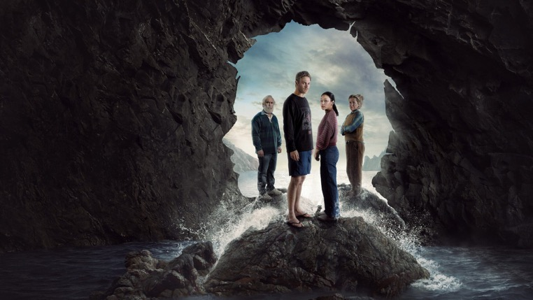
The Survivors
The Survivors debuted at #4 IN NETFLIX’S GLOBAL TOP 10 and hit the Top 10 in 85 countries, with over 19.2 MILLION VIEWS in its first four weeks.
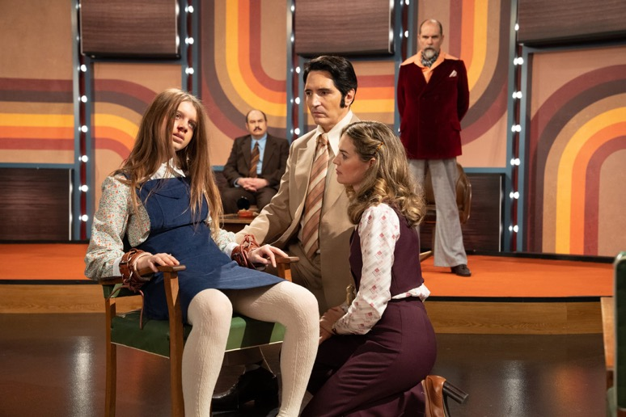
Late Night with the Devil
Low-budget indie horror Late Night with the Devil broke US BOX OFFICE RECORDS in its 2024 opening weekend for distributer IFC and retains a 97% RATING on Rotten Tomatoes.

Memoir of a Snail
Memoir of a Snail was nominated for an ACADEMY AWARD® and WON BEST FEATURE FILM at the prestigious Annecy International Animation Film Festival.
Victorian Blockbuster Games
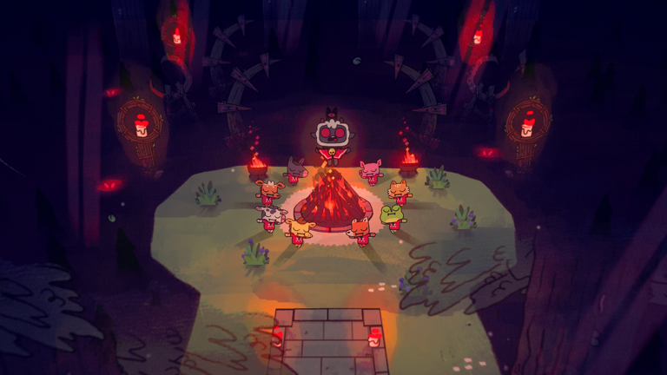
Cult of the Lamb
Cult of the Lamb SOLD 1 MILLION copies in its first week of release and won BEST INDIE GAME at the 2022 Golden Joystick Awards.
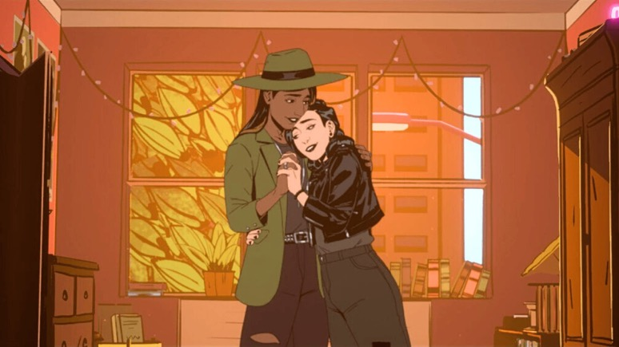
Stray Gods
Stray Gods garnered Australia's first GRAMMY NOMINATION for Best Score Soundtrack for Video Games in 2024 and sits at a 94% POSITIVE player rating on Steam.

Gubbins
Gubbins briefly overtook NYT GAMES on the Apple App store on release and has been downloaded 100,000+ times from the Google Play store.

Conscript
The debut game by a solo Victorian developer, Conscript took out GAME OF THE YEAR at the Australian Game Developer Awards in 2024.
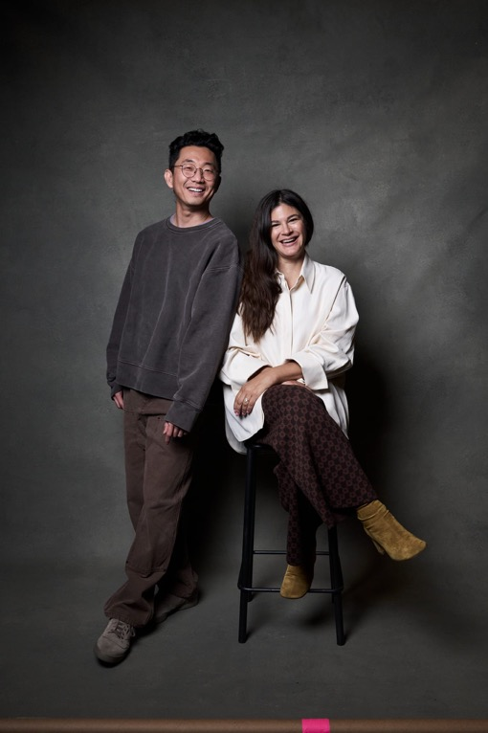
Lee Sung Jin and Joanna Calo
Advancing the Capabilities of Victorian Screenwriting Talent
400 Australian and international screen creators participated in the inaugural Future Vision in Melbourne in 2024, where they exchanged views and ideas with some of the most powerful global voices in contemporary storytelling, including the showrunners of two of the world's most popular recent series, Lee Sung Jin (Beef) and Joanna Calo (The Bear).
- 49% of in-person attendees were Victorian
- 22% of attendees live-streamed from across Australia

Strategic Priority 2: Drive Industry Growth and Jobs
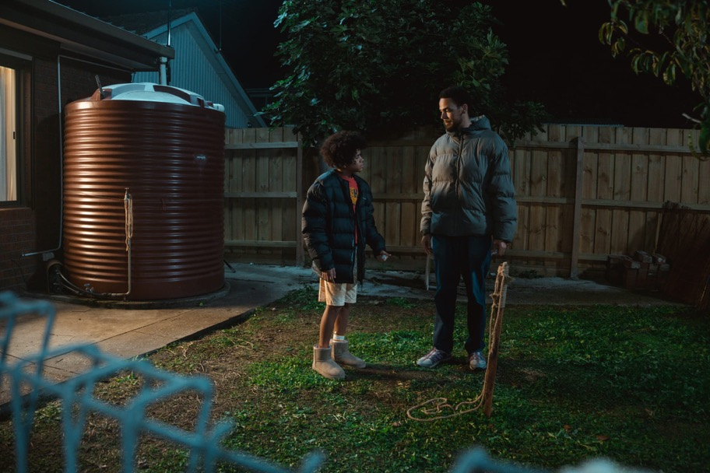
Pasa Faho
At the heart of VicScreen’s work is a commitment to expanding Victoria’s production pipeline and strengthening the state’s screen economy. This priority focuses on cultivating globally competitive screen businesses, growing a skilled workforce and boosting economic activity across the sector. By investing in infrastructure and attracting high-value productions, VicScreen is ensuring Victoria remains a leading destination for screen content creation, equipped to meet both local and international industry demand.
VicScreen generated a record year of expenditure in the state, delivering thousands of jobs and boosting economic growth. 62% of Victorian expenditure generated by physical production in 2024–25 was on projects driven by Victorian writers and directors.

In 2024–25 a record $502.4 million of Victorian expenditure was generated by VicScreen-supported production activity.

*The result in 2023–24 is lower due to industrial actions that took place in the US, lowering production levels and delaying large projects until 2024–25.
While there has been a decrease in industry jobs due to a shift towards fewer but more substantial roles, FTE roles have increased significantly, reaching their highest level in five years, demonstrating an increase in more secure employment in the Victorian screen industry.

Physical film, television and online content production dominated in 2024–25, generating peaks in production expenditure, industry jobs and FTE jobs.

War Machine
LIONSGATE
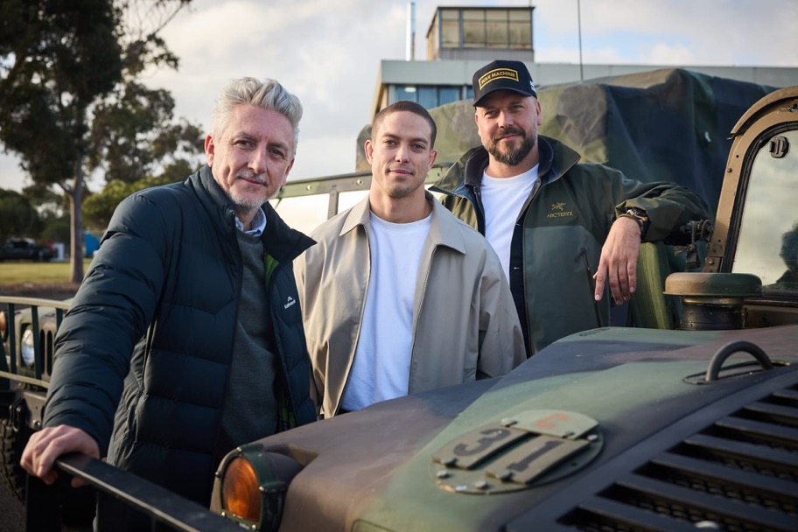
War Machine
Victorian screen creatives are at the helm of the sci-fi action thriller, War Machine, from Lionsgate and Netflix.
Produced, directed and co-written by Victorian filmmaker Patrick Hughes (The Hitman’s Bodyguard), War Machine follows the final 24 hours of the world’s toughest selection program, as a team of Army Rangers encounter a threat beyond their imagination.
Much of the filming took place on location in regional Victoria, including around Bright and Myrtleford, providing an economic boost to those areas. War Machine also filmed in Melbourne and at Docklands Studios Melbourne.
War Machine is a major production powered by Victorian creative talent, exemplifying the state’s capacity to deliver exciting screen stories on a grand scale. Driven by visionary local filmmakers, the project stands as a testament to Victoria’s exceptional artistry, technical expertise and competitiveness in screen production.
“War Machine marks the debut project from Huge Film, a proudly Victoria-based production company founded by Patrick, Screenwriter James Beaufort and myself, with the goal of creating elevated action, thriller and horror stories for global audiences.”
- Greg McLean, executive producer and VicScreen Board member
Funding
War Machine was attracted to Victoria through VicScreen’s Victorian Screen Incentive.
Outcome
War Machine proves that large-scale, globally marketable films can be written, produced and directed right here in Victoria. With high-calibre talent and infrastructure, Victoria continues to punch above its weight on the international screen stage.
Impact
- $73M Production expenditure in Victoria
- $7.5m Production expenditure in regional Victoria
- 2,100 Industry jobs generated
- 20 Heads of department roles
- 80 Local businesses engaged
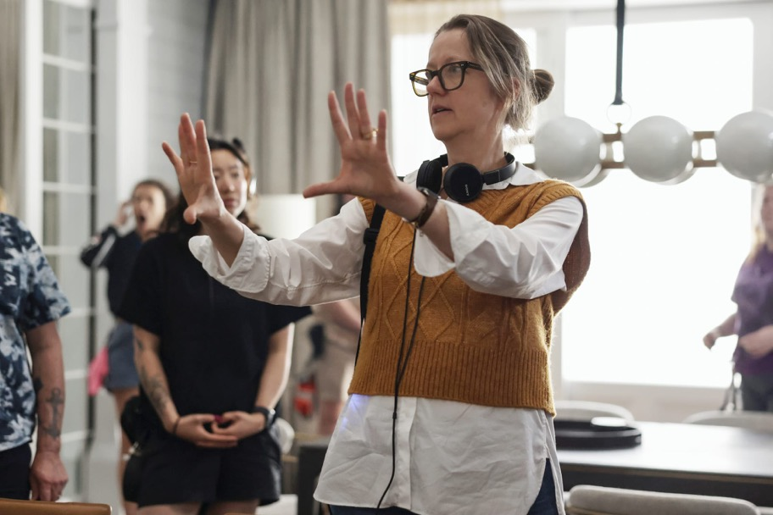
Director Kate Dennis on the set of All Her Fault

A pipeline of quality projects
This financial year, VicScreen helped draw several major international projects to the state, securing jobs for Victorian screen practitioners and work for Victorian businesses.
All Her Fault
All Her Fault, starring Emmy® winner Sarah Snook and featuring a high-profile cast including Dakota Fanning and Jake Lacy, was filmed in Melbourne in late 2024. Based on Andrea Mara’s best-selling novel, the psychological thriller was attracted to Victoria through VicScreen’s Victorian Screen Incentive, injecting over $70 million into the state’s economy, creating more than 2,000 jobs and supporting 435 local businesses.
The production filmed across several Melbourne suburbs and utilised Docklands Studios Melbourne’s cutting-edge virtual production stages. Directed by Minkie Spiro and Victorian Emmy® nominee Kate Dennis, All Her Fault demonstrates the global demand for Victoria’s screen talent, infrastructure and production capabilities.
“I feel so excited about being able to work in Melbourne again. The industry we have here, across all departments of cast and crew, is world class. There’s always a can-do attitude, and I’m particularly impressed with the sustainability efforts our team on All Her Fault are making; showing we can lower our environmental impact without compromising on quality.”
- Sarah Snook, actor
“We’re delighted to be working with VicScreen again to further develop Victorian crew skills, particularly in the areas of virtual production and sustainability. The VicScreen attachment and work placement programs are an invaluable training tool.”
- Mark Binke, Executive Vice President Production Operations, UCP
The Dispatcher
The Dispatcher, a six-part thriller, was filmed at Docklands Studios Melbourne and across Warrnambool, the Mornington Peninsula and the Yarra Valley. Led by award-winning actor Patrick Brammall and adapted by acclaimed Victorian writer Kris Mrksa, the series is based on Ryan David Jahn’s novel of the same name.
The production featured a stellar cast including Maxine Peake,
Brendan Cowell and Daniel Henshall. The project created an estimated 730 jobs, engaged 220 local businesses and injected over $45 million into the Victorian economy, with $5 million spent in regional communities. With 15 skills development placements and strong international credentials, The Dispatcher will showcase Victoria’s globally recognised talent and infrastructure. The Dispatcher was supported through VicScreen’s Victorian Screen Incentive.
“The state of Victoria afforded us an abundance of opportunities for making a series of this scale possible. Fantastic facilities, competitive incentives, incredible locations and first-class crew made filming here a really easy choice. We’re genuinely excited to be making this compelling Australian-set show for international audiences to enjoy and have it serve as a showcase for what is possible to achieve in Victoria.”
- Hakan Kousetta, Executive Producer, The Dispatcher
Untitled John Tuggle Project
Victoria’s reputation as a global screen production hub was further cemented with the commencement of filming for Untitled John Tuggle Project, a heartfelt sports drama based on the life of American footballer John Tuggle.
Attracted to the state through VicScreen’s Victorian Screen Rebate, the production created 825 jobs and engaged 125 local businesses, injecting nearly $29 million into the Victorian economy. Filming took place across Melbourne and Geelong, with Kardinia Park Stadium and La Trobe University Sports Park doubling as American football venues.
The film stars David Corenswet, Michael Shannon and Isabel May and is directed by Jonathan Levine with a screenplay by Emmy®-nominated writer Nick Santora. The project illustrates the growing appeal of Victoria’s top-tier crew, diverse locations and first-rate infrastructure to major international productions.
“We are thrilled to be making this film in Victoria with its first-class crews and screen infrastructure. The state’s amazing sports facilities and varied locations can double for locations like New York, California and Mexico, so we knew there was no better place to bring this project to life.”
- Brad Carlson, EVP of Physical Production, Skydance

Victoria leading the charge in state-of-the-art VFX
Victoria’s global reputation for VFX continued to grow this financial year, with major international studios investing in the state’s talent and infrastructure. VicScreen attracted a significant parcel of VFX work on the live-action remake of How to Train Your Dragon which was undertaken by Framestore's Melbourne studio. The project injected over $10.5 million into the local economy, employing 75 VFX artists over 12 months to animate five dragons across 313 shots.
Meanwhile, Oscar®-winning Wētā FX has established its Australian headquarters in Melbourne, creating up to 80 jobs and working on blockbuster productions including Better Man and Kingdom of the Planet of the Apes, both of which were supported by VicScreen and earned Academy Award® nominations for Best Visual Effects.
These investments by VicScreen strengthen Victoria’s visual effects sector, with Melbourne retaining its status as a centre of excellence for VFX and innovation.
Better Man had its Australian premiere in Melbourne in December 2024 and How to Train Your Dragon has been a global box office smash since opening in cinemas in June 2025.
“Working on How to Train Your Dragon, we got to bring in a lot of new talent, a lot of Victorian and Australian talent, and used it as a training ground to bring up new animators and artists. I think that’s going to be really lasting for us.”
- Glenn Melenhorst, Senior VFX Supervisor, Framestore
Victorian expenditure and FTE jobs from PDV was maintained at previous financial year levels in 2024–25.

Better Man
Better Man Productions
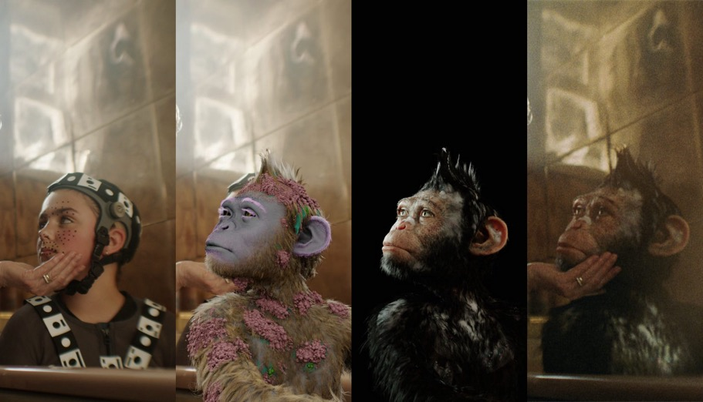
Better Man
When director Michael Gracey (The Greatest Showman) approached major studios with his concept for a Robbie Williams biopic featuring a CGI chimp as its central character, he was met with a healthy degree of scepticism.
The lauded director returned to Melbourne, his hometown, with a steadfast belief and a compelling pitch that the most authentic and engaging way to communicate Williams’ story was through a VFX-engineered character in the form of a man-sized chimpanzee. Michael managed to capture the attention of both state and federal screen agencies at VicScreen and Screen Australia respectively.
Alongside his childhood friends and fellow screenwriters, Oliver Cole and Simon Gleeson, Michael set out to draft a script with universal themes of self-love and self-acceptance. Fast forward three years and Better Man is now the largest film ever made in Victoria.
Funding
Better Man was attracted to Victoria through VicScreen’s Victorian Screen Incentive.
Outcome
Better Man was the first production to use Docklands Studios Melbourne’s Sound Stage 6. The film made its Australian premiere with a star-studded red carpet screening in Melbourne in December 2024, and in early 2025 Robbie Williams gave a free concert to 10,000 fans at Federation Square to celebrate the film's cinema release. Better Man was also instrumental in attracting Wētā FX to establish its Australian headquarters in Melbourne to create the monkey portraying Williams on screen.
“The fact that VicScreen saw that high concept idea—and it's a bold idea—and they backed it, is something I'm incredibly grateful for.
“You can have these very bold ideas, but you're never going to realise them unless you can convince an entire group of people to invest in them to the same degree that you do. And that's what I find about the crews here in Melbourne. They went all in on Better Man. And I think the real remuneration they have is the film itself. It brings me so much joy to know how proud they are of the fact that they were a part of Better Man.”
- Michael Gracey, writer/director
Impact
- $142m Production expenditure in Victoria
- 2,920 Industry jobs generated
- 428 Regional Victorians employed
- 841 Victorian businesses engaged
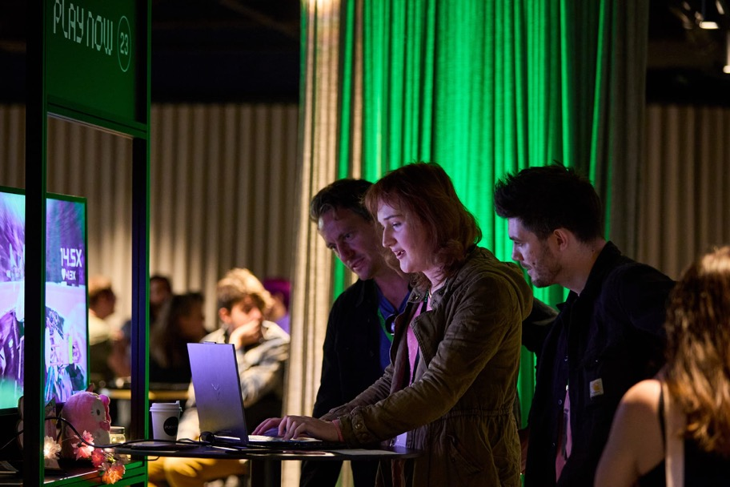
Play Now Melbourne

Melbourne markets: driving deals and creative connections
As a globally competitive and commercially driven sector, the screen industry demands strategic support to thrive. VicScreen plays a pivotal role in empowering Victorian screen businesses to scale and succeed on the world stage. Through targeted initiatives—including leading international trade delegations to premier events such as Gamescom, the Annecy International Animation Film Festival and the Game Developers Conference—VicScreen facilitates vital business development and unlocks commercial outcomes. Locally, VicScreen delivers and supports market events, creating direct pathways for industry growth, investment and global engagement.
Australia’s premier games market, Play Now Melbourne, returned in October 2024 for its dynamic second edition, attracting an even broader range of top-tier global publishers, platform holders and investors. Industry leaders including ID@Xbox, Oculus Publishing (Meta), Devolver Digital, Team17, Focus Entertainment, Raw Fury and PlaySide Studios joined the event in search of Australia’s most innovative new games.
Presented by VicScreen with support from Screen Australia, Play Now Melbourne provided a vital platform for Australian game developers to pitch their projects to international decision-makers and secure commercial opportunities. Building on the success of its inaugural year, the 2024 edition saw significant growth, with over 150 meetings scheduled and increased participation from global publishers. The event continues to strengthen Victoria’s position as a hub for creative excellence and commercial success in the games sector.
“I mean, there are so many games that have taken off here that just wouldn’t have happened without the government support, and this is just next level.”
- Jane Fiona Kennington, game developer
“The creativity….is really interesting, original ideas and many games coming from this region.”
- Shuhei Yoshida, Sony PlayStation
VicScreen proudly supports the MIFF 37°South Market, a curated industry platform connecting Victorian producers with potential financiers at the script stage. The event features targeted opportunities including buyer screenings, sessions for publishers and IP holders to pitch adaptation- ready content, and forums where writers present their screenplays to producers. A series of panel discussions further enriches the program, fostering collaboration and commercial outcomes across the screen sector.

*Reduced games incentives funding in 2024–25 affected jobs and Victorian expenditure outcomes.

New, larger site for Melbourne Screen Hub
Established in 2021 with $1.3 million of support through VicScreen, Melbourne Screen Hub marked a major milestone in August 2024 with its relocation to a significantly larger site in Footscray. Originally conceived by local crew and small screen-business owners, the hub fosters collaboration by offering shared resources, equipment storage and production office space. Supported by an additional $700,000 from VicScreen and a $300,000 loan from Docklands Studios Melbourne, the new 16,000 sqm facility—just four kilometres from the Studios—provides expanded capacity for business development and supports both local and international productions.

Locations support behind the scenes
VicScreen plays a pivotal role in supporting productions filming across Victoria by providing expert location and production services. This support includes tailored logistics advice and facilitation of key discussions with local councils and authorities such as Parks Victoria, VicRoads and Victoria Police. By supporting access and coordination, VicScreen helps ensure productions run smoothly and efficiently, reinforcing Victoria’s reputation as a film-friendly destination.

Melbourne locations on show
Apple Cider Vinegar hit screens in February 2025. The six-part Netflix and See Saw Films/Picking Scabs series filmed in Victoria thanks to VicScreen’s Victorian Screen Incentive and depicts the rise and downfall of wellness guru, Belle Gibson. Apple Cider Vinegar stars international talent Kaitlyn Dever (Dopesick) and was directed by Melbourne- born Jeffrey Walker (The Clearing). The series filmed on location in Melbourne and regional Victoria over the summer of 2023–24. Over 100 locations in Melbourne are captured in the series, from the central business district and suburbs, to parks and bars. Regionally, the series filmed in the Yarra Valley, the Dandenong Ranges and the Mornington Peninsula. The production created 450 local jobs and injected more than $13 million into the local economy.
“We explored every corner of Melbourne to tell this story. Being able to shoot real locations added a freedom to the filming, and we tried to make a character of each of those locations.”
- Jeffrey Walker, Director, Apple Cider Vinegar

Productions set up shop in regional Victoria
In 2024–25 nine projects supported by VicScreen filmed in regional Victoria. The map shows the locations where these productions set up base, providing local job opportunities and an economic boost to rural and regional Victorian communities.
Three of these received support from VicScreen’s Regional Location Assistance Fund. Cumulatively, these projects shot over 45 days in regional Victoria, creating an estimated 135 jobs and generating approx. $1.6 million in regional expenditure.
- War Machine – Bright, Myrtleford
- Dear Life – Ballarat, the Yarra Valley

Dear Life
- Leviticus – Inglewood, Robinvale, Bendigo
- Sweet Milk Lake – Alpine Shire
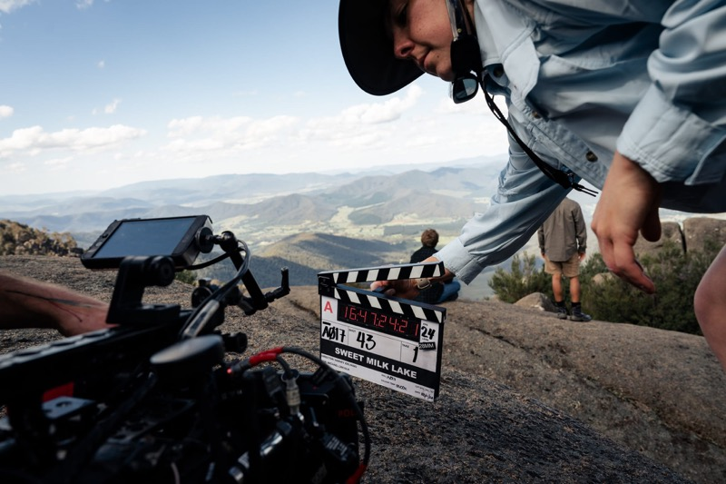
Sweet Milk Lake
- The Dispatcher – Warrnambool, the Mornington Peninsula, the Yarra Valley
- Untitled John Tuggle Project – Geelong, the Mornington Peninsula
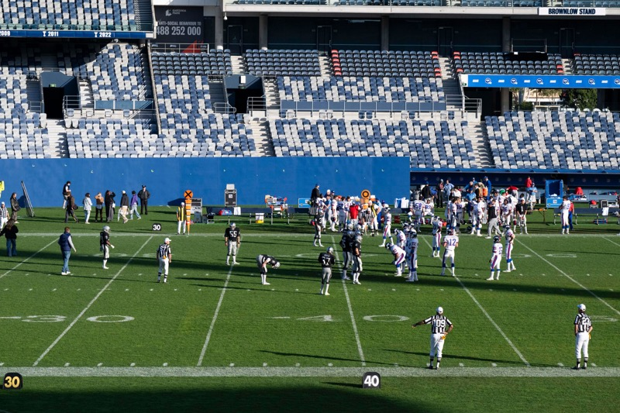
Untitled John Tuggle Project
- Play Dead – South Gippsland
- The Family Next Door – Torquay, Anglesea
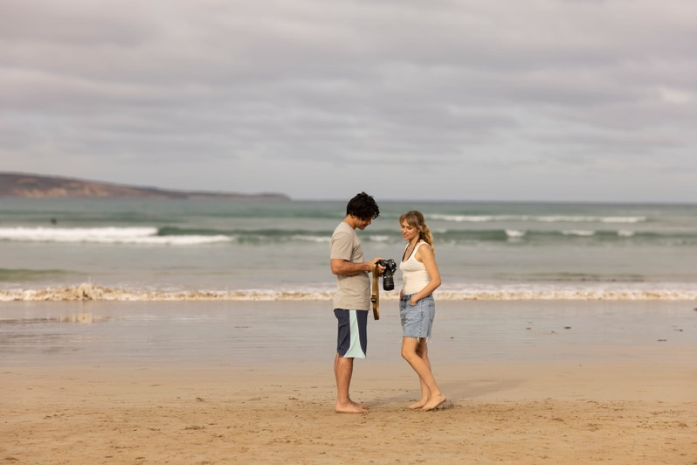
The Family Next Door
- The Mongoose – Castlemaine, Little River, Bacchus Marsh, Calder Freeway between Malmsbury, Bangholme and Harcourt
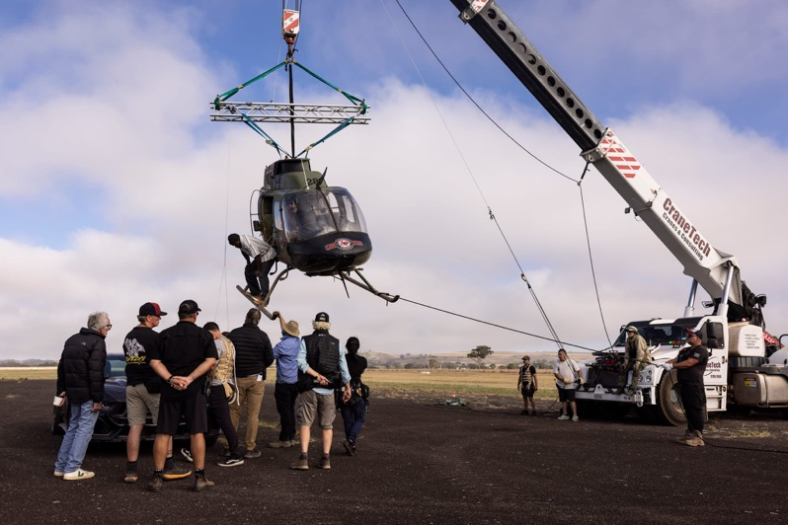
The Mongoose

4 Years in Review
The VICSCREEN strategy delivered record-breaking outcomes for employment and expenditure, attracting high-value productions and global investment. Australian and international projects with budgets over $50 million increasingly chose Victoria, supported by cutting-edge infrastructure including NantStudios’ LED volume screens at Docklands Studios Melbourne. With over 50 small businesses and sole traders at Melbourne Screen Hub and global players like Wētā FX, BBC Studios and Keywords Studios investing in the state, Victoria’s screen industry is thriving.

Total Victorian Production Expenditure

*Economic impact and employment figures are estimates, as some projects have not yet concluded reporting.
Return on Investment
In 2021–2025, for every dollar VicScreen invested in a screen production, an average of $12 was spent in Victoria.

Victorian Industry Jobs Created

Victorian FTE Jobs Created

*strategy baseline year
Between 2021–22 and 2024–25
- 337 Film, TV, games and virtual reality projects supported in production and post-production
- VicScreen-supported productions collectively engaged over 17,000 Victorian businesses
2019–2020 and 2020–21 are not included as a result of the anomalous nature of those years due to the COVID-19 pandemic.
Increased Demand for Docklands Studios Melbourne In 2021–22 To 2024–25
- 139% revenue growth
- 88% average stage occupancy growth
Filming Across Regional Victoria
- 11 film and TV projects filmed in regional Victoria with the support of the Regional Location Assistance Fund.
- $17.8m Production expenditure in regional Victoria
- 979 Local jobs
- 410 Filming days
Digital Games and PDV Incentives
The inclusion of digital games and additional funds for the Post, Digital and Visual Effects (PDV) incentive resulted in a significant increase in related Victorian expenditure.

Attracting Screen Business to Victoria
Three screen businesses were attracted to establish permanent operations in Victoria, joining recent attractions Princess Bento and Sledgehammer Games.
- NantStudios’ LED Volume Stages (Play Dead, The Survivors)
- Wētā FX (Better Man, Kingdom of the Planet of the Apes)
- Keywords Studios
New Super Stage in Melbourne
- Better Man was the first production to utilise the new
- 3,700 sqm Sound Stage 6 at Docklands Studios Melbourne.
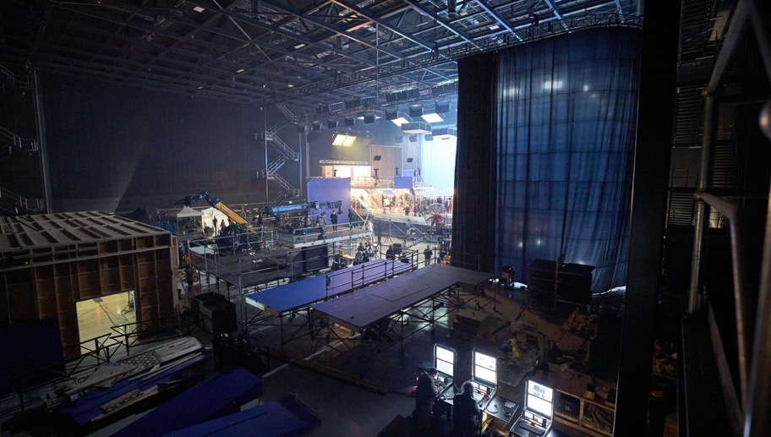
Sound Stage 6 at Docklands Studios Melbourne.
Pitching Opportunities for Victorian Game Developers
Play Now Melbourne, Australia’s pre-eminent games market, launched in 2023 to connect local game developers with publishers, platform holders and investors on home soil. Across events in 2023 and 2024:
- 97 Developer teams
- 31% Increase in developer teams from Year 1
- 21 Publishers, with 13 attending both years
- 272 Meetings
- $67m Total budget of the 97 projects pitched

Strategic Priority 3: Develop Skills and Talent
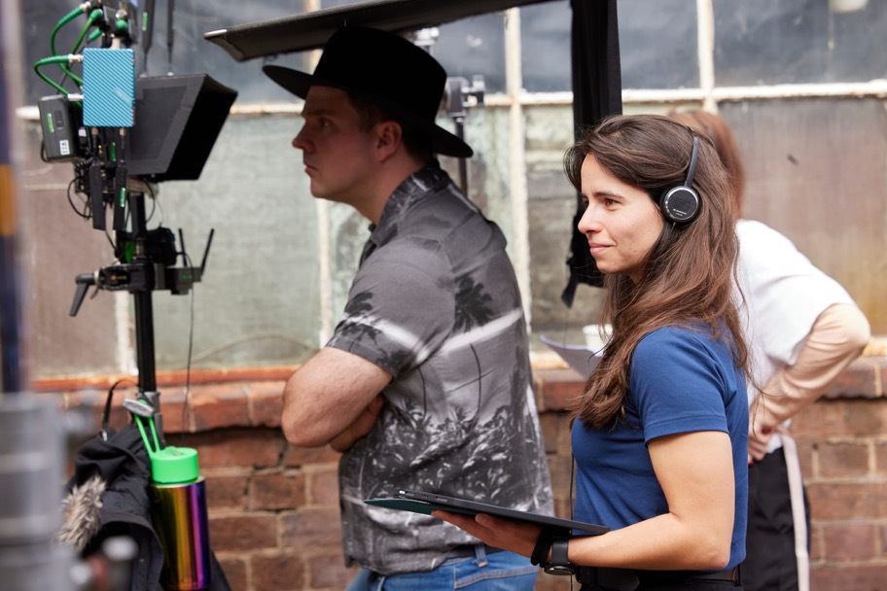
VicScreen-supported director placement Jeannie Psomoulis on the set of Spooky Files S2.
This strategic priority recognises that people— talented screen practitioners from diverse backgrounds—are at the heart of Victoria’s screen industry. VicScreen is committed to fostering inclusive pathways for skills development and talent growth, helping build a highly skilled and globally competitive talent pool that underpins a robust and expanding production pipeline.
This focus on people and professional development is central to solidifying Victoria’s reputation as a premier destination for screen production on the world stage.

Upskilling our screen industry
VicScreen is committed to strengthening the foundations of Victoria’s workforce through skills development opportunities—from conferences, workshops and international business travel to targeted training programs and organisations such as Screen Careers and GameChanger Academy. This financial year, VicScreen has achieved the highest number of attachments, placements and internships on record.
In the past year...
- $5.9m committed towards skills development opportunities, including support for Screen Careers and GameChanger Academy
- 70 professional attachments supported
- 2 internships supported
- 34 placements on a production supported
- 23 placements in a company supported

*The result in 2023–24 is lower due to industrial action that took place in the US, lowering production levels and delaying large projects until 2024–25.
VicScreen’s Key Talent Placements and Specialist Placements programs are supported by the Community Support Fund through the Victorian Government’s Department of Treasury and Finance via the Department of Jobs, Skills, Industry and Regions.

Developing emerging small screen writers into industry leaders
Since completing a writers’ placement on VicScreen-supported series Fires, a 2021 anthology series about the impact of Australia’s devastating bushfire season in 2019 and 2020, Alberto di Troia’s career has gone from strength to strength through the mentorship of leading Victorian showrunner, screenwriter and director Tony Ayres.
Following Fires, Alberto was selected as VicScreen’s participant in the inaugural SBS Emerging Writers’ Incubator in 2021, which was designed to increase diversity within writers’ rooms. He did a yearlong placement with Tony Ayres Productions (TAP), which was also supported by Screen Australia. During his time with TAP, he had the opportunity to write a script for Guy Edmonds and Matt Zeremes’ VicScreen-supported children’s series Spooky Files. On Spooky Files, alongside writing, Alberto gained hands-on experience managing aspects of the development process from an administration perspective while collaborating on concept and pitch documents.
This culminated in his most recent opportunity in the script and continuity department of Ayres’ 2025 Netflix series The Survivors, where he worked on the early stages of development. On the show, which was supported by VicScreen’s Victorian Production Fund, Alberto was Script Producer on six episodes. These opportunities have helped him maintain an ongoing relationship with TAP beyond his placement.
“My opinion has always been really valued and, the more confident I’ve been in being able to put myself up for opportunities or express my thoughts, the more rewarding it’s been for me.”
- Alberto di Troia

Local animators keep things in motion
In 2021, with a Bachelor of Animation from the Victorian College of the Arts under her belt, Lucy Davidson approached producer Liz Kearney and writer/director Adam Elliot for the opportunity to work on Memoir of a Snail. Her initiative paid off when Elliot and Kearney offered her the opportunity to undertake a placement.
Supported through VicScreen, Lucy’s director placement was meant to last six weeks, but she was then offered a role as a set dresser. Her responsibilities included dressing the set, and working with all departments and animators to ensure the scene is ready to shoot. With Lucy’s animation skills, she also had the opportunity to jump in and animate several shots on the production as well.
“It was so exciting not just to be on Adam's film, but to meet the entire Melbourne stop-motion community. As a first feature film project to work on, I couldn't have asked for a better one.”
- Lucy Davidson

Building on independent filmmaking practice
Writer Sophie Smyth had just had her script Unlovable, a half- hour dramedy series about a 20-something autistic woman, optioned by Guesswork Television when she was offered a writer’s placement on Victorian production, The Dispatcher. The Dispatcher follows police detective Ian Hunt (played by Patrick Brammall), whose life fell apart 10 years earlier when his young daughter, Maggie, disappeared without a trace.
Sophie’s placement enabled her to secure her first credit, grow her professional networks and identify future collaborators and mentors, all while developing a comprehensive understanding of how scripted series are made in a high-pressure, high- stakes environment. It also gave her an understanding of how narrative television is developed for when her optioned show hopefully heads into production.
This entry-level opportunity through VicScreen on The Dispatcher has enabled Sophie to build on her experience in the independent film space and live performance production.
“It gave me hard and soft skills development that can only be learnt on the job. I also felt a unique connection and synergy with all members of the script department—it was genuinely a joy and privilege to work with them every day.”
- Sophie Smyth

My Melbourne
Mind Blowing Films
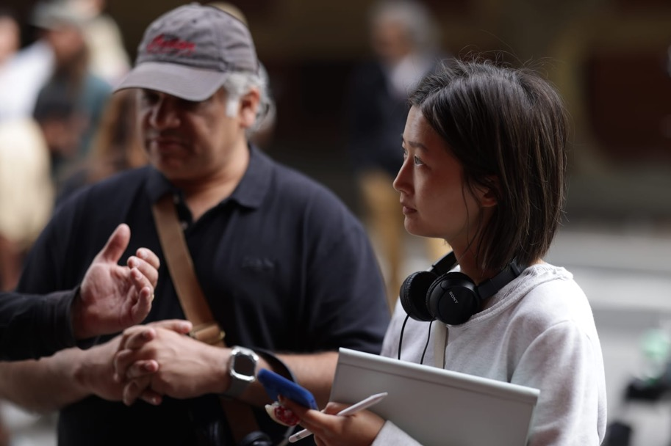
My Melbourne. Photo Jack Dixon Gunn.
Tammy Yang, Puneet Gulati and Samira Cox took on the opportunity of a lifetime in 2024, working alongside esteemed Indian film directors including Kabir Khan, Rima Das, Imtiaz Ali and Onir. Together, they helped weave the narrative of My Melbourne, a Mind Blowing Films production helmed by powerhouse industry leader, Festival Director of the Indian Film Festival of Melbourne (IFFM) and VicScreen Board member, Mitu Bhowmick Lange.
The film is built around four pillars of diversity—sexuality, gender, disability and race—connecting four disparate stories through shared themes of identity and belonging. Titled Nandini, Jules, Emma and Setara, each story is inspired by authentic migrant experiences.
My Melbourne, which is presented in five different languages including English, Bengali, Hindi, Dari and Auslan, featured in several prestigious and high-profile festivals in the subcontinent and the UK.
Samira found out about the co-director opportunity when her mum saw a post on the Deaf Arts Facebook page when the project was at concept stage.
“I was involved in developing concepts for the disability story and my idea was selected by Director Rima Das. I was then supported to develop this concept into a script and offered the opportunity to become the co-director on Emma.”
- Samira Cox, writer placement
Under the guidance of an experienced director mentor, Tammy, Puneet and Samira gained valuable insights and practical experience in a supportive and collaborative environment. This mentorship fostered meaningful learning and professional growth, helping to build confidence and capability in their creative practice.
“Working under my director mentors, Imtiaz Ali and Arif Ali, was a transformative experience. They spent a lot of time with me and the writers, Monique Nair and Shivangi Bhowmick, guiding us through the development of the story. They held us to very high standards, but at the same time, provided support and encouragement, taking the time to listen to our thoughts and ideas behind each scene.”
- Tammy Yang, director placement
VicScreen was proud to support an initiative that improved diversity behind the lens.
“There is a real lack of opportunities for filmmakers like me from diverse backgrounds, whose first language is not English, so My Melbourne was a hugely empowering opportunity from Mind Blowing Films and VicScreen.”
- Puneet Gulati, director placement
Funding
VicScreen was instrumental in supporting My Melbourne through the Industry Development program, which enabled four director placements.
Outcome
My Melbourne made its world premiere at IFFM in August 2024, before appearing at Mami Mumbai Film Festival, Kolkata International Film Festival, Goa International Film Festival and Chennai International Film Festival. My Melbourne also opened the 27th UK Asian Film Festival in London.
The initiative provided a unique opportunity for emerging Victorian talent to collaborate with acclaimed Indian directors, fostering skills development and enabling cultural and creative exchange.
Impact
- 514 Industry jobs generated
- 11 Above-the-line placements
- 7 Below-the-line attachments
- 20 Cities in India screened My Melbourne
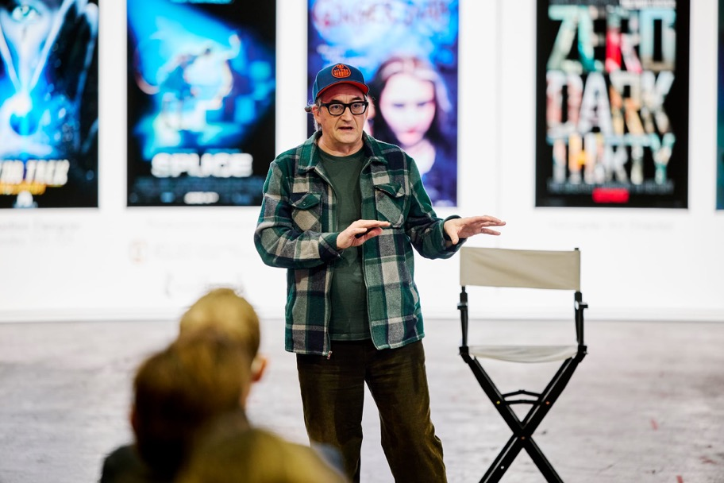
Todd Cherniawsky

Originate Series writers’ rooms
Originate Series, a multi-faceted development program, replicates the experience and processes of working in a professional writers’ room, while also providing intensive skills development and industry exposure that delivers practical, creative and business guidance to prepare participants for a career in television.
Whereas most development initiatives are conducted over a limited period with the aim of generating new IP, the objective of Originate Series is to make the participants themselves the project. The program kicked off in September 2023 and spans 24 months.
After completing the eight-month Writing for Television screenwriting program administered by the University of California, Los Angeles (UCLA), the cohort engaged in a series of paid writers’ rooms, assisting in the creation of four new primetime series from established television creators and production companies including Michael Lucas/Werner Film Productions, Tony Ayres Productions, Elise McCredie/ Easy Tiger Productions and showrunner David Hannam.
The successful participants of Originate Series are Hannah Samuel, Gemma Bird Matheson, Molly Daniels, Penny Greenhalgh, Matthew Bon, Diane Vu, Greta Nash and Serah Nathan.
Hannah Samuel, whose most recent writing credits include Bay of Fires Season 2 and Netflix’s final season of Heartbreak High, had the opportunity to take part in the development room for Easy Tiger on their recently announced series How To Kill A Client through a specialised Originate Series placement. She next serves as a writer on upcoming 2025 Stan adult dark comedy series He Had it Coming and on several more series in active development with commissioners.
“Time in writers’ rooms is a vanishingly rare and valuable resource, especially for emerging writers. So, I loved the strong, practical writers’ room focus of this program and was thrilled to get involved. And ultimately, the participants were so smart, agile, open-minded and creative, I got just as much out of the experience as they did. I genuinely look forward to collaborating with them in future.”
- Michael Lucas, Creator/Writer/Producer, The Newsreader

Knowledge building through bespoke events
Acknowledging the need for industry to continually upskill and learn from colleagues, VicScreen ran five industry masterclasses in 2024–25: All Her Fault Masterclass on Sustainable Production, A Masterclass with Ivan Sen at Birrarangga Film Festival, In Conversation with Sir William Sargent, Todd Cherniawsky: Production Design for a Virtual World and The Family Next Door: Book to Screen with Melinda Wearne, Sarah Scheller and Sally Hepworth.
In June, VicScreen hosted an intimate masterclass at NantStudios with leading international production designer Todd Cherniawsky (Lilo & Stitch) on production design for a virtual world. Cherniawsky was working on WWII thriller Play Dead in Melbourne, which was supported by VicScreen through the Victorian Screen Rebate. For the 29 attendees, composed of production designers, directors of photography, art directors, directors and educators, he demystified the process behind working with the LED volume screens, sharing timeline and budgeting details about his recent projects. Todd talked through specific scenes shot by shot and explained how he integrated set design. This provided unique practical insight for the industry attendees on incorporating new screen technology into their filmmaking practice.
“The opportunity to learn from Todd Cherniawsky about larger-scale production in the virtual production space was invaluable. At the end of the day, it is the generosity of such experts and fellow creatives sharing their rich knowledge and experience that lifts us up. The confirmation that we are on the same path of discovery and innovation here in Victoria with world-class facilities is exciting. While the problems might have different numbers at times, our local talent is more than capable and already excelling in this field.”
- Joanne Donahoe-Beckwith, cinematographer

4 Years In Review
VicScreen delivered an impactful range of programs to build a diverse, highly skilled and future-ready Victorian screen industry. Initiatives such as the First Peoples Writers’ Workshops and She Directs championed inclusion and career development across the sector. VicScreen’s continued investment in the GameChanger Academy and Screen Careers, as well as its own targeted training programs designed to prepare crew for high-demand roles, helped shape a resilient workforce ready to meet the future of screen production.
- Delivered 406 hands-on skills and training opportunities (placements, attachments, internships)
- Including 76 specialist placements to move crew and artists into high-demand positions
- 130% more hands-on skills and training opportunities (placements, attachments, internships) provided in 2024–25 than our strategy baseline year of 2018–19
VicScreen’s Key Talent Placements and Specialists Placements programs were supported by the Community Support Fund through the Victorian Government’s Department of Treasury and Finance via the Department of Jobs, Skills, Industry and Regions.
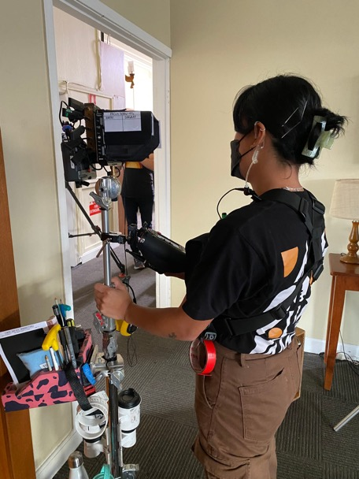
VicScreen-supported camera department attachment Kayleen Montalan on the set of Fisk S3
Meeting the Demand for Job-Ready Artists
A new animation, VFX and games tertiary institution run by CG Spectrum is delivering courses for recent graduates, entry- level trainees and mid-career talent. Designed in response to industry needs, the 12-week intensive training at its facility in Collingwood is leading to more animators, game designers and compositors entering the Victorian screen industry.
- 25% of the first intake of students gained employment with Victorian companies within a month of graduating, including Princess Bento and KOJO.
Delivering Skills Training for Crew
Screen Careers is a new Melbourne-based initiative supported by VicScreen and Screen Australia to address career pathways, training and skills shortages in the Australian screen industry. Tailored, industry-led programs are delivered in-person and online to open inclusive pathways into screen and provide career development opportunities for screen workers.
- 1,898 people undertook training across Australia since March 2024
- Victorians made up 25% of total in-person participants
- Victorians made up 47% of all participants in 2024-25
Empowering First Peoples Women In Screen
- 8 Participants from across Australia in She Directs
- 2 Victorian participants
- 1 Director placement for Victorian-based Wiradjuri Director Merryn Trescott on Goolagong
“She Directs was carefully curated to upskill and inspire a new generation of talented First Nations women screen directors in a safe, non-competitive environment. The fact that we received over 60 applications from across Australia reflects the growing hunger and need for a practical film lab designed by First Nations filmmakers for First Nations filmmakers.”
- Warramungu/Luritja Director Beck Cole
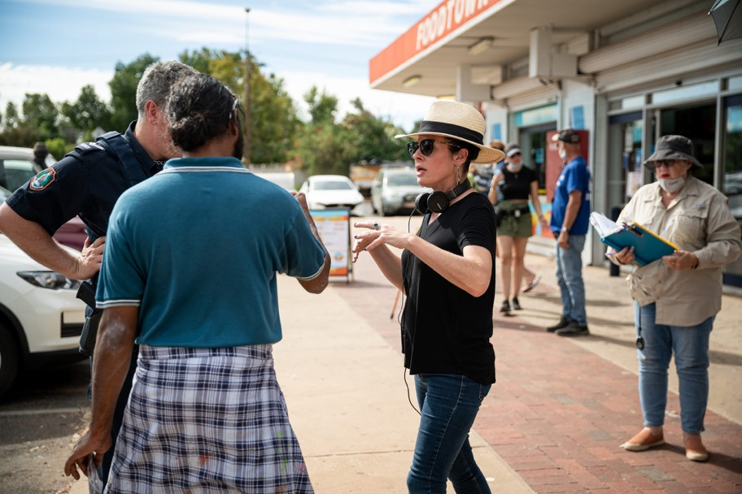
Warramunga/Luritija Director Beck Cole. Photo Jackson Finter

Strategic Priority 4: Build Market and Consumer Engagement
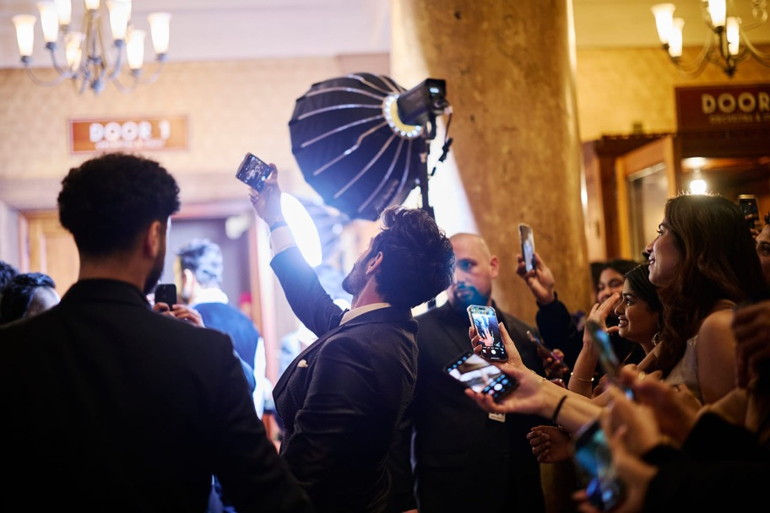
Indian Film Festival Melbourne
This strategic priority is focused on strengthening market and audience engagement by positioning Melbourne as a premier global screen destination renowned for its world-class events, festivals and experiences. VicScreen is committed to empowering communities across Victoria to access, celebrate and connect with diverse screen content.
By integrating screen experiences into the state’s broader creative, cultural and sporting landscape, VicScreen aims to foster inclusive participation and attract audiences to exceptional film festivals and screen events across both metropolitan and regional areas.

Screen event highlights
VicScreen-supported film festivals and screen events welcomed over 350,000 audience members across Victoria this financial year. Despite ongoing challenges posed by inflation, which have impacted event costs, as well as cost- of-living pressures, Victorians have continued to participate in the state’s vibrant screen culture scene. This sustained participation has resulted in strong outcomes across Melbourne and regional Victoria, underscoring the ongoing appeal of screen content.
Melbourne International Film Festival (MIFF)
This flagship festival attracted 167,000 people across its online and in-person programs, which featured an impressive 26 world premieres and 133 Australian premieres, reinforcing MIFF’s reputation as a leading event for bold and original films. The opening night film, Memoir of a Snail by Victorian Adam Elliot, garnered further international recognition with a nomination for Best Animated Feature at the 2025 Academy Awards®. Victorian director Shannon Owen’s documentary film Left Write Hook, supported through the MIFF Premiere Fund, resonated strongly with audiences and won the 2024 Audience Award.
“This year’s MIFF program featured over 250 films, with more than 400 sessions across 18 days, bringing together incredible Australian filmmaking, world cinema, drama, comedy, horror, animation and bold experimentation.”
- Al Cossar, Artistic Director, MIFF
Indian Film Festival of Melbourne (IFFM)
165,000 people participated across IFFM’s screenings and events, celebrating the best of contemporary cinema from the Indian subcontinent at venues across Melbourne and online. The festival welcomed Indian luminaries including Karan Johar, Ram Charan, Rani Mukerji and A.R. Rahman who attended the popular IFFM Awards and Independence Day flag hoisting ceremony.
The opening night film My Melbourne, supported by VicScreen, provided a unique platform for emerging Victorian talent to collaborate with acclaimed Indian directors, and develop their skills and understanding of the filmmaking process. The festival also established the inaugural IFFM Baari, a hub for diverse creative leaders to engage with emerging South Asian voices for an evening of thought- provoking discussions and vibrant cultural exchanges.
Melbourne Queer Film Festival (MQFF)
MQFF welcomed 13,000 attendees who engaged with a diverse program of over 150 LGBTQIA+ themed films. Thousands of community members and allies participated in MQFF’s public programs, panel discussions and screenings reflecting the festival’s strong cultural and social impact. MQFF activated key cinema venues, including ACMI, Bunjil Place in Narre Warren and the Victorian Pride Centre in St Kilda, reinforcing its commitment to accessibility and community engagement across the city.
“Our mission, as ever, is to change lives through the experience of shared stories—to bring the best of world queer culture to Victoria while nurturing the rise of new Australian voices. This festival is the glorious culmination of the work of thousands of filmmakers and artists, both local and international, carefully crafted to offer the LGBTQIA+ community spaces of joy, connection and contemplation.”
- David Martin Harris, CEO, Melbourne Queer Film Festival
Melbourne Cinémathèque
Renowned for its discerning selection, The Melbourne Cinémathèque’s weekly screenings are one of Melbourne’s most sought-after screen experiences. Throughout the year, 16,000 enthusiastic subscribers lined up at ACMI to view rare films and new or restored prints. Many of the 100 films presented are not readily available to view on the big screen, underscoring the program’s cultural significance and enduring appeal.
Melbourne Women in Film Festival
In 2025, over 1,500 attendees engaged with a compelling program of bold, socially resonant films created by women and gender diverse screen practitioners, all explored through the lens of the festival’s theme, 'Outré'.
Peninsula Film Festival
In January 2025, over 2,800 people came together at Rosebud’s Village Green on the Mornington Peninsula to celebrate a vibrant showcase of standout short films. The event featured a distinguished judging panel of leading screen industry figures, including Michala Banas, Doris Younane and Lachy Hulme, and awarded cash prizes of up to $5,000 to winning filmmakers.
St Kilda Film Festival
The 2025 St Kilda Film Festival welcomed a record-breaking 9,307 attendees, marking a 58% increase from the previous year and reflecting the growing enthusiasm for Victoria’s vibrant screen culture. Audiences enjoyed 191 films across 58 screenings, including 156 Top Shorts, 10 youth entries and 25 curated selections from special programs.
The festival saw unprecedented participation in its competitions, with a record 874 short films submitted to the Top Shorts Competition and 134 entries to the Under the Radar Youth Short Filmmaker Competition—a combined total of over 1,000 submissions.
The professional development opportunities that the festival offered was another highlight, with the Big Picture Filmmaker Development Day offering 44 events, workshops and panels, and attracting 1,700 registrations—a 41% increase on the previous year.
The Other Film Festival
The Other Film Festival, Australia’s first international disability film festival, celebrated its 20th anniversary in October 2024 and presented a program as part of Alter State with all films streamed across Australia on ACMI Cinema 3. The theme of ‘Agency’ highlighted the self-determination of Deaf and Disabled people and films were presented that proudly explore the agency of Deaf and Disabled people.

Birrarangga Film Festival
Typecast Entertainment
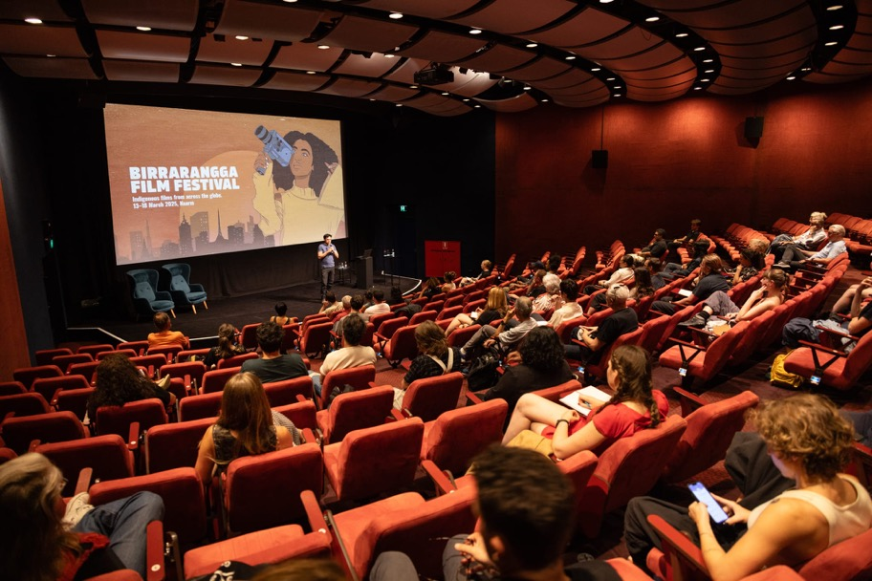
Birrarangga Film Festival.
2025 marked the fourth iteration of Birrarangga Film Festival, which has been held biennially since its inception in 2019.
Established and curated by Wurundjeri (Woiwurrung)/Yorta Yorta screen creative and actor Tony Briggs and proudly supported by VicScreen, Birrarangga Film Festival is Victoria’s only Indigenous-led film festival and continues to grow in reach and impact. Birrarangga Film Festival attracts new and diverse audiences through a compelling program of Indigenous-led films from across the globe. This year’s festival featured works from Australia, New Zealand, Samoa, Canada, Finland, Norway, Russia, Mexico, Hawaii, Sierra Leone, Kenya, Fiji, Peru and Taiwan, highlighting the richness and diversity of First Nations storytelling worldwide.
The program ran over six days, showing 169 films in 11 venues across Melbourne and included three Victorian-made films Our Warrior: The Story of Robbie Thorpe, Windcatcher and Baban Darrang (Mother Tree).
Windcatcher, a feel-good family feature, starring Jessica Mauboy, Kelton Pell and Lennox Monaghan—supported through VicScreen’s Victorian Production Fund—was widely praised for its portrayal of Australian life through a First Peoples lens.
Acclaimed screenwriter, director, cinematographer, editor, composer and sound designer Ivan Sen presented a three- hour masterclass on filmmaking in collaboration with Birrarangga Film Festival and VicScreen. Ivan is considered one of Australia’s most influential First Nations filmmakers with a career spanning internationally recognised productions such as Beneath Clouds, Toomelah, Mystery Road, Goldstone, Loveland and Limbo. The masterclass provided a unique opportunity for emerging and established filmmakers to gain invaluable insights from one of Australia’s most renowned Indigenous storytellers.
In a ground-breaking first for the festival, a new collection of 360-degree films by leading Sami filmmakers was presented on the state-of-the-art NantStudios’ LED volume screens at Docklands Studios Melbourne, enabling an innovative immersive viewing experience of Sami First Nations storytelling.
“It was a delight to attend this event as a part of Birrarangga Film Festival, not only because we were privy to the masterclass, but because events like this are an opportunity for mob in the industry to gather, catch each other up on what we’re working on, find potential collaborators and just give each other a hug. We also had the pleasure of meeting Māori and Sami filmmakers who had travelled across the seas to screen their work at the festival.”
- Merryn Trescott, Wiradjuri producer
Funding
The festival was supported through VicScreen’s Screen Culture program.
Outcome
A total audience of 3,500 people attended BFF in 2025, viewing a selection of 169 films (38 features, 120 shorts and 11 immersive 360-degree short films), including 43 Australian premieres and nine world premieres.
Impact
- 3,800 Festival cinema tickets
- 11 Sold out sessions
- 16 International guests
- 50 Languages represented in the program

4 Years in Review
Victoria’s creative excellence was recognised with three Oscar® nominations for VicScreen-supported films in 2025, including Best Animated Feature for Memoir of a Snail, and major accolades for worldwide hit games Stray Gods: The Roleplaying Musical and Cult of the Lamb. Audience engagement with screen culture flourished through VicScreen support for 40 local organisations to present screen activities and partnerships with MIFF and IFFM. The new MIFF Bright Horizons Award spotlights the next wave of filmmaking talent and reinforces Victoria’s reputation as a global screen powerhouse.
1.4m+ Victorians attended a VicScreen-supported screen activity. Victorians in more than 40 metropolitan, regional and rural places, from St Kilda, Briagolong, Cobram and Benalla, to Dandenong, Bass Shire, Echuca and Euroa, experienced…
- 3,500+ screen stories
- 89 world premieres at MIFF and IFFM
- Films in 75 languages
- 295+ panels and Q&A sessions
- 49 Extended Reality (XR) works
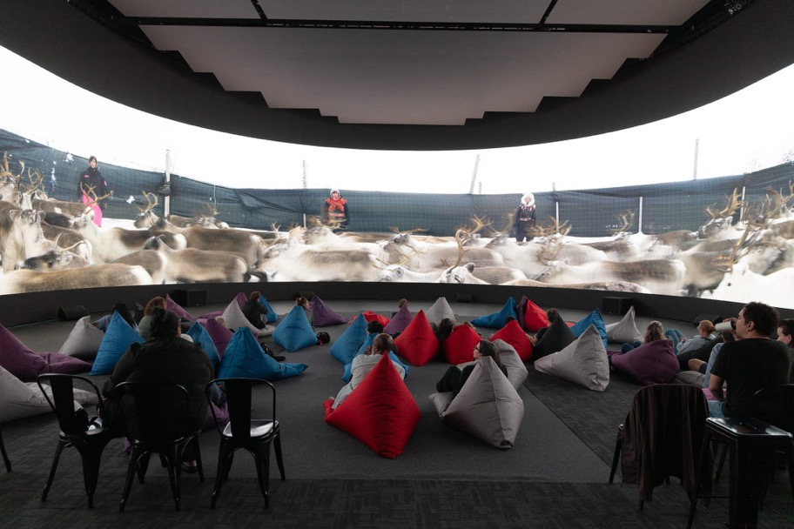
For Birrarangga Film Festival, NantStudios opened their doors for a ground-breaking new experience as a presenting partner of ÁRRAN360º, premiering 11 immersive Sami First Nations shorts on a 360-degree screen.
Melbourne International Film Festival

Melbourne International Games Week

Australian Academy of Cinema and Television Arts (AACTA) Awards

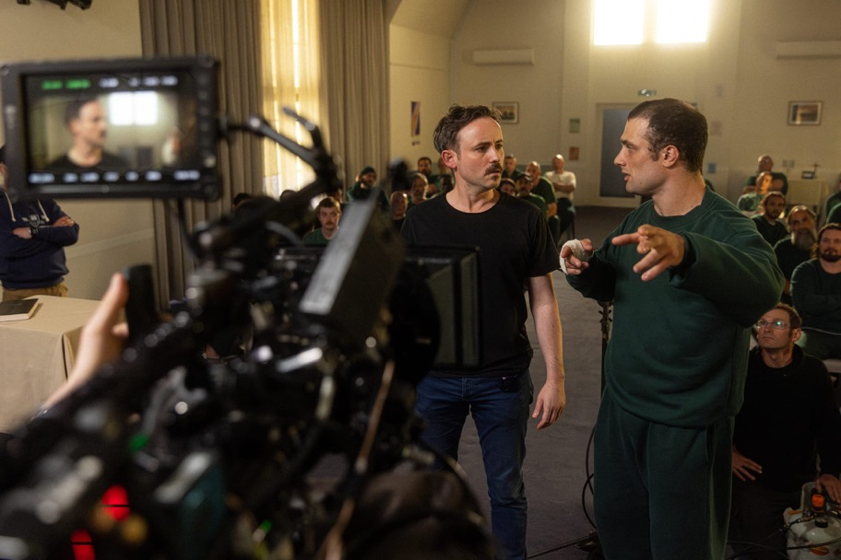
2024 Bright Horizons nominee Inside.
Heralding New Filmmaking Talent
Established in 2022, MIFF’s Bright Horizons competition presented by VicScreen and awarded by an esteemed international jury has raised the profile of MIFF on a global stage. The Bright Horizons films have quickly become one of the most popular program streams of the festival, and a VicScreen-supported feature has been among the 10 finalists each year.

Untitled Goose Game.
The Sounds of Digital Games
Encouraging the integration of screen experiences into new places, VicScreen partnered with Orchestra Victoria in 2023 to deliver Indie Symphony, a sell-out live concert celebrating monumental scores from bestselling video games, including Victorian- made title Stray Gods: The Roleplaying Musical. It was such a success that it returned to Melbourne in 2025 with two shows, this time featuring global Victorian hits Cult of the Lamb—with a special tribute to composer Narayana Johnson—and Untitled Goose Game.

Strategic Priority 5: Deliver Maximum Industry Impact
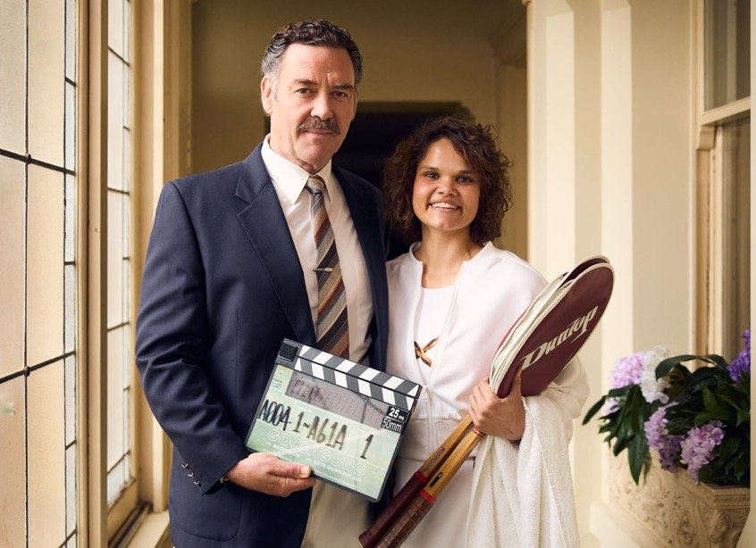
Goolagong
VicScreen is committed to delivering meaningful industry outcomes through the implementation of VICSCREEN: Victoria’s Screen Industry Strategy 2021–2025, on behalf of the Victorian Government. This strategic priority—one of five outlined in VicScreen’s Corporate Plan— underpins the successful execution of the strategy, ensuring that initiatives are aligned with long-term goals to strengthen and grow Victoria’s screen industry.

First Peoples strategy
VicScreen’s First Peoples Strategic Lead is in the early stages of developing the agency’s First Peoples strategy. Its goal is to advance content creation by First Peoples within Victoria and support their career development.
To ensure authenticity in the consultation process, the First Peoples Working Group was established, comprising screen leaders with knowledge and experience in screen business, workforce development and strategic planning.
In November 2024, the working group invited practitioners to a First Peoples screen sector development roundtable to collectively identify opportunities and address barriers to success.
Through targeted engagement, VicScreen aims to articulate principles for embedding First Peoples cultural leadership within its policies and frameworks, ensuring sustainable screen careers through ethical and culturally safe empowerment and partnerships.
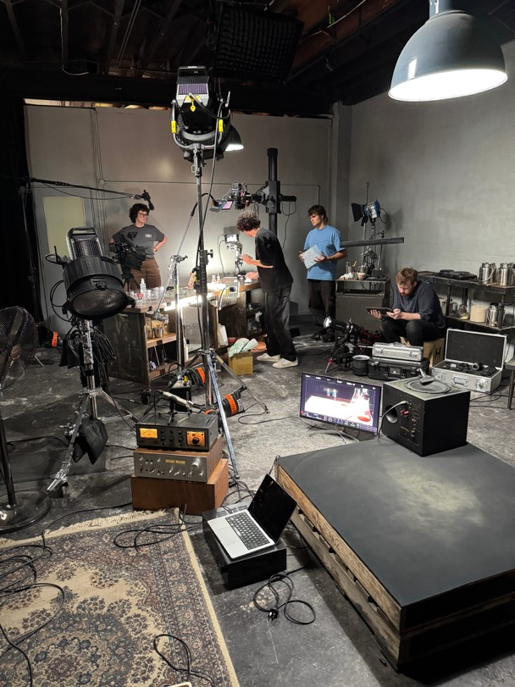
Phenomena

Evaluations and economic impact reporting
Seven program evaluations were completed in 2024–25 that assessed the efficiency and effectiveness of VicScreen initiatives. These included the Victorian Production Fund, skills programs and content development programs.
VicScreen commissioned an economic impact report, which calculated the value of the Victorian screen industry value chain. The report noted that the chain has a substantial economic footprint, valued at $3.2 billion, generating approximately 23,000 FTE jobs in a single year.

Digital transformation
VicScreen’s Digital Transformation Program aims to deliver a trusted, integrated and data-driven digital ecosystem that empowers our people, amplifies the voice of our clients and drives meaningful engagement with industry stakeholders.
The initial discovery and planning phase set the foundation for technology investment and delivery and was completed in August 2024.
Phase two is currently underway, focused on the implementation of four key technology solutions: digital asset management and locations galleries; client relationship and grants management; information and records management; and a new content management system, while integrating new ways of working across teams and systems.

Championing sustainability
Since the launch of Sustainable Screens Australia in 2023, VicScreen has been strategising ways to reduce the environmental impact of local screen production in Victoria.
Initiatives have included: delivering carbon calculator training and environmental editorial workshops; hosting industry seminars on sustainable production; building sustainability requirements into assessment criteria and reporting for supported productions; and consulting with industry both locally and globally to bring best practice to Victoria.

Bargaining for a robust enterprise agreement
The arts nexus agencies—ACMI, Museums Victoria, National Gallery of Victoria, State Library of Victoria and VicScreen— bargained for a single interest employer agreement. The nexus arrangement results in agencies adopting the Victorian Public Service Agreement wage outcomes, salary classifications and operative dates.
Bargaining commenced on 7 October 2024 and was conducted in accordance with the Victorian Government's Wages Policy and Enterprise Bargaining Framework.
The outcome is a four-year, single interest employer agreement—the Cultural and Creative Agencies Enterprise Agreement 2025.

Diversity, Equity and Inclusion
In March 2024, VicScreen released its inaugural Diversity, Equity and Inclusion (DEI) Roadmap, a 10-year strategy towards a thriving, equitable and inclusive screen industry in Victoria. The DEI Roadmap commits to building an industry that is diverse in both people and content, and focuses on three priorities—people, audience and leadership.
The implementation group meets every six weeks to discuss progress on the plan. The group met on eight occasions throughout the 2024–25 period, reporting to the executive team with minutes shared with staff.

Key Outcomes from The DEI Action Plan – Year 1
VicScreen’s progress against our Year 1 Action Plan is summarised below against our three priorities:
People
Removing barriers so all screen creators and workers can thrive.
- Supported a First Peoples placement with Kindling Pictures through the Emerging Writers Incubator.
- Delivered the fourth iteration of the Screen Internship in partnership with the ABC, GoodThing Productions and Blackfella Films. This provided 12-month internships for two screen practitioners from underrepresented communities, one First Peoples practitioner and one from the African/ Pilipino community.
- Delivered events, networking and master classes for Victorian screen creators and workers from underrepresented communities. This included providing access for 10 Victorian First Peoples practitioners to attend the Indigenous Creators Program at the Australian International Documentary Conference (AIDC).
- Collaborated with Birrarangga Film Festival to present a masterclass for 80 people with acclaimed screenwriter, director, cinematographer, editor, composer and sound designer, Ivan Sen. VicScreen hosted approximately 40 First Peoples practitioners to attend free of charge.
Audience
Increasing audience access to and engagement with content that is diverse and inclusive.
MIFF, the Melbourne Queer Film Festival and IFFM had their contracts renewed this financial year, with new terms added to track their commitment to diversity, equity and inclusion.
MIFF had 16 sessions with audio description, 15 sessions with open captions, 89 fully subtitled films, 100% step-free and wheelchair accessible venues, seven sensory-friendly sessions, two cry baby sessions, films in 55 languages, seven First Peoples-led projects and 106 titles with one or more female or non-binary directors.
IFFM presented films in 27 languages, had two free public screenings, regional screenings in four locations, hosted sensory friendly screenings, had Auslan interpreters at their Awards Night and Opening Night (which also included open captions) and all IFFM screenings had English subtitles to welcome new audiences and encourage broader participation.
The Screen Culture program also supported 10 activities that amplified underrepresented voices:
- Four focused on directly amplifying the voices of underrepresented communities in 100% of their program (First Peoples, deaf and disabled or hard of hearing, women and gender diverse, LGBTIQ+)
- Two presented regionally
- One focused on emerging filmmakers.
Leadership
Demonstrating inclusive leadership in VicScreen decision-making and behaviours.
A DEI Governance and Reporting Framework for the implementation and ongoing management of the DEI Roadmap was established and includes:
- The formation of an implementation group, which meets every six weeks to monitor progress against the agreed annual action plan
- The addition of DEI to the VicScreen executive team's meeting agenda as a standing agenda item
- The provision of updates to the VicScreen Board through regular management reporting
- The inclusion of updates through VicScreen’s Annual Report.
VicScreen implemented Gender Impact Assessments from 2024–25 as required under the Gender Equality Act 2020 and continues to do so as required.
VicScreen continues to actively engage in The Everyone Project, an industry-endorsed organisation that provides a simple but comprehensive way of measuring and reporting on diversity. VicScreen continues to review Victorian projects to ascertain participation rates in the Everyone Counts report.
Staff-wide initiatives have been implemented through People, Culture and Capability including:
- VicScreen staff attended the First Peoples Cultural Competency Program at Melbourne Museum
- SBS Inclusion Core Training Units were introduced. Modules included cultural diversity, generational diversity, appropriate workplace behaviour, gender equality, LGBTIQ+, disability, First Nations, core inclusion and gender equity
- DEI competencies were incorporated into VicScreen position descriptions and performance and development review templates
- Employee induction materials were updated to include the DEI Roadmap.
Development and production funding documentation was updated for the new financial year, clarifying and making consistent the requirement for applicants to demonstrate how robustly their project advances diversity across core areas.
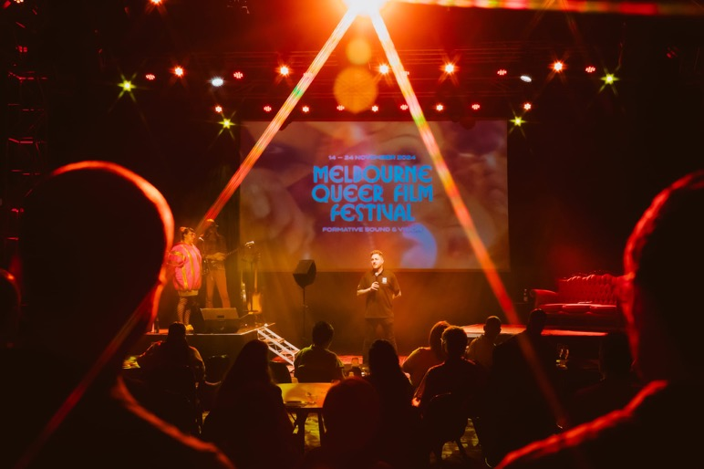
Melbourne Queer Film Festival

Summary Of DEI Aligned 2024–25 Projects
A list of project outcomes that support our DEI efforts across departments are outlined below:
- VicScreen funded the launch of the Disability Justice Lens, a bold new eLearning course created in Victoria by disability-led production company A2K Media.
- 50% of supported Victorian Production Fund – Games projects and 80% of supported Originate Games Projects rated very high in their DEI assessment criteria.
- VicScreen provided development funding to Ned Lander Media Pty Ltd for the fifth season of animated First Peoples series Little J & Big Cuz. It was nominated for Best Children’s Program at the 2025 Logies.
- VicScreen supported The Other Film Festival in 2024 to mount a hybrid screen festival that celebrates the stories of Deaf and Disabled experiences.
- VicScreen supported the Melbourne Queer Film Festival to showcase 150 films, including features, documentaries and shorts.
- VicScreen supported the debut feature films of three new creative voices from diverse backgrounds through its Originate Features program and Victorian Production Fund, with the first to premiere at MIFF in 2025.
- VicScreen supported children’s animated series Happy House, which is created, produced and directed by an all-female team from diverse backgrounds, unprecedented for the Victorian animation industry.

Governance & Report of Operations
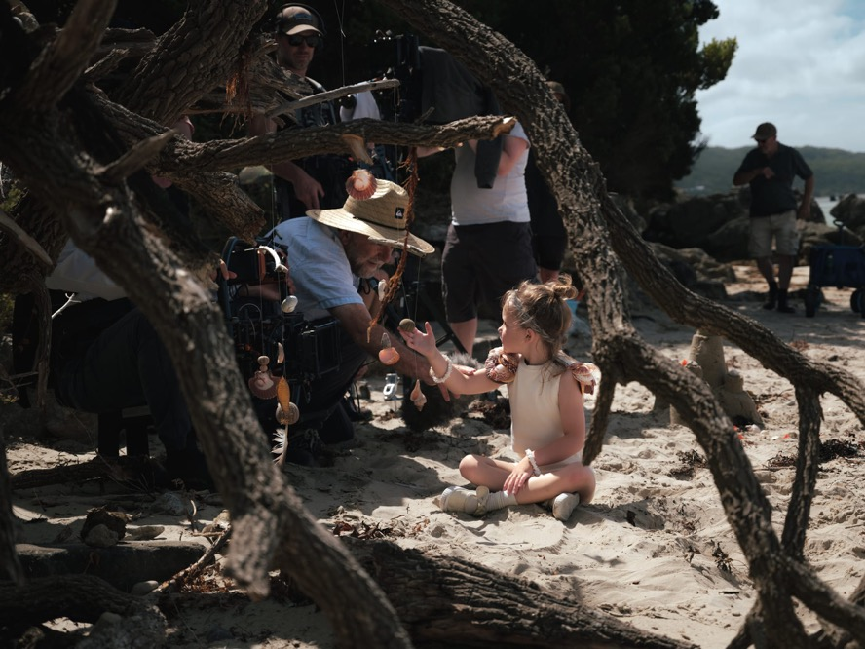
Director Robert Connolly on the set of Magic Beach.

Dead Static Drive.

Governance and Organisational Structure
In 2024–25, VicScreen reported to the Minister for Creative Industries, The Hon. Colin Brooks MP.

As of 30 June 2025
- Minister for Creative Industries
The Hon. Colin Brooks MP
  - VicScreen Board
Audit & Risk Committee
Finance Committee
People and Executive Remuneration Committee
Victorian Screen Economic Development Committee
    - VicScreen Chief Executive Officer
Caroline Pitcher
      - Office of the CEO
      - Content and Talent
Ross Hutchens
        - Talent Development
Games & Interactive
Project Development
Production Investment
      - Economic and Industry Development
Michael Hudson
        - Strategy & Industry Development
Skills & Business Development
Incentives & Production Support
      - Governance and Operations
Liahn Nortjé
        - Finance, Risk & Procurement
Information Technology
Grant Governance & Administration
Legal
Strategy & Performance
      - Marketing and Engagement
Kirsten Badcock
        - Marketing & Communications
Stakeholder Engagement
Audience Engagement
Industry Engagement
Screen Culture
      - People, Culture and Capability
Alison Bennett
        - HR Operations
Organisational Effectiveness & Engagement
Learning & Development
Safety & Wellbeing
  - Department of Jobs, Skills, Industry and Regions (DJSIR) Secretary
Tim Ada (to 28 February 2025)
Matt Carrick (from 3 March 2025)
    - Creative Victoria Chief Executive Officer
Claire Febey

Vicscreen Board
As per the Film Act 2001, Board members are appointed by the Governor in Council on the recommendation of the Minister. The majority of members should be persons who, in the opinion of the Minister, are experienced in the film, television or multimedia industry, and the remaining members are to be chosen based on their experience in business administration or another field appropriate to the functions of VicScreen.

George Lekakis AO, President, Since October 2022
George has worked in the not-for-profit community services sector and government.
An experienced industry leader, he has spent much of his 40-year social work career in leadership roles.
George was the longest serving chairperson of the Victorian Multicultural Commission having held the role from September 2001 to January 2011. He also served as the Chief Executive Officer of the New Hope Foundation and Fronditha Care and was an Executive Director of the Victorian Department of Business and Innovation.
Most recently George chaired the Board of the Victorian Interpreting and Translating Service, and Multicultural Arts Victoria. Currently he is also a Board Director of the Chisholm Institute and the Victorian Fisheries Authority.
George has also been a member of many other government and non- government boards and committees in executive roles.

Mitu Bhowmick Lange AM, Since July 2018
Mitu is a Festival Director, distributor, producer and cultural connector whose work has transformed the presence of Indian cinema in the Pacific region.
As founder of Mind- Blowing Films and the Indian Film Festival of Melbourne, she has championed stories that bridge cultures and celebrate diverse voices. Under her leadership, Indian films entered the Australian mainstream, with record-breaking box office success and historic festival milestones.
Mitu serves on the board of the Centre for Australia- India Relations and was appointed to the Premier’s Business Council in 2023. She continues to be a powerful advocate for inclusive storytelling in the global screen industry.

Andrea Denholm, Since July 2018
Andrea is a highly skilled creative with expertise in creating, developing and producing distinctive, premium scripted content. She is also an experienced executive who has held senior roles in major production companies. She is currently Executive Producer and Head of Development for Tony Ayres Productions.
Her credits as producer, executive producer, story producer and writer span over 100 hours of content including top- rated Netflix drama The Survivors; award winning ABC drama series Fires; BBC/ABC children's live action series, Spooky Files; International Emmy® nominated Wrong Kind of Black; screen opera The Divorce; returning seasons of popular comedies How to Stay Married and It’s A Date; Indigenous comedy 8MMM Aboriginal Radio; and landmark documentary series Sporting Nation with John Clarke.
Andrea's other credits include Tripping Over, SeaChange (1998- 2000), After the Deluge, CrashBurn, Worst Best Friends and Outland.
Andrea is Deputy Chair of the Australian Children’s Television Foundation.

Nick Forward, Since February 2024
Nick is currently the General Manager of Digital at the AFL where he oversees content, product, customer experience and marketing. Prior to the AFL, Nick spent time in the Middle East as Managing Director and Group Chief Content Officer for leading local streamer OSN+. Nick was also Stan's first Chief Content Officer, where he played a pivotal leadership role in bringing both the concept of the Stan streaming platform to life and growing it into the product it has become.
During his time at Stan, Nick commissioned and produced several acclaimed series and movies including the Palme D'Or nominated NITRAM in 2021, as well as Logie and AACTA winning series including No Activity, Bloom, Bump, Wolf Creek and Romper Stomper.
Prior to Stan, Nick spent time at Sky UK, Virgin Media and Lonely Planet where he gained significant experience across media, product, marketing, general management roles.

Liz Grainger, Since September 2019
A chartered accountant and a graduate member of the Australian Institute of Company Directors, Liz provides consultancy services to a wide range of public and not-for-profit organisations in the areas of strategy, governance, public sector funding and financial management.
She has held senior executive roles at Deloitte in London and in the Federal and Victorian public sectors. Liz is a former Board member of Craft Victoria and Arena Theatre Company and is currently a director of the Melbourne Recital Centre, The Mission to Seafarers Victoria Inc. and Geografia.
Liz has also served as an external member on the Audit and Risk Committees of Victoria Police, Southern Metropolitan Cemeteries Trust and VicScreen (prior to joining the Board), and currently serves in this capacity on the Audit and Risk Committee of Energy Safe Victoria.

Lisy Kane, Since October 2023
An experienced videogame producer and creative leader, Lisy is Production Director at CULT Games and assessor for the WINGS Fund as well as board member of the IGDA Foundation.
In 2014, Lisy joined independent games studio League of Geeks and co-founded Girl Geek Academy, a social startup focusing on advocating and driving gender equality within the STEM sector. From her work on Girl Geek Academy, Lisy and her co-founders were awarded QUT’s Young Innovation & Entrepreneurship Alumni Award (2018).
In 2017, Lisy was recognised by Forbes in its prestigious top 30 list: Forbes 30 Under 30 2017: Games.

Greg McLean, Since September 2018
Greg is an acclaimed Australian writer, director and producer known for bold, visceral storytelling across film and television. He broke out with the horror classic Wolf Creek, followed by Rogue, Wolf Creek 2, The Belko Experiment and Jungle starring Daniel Radcliffe. He created two seasons of the Wolf Creek spin-off series and directed every episode of Territory (2024), Netflix’s hit neo- Western drama, which topped charts in 70+ countries.
His TV directing credits include Jack Irish, The Gloaming, BLOOM, La Brea, The Twelve and Scrublands. Working across multiple genres, Greg is known for nerve- shredding psychological tension, cinematic visuals and scale, powerful emotion and rich character work.
He recently co-founded Huge Film with filmmaker Patrick Hughes and screenwriter James Beaufort – an Australian-based production company dedicated to high-concept thriller, horror and action stories. Huge Film’s debut feature is War Machine, a Netflix action/sci-fi film written by Patrick Hughes and James Beaufort, directed by Hughes, with Greg serving as producer.

Leonie Morgan AM FAICD, Since September 2016
Leonie works across the private, government and not-for-profit sectors in Australia and the Asia Pacific. With a background in corporate governance, strategic leadership and human resource management, her focus is building strong and resilient organisational culture, as well as establishing and maintaining effective internal and external stakeholder relationships.
An experienced Board director, Leonie is a Fellow of the Australian Institute of Company Directors. She is recognised on the Victorian Women’s Honour Roll and nationally through her Membership of the Order of Australia for significant services to women, in particular equitable political representation.
Leonie holds a Master of Education, is President of Circus Nexus and a former director of Holmesglen TAFE Institute and SYN Media.

Tiriki Onus, Since October 2022
Tiriki is a Yorta Yorta and Dja Dja Wurrung artist, academic and filmmaker who currently holds the roles of Pro Vice- Chancellor (Indigenous), Head of the Wilin Centre for Indigenous Arts and Cultural Development and Co-Director of the Research Unit in Indigenous Arts and Culture at the University of Melbourne.
He is a successful visual artist, curator, performance artist and opera singer. In 2014 Tiriki was awarded the inaugural Hutchinson Indigenous Fellowship at the University of Melbourne, working with numerous Indigenous communities to revitalise traditional technologies of Biganga (possum skin cloak) creation.
Recently, Tiriki co-directed the feature documentary Ablaze, which premiered at the 2021 Melbourne International Film Festival to great acclaim. The documentary uncovers a film made 70 years ago by Tiriki’s grandfather, William ‘Bill’ Onus, an important leader in the Aboriginal rights movement.
Tiriki’s PhD Biganga - Mapping Paths Back to Knowing was submitted for examination in early 2025. His work continues to foster innovation in research, development, advocacy, representation and inclusion of Indigenous arts, cultural practices and practitioners.

Jenny Taing (Sheehy) OAM, Since June 2023
Jenny is a lawyer and experienced chair and non-executive director.
Jenny is Chair of the Western Bulldogs Football Club Community Foundation and a board member of AFL Victoria. She has also served on the boards of Screen Australia, Channel 31, the Australian Health Practitioner Regulation Agency, The Royal Victorian Eye & Ear Hospital, was Vice President of the University of Melbourne Alumni Council and Commissioner of the Victorian Multicultural Commission.
Jenny has a Bachelor of Arts/Bachelor of Laws (Honours) from the University of Melbourne, attended Harvard Business School as the Hugh DT Williamson Scholar, appeared in the AFR 100 Women of Influence List and received the Medal of the Order of Australia (OAM) for service to the financial and investment sectors, and to the community.

Committees and Assessment Panels
Board committees
The VicScreen Board has committees that review and assist organisational performance and assess funding applications. Committees are comprised of Board members and external members (where noted).
People and Executive Remuneration Committee
The People and Executive Remuneration Committee assist the VicScreen Board in fulfilling its responsibilities in relation to remuneration and performance of the organisation’s Chief Executive Officer and the remuneration of its Executive Officers. The People and Executive Remuneration Committee also provides oversight of VicScreen’s Board-approved people strategies, focusing on their ongoing alignment with the organisation's strategy and the effectiveness of their implementation.
The committee’s members are George Lekakis AO (Chair), Nick Forward and Leonie Morgan AM.
The committee met on three occasions in 2024–25.
Victorian Screen Economic Development Committee
The Victorian Screen Economic Development Committee considers applications to the Victorian Screen Incentive (VSI), Victorian Digital Screen Rebate (VDSR), Victorian Screen Rebate (VSR) and Regional Location Assistance Fund (RLAF) programs.
The committee’s members are George Lekakis AO (Chair), Nick Forward, Leonie Morgan AM, Debra Allanson (external member) and Sarah Coughlan (external member, Creative Victoria).
The committee met on 11 occasions in 2024–25 and assessed a total of 36 applications, of which 36 were supported.
Audit and Risk Committee
The Audit and Risk Committee assists VicScreen to achieve its strategic objectives in an efficient and effective manner. The committee achieves this through independently reviewing and assessing the effectiveness of VicScreen’s systems and controls for financial management, performance, sustainability, risk management and any other matters referred to it by the Board. The committee oversees and reviews the internal and external audit functions, including considering recommendations made by these functions, and monitors the implementation of remedial actions.
The committee’s members are Liz Grainger (Chair), Jenny Taing OAM, Andrea Denholm and Kushal Shah (external member, from December 2024). All members are independent members.
The committee met on five occasions in 2024–25.
Finance Committee
The Finance Committee assists VicScreen to achieve its strategic objectives by monitoring, advising and reporting to the Board on matters relating to VicScreen’s financial performance. The committee does not have any delegated authority.
The committee’s members are George Lekakis AO (Chair) and Jenny Taing OAM.
The committee met on four occasions in 2024–25.
External Assessor Pool
VicScreen engages screen industry experts for a three- year period to assess certain funding applications for project development and production and make funding recommendations for final approval by financial delegates (heads of division, CEO or Board).
Board member Greg McLean participated as an assessor in Victorian Production Fund – Film, TV & Online assessment meetings.
External assessors who participated in assessment meetings for project development and production programs in 2024–25 were:
- Alice Burgin
- Anna Jeffries
- AP Pobjoy
- Beth Frey
- Brendan Keogh
- Brian Udovich
- Britt Arthur
- Cherie Davidson
- Clea Frost
- Corrie Chen
- David Hannam
- Emma Fitzsimons
- Erin Bretherton
- George Adams
- Hollie Black
- Isaac Elliott
- Jacob Hickey
- Jason Imms
- Jeff Daniels
- Jini Maxwell
- Joe Park
- Kelly Lefever
- Kim Ho
- Laura Crawford
- Lexa Francis
- Liam Esler
- Liz Kearney
- Magda Wozniak
- Michele Turnure-Salleo
- Paul Walton
- Pip Campey
- Rae Johnston
- Rhian Skirving
- Rhiannon Poley
- Sarah Shaw
- Seph Mckenna
- Tim Williams
- Virginia Whitwell
- Wendall Thomas
Staff members who participated in the assessment and/ or approval of applications across all funding programs in 2024–25 were:
- Chief Executive Officer Caroline Pitcher
- Director Content and Talent Ross Hutchens
- Director Economic and Industry Development Michael Hudson
- Director Marketing and Engagement Kirsten Badcock
- First Peoples Strategic Lead Sarah Bond
- Head of Content Investment Samantha Dinning
- Head of Games and Interactive Paul Callaghan
- Head of Incentives and Production Support Joe Brinkmann
- Production Executive Katy Roberts
- Production Executive Davey Thompson
- Production Executive Ariel Waymouth
- Production Executive Lise Leitner
- Manager Development Mackenzie Lush
Manager Industry and Skills Development Jana Blair (until 27 September 2024)
- Manager Industry and Skills Development Chris Barker (from 30 September 2024)
- Manager Partnerships and Engagement Matthew Phoenix
- Manager Screen Culture Jacqueline Hanlin
- Development Coordinator Kate Darrigan
- Industry and Skills Development Coordinator Chris Barker (until 27 September 2024)
- Industry and Skills Development Coordinator Kara Masters
- Industry and Skills Development Coordinator Marea Markou (from 26 November 2024)
- Events and Engagement Coordinator Rachel Duffy (from 19 August 2024)
Board attendance
Name | Eligible to attend | Attended
George Lekakis AO (Chair) | 8 | 8
Mitu Bhowmick Lange (AM) | 8 | 4
Andrea Denholm | 8 | 6
Nick Forward | 8 | 8
Liz Grainger | 8 | 8
Lisy Kane | 8 | 8
Greg McLean | 8 | 7
Leonie Morgan AM | 8 | 6
Tiriki Onus | 8 | 7
Jenny Taing OAM | 8 | 7
Note: This excludes urgent out-of-session meetings of the VicScreen Board during 2024–25.
Applications assessed and approved
Program | Received | Supported
Audience Engagement – Programs | 18 | 10
Industry Development – Programs | 9 | 9
Industry Development – Partnerships | 3 | 3
International Travel | 81^ | 53*
Key Talent Company Placements | 10^ | 8*
Key Talent Placements Register (New applicants) | 103 | 82
Key Talent Production Placements | 24# | 19
On Demand Documentary | 44 | 18
On Demand Fiction | 58^ | 14
Originate Games | 33 | 5
Originate Genre | 161 | 8
Originate Slate | 2 | 2
Professional Attachments Register (New applicants) | 343^ | 265*
Professional Attachments | 52 | 52
Screen Internships Program | 70 | 2
Specialist Placements | 14 | 11
Victorian Production Fund – Film, TV & Online | 67^ | 32*
Victorian Production Fund – Games | 56^ | 19*
Applications assessed and approved by Initiative
Initiative | Received | Supported
AIDC 2025 Leading Lights passes | 13 | 13
AIDC 2025 First Peoples Creators Passes | 10 | 10
First Peoples Business Capability Grant | 8 | 4
Footy Shorts | 6 | 5
Play Now 2024 | 72 | 59
^Some applications are yet to be assessed.
*Yet to be approved.
#Some applications received in prior year are not included here.

Overview of Financial Performance for the year ended 30 June 2025
Five-Year Financial Summary
 | Note | 30-Jun-25  $’000 | 30-Jun-24  $’000 | 30-Jun-23  $’000 | 30-Jun-22  $’000 | 30-Jun-21  $’000
Comprehensive result – surplus / (deficit) | 1 | 11,611 | (1,970) | 20,247 | 9,653 | 22,974
Comprising:
Income from the Victorian Government | 1 | 61,131 | 51,741 | 67,215 | 46,228 | 46,335
Other income | 2 | 3,955 | 4,260 | 4,110 | 718 | 605
Less:
Program costs | 3 | (40,318) | (46,595) | (40,120) | (28,526) | (16,532)
Operating expenses | 4 | (13,155) | (11,369) | (10,965) | (8,750) | (7,475)
Other economic flows |  | (1) | (7) | 6 | (17) | 41
Commitments | 5 | 95,166 | 102,230 | 113,199 | 108,535 | 55,741
Total assets |  | 90,898 | 78,501 | 80,774 | 58,117 | 48,981
Total liabilities |  | (4,566) | (3,779) | (4,083) | (1,673) | (2,190)
Net worth | 6 | 86,333 | 74,721 | 76,691 | 56,444 | 46,791
Net cash inflow / (outflow) | 7 | 13,118 | (23) | 17,903 | 9,270 | 22,915
Comprehensive result
The nature and scale of VicScreen’s Comprehensive result will vary year on year, reflecting timing differences between when income from the Victorian Government is recognised in the Financial Statements, and when the related expenditure on programs is accounted for. The former is generally recognised when received, as required under Australian Accounting Standards, whereas program costs are only brought to account once contracted milestones are reached, or other grant conditions are met. This can be more than two years after the relevant income is received.
Government funding in 2024–25 is higher than the previous year largely due to additional funding received in support of the Victorian Screen Rebate program, the GameChanger Academy, a new games co-working space and the NBCUniversal Partnership (a multi-year government partnership announced in the 2022–23 State Budget). In partial offset of this increase, 2023–24 included additional funding in support of the Victorian Digital Screen Rebate Pilot program.
2. Other income
Other income includes interest earned on cash deposits held with the State Centralised Banking System and program income received from sources other than the Victorian Government. Other income is relatively consistent with the prior year.
3. Program costs
Program costs are payments made under VicScreen’s grant agreements and are only recognised as an expense in the comprehensive operating statement once contracted milestones are reached, or other grant conditions are met. For larger productions this can be more than two years after funds have been committed.
4. Operating expenses
Staff costs make up the majority of VicScreen’s operating expenses. Staff costs include a provision for 3% salary increments and a one-off $5,600 payments to eligible employees related to the Cultural and Creative Agencies Enterprise Agreement 2025. Staff costs for the year end 30 June 2025 also include progression payments under the Film Victoria Enterprise Agreement 2020 and some non- recurring project related resourcing
The current year also included some non-recurring expenses with respect to lapsing program evaluations that are required under the Department of Treasury and Finance's Resource Management Framework when seeking renewal of lapsed funding.
5. Commitments
Commitments largely relate to contracted program costs which are not yet due at the year-end and are, therefore, not recognised in the Balance sheet as liabilities. Project commitments are only recognised as a liability once all obligations under the funding agreements are met and as described above, this can be some time after the initial commitment is made.
All commitments are either fully funded by existing cash holdings, or by confirmed future government income. Further details of commitments are provided in Note 6.2 of the Financial Statements.
6. Net worth
Total assets mainly comprise cash and cash equivalents, the majority of which are allocated to funding existing program commitments, as explained above.
Total liabilities include provisions for benefits accruing to employees, including annual and long service leave, and liabilities in respect of the office lease.
7. Net cash flow
Cash flows are primarily affected by the timing of program costs and the receipt of government income.
8. Subsequent events
The terms of the Cultural and Creative Agencies Enterprise Agreement 2025 were agreed on by the State of Victoria and the Community Sector Union prior to 30 June 2025. The employee ballot for the Enterprise Agreement concluded on 28 June 2025 with VicScreen employees voting in support of the agreement. The related expenses and liabilities of $698,265 have been recognised as part of the 2024–25 financial report. These include 3% salary increments and a one-off $5,600 payment to eligible employees. The Fair Work Commission formally approved the Cultural and Creative Agencies Enterprise Agreement 2025 on 12 August 2025.
VicScreen is not aware of any other material events after the Balance sheet date which would materially affect these Financial Statements.

Employment-Related Disclosures
Health, safety and wellbeing
VicScreen’s Health, Safety and Wellbeing policy outlines its commitment to providing and maintaining a work environment that is, so far as is reasonably practicable, safe and free of risks to staff member and visitor health, safety and wellbeing. An Occupational Health & Safety (OH&S) framework comprising health and safety representatives, building wardens and first aid officers is part of a system of safe work and is critical to VicScreen meeting its responsibilities under the Occupational Health and Safety Act 2004.
The OH&S Committee, with management and staff representation, met regularly throughout the year. Scheduled workplace inspections were conducted by employee health and safety representatives with results reviewed by the OH&S Committee.
Incident management
VicScreen continued to maintain a workplace with a low rate of accidents, incidents and hazards. All reported incidents were reviewed and where appropriate, investigated further with control measures put in place to eliminate or reduce risks. There was an increase in reported incidents from the previous year, driven by greater employee awareness of the need to identify and report incidents as part of a proactive approach to health and safety in the workplace.
There were 10 incident reports received in 2024–25, all of which were minor with no lost time injuries or notifiable incidents for this period.
Measure | KPI | 2024/25 | 2023/24
Incidents | Number of reported incidents | 10 | 5
 | Rate per 100 FTE | 15.2 | 8.2
 | Number of incidents requiring first aid and/or further medical treatment | 4 | Not reported
Fatalities | Number of fatality claims | - | -
Consultation and participation | Evidence of agreed OH&S structure, health and safety representatives and issue resolution procedures | Yes | Yes
Policy currency | OH&S policy current (reviewed at least annually) | Yes | Yes
Risk management | Number of quarterly OHS committee meetings | 4 | 4
 | Percentage of internal audits/inspections conducted as planned | 100% | 100%
 | Percentage of reported incidents investigated* | 100% | 100%
 | Number of Improvement Notices issued by a WorkSafe Inspector | - | -
 | Percentage of issues identified and actioned arising from: | - | -
 | — Internal OH&S audits | 100% | 100%
 | — HSR provisional improvement notices | - | -
 | — WorkSafe notices | - | -
Note: In the interests of confidentiality, details relating to claims received, their cost and status have not been disclosed due to the low baseline number of employees at VicScreen.
*This includes investigations or where no investigation was required.
Employment and conduct principles
VicScreen applies merit and equity principles when appointing staff. The selection processes ensure applicants are assessed and evaluated fairly and equitably based on key selection criteria and other accountabilities without discrimination.
The Public Administration Act 2004 established the Victorian Public Sector Commission (VPSC). The VPSC’s role is to strengthen public sector efficiency, effectiveness and capability, and advocate for public sector professionalism and integrity. The VicScreen enterprise agreement (Film Victoria Enterprise Agreement 2020), and its policies and practices, are consistent with the VPSC’s employment standards and provide for fair treatment, career opportunities and the early resolution of workplace issues. All employees are advised on how to avoid conflicts of interest, how to respond to offers of gifts and how VicScreen deals with misconduct. The Film Act 2001 also provides guidance for the Board, its executive and other staff on conflict-of-interest issues.
VicScreen’s induction program educates new staff on appropriate workplace behaviours and procedures to ensure understanding of equal opportunity, harassment and discrimination and the dispute resolution process. A program of online learning supports this by providing information on topics such as workplace bullying, equal opportunity and discrimination.
VicScreen staff participated in Diversity, Equity and Inclusion training, including the Museums Victoria First Peoples Cultural Competency Program and completion of SBS Inclusion training modules hosted online. This learning included modules on LGBTIQ+, Disability, First Peoples and Generational Diversity.
Industrial disputes
VicScreen works cooperatively with the Community and Public Sector Union (CPSU) and employee representatives.
No days were lost in the year due to industrial dispute.
Workforce data
VICSCREEN: Victoria’s Screen Industry Strategy 2021–2025 stated the strategy will be led and delivered by a “rebranded and expanded Film Victoria”. Following significant consultation and communication, a proposed workforce structure was implemented in 2021–22 and fully realised in 2022–23. This structure was informed by the strategy, grounded in clear design principles and within budget. This has resulted in an increase to staffing levels.
The table below discloses the FTE staff trends for VicScreen for the period 2021 to 2025.
FTE staff at reporting date, which reflects an expanded VicScreen to deliver the VICSCREEN strategy
 | 2025 | 2024 | 2023 | 2022 | 2021
All employees | 66* | 62.2 | 59.2 | 46.5 | 42
Including:
Fixed term industry interns | 1.0 | 2.0 | 3.0 | 2.0 | 2.0
Fixed term (part-time) | - | - | - | - | 1.0
*Includes two employees on paid parental leave.

Employment levels in June 2025 and June 2024, which reflect that at least two thirds of VicScreen staff identify as women or self-described
June 2025
 |  | All employees – Headcount | All employees – FTE | Ongoing – Full-time (headcount) | Ongoing – Part-time (headcount) | Ongoing – FTE | Fixed term and casual – Headcount | Fixed term and casual – FTE
Demographic | Gender
 | Female | 43 | 41.2 | 29 | 4 | 31.5 | 10 | 9.7
 | Male | 21 | 20.4 | 16 | 0 | 16 | 5 | 4.4
 | Self-described | 2 | 2 | 0 |  | 0 | 2 | 2
 | Age
 | 15–24 | - | - | - | - | - | - | -
 | 25–34 | 15 | 14.6 | 8 | 1 | 8.8 | 6 | 5.8
 | 35–44 | 21 | 19.9 | 14 | 2 | 15.2 | 5 | 4.7
 | 45–54 | 26 | 25.1 | 20 | 1 | 20.5 | 5 | 4.6
 | 55–64 | 3 | 3 | 2 | 0 | 2 | 1 | 1
 | 65+ | 1 | 1 | 1 | - | 1 | - | -
Classification | Grade
 | VPS 2 | 1 | 1 | - | - | - | 1 | 1
 | VPS 3 | 14 | 12.5 | 8 | 2 | 8.9 | 4 | 3.6
 | VPS 4 | 20 | 19.4 | 15 | 1 | 15.8 | 4 | 3.5
 | VPS 5 | 16 | 15.8 | 8 | 1 | 8.8 | 7 | 7
 | VPS 6 | 10 | 9.9 | 9 | 0 | 9 | 1 | 1
 | Executives | 5 | 5 | 5 | 0 | 5 | - | -
Total employees |  | 66 | 63.6 | 45 | 4 | 47.5 | 16 | 15.1

June 2024
 |  | All employees – Headcount | All employees – FTE | Ongoing – Full-time (headcount) | Ongoing – Part-time (headcount) | Ongoing – FTE | Fixed term and casual – Headcount | Fixed term and casual – FTE
Demographic | Gender
 | Female | 44 | 42.2 | 28 | 6 | 32.2 | 10 | 10
 | Male | 19 | 19 | 15 | - | 15 | 4 | 4
 | Self-described | 1 | 1 | - | - | - | 1 | 1
 | Age
 | 15–24 | - | - | - | - | - | - | -
 | 25–34 | 15 | 14.8 | 8 | 1 | 8.8 | 6 | 6
 | 35–44 | 22 | 21.3 | 15 | 2 | 16.3 | 5 | 5
 | 45–54 | 25 | 24.1 | 18 | 3 | 20.1 | 4 | 4
 | 55–64 | 1 | 1 | 1 | - | 1 | - | -
 | 65+ | 1 | 1 | 1 | - | 1 | - | -
Classification | Grade
 | VPS 2 | 2 | 2 | - | - | - | 2 | 2
 | VPS 3 | 13 | 12 | 9 | 2 | 10 | 2 | 2
 | VPS 4 | 20 | 19.8 | 16 | 1 | 16.8 | 3 | 3
 | VPS 5 | 13 | 12.6 | 6 | 2 | 7.6 | 5 | 5
 | VPS 6 | 11 | 10.8 | 7 | 1 | 7.8 | 3 | 3
 | Executives | 5 | 5 | 5 | - | 5 | - | -
Total employees |  | 64 | 62.2 | 43 | 6 | 47.2 | 15 | 15

Executive data
For VicScreen, a member of the Senior Executive Service (SES) is defined as a person employed as an executive under Part 3 of the Public Administration Act 2004. All figures reflect employment levels at the last full pay period in June of the reporting year.
The table below shows no changes to the number and gender breakdown of VicScreen’s SES between the current and previous reporting periods.
Total number and gender of SES employees for VicScreen in June 2025, compared to the previous reporting period
Classification | All – 2025 | All – 2024 | Women – 2025 | Women – 2024 | Men – 2025 | Men – 2024 | Self-described – 2025 | Self-described – 2024
SES-3 | - | - | - | - | - | - | - | -
SES-2 | 1 | 1 | 1 | 1 | - | - | - | -
SES-1 | 4 | 4 | 1 | 1 | 3 | 3 | - | -
Total | 5 | 5 | 2 | 2 | 3 | 3 | - | -
Reconciliation of Executive numbers
 | 2024/25 | 2023/24
Executives (Financial statements Note 8.2) | 4 | 4
Accountable Officer (CEO) | 1 | 1
Total | 5 | 5

Other Disclosures
Performance against output performance measures
VicScreen reports to the Victorian Government on three budgetary and performance outputs with associated targets. Results for the 2024–25 reporting period are below.
Performance indicator | 24/25  Actual | 24/25  Target | 24/25  Variance | 23/24  Actual
Value of film, television and digital media production supported by VicScreen. The result is higher than the target due to the rebound of production attraction post US industrial action and the successful attraction of high-value projects in 2024–25. | $502m | $278m | 80.6% | $331m
Additional employment from production supported by VicScreen | 8,141 | 8,500 | -4.2% | 6,970
Direct FTE roles from production supported by VicScreen  The result is higher than the target due to the rebound of production attraction post US industrial action and the successful attraction of high-value projects in 2024–25. | 3,594 | 1,625 | 121.2% | 2,626
Consultancies under $10,000
In 2024–25 VicScreen did not engage any consultancies where the total fees payable to the consultants were less than $10,000.
Consultancies over $10,000
In 2024–25 there were five new consultancies and one continuing consultancy where the total fees payable to the consultant were $10,000 or greater. The total expenditure incurred during 2024–25 in relation to these consultancies was $578,790 (excluding GST). Details of individual consultancies are outlined below. Further detail on these consultancies is also disclosed under reviews and studies expenditure.
Consultant | Purpose of consultancy | Start date | End date | Total approved  project fee ($) | Expenditure  2024–25 ($) | Future  expenditure ($)
dandolo partners | Lapsing program evaluation* | May-24 | Jul-24 | 79,989 | 29,989 | -
ACIL Allen | Lapsing program evaluation* | Jul-24 | Oct-24 | 98,913 | 98,913 | -
ACIL Allen | Economic impact study | Sep-24 | Dec-24 | 149,727 | 149,727 | -
First Person Consulting Pty Ltd | Lapsing program evaluation* | Jul-24 | Nov-24 | 66,850 | 66,850 | -
First Person Consulting Pty Ltd | Lapsing program evaluation* | Jul-24 | Nov-24 | 66,850 | 66,850 | -
Cube Group | Strategy development | Jul-24 | Jan-25 | 166,461 | 166,461 | -
* Lapsing program evaluations are required under the Department of Treasury and Finance's Resource Management Framework when seeking renewal of lapsed funding.
Reviews and studies expenditure
In 2024–25, VicScreen commenced and/or completed five reviews and studies. The majority of these were to evaluate the performance of VicScreen’s funding programs in the lead up to the development of the successor strategy to VICSCREEN: Victoria’s Screen Industry Strategy 2021–2025. The total expenditure incurred during 2024–25 in relation to these reviews and studies was $412,329 (excluding GST).
Note: these were not in addition to the consultancies listed on page 139. Details of individual reviews and studies are outlined below.
Name of the review or study: Evaluation of the Victorian Production Fund
Reasons for review/study: To evaluate the performance of a VicScreen funding program
Terms of reference/scope: Lapsing program evaluation*
Outcomes/Anticipated outcomes: Improved outcomes for Victorian screen industry stakeholders, Improved use of resources, Improved program delivery processes
Estimated cost for the year (excl. GST) ($): 98,913
Final cost if completed (excl. GST) ($): 98,913
Publicly available (Y/N) and URL: N
Name of the review or study: Evaluation of the Content Development program
Reasons for review/study: To evaluate the performance of a VicScreen funding program
Terms of reference/scope: Lapsing program evaluation*
Outcomes/Anticipated outcomes: Improved outcomes for Victorian screen industry stakeholders, Improved use of resources, Improved program delivery processes
Estimated cost for the year (excl. GST) ($): 66,850
Final cost if completed (excl. GST) ($): 66,850
Publicly available (Y/N) and URL: N
Name of the review or study: Evaluation of the Skills and Work Placements program
Reasons for review/study: To evaluate the performance of a VicScreen funding program
Terms of reference/scope: Lapsing program evaluation*
Outcomes/Anticipated outcomes: Improved outcomes for Victorian screen industry stakeholders, Improved use of resources, Improved program delivery processes
Estimated cost for the year (excl. GST) ($): 66,850
Final cost if completed (excl. GST) ($): 66,850
Publicly available (Y/N) and URL: N
Name of the review or study: Evaluation of a screen festival
Reasons for review/study: To evaluate the performance of a VicScreen funded screen festival
Terms of reference/scope: Lapsing program evaluation*
Outcomes/Anticipated outcomes: Improved outcomes of festival, Improved use of resources
Estimated cost for the year (excl. GST) ($): 29,989
Final cost if completed (excl. GST) ($): 79,989
Publicly available (Y/N) and URL: N
Name of the review or study: Economic impact study
Reasons for review/study: Research into the economic impact of the Victorian screen industry
Terms of reference/scope: Economic impact study
Outcomes/Anticipated outcomes: Improved understanding of the size and scale of the Victorian screen industry
Estimated cost for the year (excl. GST) ($): 149,727
Final cost if completed (excl. GST) ($): 149,727
Publicly available (Y/N) and URL: N
* Lapsing program evaluations are required under the Department of Treasury and Finance's Resource Management Framework when seeking renewal of lapsed funding.
Government advertising expenditure
VicScreen’s expenditure on government advertising in the 2024–25 reporting period did not exceed $100,000.
ICT expenditure 2024–25
ICT expenditure refers to VicScreen’s costs in providing business-enabling ICT services within the current reporting period. It comprises business as usual (BAU) and non- business as usual (non-BAU) ICT expenditure. Non-BAU ICT expenditure relates to extending or enhancing VicScreen’s current ICT capabilities. BAU ICT expenditure is all remaining ICT expenditure, which primarily relates to ongoing activities to operate and maintain the current ICT capability.
In 2024–25, VicScreen had a total ICT expenditure of $1,180,000, with details shown in the table below.
ICT expenditure 2024/25 | Expenditure ($)
Operational expenditure
Business as usual | 580,000
Non-business as usual | 500,000
Total ICT operating expenditure | 1,080,000
Capital expenditure
Business as usual | 100,000
Non-business as usual | Nil
Total ICT capital expenditure | 100,000
Local Jobs First policy
The Local Jobs First Act 2003 introduced in August 2018 brings together the Victorian Industry Participation Policy (VIPP) and the Major Project Skills Guarantee (MPSG) policy, which were previously administered separately.
Departments and public sector bodies are required to apply the Local Jobs First policy in all projects valued at $3 million or more in metropolitan Melbourne or for state- wide projects, or $1 million or more for projects in regional Victoria.
VicScreen was provided with an exemption from the Local Jobs First Act 2003 in October 2020, which is limited exclusively to grants provided to private industry. This exemption recognises that grants to support screen production in Victoria also support the purchase of Victorian goods and services and create local jobs in line with Local Jobs First policy objectives.
Emergency procurement
VicScreen’s Emergency Procurement protocols were not activated in 2024–25, resulting in nil spend on emergency procurement.
Social procurement
The Social Procurement Framework governs how the Victorian Government undertakes social procurement. The framework applies to the procurement of all goods, services and construction undertaken by, or on behalf of, entities subject to the Standing Directions 2018 under the Financial Management Act 1994.
The framework enables buyers and suppliers to use the Government’s buying power to deliver social, economic and environmental outcomes that benefit the Victorian community, the economy and the environment.
VicScreen prioritises the social procurement objectives of:
- Sustainable Victorian social enterprises and Aboriginal businesses
- Women’s equality and safety
- Environmentally sustainable business practices.
VicScreen incorporates social value into procurement processes to deliver a positive impact on local communities and our environment. This included using evaluation criteria to favour businesses whose practices support social and sustainable procurement objectives. VicScreen also seeks opportunities where available to directly or indirectly procure from social enterprises, Australian Disability Enterprises or Aboriginal businesses.
Procurement complaints
Under the Governance Policy of the Victorian Government Purchasing Board, VicScreen must disclose any formal complaints relating to procurement of goods and services. VicScreen received no procurement complaints in 2024–25.
Environmental reporting
VicScreen endeavours to reduce its environmental impact where possible, noting it has limited control over some impacts as a tenant of a shared office building. For instance, VicScreen encourages recycling using a three-bin system and utilising Victoria’s Container Deposit Scheme, uses recycled, carbon neutral or sustainably sourced paper and ensures most office spaces are equipped with timers to automatically switch off lights and heating/cooling during evenings and weekends. All electricity is purchased.
Indicator | 2024/25 | 2023/24
Total units of copy paper purchased (reams) | 45 | 20
Percentage of purchased reams that were either 100% recycled content, carbon neutral or sustainably sourced | 100 | 100
Average daily energy usage (kWh) | 159.88 | 151.01
Average quarterly greenhouse gas emissions (tonnes) | 12.47 | 14.25
Percentage of electricity matched by renewable sources | 100 | 100
Competitive Neutrality policy
Competitive neutrality requires government businesses to ensure where services compete, or potentially compete with the private sector, any advantage arising solely from their government ownership be removed if it is not in the public interest. Government businesses are required to cost and price these services as if they were privately owned.
The Competitive Neutrality policy supports fair competition between public and private businesses and provides government businesses with a tool to enhance decisions on resource allocation. This policy does not override other policy objectives of government and focuses on efficiency in the provision of service.
VicScreen continues to apply the Competitive Neutrality policy principles in its business undertakings.
Building Act 1993
VicScreen does not own or control any government buildings and consequently is exempt from notifying its compliance with the building and maintenance provisions of the Building Act 1993.
Freedom of Information Act 1982
Under the Freedom of Information Act 1982 (Vic), everyone has a right to request access to documents held by Victorian public sector agencies, including VicScreen. This comprises documents both created by VicScreen or information supplied to VicScreen by an external party.
The Act allows VicScreen to refuse access, in full or in part, to certain documents including cabinet documents, some internal working documents, documents covered by legal professional privilege (such as legal advice), personal information about other people, and information provided to VicScreen in confidence.
Under the Act, the processing time for FOI requests is 30 days. However, when external consultation is required under ss29, 29A, 31, 31A, 33, 34 or 35, the processing time is 45 days. Processing time may also be extended by periods of 30 days in consultation with the applicant. With the applicant’s agreement this may occur any number of times. However, obtaining an applicant’s agreement for an extension cannot occur after the expiry of the timeframe for deciding a request.
If an applicant is not satisfied by a decision made by VicScreen, under section 49A of the Act they have the right to seek a review by the Office of the Victorian Information Commissioner (OVIC) within 28 days of receiving a decision letter.
Making an FOI request
As detailed in section 17 of the Freedom of Information Act, access to documents in the possession of VicScreen may be obtained through a written request to VicScreen’s FOI Officer – by email foi@vicscreen.vic.gov.au or sent via mail to:
Freedom of Information Officer
VicScreen
563 Bourke Street
Melbourne Victoria 3000
An application fee of $32.70 applies. Access charges may also be payable if the document pool is large and the search for material is time consuming. Applicants should make sure FOI requests are in writing, clearly identify what types of material/documents are being sought and are accompanied by the application fee.
FOI applications
VicScreen received two FOI requests in 2024–25, both from the general public. However, the requests were not valid under the Freedom of Information Act and were not processed.
Further information
Further information regarding the operation and scope of FOI can be obtained from the Act, regulations made under the Act and ovic.vic.gov.au.
Public Interest Disclosures Act 2012
The Public Interest Disclosures Act 2012 encourages and assists people in making disclosures of improper conduct or detrimental action by public officers and public bodies. The Act provides protections to people who make disclosures in accordance with the Act and establishes a system for the matters disclosed to be investigated and for rectifying action to be taken.
VicScreen condemns improper conduct and detrimental action taken in reprisal for a public interest disclosure.
VicScreen is committed to ensuring transparency and accountability in its administrative and management practices, and supports the making of disclosures that reveal improper conduct and/or detrimental conduct.
VicScreen is committed to the protection of people making public interest disclosures and to protect the welfare of people who have cooperated or intend to cooperate with an investigation of a public interest disclosure, including members of the public who may be clients or users of VicScreen’s services. As an employer, VicScreen has legislative and administrative obligations to ensure the health and wellbeing of staff members.
Reporting procedures
The responsible authority for receiving disclosures of improper conduct or detrimental action by VicScreen or its employees is the Independent Broad-based Anti-Corruption Commission Victoria (IBAC). Contact details for IBAC are:
Level 1, North Tower 459 Collins Street
Melbourne Victoria 3000
1300 735 135
IBAC, GPO Box 24234, Melbourne Victoria 3001
ibac.vic.gov.au
Further information
VicScreen has a policy for the protection of persons from detrimental action in reprisal for making a protected disclosure about VicScreen or its employees. This policy can be obtained on the VicScreen website.
Additional information available on request
In compliance with the requirements of the Standing Directions 2018 under the Financial Management Act 1994, details in respect of the items listed below have been retained by VicScreen and are available on request, subject to the provisions of the Freedom of Information Act 1982.
In compliance with best practice disclosure policies and where relevant, details about some of the following matters have been disclosed in this annual report:
- A statement that declarations of pecuniary interests have been duly completed by all relevant officers
- Details of shares held by a senior officer as nominee or held beneficially in a statutory authority or subsidiary
- Details of publications produced by VicScreen about its activities and how they can be obtained
- Details of changes in prices, fees, charges, rates and levies charged by VicScreen
- Details of major external reviews carried out in respect of the operation of VicScreen
- Details of major research and development activities undertaken by VicScreen
- Details of overseas visits undertaken including a summary of the objectives and outcomes of each visit
- Details of major promotional, public relations and marketing activities undertaken to develop community awareness of VicScreen and its services
- Details of assessments and measures undertaken to improve the occupational health and safety of employees
- A general statement on industrial relations within the organisation and details of time lost through industrial accidents and disputes
- A list of major committees sponsored by VicScreen, the purposes of each committee, and the extent to which the purposes have been achieved
- Details of all consultancies and contractors including:
  - Consultants/contractors engaged
  - Services provided
  - Expenditure committed to each engagement.
This information is available on request from:
Chief Operating Officer
VicScreen
03 9660 3200
contact@vicscreen.vic.gov.au

Disclosure of Payments 2024/25
During the 2024–25 financial year, VicScreen made a total of $39,641,063 in grants payments to various organisations and individuals.
This comprises $22,974,582 in discretionary grants and $16,666,481 in Commercial-in-Confidence grants.
Total funding provided is often split over multiple financial years.

Development Programs

Content Development
The Content Development program supports Victorian producers and talented content creators to develop projects through the Slate Development Fund and Originate initiatives.
Recipient | Payment $
Adam Bigum | 16,000
AGP12 Games | 25,000
Back To Back Pictures Pty Ltd | 6,000
Big Bold Wolf | 16,000
Blackfella Films Pty Ltd | 80,800
Danny Braunstein | 4,500
Diane Vu | 820
Dreamchaser Productions Pty Ltd | 15,000
Easy Tiger Productions Pty Ltd | 75,686
Elliot Herriman | 40,000
Film Camp Pty Ltd | 1,324
Frame Documentary Ltd | 12,000
Gemma Bird Matheson | 900
Greta Nash | 768
Gristmill Pty Ltd | 103,200
Guesswork Television Pty Ltd | 70,216
Harvey Dang | 23,159
Ivy Mutuku | 1,842
Matchbox Productions Pty Ltd | 45,064
Matthew Bon | 735
Molly Daniels | 701
Molly O'Connor | 4,500
New Mac Video Agency Pty Ltd | 4,500
Paige Cardona | 16,000
Pasa Faho Pty Ltd | 35,000
Penelope Greenhalgh | 660
Princess Pictures Holdings Pty Ltd | 118,810
Prodigy Pictures Pty Ltd | 60,640
Quinn Franks | 13,100
Serah Nathan | 885
Stingray Pictures Pty Ltd | 4,500
Strong Women Documentary Pty Ltd | 4,500
Sweet Milk Productions Pty Ltd | 322,500
The Two Jons Pty Ltd | 92,416
Tony Ayres Productions Pty Ltd | 39,040
Trak Studios Pty Ltd | 16,000
Typecast Pty Ltd | 16,000
Wali Studios Pty Ltd | 50,000
Weird Flex Studio Pty Ltd | 49,960
Werner Film Projects Pty Ltd | 224,655
TOTAL CONTENT DEVELOPMENT | 1,613,381

Development On Demand
The Development On Demand program supports writers and producers to develop narrative fiction or documentary projects, including VR for any release platform, including cinema, television, and online.
Recipient | Payment $
Arenamedia Pty Ltd | 19,700
BBC Studios Productions Australia Pty Ltd | 14,968
Caltiki Pictures Pty Ltd | 6,000
Carver Films Pty Ltd | 3,000
Cascade Films Pty Ltd | 7,500
Cathartic Pictures Pty Ltd | 7,200
Chaos & Co Productions Pty Ltd | 13,700
Chemical Media Pty Ltd | 10,500
Common Room Productions Pty Ltd | 10,000
Daniel Cohen | 7,500
Daybreak Films Pty Ltd | 15,000
Draw Pictures Pty Ltd | 10,000
Dreamchaser Entertainment Pty Ltd | 49,662
Dreamchaser Productions Pty Ltd | 49,436
Easy Tiger Productions Pty Ltd | 32,000
Endemol Shine Australia Pty Ltd | 16,260
Enoet Râz | 6,000
Film Camp Pty Ltd | 4,500
Fringe Dweller Films Pty Ltd | 10,500
Ghost Pictures Pty Ltd | 15,000
Goldynaut Pty Ltd | 10,500
Good Thing Productions Company Pty Ltd | 51,207
Guesswork Television Pty Ltd | 4,200
Jotz Productions Pty Ltd | 4,500
KOJO Stampede Alliance Pty Ltd | 6,917
Latenite Films Pty Ltd | 10,500
Lingo Pictures Pty Ltd | 13,031
Making Visible Pty Ltd | 7,000
Melba Productions Pty Ltd | 4,500
Old Dog Pictures 5 Pty Ltd | 20,947
Oldbaby Films Pty Ltd | 14,000
Phoria Studios Pty Ltd | 20,500
Pink Lake Creative Pty Ltd | 16,100
Princess Pictures Holdings Pty Ltd | 28,430
Renegade Films (Australia) Pty Ltd | 4,500
Ruby Entertainment Pty Ltd | 3,450
Sara Kern | 16,000
StarSapphire Productions Pty Ltd | 7,000
Sweet Shop Green Pty Ltd | 28,655
Tamarind Tree Pictures Pty Ltd | 4,500
Triptych Pictures Pty Ltd | 6,000
Walking Fish Productions Pty Ltd | 4,500
Werner Film Projects Pty Ltd | 30,000
Whitefalk Films Pty Ltd | 8,400
Wildbear Entertainment Pty Ltd | 24,825
Wooden Horse Pty Ltd | 42,466
TOTAL DEVELOPMENT ON DEMAND | 701,054
TOTAL DEVELOPMENT PROGRAMS | 2,314,435

Investment Programs

Victorian Production Fund – Film, Tv & Online
The Victorian Production Fund – Film, TV & Online supports Victorian production companies, Victorian project originators and Victorian key creatives to produce high-quality, diverse and engaging film, television, online and virtual reality (VR) projects.
Recipient | Payment $
11:11 Film Pty Ltd | 35,000
2G Films Pty Ltd | 96,000
BANTA Productions Pty Ltd | 33,066
Big Yellow Taxi Productions Pty Ltd | 24,500
Breakaway Femmes Pty Ltd | 33,000
Brewer Juice Productions Pty Ltd | 110,000
Careless SPV Pty Ltd | 74,400
Coach Productions Pty Ltd | 23,000
Concrete Dreams Pty Ltd | 100,000
Curio HC SPV Pty Ltd | 200,000
Early Works Pty Ltd | 10,000
Ellis Park Films Pty Ltd | 20,000
Evelyn Bay Productions Pty Ltd | 240,000
Fake S1 SPV Pty Ltd | 100,000
Fantale Films Pty Ltd | 9,024
Film Camp Pty Ltd | 16,000
First Light Feature Pty Ltd | 65,300
Fisk S3 Pty Ltd | 81,000
Formula Error Pty Ltd | 55,000
Fremantlemedia Australia Pty Ltd | 1,030,000
Ghost Crowded House Pty Ltd | 72,500
Hard As Puck Pty Ltd | 33,691
Haven't You Done Well Productions Pty Ltd | 6,200
J.M.K. Nominees Pty Ltd | 34,598
Knee High Spies Productions Pty Ltd | 437,673
Latenite Films Pty Ltd | 32,803
Lemon Meringue Pictures Pty Ltd | 42,672
Like My Brother Pty Ltd | 10,000
Lilydale Films Pty Ltd | 10,194
Lismore Documentary Pty Ltd | 50,000
Love Divided SPV Pty Ltd | 680,000
Magic Beach Productions Pty Ltd | 30,000
Mostly Fish Pty Ltd | 36,000
Newsreader 3 Productions Pty Ltd | 172,800
Pandoras Docs Pty Ltd | 21,100
Penny Lane Film Pty Ltd | 140,000
Phoria Pty Ltd | 14,520
Positive Ape Pty Ltd | 10,000
Racing Pulse Productions Pty Ltd | 50,000
Retaining Wall Productions Pty Ltd | 104,000
River Guardianship Pty Ltd | 66,400
Saccharine Pty Ltd | 908,000
Second To None Documentary Pty Ltd | 18,377
Silver City Productions Pty Ltd | 300,000
Snails Pace Films Pty Ltd | 68,811
Spooky Files 2 Pty Ltd | 164,000
STBS Productions S2 Pty Ltd | 9,000
Strange Chores 3 Pty Ltd | 97,900
Sweet Milk Productions Pty Ltd | 332,500
Tequila Time Pty Ltd | 86,000
Themeda Productions Pty Ltd | 42,558
This Is Us Production Pty Ltd | 9,000
Warner Bros. International Television Production Australia Pty Ltd | 100,000
Waves Film Pty Ltd | 75,190
White Fever Series 1 Pty Ltd | 99,999
Whooshka Media Pty Ltd | 85,000
TOTAL VICTORIAN PRODUCTION FUND – FILM, TV & ONLINE | 6,806,776

Victorian Production Fund – Games
The Victorian Production Fund – Games supports Victorian digital games companies and Victorian key creatives to develop and release high-quality, diverse and engaging digital games.
Recipient | Payment $
2pt Pty Ltd | 142,500
Andrew Brophy | 3,000
Anthony Lik Wei Liew | 4,950
Barrel Smash Studios Pty Ltd | 48,000
Bin Chicken Studios Pty Ltd | 54,000
Bob Hawke Surf Team Pty Ltd | 79,971
BONE Assembly | 59,400
Cain Maddox | 6,000
Dinko | 125,280
Drop Bear Bytes Pty Ltd | 6,444
Effort Star Pty Ltd | 60,000
Escape Pod Games Pty Ltd | 71,754
Fictive Enterprises Pty ltd | 254,000
Fine Feathered Fiends Pty Ltd | 40,500
Galaxy Interactive Pty Ltd | 7,910
Ghost Moth Pty Ltd | 45,000
Ghostbat Games Pty Ltd | 45,565
Ghoulish Pty Ltd | 41,977
Guck Pty Ltd | 240,000
Juicegoose Games Pty Ltd | 81,600
League of Geeks Pty Ltd | 90,000
Little Pink Clouds Pty Ltd | 112,928
Mark Briggs | 5,000
Nonsense Machine Pty Ltd | 35,000
Oddlark Pty Ltd | 136,000
Onerat Pty Ltd | 36,120
Panda Arcade Pty Ltd | 46,811
Paper House Pty Ltd | 74,000
Playlunch Games Pty Ltd | 40,000
Savy Soda Pty Ltd | 48,000
Searching Interactive Pty Ltd | 70,500
ShawnTheMiller Pty Ltd | 47,500
Slipstitch Games | 30,000
Studio Folly Pty Ltd | 240,000
Tin Man Games Pty Ltd | 60,000
Toot Games Pty Ltd | 80,410
Twice Different Pty Ltd | 42,000
Universe Creation 101 Pty Ltd | 134,809
Vectorstorm Pty Ltd | 75,000
Winters Group Estate Pty Ltd | 35,780
Yak & Co Pty Ltd | 120,000
TOTAL VICTORIAN PRODUCTION FUND – GAMES | 2,977,709
TOTAL INVESTMENT PROGRAMS | 9,784,485

Screen Culture Programs
The Screen Culture program supports innovative and inclusive screen activity that brings audiences together to enjoy the very best Victorian, Australian and international screen content and storytelling.
Recipient | Payment $
Arts Access Society Inc | 24,000
Australian Film Institute | 35,000
Birrarangga Film Festival Ltd | 64,000
C-doc Ltd | 18,400
City of Port Phillip | 41,400
Film Festivals Australia Pty Ltd | 10,000
Filmfest Ltd t/as Melbourne International Film Festival | 2,436,000
Melbourne Cinematheque Inc | 15,000
Melbourne Queer Film Festival Inc | 50,000
Melbourne Women In Film Festival Ltd | 12,000
Mind Blowing Films Pty Ltd | 520,852
TOTAL SCREEN CULTURE PROGRAMS | 3,226,652

Skills And Industry Development Programs

Industry Development
The Industry Development program supports organisations and guilds to deliver activities that provide skills, capacity and capability development opportunities for a diverse and inclusive range of Victorian key creatives and crew.
Recipient | Payment $
A2K Media Pty Ltd | 6,000
Australian Children's Television Foundation | 150,000
Australian Guild of Screen Composers Ltd | 8,000
Australian International Documentary Conference Ltd | 360,000
Australians in Film | 379,824
CG Spectrum Pty Ltd | 2,330,000
Filmfest Ltd t/as Melbourne International Film Festival | 1,784,400
IGEA Conference Holdings Pty Ltd | 25,000
Melbourne Community Television Consortium Ltd | 5,000
Melbourne Screen Hub Ltd | 100,000
My Melbourne Film Pty Ltd | 120,000
Screen Producers Association of Australia | 27,782
TOTAL INDUSTRY DEVELOPMENT | 5,296,006

Skills Development
The Skills Development program supports Victorian key creatives and crew to develop and increase their practical skills and industry knowledge and experience, helping to build and maintain a skilled and professional screen industry workforce.
Recipient | Payment $
All Her Production Pty Ltd | 61,274
Arenamedia Pty Ltd | 59,554
Australian Footbal League | 10,000
Beethoven & Dinosaur Pty Ltd | 14,199
Bin Chicken Studios Pty Ltd | 41,886
Birrarangga Film Festival Ltd | 16,600
Black Apple Productions Pty Ltd | 7,000
Blackfella Films Pty Ltd | 32,000
Bus Stop Films Ltd | 4,448
Cathartic Pictures Pty Ltd | 3,455
Corinne Megan Innes | 30,000
Dreamchaser Entertainment Pty Ltd | 72,000
Dreamchaser Productions Pty Ltd | 1,810
Dreamscreen Australia Pty Ltd | 49,406
Easy Tiger Productions Pty Ltd | 6,514
Family Next Door S1 Pty Ltd | 23,520
Fictive Enterprises Pty ltd | 69,690
Film Camp Pty Ltd | 9,778
Filmfest Ltd t/as Melbourne International Film Festival | 7,960
First Light Feature Pty Ltd | 34,980
Framestore Australia Pty Ltd | 37,652
Fremantlemedia Australia Pty Ltd | 633,750
Gnometown Pty Ltd | 32,858
Guck Pty Ltd | 4,000
Haley Erickson | 400
Haven't You Done Well Productions Pty Ltd | 4,743
Kindling Pictures Pty Ltd | 6,000
Knee High Spies Productions Pty Ltd | 17,600
Latenite Films Pty Ltd | 8,880
Love Divided SPV Pty Ltd | 109,764
Media World Pictures Pty Ltd | 12,672
Moyne River Pty Ltd | 100,440
Orange Entertainment Pty Ltd | 7,997
PR Productions Pty Ltd | 55,003
Princess Pictures Pty Ltd | 7,890
Screen Careers Institute Ltd | 350,000
Spooky Files 2 Pty Ltd | 11,200
Sweet Milk Productions Pty Ltd | 2,445
Sweet Shop Green Pty Ltd | 22,035
Truce Films Pty Ltd | 4,357
Typecast Pty Ltd | 27,000
Vee Siong Ho | 3,600
Walking Fish Productions Pty Ltd | 24,472
Waves Film Pty Ltd | 15,328
Wellington St Productions Pty Ltd | 23,680
Werner Film Projects Pty Ltd | 2,369
Wildbear Entertainment Pty Ltd | 51,000
WM Movie Pty Ltd | 30,645
TOTAL SKILLS DEVELOPMENT | 2,163,854

Travel
The Travel program supports Victorian creators to attend international festivals, markets and business meetings in person to build international connections and promote their skills, projects and businesses.
Recipient | Payment $
Arenamedia Pty Ltd | 4,000
Ausfilm International Incorporated | 7,000
Better Man Productions Pty Ltd | 4,000
Bin Chicken Studios Pty Ltd | 5,000
Buon Giorno Productions Pty Ltd | 4,000
Cain Maddox | 3,400
Damian Walshe-Howling | 4,000
DeadLeaf Games Pty Ltd | 5,000
Diane Vu | 2,000
Elysim Studios Pty Ltd | 5,000
Eva J Torkkola | 3,000
Fictive Enterprises Pty ltd | 19,000
Good Thing Productions Company Pty Ltd | 4,000
GYLD Pty Ltd | 5,000
Jayde Harding | 3,000
Jesse Samos Leaman | 4,000
Laura Madeleine Wheelwright | 4,000
Lucy M Davidson | 4,000
Luggarrah Pty Ltd | 4,000
Matija Sraj | 3,000
Mod.io Pty Ltd | 5,000
Nandita Chakraborty | 3,000
Next-Gen Dreams 3D Pty Ltd | 10,000
Onerat Pty Ltd | 5,000
Oskar Weimar | 2,000
Princess Pictures Pty Ltd | 4,000
Recliner Pty Ltd | 4,000
Regen Studios Pty Ltd | 4,000
Savy Soda Pty Ltd | 5,000
Searching Interactive Pty Ltd | 3,750
ShawnTheMiller Pty Ltd | 5,000
Shockbyte Pty Ltd | 5,000
Stephen McCallum | 3,000
Strange Creatures Pty Ltd | 4,000
Sub-Zero Sound Pty Ltd | 5,000
The Trustee for Tandem Media Unit Trust | 4,000
Twice Different Pty Ltd | 5,000
Visible Studios Pty Ltd | 4,000
Wali Studios Pty Ltd | 5,000
Walking Fish Productions Pty Ltd | 3,000
Zhao Yang | 4,000
TOTAL TRAVEL | 189,150
TOTAL SKILLS AND INDUSTRY DEVELOPMENT PROGRAMS | 7,649,010

Screen Incentive Programs

Commercial-In-Confidence
The Incentives programs are economic development initiatives that offer grants to attract footloose physical productions and/or post-production, regional filming, VFX, animation and digital games projects activities in Victoria.
Recipient | Payment $
Regional Location Assistance Fund — 7 recipients | 345,000
Victorian Screen Rebate — 27 recipients | 16,321,481
TOTAL SCREEN INCENTIVE PROGRAMS | 16,666,481
TOTAL PAYMENTS | 39,641,063
Note: All amounts are GST exclusive and disclosed on a gross basis (investment program payments include any applicable development investment).
Figures in the tables and in the text have been rounded to the nearest dollar. Discrepancies in tables between totals and sums of components reflect rounding.

Image credits:
Writer/director of Memoir of a Snail, Adam Elliot. Photo Matt Irwin 1
The Family Next Door 4
St Kilda Film Festival 5
Photo Daniel Mahon 8
Caroline Pitcher and Andy Lee, creator of Do Not Watch This Show, with Richmond Primary School students 11
Do Not Watch This Show 16
Apple Cider Vinegar 17
Director Michael Shanks on the set of Together. 18
Future Vision 20
Memoir of a Snail 24
Bush Boots, produced through Footy Shorts, an initiative of MIFF, the AFL and VicScreen. 26
Writer/Director Michael Gracey on the set of Better Man. 33
Fisk 33
The Newsreader 34
Surviving Summer 34
The Survivors 35
Late Night with the Devil 35
Memoir of a Snail 36
Cult of the Lamb 36
Stray Gods 37
Gubbins 37
Conscript 38
Lee Sung Jin and Joanna Calo 39
Pasa Faho 40
War Machine 44
Director Kate Dennis on the set of All Her Fault 46
Better Man 52
Play Now Melbourne 55
Dear Life 60
Sweet Milk Lake 61
Untitled John Tuggle Project 61
The Family Next Door 62
The Mongoose 62
Sound Stage 6 at Docklands Studios Melbourne. 67
VicScreen-supported director placement Jeannie Psomoulis on the set of Spooky Files S2. 68
My Melbourne. Photo Jack Dixon Gunn. 73
Todd Cherniawsky 76
VicScreen-supported camera department attachment Kayleen Montalan on the set of Fisk S3 80
Warramunga/Luritija Director Beck Cole. Photo Jackson Finter 82
Indian Film Festival Melbourne 83
Birrarangga Film Festival. 88
For Birrarangga Film Festival, NantStudios opened their doors for a ground-breaking new experience as a presenting partner of ÁRRAN360º, premiering 11 immersive Sami First Nations shorts on a 360-degree screen. 92
2024 Bright Horizons nominee Inside. 93
Untitled Goose Game. 94
Goolagong 95
Phenomena 97
Melbourne Queer Film Festival 103
Director Robert Connolly on the set of Magic Beach. 105
Dead Static Drive. 106
Published by VicScreen
Melbourne Victoria Australia
September 2025
Also published at vicscreen.vic.gov.au
© Copyright VicScreen 2025
You are free to re-use this work under a Creative Commons Attribution — No Derivatives 4.0 International Licence provided you credit VicScreen as author, indicate if changes were made and comply with the other licence terms. The licence does not apply to any images, photographs or branding, including the VicScreen logo and Victorian Government logo.

