
Diversity, Equity and Inclusion Roadmap to 2033
A 10-year strategy towards a thriving, equitable and inclusive screen industry that is diverse in people and content.



Contents
Acknowledgment of Traditional Owners 3
Our commitment to reconciliation 3
Foreword 5
The need for action and collaboration 7
Developing the Roadmap 10
Our DEI Commitment 11
Our DEI Priorities 11
People 12
Audience 14
Leadership 16
Our DEI guiding principles 18
Recognition of identity and experiences 19
Adaptive, courageous learning 19
Shared responsibility and accountability 19
Regular, respectful collaboration 20
First Peoples’ own storytelling 21
The road ahead 22
Making progress 22
Responsibility and accountability 23
Measuring and reporting 24
Appendix 1: Key definitions 25
You can support the roadmap 27

Acknowledgment of Traditional Owners
We acknowledge the Traditional Owners of Country throughout Victoria, their ongoing connection to this land and water, and we pay our respects to their culture and their Elders, past and present.
We acknowledge that First Peoples self-determination is a human right as enshrined in the United Nations Declaration on the Rights of Indigenous Peoples. Building on this, we are committed to developing strong and enduring partnerships with First Peoples that will contribute to growing a prosperous, thriving and strong Victorian First Peoples community.

Our commitment to reconciliation
We celebrate and honour the creativity and storytelling excellence of First Peoples in Victoria, a vibrant legacy that spans tens of thousands of years. This rich cultural heritage continues to thrive despite the challenges posed by the historical and ongoing impacts of colonisation and dispossession.
As Victoria’s creative and economic screen development agency, operating on the unceded land of our First Peoples, VicScreen is committed to improving disparities in access and opportunity between First Peoples and non-First Peoples who work and aspire to work in the Victorian screen industry.
VicScreen has a vision for reconciliation where the diverse, unique and ongoing storytelling of Victorian First Peoples is celebrated, and where all people across the screen industry actively and collectively work to maximise opportunities to increase First Peoples’ leadership, representation and employment in the Victorian screen industry.
During our consultation we heard and understood the need to acknowledge the unique difference between a commitment to diversity, equity and inclusion and a commitment to supporting Australia’s First Peoples. Through this roadmap we are working towards equality within VicScreen and across the broader screen industry and alongside this, we are also developing further complementary actions to specifically promote and support First Peoples.

Foreword
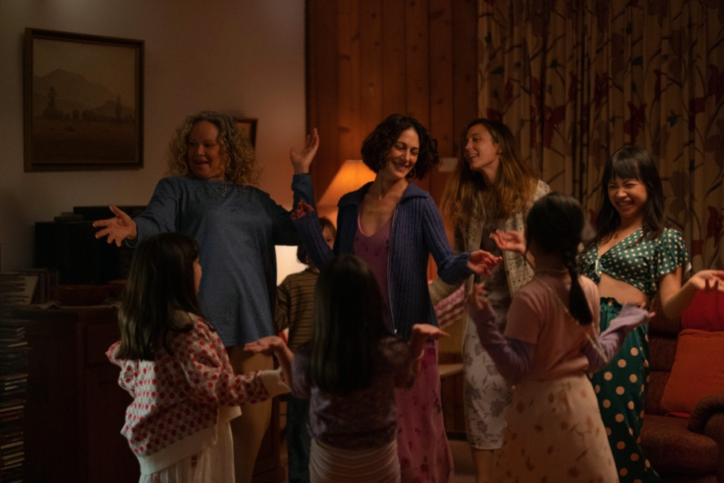
We are proud to introduce VicScreen’s Diversity, Equity and Inclusion (DEI) Roadmap; a 10-year strategy towards a thriving, equitable and inclusive screen industry that is diverse in people and content.
Victoria is home to more than 6.6 million people, embodying a breadth of experiences, identities, cultures and languages. Yet together our screen industry has some work to do in representing this diversity accurately on screen and behind the scenes. This DEI Roadmap is our response to the status quo and our commitment to championing the voices, talents and stories of all Victorians.
At VicScreen, our commitment to DEI is multifaceted and steadfast in its dedication—through a set of clearly defined guiding principles—to creating a truly diverse, equitable and inclusive screen industry. One that sees people from different communities represented in decision-making roles and positions of power across all segments of the industry. We recognise that working towards this vision requires more than just words; it requires action. That’s why our DEI Roadmap focuses on three core priorities: People, Audience and Leadership; each with associated Strategic Actions.
With global demand for diverse content continuing to rise, the road ahead is full of opportunity. The roadmap outlines how we can foster an environment where people feel valued, seen, heard, respected and empowered to reach their potential and, in turn, this will increase opportunities for growth and innovation across the screen industry.
The DEI Roadmap was developed through rigorous consultation with people across the screen industry, who shared their lived experiences and expertise with us. It is a living document, agile in its approach and able to be adjusted as we learn and roll out each year’s Action Plan. We expect 2024 to 2033 to be a transformative decade for diversity, equity and inclusion in Victoria’s screen industry, and we invite everyone to work together to achieve lasting change.
George Lekakis AO
Board President
Our DEI Commitment: Victoria is a global screen leader, with a thriving, equitable and inclusive industry that is diverse in people and content.

The need for action and collaboration
Our screen industry tells stories that allow us to connect with one another, and to better understand ourselves and each other.
In Victoria:
- Around 20% of people identify as d/Deaf or disabled
- Over half of the population are women
- Nearly a quarter of people live in regional Victoria
- More than 5% identify as LGBTIQA+
- 1% are First Peoples
- Nearly a third of people earn a low income (less than $500 a week)
- Young people aged 12–25 make up approx. 18% of the population
- Just under a third of people were born overseas and 28% speak a language other than English at home
- People come from more than 200 countries, speak 260 languages and dialects and follow 135 religious’ faiths.
Sources: Australian Bureau of Statistics; Victorian Multicultural Commission;
2017 Victorian Population Health Survey
In the last decade, the global screen industry has grown exponentially with further growth predicted. Rapid innovation and the resulting emergence of digital technologies, platforms and business models mean the demand for content is at unprecedented levels.
Victorian projects gain the attention of local and global audiences and receive strong international recognition, and our screen creators, workers and businesses remain among the best in the world.
The screen industry faces structural and systemic barriers related to DEI. There are efforts being made, but more needs to be done to redress the exclusion of people from underrepresented communities and facilitate equal opportunities for everyone to participate in, contribute to, and drive the direction of our vibrant industry. Addressing the lack of representation, both on and off screen, and rectifying this imbalance provides a great opportunity to expand the creative richness of the screen industry.
During our consultation, screen creators and workers from underrepresented communities shared entry and progression obstacles in the screen industry, including a lack of visible role models, obscured career options and pathways, the impacts of informal recruitment practices, inaccessible workplaces, concerns around safety and restricted access to digital technologies. Combined with the screen industry’s project-based work patterns, these obstacles can make entering and progressing in the screen industry particularly difficult for people from underrepresented communities.
Tackling these structural and systemic challenges is vital if we are to create a screen industry of the future. A thriving, equitable and inclusive industry that is diverse in people and content results in better economic outcomes. Diversity is a key driver of innovation in workplaces, and a proven determinant for increased productivity and performance.
The time is now to make Victoria's screen sector more diverse, equitable, inclusive and, as a result, more successful.

Developing the Roadmap
VicScreen, and its expert partners, sought and considered qualitative and quantitative research on DEI in the Victorian, Australian and global screen industries to develop the roadmap.
Throughout the process, VicScreen consulted with over 270 people from the Victorian, national and international screen industry.
We held workshops and interviews with Victorian screen creators and workers from underrepresented communities, who each brought their unique voice shaped by their own lived experiences and diverse backgrounds and identities. These workshops also included screen industry members who have the power and agency to make change around DEI, including people from production companies and studios, broadcasters, networks and streamers, industry guilds and associations, funding agencies, advocacy groups, peak bodies, government departments and educational institutions. We also undertook an anonymous online survey, distributed via targeted email and VicScreen’s e-newsletter.
With the input and feedback from this rigorous consultation process, an internal DEI working group, comprising VicScreen staff and supported by members of the VicScreen Board and Executive Team, came together to create the DEI Roadmap.

Our DEI Commitment
Victoria is a global screen leader, with a thriving, equitable and inclusive industry that is diverse in people and content.
Our DEI Commitment reflects our organisational vision: Victoria is a global powerhouse for screen, enriching the lives of all Victorians. We will continuously work towards this commitment to create a successful screen industry where everyone sees a place for themselves.

Our DEI Priorities
Three DEI Priorities will frame our focus over the next 10 years. These align with VICSCREEN: Victoria’s Screen Industry Strategy 2021-2025 and will inform the development of its successor strategy.
People | Remove barriers so all screen creators and workers can thrive.
Audience | Increase audience access to and engagement with content that is diverse and inclusive.
Leadership | Demonstrate inclusive leadership in VicScreen decision-making and behaviours.

People
Remove barriers so all screen creators and workers can thrive.

What we’re working towards
The uniqueness of Victorians will be celebrated on screen through culturally and commercially significant content that authentically reflects the diversity of Victorian people and communities. The Victorian screen industry will be free from barriers that limit the participation and success of people because of their identity, background and socio-economic positioning. Everyone will see a place for themselves in the screen sector and workplaces will be safe and accessible spaces. Skills, talent and professional development opportunities will be accessible, and there will be better and clearer pathways from educational institutions to early successes to building a professional career in the screen industry.
How we will help to get there
VicScreen Priorities:
- Generate compelling Victorian content and IP.
- Drive industry growth and jobs.
- Develop skills and talent.
DEI Priority:
PEOPLE: Remove barriers so all screen creators and workers can thrive.
Strategic Actions:
- Collaborate with screen industry partners to develop and nurture career pathways for Victorian screen creators and workers from underrepresented communities.
- Collaborate with screen creators and workers from underrepresented communities and screen industry partners to review or design funding programs.
- Support access to safe and inclusive employment, networking, markets and educational opportunities for Victorian screen creators and workers from underrepresented communities.
- Promote and champion Victorian screen creators and workers from underrepresented communities.

Audience
Increase audience access to and engagement with content that is diverse and inclusive.

What we’re working towards
Audiences around the world will seek out content by Victorian screen creators, workers and businesses. Victorians will be aware of the diversity of our local screen creators and feel pride in their stories and successes. They will understand the cultural significance and commercial value of diverse stories and drive demand for content that celebrates different perspectives. Audiences will feel confident that the experiences of watching, playing and interacting with screen content are accessible to everyone, due to authentic representation, inclusive design and accessible technology.

How we will help to get there
VicScreen Priority:
Build market and consumer engagement.
DEI Priority:
AUDIENCE: Increase audience access to and engagement with content that is diverse and inclusive.
Strategic Actions:
- Advocate for and embed improved access to screen content, including at events and screen activities delivered and/or supported by VicScreen.
- Foster audience awareness of and engagement with content that is diverse and inclusive.

Leadership
Demonstrate inclusive leadership in VicScreen decision-making and behaviours.
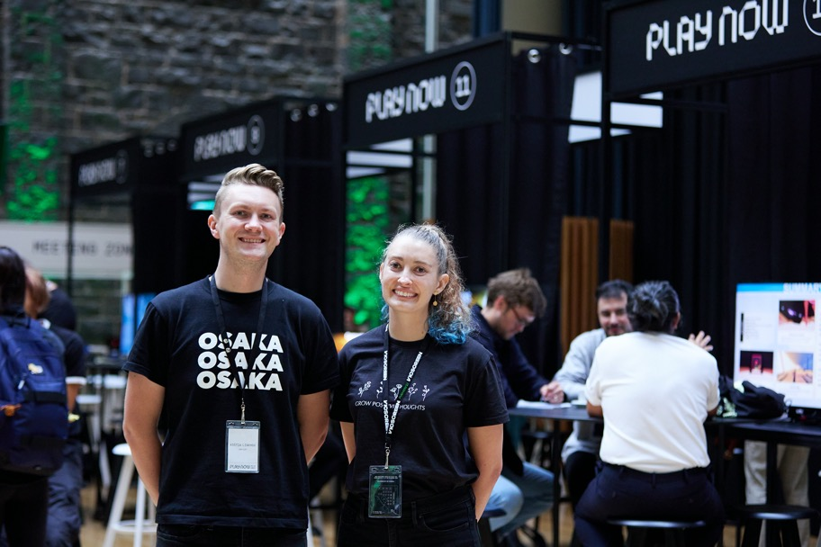
What we’re working towards
VicScreen will be recognised as a leader and advocate for improved DEI outcomes across the screen industry. We will have effective relationships with screen industry partners that enable continuous improvement and national alignment in DEI. Our Board, staff and external assessors will be reflective of our industry and the communities we work with. VicScreen’s business processes, policies and procedures will align with our DEI Guiding Principles. Our people will demonstrate inclusive leadership and be competent in actively promoting inclusion at both the individual and systemic level. We will understand the demographic makeup of our organisation and the screen industry workforce, and sound data and research will inform our decisions.
How we will get there
VicScreen Priority:
Deliver maximum industry impact.
DEI Priority:
LEADERSHIP: Demonstrate inclusive leadership in VicScreen decision-making and behaviours.
Strategic Actions:
- Generate more robust data to inform decision-making.
- Create and maintain structures and processes at VicScreen that model accountability for organisational and industry DEI improvement.
- Promote industry best practice in DEI and encourage screen industry-wide positive change.

Our DEI guiding principles

The VicScreen DEI Roadmap is underpinned by a set of principles to guide every step of the process, from decision-making and implementation, to refining and reporting. These principles emerged from consultation and reflect an industry ready to create long-lasting, positive change in DEI. They also speak to VicScreen’s organisational values of being open, brave, collaborative, excellent and energetic, and will inform our approach to embedding the roadmap into our ways of working.

Recognition of identity and experiences
VicScreen acknowledges the unique identity of each individual and recognises that experiences of inequality are different. It is important to us that everyone sees themselves reflected in this roadmap: people from underrepresented communities, people in all roles in the screen sector and people looking for a career in the Victorian screen industry. We will work with underrepresented groups within the screen industry to develop targeted approaches, while striving to achieve more inclusive and responsive funding and program delivery outcomes for all screen creators and workers.
Adaptive, courageous learning
Learning is a fundamental part of creating a more inclusive and equitable screen industry. Understanding the way organisational systems, policies and processes have historically excluded specific communities is crucial in establishing a more equitable future. VicScreen invites the screen industry to join us in being courageous in our DEI learning journey and to use the knowledge gained to change the way each of us thinks and behaves and, in turn, how the screen industry operates.
Shared responsibility and accountability
Building a more diverse, equitable and inclusive screen industry helps create social, cultural and economic outcomes that benefit everyone working across Victoria’s screen ecosystem, not just people from underrepresented communities. Everyone participating in and benefiting from the Victorian screen industry has a shared responsibility to incorporate DEI in their daily individual and organisational behaviours and practices. By publicly stating our DEI commitments, we also hold ourselves and each other to account for progress in creating positive change.
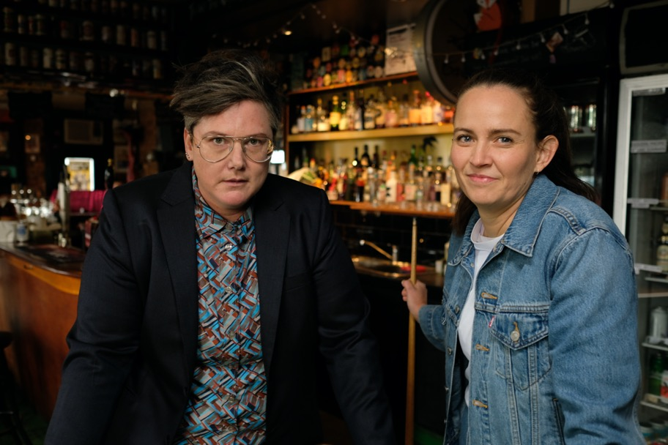
Regular, respectful collaboration
An ambitious, long-term roadmap like this can only be realised if everyone works together in a respectful manner. This includes actively listening and ensuring people feel comfortable and safe when they contribute differing views. Sharing ideas, learnings and experiences can also accelerate the pace of change. Consultation with people from underrepresented communities will continue on a regular basis throughout the 10-year lifespan of the roadmap, including collaboration on the design of targeted programs and initiatives.
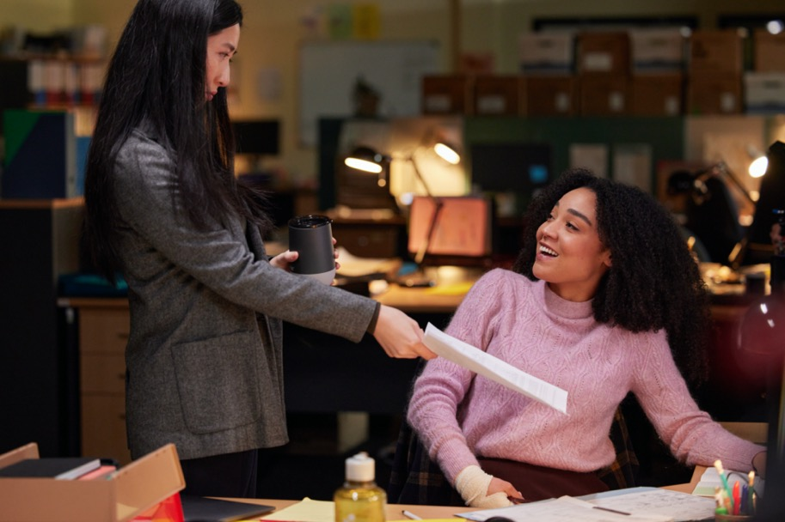
First Peoples’ own storytelling
Our First Peoples have been telling their own stories for millennia and the continuation of 65,000 years of unbroken storytelling enriches all Victorians. VicScreen is committed to strengthening its relationship with Victorian First Peoples screen creators, workers and businesses, as well as wider First Peoples communities. As an organisation, we will continue to support the creative freedom of all our screen creators and industry partners, but it must be done in a way that respectfully honours the fundamental and inalienable right of First Peoples to tell their own stories. Further actions by VicScreen to promote and support First Peoples are currently in development.

The road ahead

The VicScreen DEI Roadmap is an ambitious 10-year plan that demonstrates our commitment to enduring positive change to create a Victorian screen industry that is more diverse, equitable and inclusive.
Making progress
As Victoria’s creative and economic screen development agency, VicScreen will drive DEI progress in the Victorian screen industry as well as the broader screen sector through:
- Program design and delivery
- Leadership and advocacy
- Engagement and collaboration
- Empowerment and celebration
Our DEI Priorities lay out our long-term plan for working towards our DEI Commitment. Each Priority has associated high-level Strategic Actions which we will review annually and update to ensure continuous and sustained progress. An annual Action Plan of detailed tasks will support delivery of the Strategic Actions.
Both the screen industry and DEI are dynamic and constantly changing. Over the 10-year period of the roadmap, we will take a phased and agile approach, monitoring progress and making necessary course corrections along the way.
Responsibility and accountability
The implementation of this roadmap will happen across every level and division at VicScreen, with DEI to be embedded in everyday work.
Delivery of the roadmap will be supported by a screen industry DEI Advisory Group comprised of people from underrepresented communities and an internal DEI working group.
The VicScreen Board will approve any updates to the DEI Roadmap over its 10-year lifespan and will be accountable for its delivery. Responsibility for the day-to-day implementation of the Action Plan rests with the VicScreen CEO and Executive Team. VicScreen makes this commitment within the context of its legislative and regulatory framework, agreements with and obligations to government, and within its funding levels, resources and financial capacity.

Measuring and reporting
VicScreen will measure the performance of the DEI Roadmap in two ways:
- Implementation will track how the roadmap is progressing against the Action Plan
- Outcomes will measure the impact on the Victorian screen industry.
To set the measures for outcomes, we need to review our approach to data collection for VicScreen programs and initiatives to better understand how our funding is spread across underrepresented communities. At the same time, we will be implementing the other tasks in the Action Plan to drive the roadmap forward.
We will share our baselines and targets/quotas once they have been set, and report on our progress and impact annually.


Appendix 1: Key definitions
Diversity refers to all the differences between people that make them who they are. They can be both visible and invisible, and can include differences in age, ability, race, cultural background, sexual orientation, gender, education, religion, experience and socio-economic background.
Equity is about recognising that people have different circumstances and works to identify and eliminate structural and systemic barriers that prevent full participation in society.
Inclusion is when all people feel, and are, valued and respected, have access to opportunities and resources, and are able to operate at their best.

Other language used in the roadmap
VicScreen recognises that language is evolving, contested and deeply personal for some people and that self-determination is important. Over the duration of the roadmap, we will review and update the language and always be open to hearing feedback.
Underrepresented
We use ‘underrepresented’ to refer to people who have been historically underrepresented in the screen industry due to First Peoples identity, race, cultural background, gender, sexual orientation, disability, age, socio-economic background and/or geographic location.

Victorian First Peoples
We use ‘Victorian First Peoples’ to refer to Traditional Owners of Victoria and all other Aboriginal and Torres Strait Islander peoples who reside in this state.
Disabled people
We use the identity-first language of ‘disabled people’. This is in keeping with the social model of disability, a way of viewing the world developed by disabled people, in which ‘disability’ is a social construct. We recognise that some people prefer person-first language, such as ‘people with disability’, and that some choose to identify with a specific community, such as d/Deaf, or prefer not to refer to themselves as disabled.
Screen creators
We use ‘screen creators’ to encompass those roles that are drivers of screen production such as directors, producers, writers and game designers. These roles lead the overall creative direction of screen projects, covering other terms commonly used in the screen industry such as above-the-line, key creatives, storytellers, filmmakers and talent.
Screen workers
We use ‘screen workers’ to encompass the wide range of highly skilled roles within a screen production, including programmers, artists, digital matte painters, animators, production designers, sound mixers and camera operators. This covers other terms commonly used in the screen industry for these roles such as below-the-line, practitioners and crew.
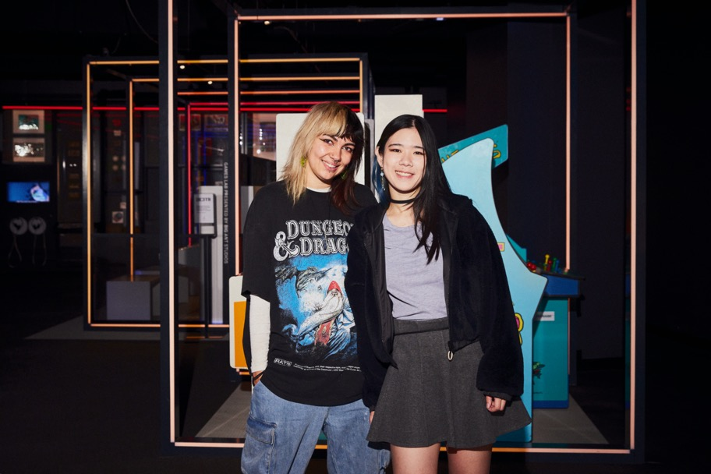

You can support the roadmap
VicScreen will implement this DEI Roadmap in collaboration with the Victorian screen industry. We are open to hearing and learning from everyone.
If you have any questions or feedback, please contact us.
T +61 3 9660 3200
E hello@vicscreen.vic.gov.au
W vicscreen.vic.gov.au
VicScreen is grateful to everyone who contributed to the development of our DEI Roadmap.
We acknowledge PwC, MindTribes and SEC Newgate; our reviewers; and the VicScreen DEI working group and Board and Executive Team sponsors.
This Roadmap was prepared by VicScreen’s Strategy & Performance team.
© Copyright VicScreen 2024
Published by VicScreen
Melbourne/Naarm Victoria Australia, February 2024
Also published at vicscreen.vic.gov.au
You are free to re-use this work under a Creative Commons Attribution — No Derivatives 4.0 International Licence provided you credit VicScreen as author, indicate if changes were made and comply with the other licence terms. The licence does not apply to any images, photographs or branding, including the VicScreen logo and Victorian Government logo.

Image Credits
Cover: Mira Russo, Ayiana Ncube and Riya Mandrawa in Turn Up The Volume, Matchbox Pictures. Photo Jane Zhang.
Page 5: Leah Purcell, Zar Amir Ebrahimi, Eve Morey and Jillian Nguyen in Shayda, Origma 45. Photo Jane Zhang.
Page 12: Originate Features finalists Kalu Oji, Rosie Lourde, Hannah Ngo, Ivy Mutuku, Mimo Mukii, Katie Found, Adrian Chiarella and Harvey Zielinski. Photo Sarah Chavdaroska.
Page 14: Anurag Kashyap at Indian Film Festival of Melbourne. Photo Daniel Mahon.
Page: 16: Kostia Liakhov and Samantha Cable at Play Now Melbourne. Photo Sarah Chavdaroska.
Page 18: Moving Out, SMG Studio.
Page 20: Hannah Gadsby and Zoë Coombs Marr Queerstralia, Guesswork Television.
Page 21: Mabel Li and Aisha Dee in Safe Home, Kindling Pictures. Photo Narelle Portanier.
Page 22: Sky Katz and Kai Lewins in Surviving Summer S2, Werner Film Productions. Photo Ben Saunders
Page 24: Eliza Scanlen and Hunter Page-Lochard in Fires, Tony Ayres Productions. Photo Ben King
Page 34: Victorian Games Development Interns Phoebe Watson and Memia Lin. Photo Sarah Chavdaroska.

